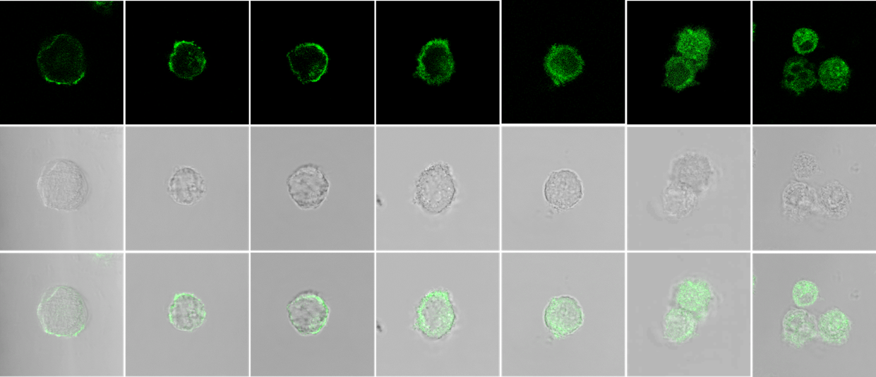
1 h
3 h
6 h
1 d
2 d
3 d
5 d
GFP
Bright field
Merge

Fig. S1. Confocal imaging of Alexa488-PEG-modified C3H10T1/2 cells. Alexa488-PEG-modified C3H10T1/2 cells were cultured on Nunc Lab-Tek II Chambered Coverglasses and observed using a confocal laser scanning microscope (scale bars: 20 μm).

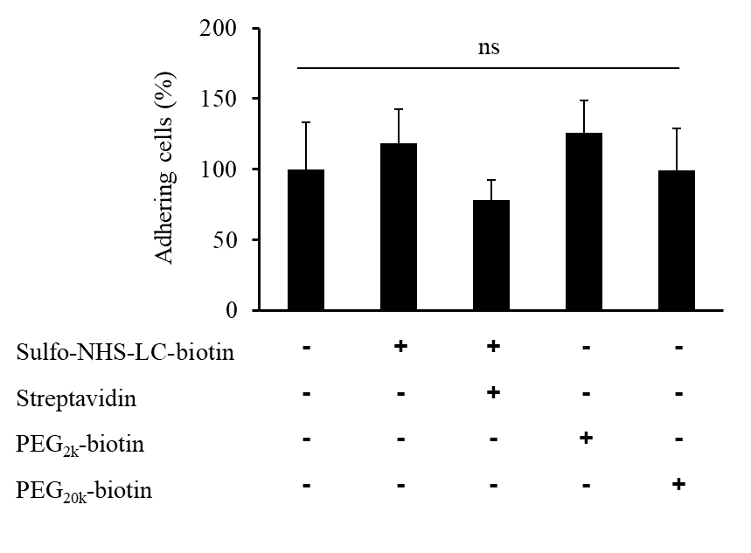

Fig. S2. Influence of biotin- or streptavidin-modification on cell adhesion. Biotin- or streptavidin-modified C3H10T1/2/Nluc cells or, PEG-biotin-treated unmodified C3H10T1/2/Nluc cells were seeded onto a monolayered MAECs. Two hours after incubation, nonadherent C3H10T1/2/Nluc cells were removed by PBS wash and the luciferase activity was measured. The error bars represent ± SD, n = 4 (ns; not significant).

ns
Unmodified
PEG_{2k}
PEG_{20k}
6×10⁵
4×10⁵
3×10⁵
0

Fig. S3. Number of PEG-C3H10T1/2 cells adhering to MAECs at 12 h after seeding. PEG2k-C3H10T1/2 cells, PEG20k-C3H10T1/2/Nluc cells, and unmodified C3H10T1/2/Nluc were seeded onto a monolayered MAECs. Twelve hours after seeding, nonadherent C3H10T1/2/Nluc cells were removed by PBS wash, and the luciferase activity was measured. The error bars represent ± SD, n = 4 (ns; not significant).

*
*
Vehicle
CCl₄
Vehicle

Fig. S4. Serum AST and ALT levels of CCl₄-induced acute liver failure model mice. CCl₄ (1.5 mL/kg) was intraperitoneally injected to FVB mice, at 6 h after injection, the serum AST and ALT levels were measured. The error bars represent ± SD, n = 4, *p < 0.05 versus vehicle group.

