Supporting Information

NG2-positive pericytes regulate homeostatic maintenance of slow-type skeletal muscle with rapid myonuclear turnover

Takamitsu Tatsukawa et al.

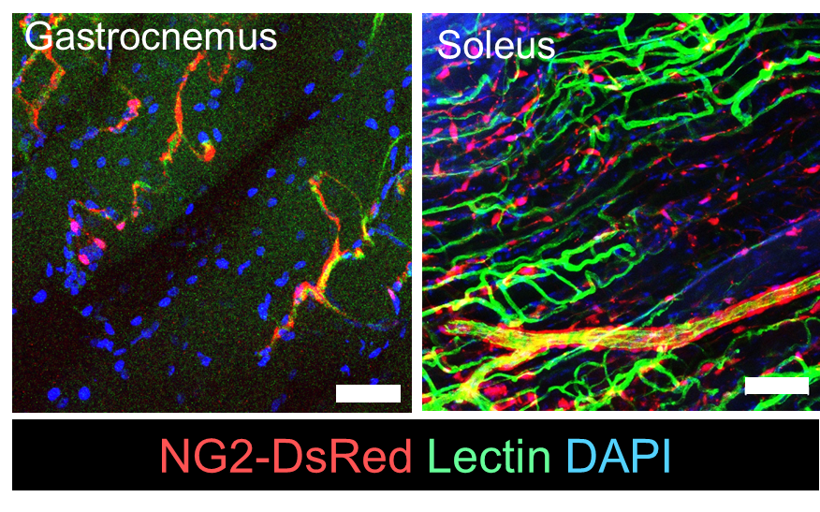

Supplementary Figure 1. Localization of NG2⁺ cells in adult skeletal muscle tissues. Circulating vessels in NG2-DsRed mice were visualized by intravenous injection of FITC-conjugated lectin. The lower limb skeletal muscles (gastrocnemius and soleus) were fixed and transparentized with RapiClear reagent. Microvessels, lectin-labeled endothelium tubes (lectin; green), and NG2⁺ cells (DsRed; red) within transparent muscles were visualized in a 3D view using confocal fluorescent microscopy. The nuclei were counterstained with DAPI. Scale bar = 50 μm.

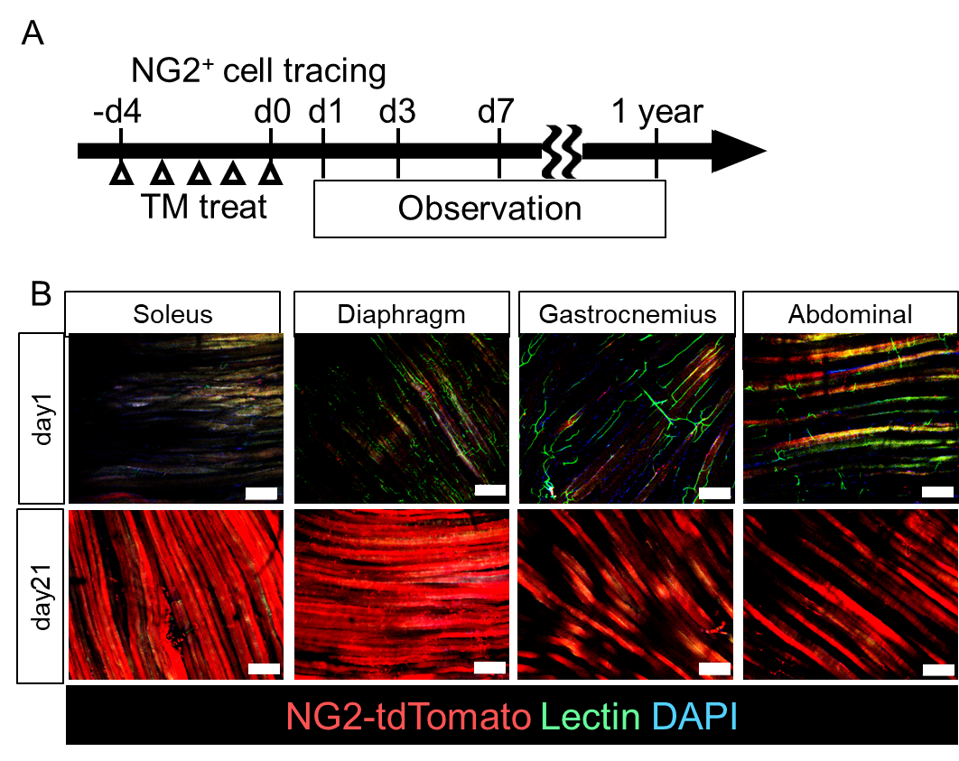

Supplementary Figure 2. NG2⁺ cell lineage tracing within the skeletal muscle. The tdTomato expression driven by the universal Rosa26 promoter was specifically induced in NG2⁺ cells using NG2-CreERT/Rosa-tdTomato mice. After five days of constitutive treatment with Tam, NG2⁺ cells were expressed. B. On day 1 of the observation period, tdTomato⁺ cells were observed only at perivascular sites, such as PCs. On day 21, tdTomato-expressing myofibers were observed in most muscle tissues. The ratio of tdTomato⁺ myofibers to total myofibers varied by muscle site, i.e., over 80% of tdTomato⁺ myofibers in the soleus and diaphragm and 20–30% in the gastrocnemius and rectus abdominal muscles. Scale bar = 200 μm.

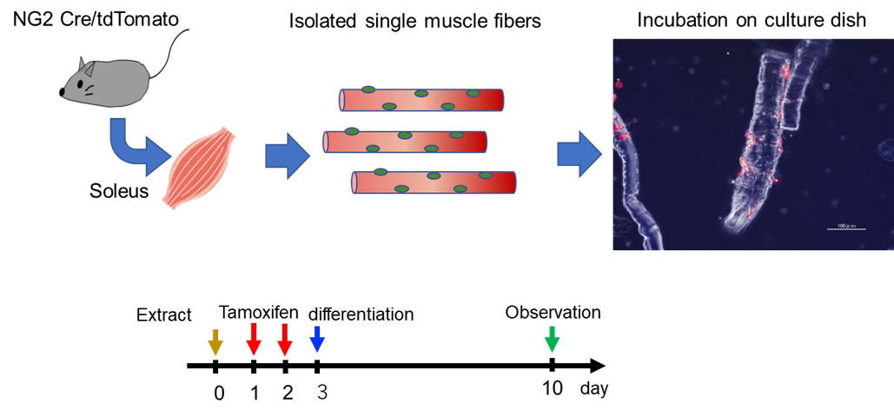

Supplementary Figure 3. Schematic diagram for the in vitro muscular differentiation assay. Myofibers were isolated from the soleus of NG2-CreERT/Rosa-tdTomato mice by using a collagenase-containing medium. Isolated myofibers were incubated in DMEM-containing 10% FBS and Tam (2 µM) for three days to label NG2⁺ PCs. The medium was then changed to a differentiation medium containing 2% horse serum. After six days of induction, the myogenesis of NG2⁺ PCs was observed.

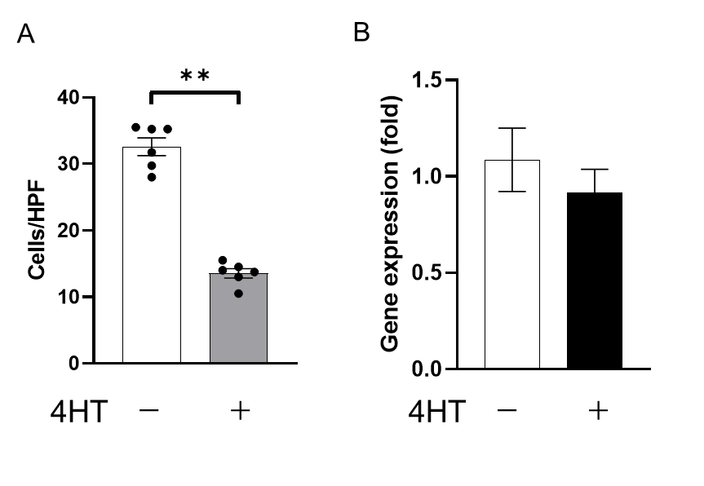

Supplementary Figure 4. Tam treatment induces deletion of NG2⁺ cells. A. In vitro effects of 4-hydroxytamoxifen (4-HT) on NG2⁺ cells isolated from subcutaneous adipose tissues of NG2-CreERT/Rosa26-DTA mice. Cells at confluent were incubated in medium containing hydroxy-Tam for 5 days, and the number of cells were counted. B. Gene expression of NG2 in NG2⁺ cells with Tam was esteemed by qPCR.

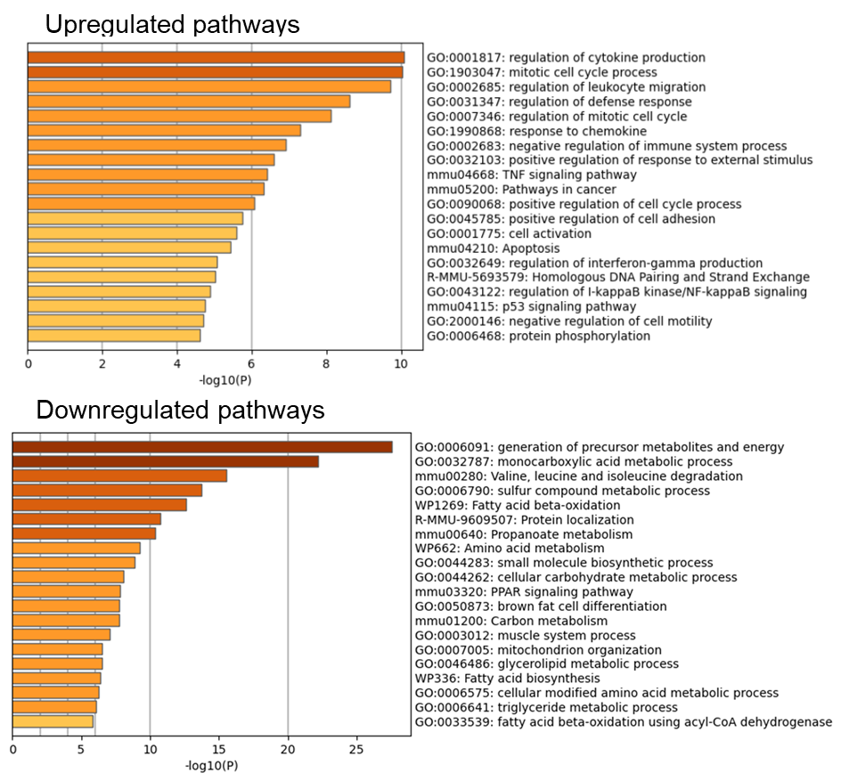

Supplementary Figure 5. Microarray enrichment analysis in response to PC deletion. After induction of NG2⁺ PC deletion for one month, microarray analysis of the soleus of PC-deletion and control mice was performed. The top 20 upregulated and downregulated pathway-related gene sets are listed.

