SUPPLEMENTARY MATERIALS

TABLE S1. Search strategy

Database | Keywords
PUBMED
#1 | (("birth s"[All Fields] OR "birthed"[All Fields] OR "birthing"[All Fields] OR "parturition"[MeSH Terms] OR "parturition"[All Fields] OR "birth"[All Fields] OR "births"[All Fields]) AND ("characteristic"[All Fields] OR "characteristics"[All Fields])) OR ("birth weight"[MeSH Terms] OR ("birth"[All Fields] AND "weight"[All Fields]) OR "birth weight"[All Fields])  birth: "birth's"[All Fields] OR "birthed"[All Fields] OR "birthing"[All Fields] OR "parturition"[MeSH Terms] OR "parturition"[All Fields] OR "birth"[All Fields] OR "births"[All Fields]  characteristics: "characteristic"[All Fields] OR "characteristics"[All Fields]  birth weight: "birth weight"[MeSH Terms] OR ("birth"[All Fields] AND "weight"[All Fields]) OR "birth weight"[All Fields]
#2 | "prenatal"[All Fields] OR "prenatally"[All Fields] OR "prenatals"[All Fields] OR "perinatal"[All Fields] OR "perinatally"[All Fields] OR "perinatals"[All Fields]
#3 | #1 OR #2
#4 | "neuroblastoma"[MeSH Terms] OR "neuroblastoma"[All Fields] OR "neuroblastomas"[All Fields]
#5 | #3 AND #4
#6 | "cross sectional studies"[MeSH Terms] OR ("cross sectional"[All Fields] AND "studies"[All Fields]) OR "cross sectional studies"[All Fields] OR ("cross"[All Fields] AND "sectional"[All Fields] AND "study"[All Fields]) OR "cross sectional study"[All Fields] OR "case-series"[All Fields] OR ("case control studies"[MeSH Terms] OR ("case control"[All Fields] AND "studies"[All Fields]) OR "case control studies"[All Fields] OR ("case"[All Fields] AND "control"[All Fields] AND "study"[All Fields]) OR "case control study"[All Fields]) OR ("follow up studies"[MeSH Terms] OR ("follow up"[All Fields] AND "studies"[All Fields]) OR "follow up studies"[All Fields] OR ("follow"[All Fields] AND "up"[All Fields] AND "study"[All Fields]) OR "follow up study"[All Fields]) OR ("cohort studies"[MeSH Terms] OR ("cohort"[All Fields] AND "studies"[All Fields]) OR "cohort studies"[All Fields] OR ("cohort"[All Fields] AND "study"[All Fields]) OR "cohort study"[All Fields])
#7 | #5 AND #6
EMBASE
S1 | ((birth or "childbirth" or "delivering the baby" or "giving birth" or "labor delivery" or "parturition" or "parturitions") characteristics) OR ((birth or "childbirth" or "delivering the baby" or "giving birth" or "labor delivery" or "parturition" or "parturitions") weight)
S2 | ((prenatal or "antenatal")) OR perinatal
S3 | S1 OR S2
S4 | neuroblastoma
S5 | S3 AND S4
S6 | (((((((cross-sectional study) or "synchronic study")) or ("synchronic study" or "cross-sectional study"))) or (("synchronic study" or "cross-sectional study") or ("cross-sectional study" or "synchronic study")))) OR case-series OR (case-control study) OR (((((((cohort study) or "follow-up study")) or ("follow-up study" or "cohort study"))) or (("follow-up study" or "cohort study") or ("cohort study" or "follow-up study"))))
S7 | S5 AND S6
WoS
#1 | (ALL=(birth characteristics)) OR ALL=(birth weight)
#2 | (ALL=(prenatal)) OR ALL=(perinatal)
#3 | ALL=(neuroblastoma)
#4 | (#1) OR #2
#5 | (#3) AND #4
#6 | (((((ALL=(cross-sectional study)) OR ALL=(synchronic study)) OR ALL=(case-series)) OR ALL=(case-control study)) OR ALL=(follow-up study)) OR ALL=(cohort study)
#7 | (#6) AND #5
SCOPUS
#1 | birth AND characteristics OR birth AND weight
#2 | prenatal OR perinatal
#3 | #2 OR #1
#4 | neuroblastoma
#5 | #3 AND #4
#6 | cross-sectional AND study OR synchronic AND study OR case-series OR case-control AND study OR follow-up AND study OR cohort AND study
#7 | #6 AND #5

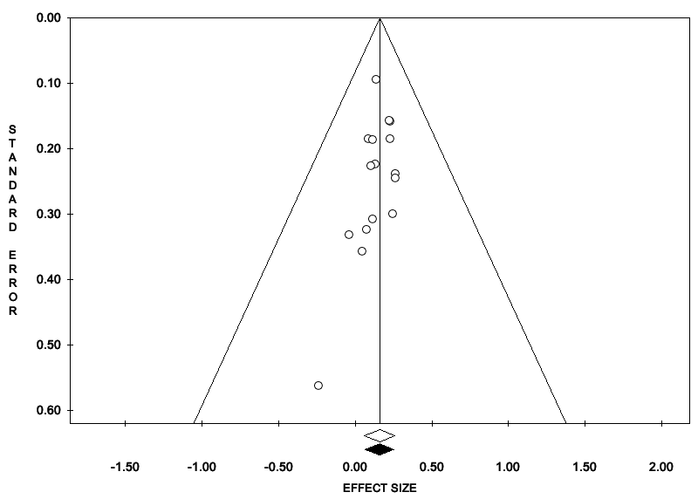
FIGURE S1. Funnel plot showing the high birth weight and neuroblastoma risk

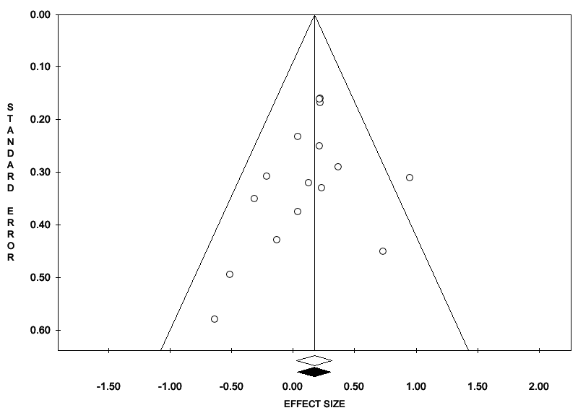
FIGURE S2. Funnel plot showing the low birth weight and neuroblastoma risk

