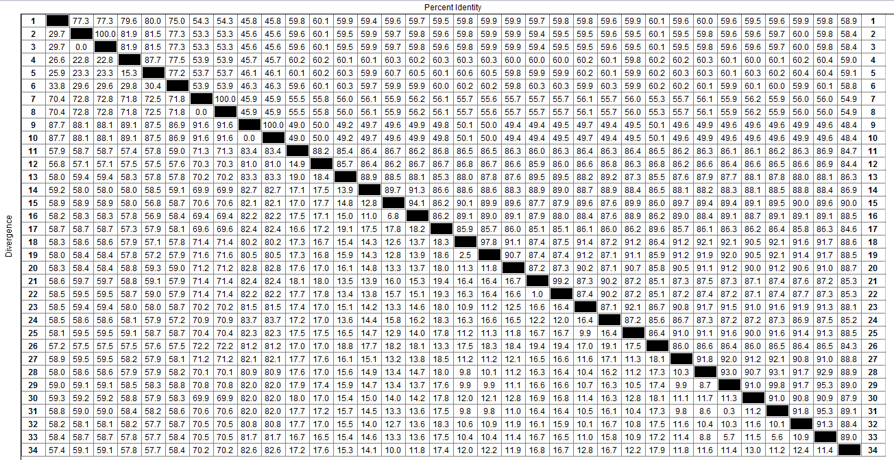
(A)
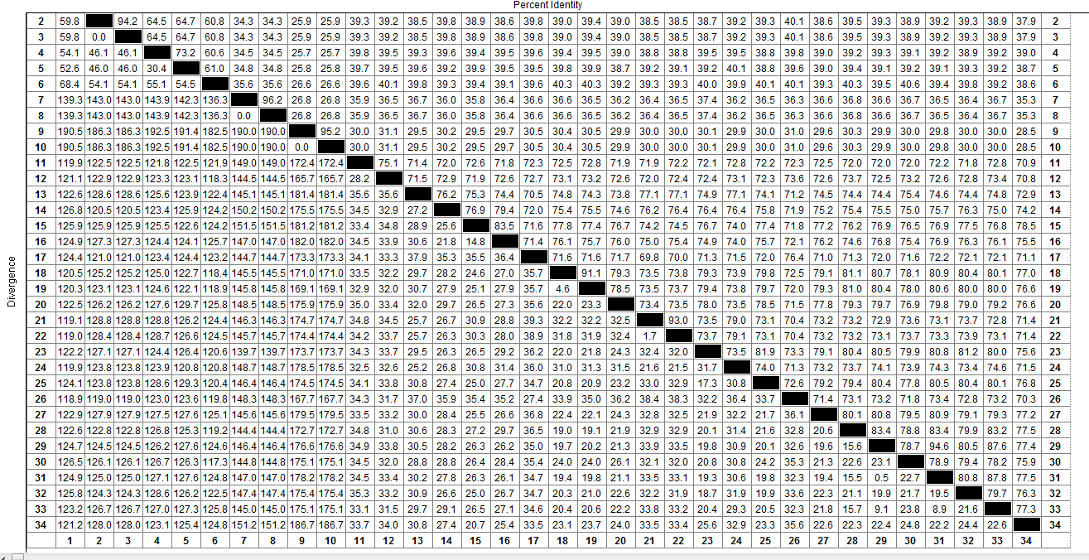
(B)
Supplementary Figure 1: Nucleotide and amino acid identities for SHCM2019. (A) Nucleotide identities (B) Amino acid identities

Supplementary Figure 2: Phylogenetic analysis of the VP1 nucleotide sequence for PSV/SHCM2019. A phylogenetic tree was constructed by the neighbour-joining method in the MEGA7.0 software. The numbers at the branches are bootstrap values (%) following 1000 replicates. A dot has been added to the front of the PSV strain isolated in this study.

