Supplementary methods
Measurement of FITC flux in mouse intestinal colon organoids
Cultured colon organoids were divided into eight groups, one of which served as a control group, while different concentrations of Nod (5, 10, 20 μM) were added to three other groups. In addition, the remaining four groups were stimulated with 5 mM adenosine 5-triphosphate (ATP) alone for 2 h, followed by 200 ng/mL lipopolysaccharide (LPS) alone for 8 h, and different concentrations of Nod (5, 10, 20 μM) were randomly added to three of these four groups for treatment.
The relative permeability of the colon was measured by adding 0.1 mg/mL FD4 to the growth medium and measuring FD4 flux into colon organoids after 24 h. The surface area and volume of the colon were calculated from the measured radius to calculate the FD4 flux (ng/cm².h).

Supplementary figure legends
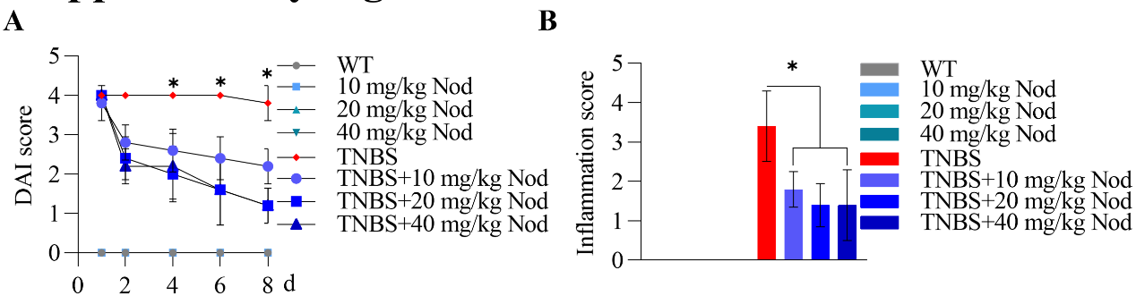
Supplementary Figure 1. Nodakenin improved experimental colitis in TNBS-induced mice.
(A) DAI scores of the different concentrations of Nod-treated WT or TNBS-induced mice. Inflammation scores (B) of the colon tissue from WT or TNBS-induced mice treated with different concentrations of Nod. n=10; the data are expressed as the means ± SD; *P<0.05.
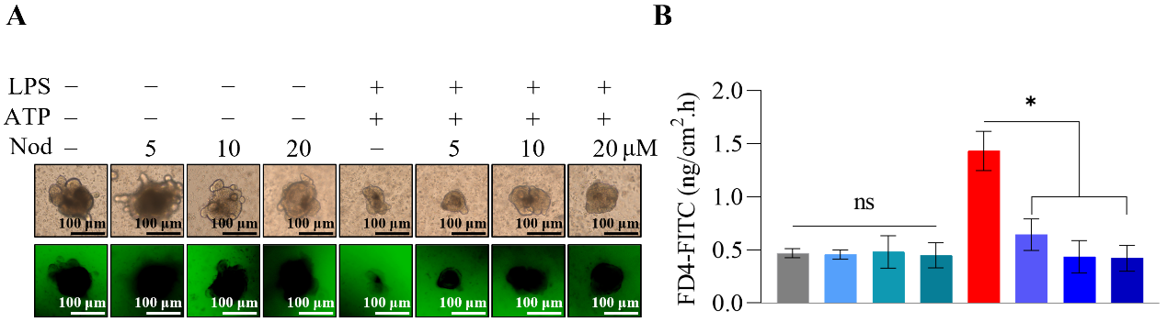
Supplementary Figure 2. Nodakenin rescued the permeability increase induced by LPS and ATP in mouse colon organoids.
(A) Representative optical slices through a human colonoids bathed in growth media containing 0.1 mg/mL FD4. (B) FD4 flux normalized to colonic surface area by colonic epithelium. n=3; the data are expressed as the meana ± SD; *P<0.05.
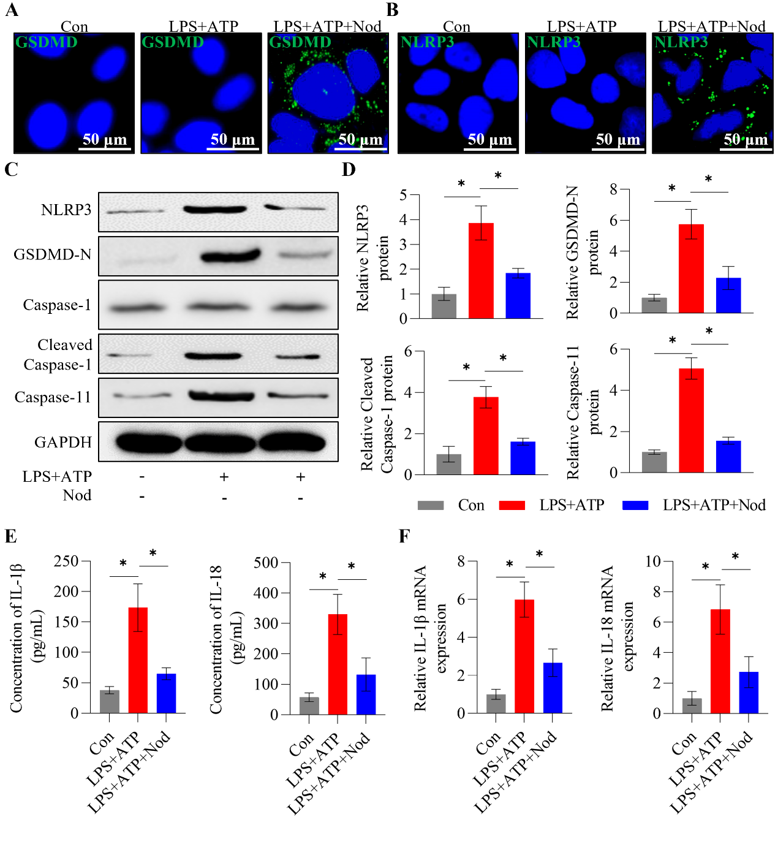
Supplementary Figure 3. Nodakenin inhibited pyroptosis in intestinal epithelial cells.
We stimulated mouse intestinal organoids with LPS and ATP in vitro, followed by immunofluorescence staining for (A) GSDMD-N and (B) NLRP3 to confirm the establishment of a pyroptosis model, and found that Nod inhibited the pyroptosis of intestinal epithelial cells (Caco-2). (C-D) Western blotting was used to measure the protein expression levels of GSDMD-N, NLRP3, cleaved caspase-1 and caspase-11 in Caco-2 cells treated with and without Nod. (E) The mRNA expression levels of IL-1β and IL-18 in Caco-2 cells after Nod treatment were measured by RT–qPCR. (F) The expression levels of IL-1β and IL-18 in the culture medium of Caco-2 cells after Nod treatment were measured by ELISA. n=3; the data are expressed as the means ± SD; *P<0.05.

