Real-time observation of phase transition from layered to spinel phase under electron beam irradiation
Jong Hyeok Seo^{1,2}, Joon Yong Park³, Yong-Il Kim¹, Ki Min Nam³, Jae-Hyuck Jang⁴, Ji-Hwan Kwon^{1,2,*}
¹ Korea Research Institute of Standard and Science, Daejeon 34113, Republic of Korea
² Korea University of Science and Technology, Daejeon 34113, Republic of Korea
³ Department of Chemistry and Chemistry Institute for Functional Materials, Pusan National University, Busan 46241, Republic of Korea
⁴ Electron Microscopy Research Center, Korea Basic Science Institute, Daejeon 34133, Republic of Korea

Porous morphology of e-beam irradiated Co(OH)₂
The irradiation was performed in STEM mode and the corresponding screen current was about 10 pA. Like the e-beam irradiation in TEM mode, the layered structure of Co(OH)₂ changed into spinel Co₃O₄ structure under the e-beam irradiation in STEM mode. The higher screen current (electron dose) accelerated the phase transition from layer to spinel phase. As the e-beam scanned the sample, some dark spots (dark spots’ contrast varies) began to appear as shown in Figure S1. Figure S1 shows a high-resolution high-angle annular dark field(HAADF)-scanning transmission electron microscopy(STEM) image of Co(OH)₂ after the phase transition finished. The contrast of transformed spinel Co₃O₄ is inhomogeneous. Since the dark contrast region showed the same spinel Co₃O₄ structure in fast Fourier transform (FFT), the regions with lower densities are thought to be the cause of the dark contrast. Note that the intensity of HAADF-STEM image depends on atomic number Z or the thickness of the sample. The HR-TEM image also showed similar inhomogeneous contrast and the size of dark contrast is similar to that found in HAADF-STEM image. Based on the HAADF-STEM and HR-TEM image, we expect that the rather dense layered sample changed into porous spinel phase due to the extraction of water molecules by the e-beam irradiation. It is worth noting that the annealed Co(OH)₂ sample also changed into spinel Co₃O₄ phase with similar porous morphology, which is observed in HAADF-STEM image as shown in Figure S1.

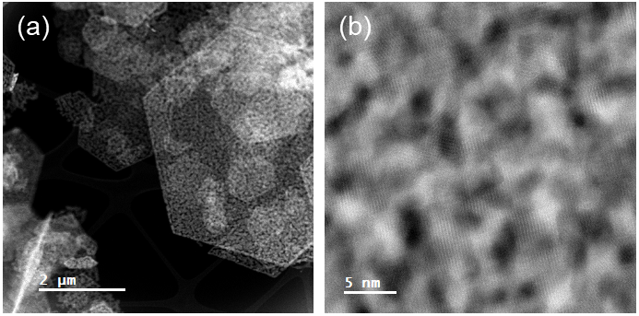

Figure S1. High angle annular dark field images of the transformed spinel Co₃O₄ phase. (a) HAADF-STEM image. (b) Magnified image from (a), showing the particles having a porous morphology.

The shrinkage of thickness after e-beam irradiation
Figure S2 displays a cross-sectional HR-TEM images of Co(OH)₂ before and after the e-beam irradiation. The thickness of both α-Co(OH)₂ and β-Co(OH)₂ decreased under the e-beam irradiation. Especially, α-Co(OH)₂ showed significant shrinkage in thickness due to the extraction of water molecules by the e-beam.
Figure S2. Cross-sectional TEM images: (a, b) α-Co(OH)₂ and (c, d) β-Co(OH)₂ before and after electron beam irradiation

The electron diffraction simulation with tilting from the [111] zone axis
On the [111] zone axis of spinel structure, the tilting of some nanograins with respect to <112> direction cannot be discerned as the diffraction patterns of not-tilted and tilted are overlapped each other. Figure S3 shows a simulated electron diffraction pattern of the [111] zone axis of spinel Co₃O₄ (not-tilted) and the tilted diffraction patterns, which are rotated by 15.79°, 25.24°, and 38.94° from [111] zone axis with respect to [1-21] direction. As seen in the Figure S3, {220}, {440} family peaks coincide in the not-tilted and the tilted diffraction patterns. Although the other peaks also exist in the tilted diffraction pattern, those peaks are difficult to be observed in the real diffraction (FFT) as they contain low intensity.
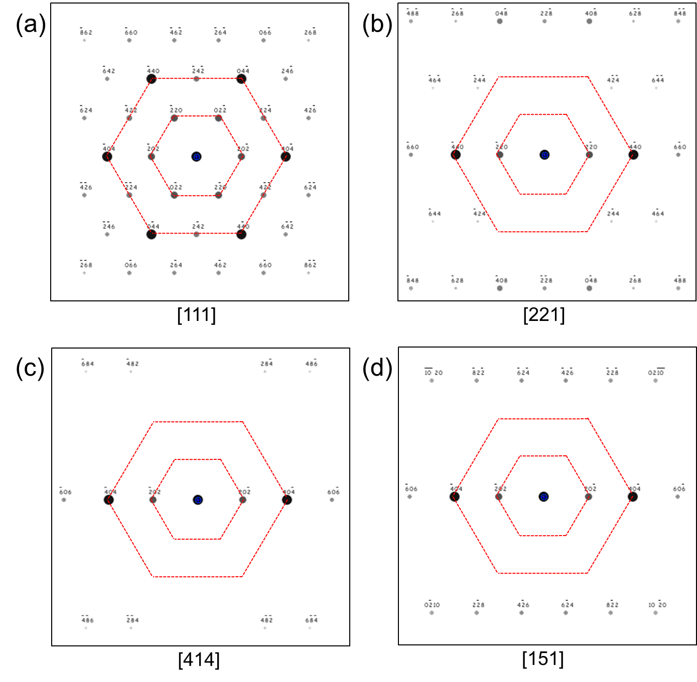
Figure S3. Simulated electron diffraction patterns of Co₃O₄ for (a) [111], (b) [221], (c) [414], (d) [151] zone axis, respectively.

