Supplementary materials for
The importance of species addition and replacement varies over succession in plant communities after glacial retreat
Isabel Cantera¹, Alexis Carteron¹, Alessia Guerrieri^{,2}, Silvio Marta¹, Aurélie Bonin^{1,}, Roberto Ambrosini¹, Fabien Anthelme, Roberto Sergio Azzoni^{1,}, Peter Almond, Pablo Alviz Gazitúa, Sophie Cauvy-Fraunié, Jorge Luis Ceballos Lievano, Pritam Chand, Milap Chand Sharma, John Clague, Justiniano Alejo Cochachín Rapre, Chiara Compostella⁵, Rolando Cruz Encarnación¹², Olivier Dangles, Andre Eger, Sergey Erokhin, Andrea Franzetti, Ludovic Gielly, Fabrizio Gili^{1,}, Mauro Gobbi, Sigmund Hågvar,, Norine Khedim¹⁵, Rosa Isela Meneses, , Gwendolyn Peyre, Francesca Pittino¹⁸, Antoine Rabatel, Nurai Urseitova¹⁷, Yan Yang, Vitalii Zaginaev¹⁷, Andrea Zerboni⁵, Anaïs Zimmer, Pierre Taberlet¹⁷, Guglielmina Adele Diolaiuti¹, Jerome Poulenard¹⁵, Wilfried Thuiller¹⁷, Marco Caccianiga and Gentile Francesco Ficetola^{1,19}
Corresponding author: isa_cantera@hotmail.com
Supplementary material includes:
Supplementary Notes 1 and 2
Supplementary Tables 1 to 8
Supplementary Figures 1 to 7

Supplementary Notes

Note 1: Permanent plots to support conclusions from the chronosequence approach
Two approaches have been most commonly used to study plant succession in glacier forelands: the chronosequence approach and temporal data obtained from permanent plots. The chronosequence approach represents a space-for-time substitution to infer temporal changes in vegetation dynamics through contemporary spatial patterns. This approach is the most widely used as it is the only one enabling us to reconstruct long term (>100 years) trends of ecosystem development^{31,59}. In successions after glacier retreat, the chronosequence approach uses the assumption that communities establishing in terrains that are ice-free since longer times underwent a longer development time. However, the ability of chronosequences to reflect reliable temporal patterns has been questioned³² (but see³¹). For instance, the method might misestimate the relative contribution of replacement and taxa addition if the landscape context strongly differs between sites along the chronosequences. Therefore, we used data obtained in permanent plots set up in 2005 from Fickert & Grüninger⁶⁰ to validate the conclusions obtained through our analysis of chronosequences. Fickert & Grüninger⁶⁰ sampled 12 permanent plots during the first decade after the deglaciation of two glaciers in the Alps: Goldbergkees (Austria) and Lenksteinferner (Italy). Vascular plants in the plots were sampled with traditional methods every two years from 2005 to 2015. We used the compositional data of the permanent plots from Fickert & Grüninger⁶⁰ to calculate β-diversity between communities within the same foreland using the Jaccard’s index based on the presence/absence data. Carvalho et al.⁷‘s approach was used to decompose dissimilarity into β-replacement and β-richness and the same Bayesian GMMs that we used for our main analyses were run with this data.This analysis confirmed that in early successional communities the contribution of taxa addition is significantly higher than replacement (Fig. S4, paired t-test: t = -7.88, df = 29, P < 0.0001), and that the importance of addition decreases through time, even if the trend is less marked than for our main results (Table S5).

Note 2: Partitioning β-diversity with the Baselga et al. ⁵³’s approach
As the Baselga et al.⁵³’s approach has being often used to partition β-diversity, we used this approach to partitioned dissimilarity into turnover and nestedness with the betapart package⁶¹. Most of the dissimilarity was attributed to turnover for both eDNA and traditional data (average β-diversity attributed to turnover: 89% and 66% respectively, Fig. S5), while nestedness showed limited importance (11% and 34% with eDNA and traditional data, respectively, Fig. S5). Despite retrieving similar patterns than the ones obtained with Carvalho et al.⁷’s approach for traditional data (Fig. S6), for eDNA data the nestedness values were low and the total dissimilarity was mostly driven by the turnover component. Thus, those measures were not considered because of high collinearity between total β-diversity and turnover (Fig. S7). Aligned with those results, it has been suggested to underestimate nestedness and overestimate the turnover component, especially when the number of shared taxa between the compared communities is very low and when richness differences between compared communities are large^{7,8,54}. Specifically, when two compared communities have no species in common but still present richness differences, the nestedness will be equal to zero and all of the dissimilarity will be attributed to the turnover components, as they are additive.

Supplementary Tables

Table S1: Detected taxa by site matrix obtained with eDNA sampling using the Sper01 marker. Read numbers per MOTU after bio-informatic filtering is provided.

Table S2: Observed taxa by site matrix obtained with traditional sampling of vascular plant communities.

Table S3: Results of the Bayesian generalized mixed models assessing the effects of time (mean age of compared moraines) and age differences between compared moraines on the different β-diversity measures. Glacier identity and cross-site identity of sites involved in the comparisons were integrated as random factors. Parameters with 95% credible intervals (CI) non-overlapping zero are highlighted in bold. R²_{M}: marginal R²; R²_{C}: conditional R².
 |  | eDNA |  |  |  |  | Traditional
Dependent variable | Independent variables | B | 95%CI |  | R²_{M} | R²_{C} | B | 95%CI |  | R²_{M} | R²_{C}
Dependent variable | Independent variables | B | Lower | Upper | R²_{M} | R²_{C} | B | Lower | Upper | R²_{M} | R²_{C}
β-Total | Age differences | 0.5 | 0.38 | 0.63 | 0.11 | 0.32 | 0.47 | 0.3 | 0.64 | 0.26 | 0.86
β-Total | Mean age | -0.68 | -0.83 | -0.52 | 0.11 | 0.32 | -0.22 | -0.69 | 0.26 | 0.26 | 0.86
β-Richness | Age differences | 0.4 | 0.21 | 0.59 | 0.05 | 0.58 | 0.89 | 0.62 | 1.16 | 0.32 | 0.84
β-Richness | Mean age | -0.48 | -0.73 | -0.24 | 0.05 | 0.58 | -0.77 | -1.13 | -0.38 | 0.32 | 0.84
β-Replacement | Age differences | -0.05 | -0.23 | 0.14 | 0.01 | 0.63 | -0.22 | -0.45 | 0.01 | 0.2 | 0.76
β-Replacement | Mean age | 0.16 | -0.08 | 0.40 | 0.01 | 0.63 | 0.55 | 0.25 | 0.85 | 0.2 | 0.76

Table S4: BIC values comparing segmented regressions with linear regression of the β-diversity components over time since glacier retreat. Mixed linear models were built using glacier identity and cross-site identity of sites involved in the comparisons as random factors.
 |  | Linear regression | Segmented regression
eDNA | Richness differences | 112.2 | 114.9
eDNA | Replacement | 38.1 | 40.9
eDNA | Total β-diversity | -959.7 | -951.9
Traditional | Richness differences | -48.5 | -45.5
Traditional | Replacement | -74.4 | -69.7
 | Total β-diversity | -108.7 | -105.8

Table S5: Comparison of temporal patterns of beta diversity measured with temporal data from Fickert and Grüninger⁴⁷. Vascular plants were sampled with traditional methods in permanent plots during the first decade after the deglaciation of two glaciers in the Alps. Results of the Bayesian generalized mixed models assessing the effects of time (mean age of compared moraines) and age differences between compared moraines on the different β-diversity measures. Glacier identity and cross-site identity of sites involved in the comparisons were integrated as random factors. Age differences and mean ages were log-transformed and scaled (mean = 0, SD = 1) to allow comparison of their estimated effects. include zero. R²_{C}: conditional R²; R²_{M}: marginal R².
Dependent variable | Independent variables | B | 95C.I. |  | 85C.I. |  | R²_{C} | R²_{M}
 |  |  | lower | upper | lower | upper
Total Carvalho | Age differences | 0.78 | 0.44 | 0.96 | 0.55 | 0.87 | 0.93 | 0.84
Total Carvalho | Mean age | -0.4 | -0.84 | 0.04 | -0.64 | -0.14 | 0.93 | 0.84
Richness differences | Age differences | 0.81 | 0.46 | 1.14 | 0.59 | 1.02 | 0.91 | 0.82
Richness differences | Mean age | -0.61 | -1.15 | -0.05 | -0.93 | -0.28 | 0.91 | 0.82
Replacement | Age differences | -0.11 | -0.55 | 0.37 | -0.4 | 0.2 | 0.59 | 0.39
Replacement | Mean age | 0.52 | -0.24 | 1.25 | 0.05 | 0.97 | 0.59 | 0.39

Table S6: Site information of the sites sampled with eDNA (N=266) and traditional inventories (N=57). The table indicates the name of the glacier, the country where the glacier is located, the geographical locations of the sites, the time since glacier retreat, the number of sampled plots per site (field replicates), and the number of detected taxa.

Table S7: Number of sequence reads and the number of unique MOTUs retained at different steps of bio-informatic treatment and data filtering.

 | Number of reads | Number of different MOTUs
Raw sequences | 138.373.955
Kept after filtering | 94.240.938 | 38.810
Kept after clustering | 94.240.938 | 26.245
Kept after removal of contaminants and sequences detected in just one sample | 11.648.426 | 530

Table S8: WAIC (Widely Applicable Information Criterion) of the Bayesian generalized mixed models assessing the effects of time (mean age of compared moraines) and age differences between compared moraines on the different β-diversity measures. For each dependent variable, two models built: one with glacier identity as random intercepts and another with glacier identity as both random intercepts and slopes.
 | Dependent variable | Random slopes and intercepts | Random intercepts
eDNA | β-Richness | -1007.8 | -1012.3
eDNA | β-Replacement | -1224.1 | -1225.4
eDNA | β-Total | -3137.4 | -3139.2
Traditional | β-Richness | -184.5 | -170.6
Traditional | β-Replacement | -162.5 | -162.7
Traditional | β-Total | -258.1 | -238.5

Supplementary Figures

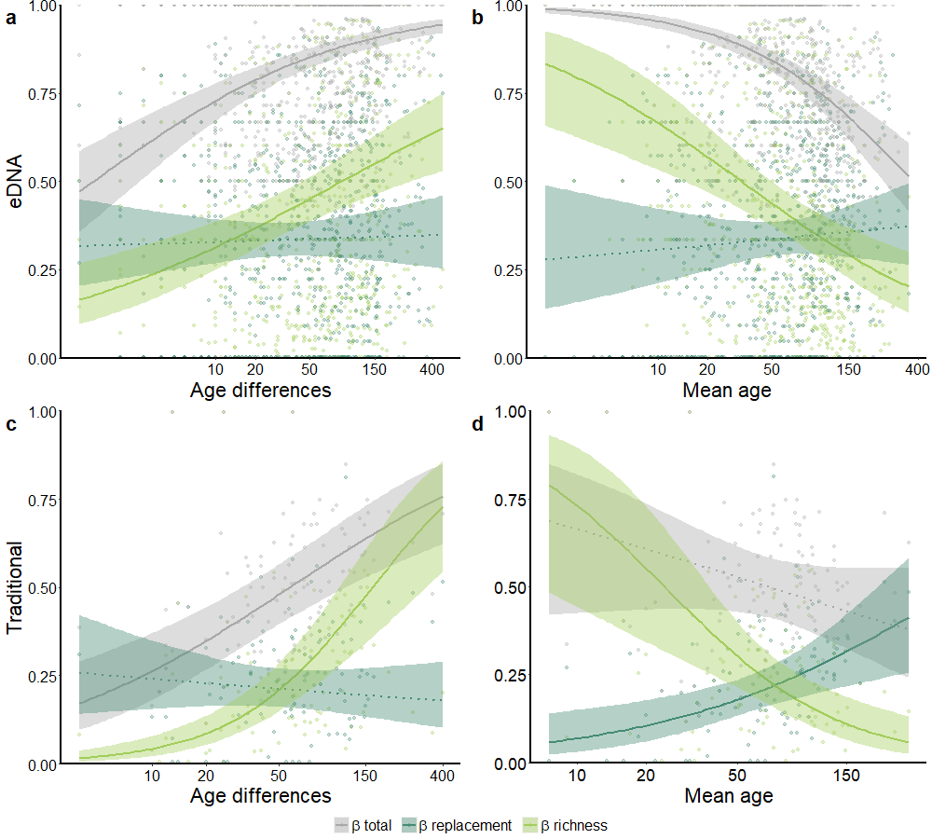 Fig. S1: Patterns of β-diversity components over plant succession following glacier retreat calculated using the Sørensen’s index. Changes of total dissimilarity (β-total, grey), taxa replacement (β-replacement, dark green), and taxa addition (β-richness, light green) with age differences (a, c) and mean age (b, d) between compared communities. a-b patterns were obtained with eDNA data (771 comparisons); c-d patterns were obtained with traditional data (102 comparisons). Shaded areas are 95% credible intervals obtained from Bayesian generalized mixed models (see Methods). Parameters with 95% credible intervals non-overlapping and overlapping zero were represented with solid and dashed lines, respectively. The age differences between compared sites indicate how different the communities are, in terms of age, from each other. The mean age represents the average time since the glacier retreat of the compared communities.

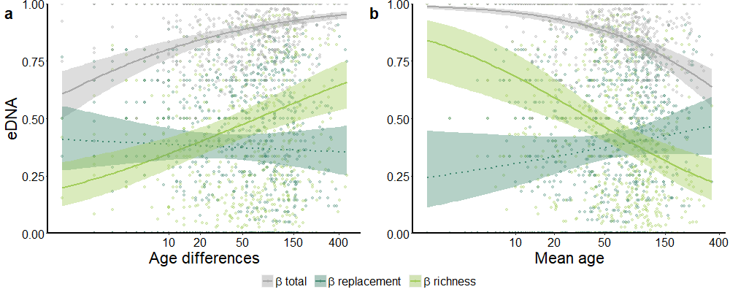

Fig. S2: Patterns of β-diversity components over plant succession following glacier retreat. β-diversity measures were calculated for eDNA data (771 comparisons) after removing rare MOTUs (80 taxa). Changes of total dissimilarity (β-total, grey), taxa replacement (β-replacement, dark green), and taxa addition (β-richness, light green) with age differences (a) and mean age (b) between compared communities. Shaded areas are 95% credible intervals obtained from Bayesian generalized mixed models (see Methods). Parameters with 95% credible intervals non-overlapping and overlapping zero were represented with solid and dashed lines, respectively. The age differences between compared sites indicate how different the communities are, in terms of age, from each other. The mean age represents the average time since the glacier retreat of the compared communities.

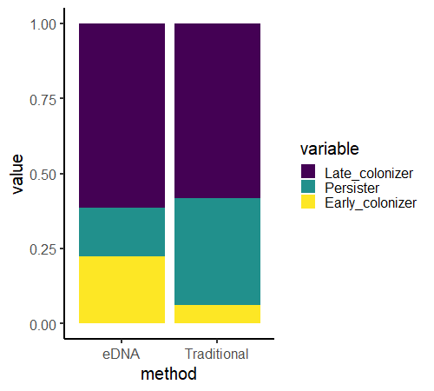

Fig. S3: Proportion of taxa being present only in communities having <50 years of succession (“Early colonizer”), taxa being present only in communities having > 50 years of succession (“Late colonizer”) and taxa being present in both groups of communities (“Persister”). The assignment of the taxa category was made within each chronosequence.

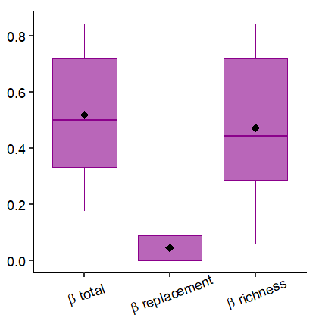

Fig. S4: β-diversity measures and components obtained with temporal data from Fickert & Grüninger⁴⁷ of vascular plants sampled with traditional methods in permanent plots during the first 10 years after the deglaciation of two glaciers in the Alps. N=90 comparisons. Boxplots indicate median (middle line), 25th, 75th percentiles (box), and maximum and minimum values (whiskers) as well as outliers (dots). Diamonds indicate the mean values.

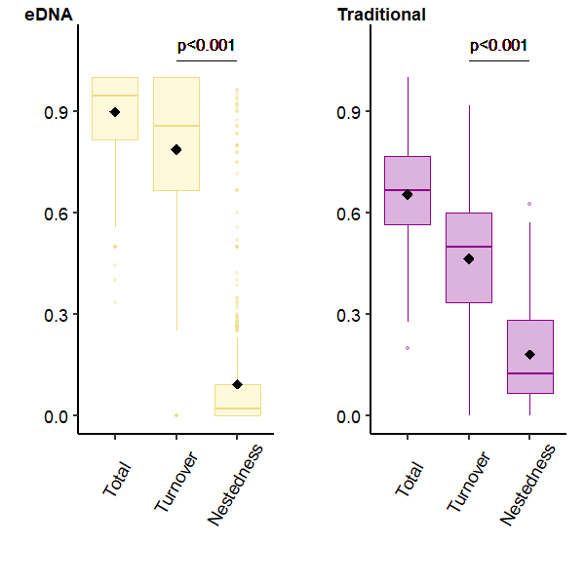

Fig. S5: β-diversity components obtained with eDNA (771 comparisons) and traditional (102 comparisons between communities within the same glacier foreland) data using Baselga et al’s approach⁶¹. Boxplots indicate median (middle line), 25th, 75th percentiles (box), and maximum and minimum values (whiskers) as well as outliers (dots). Diamonds indicate the mean values and p-values are obtained by a Wilcoxon paired test assessing the statistically significant differences between β-replacement and β-richness values.

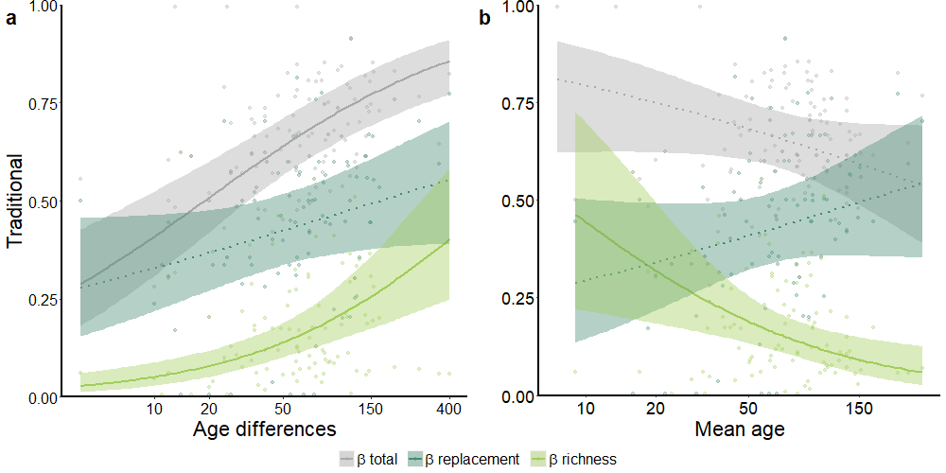Fig. S6: Patterns of β-diversity components over plant succession following glacier retreat using the Baselga et al.’s approach⁶¹ to decompose β-diversity of traditional data (102 comparisons). Changes of total dissimilarity (Total, grey), taxa replacement (Turnover, dark green), and taxa addition (Nestedness, light green) with age differences (a) and mean age (b) between compared communities. Shaded areas are 95% credible intervals obtained from Bayesian generalized mixed models (see Methods). Parameters with 95% credible intervals non-overlapping and overlapping zero were represented with solid and dashed lines, respectively (see Table S3). The age differences between compared sites indicate how different the communities are, in terms of age, from each other. The mean age represents the average time since the glacier retreat of the compared communities.

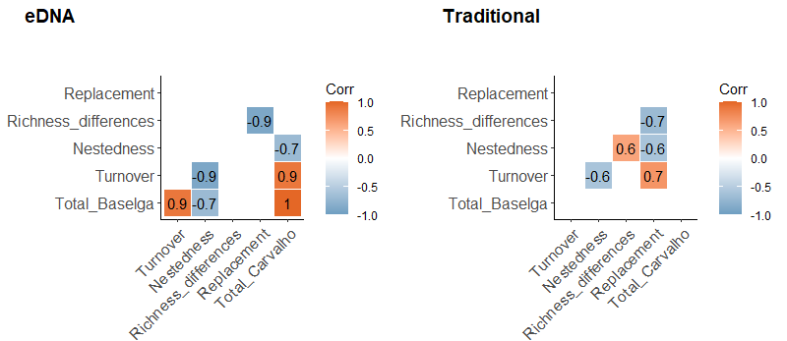

Fig S7: Spearman correlation coefficients between β-diversity measures, only statistically significant correlations are shown.

Dipartimento di Scienze e Politiche Ambientali, Università degli Studi di Milano, via Celoria 10, 20133 Milano, Italy
Argaly, Bâtiment CleanSpace, 354 Voie Magellan, 73800 Sainte-Hélène-du-Lac, France
AMAP, Univ. Montpellier, IRD, CIRAD, CNRS, INRAE, Montpellier, France
Dipartimento di Scienze della Terra “Ardito Desio”, Via L. Mangiagalli 34, 20133 Milano, Italy
Department of Soil and Physical Sciences, Lincoln University, Lincoln 7647, New Zealand
Departamento de Ciencias Biológicas y Biodiversidad, Universidad de Los Lagos, Osorno, Chile
INRAE, UR RIVERLY, Centre de Lyon-Villeurbanne, Villeurbanne, France
Instituto de Hidrología, Meteorología y Estudios Ambientales IDEAM, Bogotá, Colombia
Department of Geography, School of Environment and Earth Sciences, Central University of Punjab, VPO- Ghudda, Bathinda -151401, Punjab, India
Centre for the Study of Regional Development - School of Social Sciences, Jawaharlal Nehru University, New Mehrauli Road, 110067 New Delhi, India
Department of Earth Sciences, Simon Fraser University, 8888 University Drive, Burnaby, V5A 1S6, Canada
Área de Evaluación de Glaciares y, Autoridad Nacional del Agua, Huaraz, Perú
CEFE, Univ Montpellier, CNRS, EPHE, IRD, Univ Paul Valéry Montpellier 3, Montpellier, France
Mannaki Whenua - Landcare Research, Soils and Landscapes, 54 Gerald St, Lincoln 7608, New Zealand
Institute of Water Problems and Hydro-Energy, Kyrgyz National Academy of Sciences, 720033, Frunze, 533, Bishkek, Kyrgyzstan
Department of Earth and Environmental Sciences (DISAT) - University of Milano-Bicocca, Milano, Italy
Univ. Grenoble Alpes, Univ. Savoie Mont Blanc, CNRS, LECA, F-38000 Grenoble, France
Department of Life Sciences and Systems Biology, University of Turin, Via Accademia Albertina 13, 10123 Turin, Italy
Research and Museum Collections Office, Climate and Ecology Unit, MUSE-Science Museum, Corso del Lavoro e della Scienza, 3, 38122 Trento, Italy
Faculty of Environmental Sciences and Natural Resource Management (INA), Norwegian University of Life Sciences, Universitetstunet 3, 1433 Ås, Norway
UiT – The Arctic University of Norway, Tromsø Museum, Tromsø, Norway
Herbario Nacional de Bolivia: La Paz, Bolivia
Universidad Católica del Norte, Antofagasta, Chile
Department of Civil and Environmental Engineering, University of the Andes, Bogotá, Colombia
Univ. Grenoble Alpes, CNRS, IRD, Grenoble-INP, Institut des Géosciences de l’Environnement (IGE, UMR 5001), Grenoble, France
Institute of Mountain Hazards and Environment, Chinese Academy of Sciences, Chengdu, 610041, China
Department of Geography and the Environment, University of Texas at Austin, 78712 Austin, TX, USA
Dipartimento di Bioscienze, Università degli Studi di Milano, via Celoria 10, 20133 Milano, Italy

