Supporting Information

Photocatalytic Decomposition of
O-ethyl S-[2-diisopropylaminoethyl] methylphosphonothioate, VX, Molecule as Organophosphorus Compound on Titanium Dioxide in Ambient Condition by means of ATR-FTIR Spectroscopy

¹*Tsutomu Hirakawa, (0000-0003-2486-2580) ¹Ayman Kotb, (0000-0002-0343-0124) ^{1§}Chifumi K. Nishimoto, ²Asuka Komano, ²Mai Otsuka, (0000-0002-2689-567X) ¹Nobuaki Negishi, (0000-0002-3800-6972) ²Hajime Miyaguchi, (0000-0002-9768-196X) ^{2ζ}Yasuo Seto, (0000-0002-0983-4162) ¹Koji Takeuchi (0000-0001-5235-3383)

¹National Institute of Advanced Industrial Science and Technology (AIST), Tsukuba-west 16-1, Onogawa, Tsukuba, Ibaraki, 305-8569, Japan
²National Research Institute of Police Science (NRIPS), 6-3-1 Kashiwanoha, Kashiwa, Chiba, 277-0882, Japan

Keywords: VX, CWA, TiO₂ photocatalysis, ATR-FTIR

* To whom correspondence should be addressed.
* Tsutomu Hirakawa, E-mail: t-hirakawa@aist.go.jp

Co-vaporization of surface water layer
Before casting the DCM containing VX, the powdery TiO₂ film is treated by the UV-irradiation for decomposing and removing the organic contaminant adsorbed at the surface of TiO₂. Then, the surface condition become hydrophilic and the IR frequency at around 3000 to 4000 cm⁻¹ broadly increased as a results of the increase of the surface adsorbed water coming from experimental atmosphere.[1] The hydrophilic surface condition is used as the base line of the IR measurement before casting DCM including VX. By casting DCM solvent containing VX, the IR frequency at around 3000 to 4000 cm⁻¹ is decreased as seen at the IR spectrum of 4.5 VX molecule / nm² casting in Figure SI-1, it is indicating that the water adsorbed at the surface of TiO₂ is desorbed from the surface. We could not estimate actual number of water molecules vaporized from the surface. Then it may be suggested that the IR peaks of adsorption of VX at surface OH groups is sunk in the decrement of the IR intensity of water layer. That is, the desorption of the water molecule is attributable to the co-vaporization with DCM. The similar phenomenon had observed in our previous study. [2] Notice here that some surface OH groups is then consumed as a result of a hydrolysis of VX to EMPA [2]
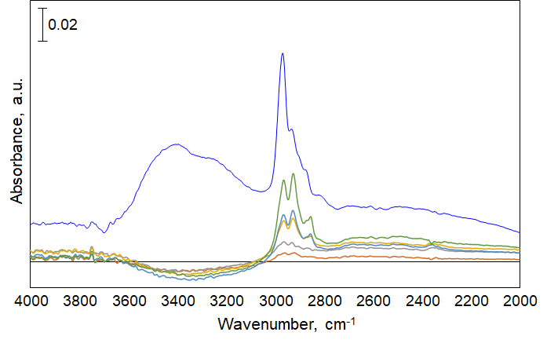

Figure SI-1. ATR-FTIR spectra observed from VX adsorbed at the surface of TiO₂. The number of VX molecule is stepwise increased from 4.5 to 27.0. The IR spectrum is at 2000 – 4000 cm⁻¹.

IR Spectrum of Liquid condensed VX
Figure SI-2 shows IR spectrum of liquid condensed VX molecule provided from supplier. The characteristic IR frequencies appear. From 1500 to 2500, 3100 to 4000 cm⁻¹, there are no any characteristic IR frequency. Similar IR spectrum have also reported from other research groups. [3]

Figure SI-2. IR spectrum of condensed liquid VX. The data sheet is obtained from supplier.
IR frequency of isopropoxide at the surface of TiO₂
The IR frequencies of an isoporpoxide as iPrOH adsorbed at the surface of TiO₂ as has been reported by other research groups are listed in Table SI-1. The VX has iPr as function groups and the IR frequency of that basically appear similar to iPr.[4-7]
TABLE SI-1: Spectroscopic assignments of the vibrational modes of isopropoxide adsorbed at the surface of TiO₂.
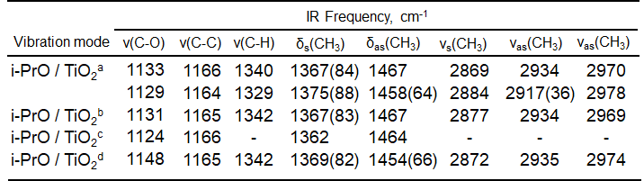
ª The IR frequency is taken from reference [4]. ^{b} the value taken from reference [5]. ^{c} value taken from reference [6]. ^{d} assignments from references [7].

IR frequency of 2-aminoethanthiol adsorbed at the surface of Ag(111) and Au(111), and n-butanol adsorbed at the surface of TiO₂
The IR frequencies of 2-aminoethanthiol (AET) adsorbed at the surface of Ag(111) and Au(111) as has been reported by other research groups are listed in Table SI-2.[8] The IR frequencies of n-BuOH adsorbed at the surface of TiO₂ as has been reported by other research groups are listed in Table SI-3.[9, 10] The chemical structure of AET is partially similar to the VX molecule as DESH and 2-(buthylamino)ethanthiol, 2-BAET as VX simulant. In this study, BAET is used as simulant of DESH groups of VX. Therefore, the IR frequency of AET and n-BuOH is used as reference to assign the 2-BAET adsorbed at the surface of TiO₂ in this study as shown in Figure SI-4.
TABLE SI-2: Spectroscopic assignments of the vibrational modes for 2-aminoethanthiol (AET) adsorbed at the surface of Ag(111) and Au(111).[8]

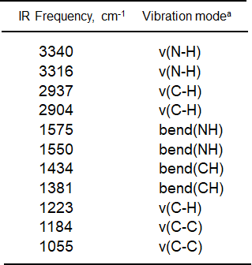
TABLE SI-3: Spectroscopic assignments of the vibrational modes for n-Butanol adsorbed at the surface of TiO₂.[9,10]

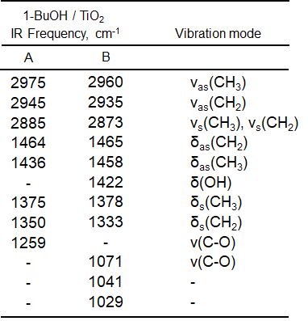

IR frequency of DIIPA and 2-BAET at the surface of TiO₂
The VX adsorbed at the surface of TiO₂ is decomposed to DESH and EMPA. Since we could not obtain the DESH as chemical reagent, 2-BAET as VX simulant is used as analysis to assign DESH. The observation procedure of 2-BAET at the surface of TiO₂ are described in Experimental section of manuscript. The 2-BAET reagent spreads at the surface of powdery TiO₂ film. After casting, the FTIR spectrum is measured. The observation of the IR spectrum starts immediately after casting the solvent.
Figure SI-3 shows the IR spectrum of 2-BAET adsorbed at the surface of TiO₂. The IR frequency of S-H mode is not observed, it is indicating that the S of 2-BAET is directly adsorbed at the surface of TiO₂. The characteristic IR peaks of 2-BAET appear, and the IR frequencies are assigned based on the IR vibration mode as listed in Table SI-2 and 3, and the assignment of 2-BAET are listed in Table SI-4.
Here, as secondary amin, diisopropylamine, DIIPA is also used as the partial function groups of DESH. Figure SI-4 shows the IR spectrum of DIIPA adsorbed at the surface of TiO₂. The characteristic IR peak appear, and the IR frequencies are assigned based on the IR vibration mode as listed in Table SI-1 and reported frequencies as listed in reference [8,9], and the assignment of DIIPA are listed in Table SI-4. The IR vibration mode is mainly attributable to iPr.

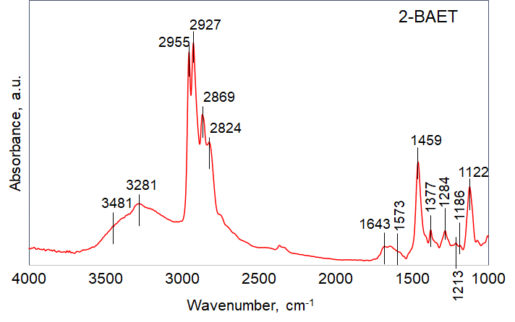
Figure SI-3. IR spectrum observed from 2-(butylamino)ethanthiol (2-BAET) adsorbed at the surface of TiO₂.

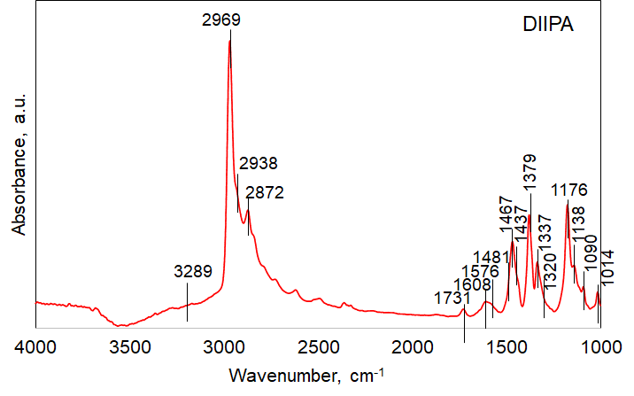
Figure SI-4. IR spectrum observed from diisopropylamino (DIIPA) adsorbed at the surface of TiO₂.
The IR frequency at 1608 and 1643 cm⁻¹ observed from 2-BAET and DIIPA is assigned to combination band of 2 × ν(N-C) mode.[11] Similar IR vibration mode is calculated to combination band of 820 cm⁻¹ in which is assigned to ν(N-C) as the vibration mode by DFT calculation in this study. [11]

TABLE SI-4: Observed and calculated infrared absorption bands and mode assignment for diisopropylamine (DIIPA) and 2-(butylamino)ethanthiol (2-BAET).
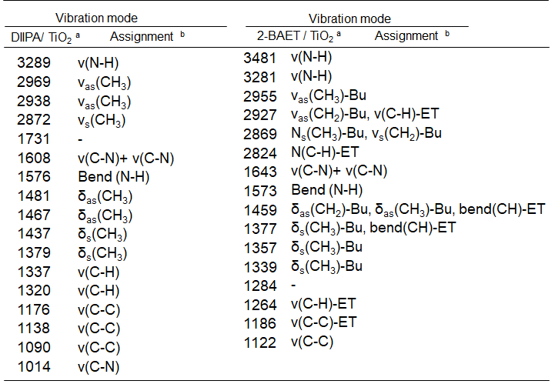
ª Measured in this study. ^{b} the IR assignment is referred by [8-11].
Identification of IR frequencies at barren region: Adsorption
The IR frequencies at 2606 and 2708 cm⁻¹ are observed from condensed liquid VX as shown in Figure SI-2 and VX molecule adsorbed at the surface of TiO₂ as seen in Figure 1-(b). The similar IR spectrum of VX molecule has been observed from other research groups. [3] The IR frequency at 2606 cm⁻¹ may be attributable to the S-H vibration mode. The VX molecule have P-(S)-C groups and the S have no hydrogen bonding as S-H in the VX molecular structure. When the VX molecule is hydrolyzed by self-hydrolysis, the S-H vibration mode may appear at around 2600-2580 cm⁻¹ as a consequence of the P-S cleavage. However, we believe the purity of the VX is high even though some of VX molecule is hydrolyzed. In the case of the IR frequency at 2708 cm⁻¹, the IR frequency may be attributable to tertial amine as >NH⁺- (2700 to 2330 cm⁻¹).[12-14]
Here, these IR frequencies are also computationally estimated by DFT calculation. The IR vibration mode of the IR frequency at 2606 cm⁻¹ is then calculated to an anhamonic vibration modes as the combination of C-H vibration mode in the hydrocarbon of iPr, EtO and ET, by DFT calculation.[15] About 2707 cm⁻¹, the combination band similar to the case of 2606 cm⁻¹ is also calculated and the overtone band is also estimated at 2702 cm⁻¹ of which is attributable to the vibration of δ(CH₃)-Et and δ(CH₂)-Et. These results mean that the IR frequencies might be attributable to aliphatic function groups as EtO and iPr including tertial amin of VX.
On the basis of the molecular structure of VX, these vibration modes may be plausible and the IR frequencies at 2606 and 2708 cm⁻¹ may be the overlapped of the vibration mode as stated above. However, these assignments are not conclusive in the present stage.

Identification of IR frequencies at barren region: Photocatalysis
Under the photocatalysis, the IR frequencies newly appear at 2496 and 2719 cm⁻¹. These IR frequencies then may be generally attributable to the secondary as -NH₂⁺-. [12-14] Such IR vibration mode as amine salts are observed from the H-bonding between amine and hydrohalides species in liquid and solid phase. [12-14] Then the IR frequency of secondary amine species appear.
Figure SI-5. IR spectrum of DIIPA adsorbed at the surface of TiO₂. The concentration of DIIPA is changed from 1 to 10 μL for evaporation.
Similar IR frequencies are observed from DIIPA and 2-BAET/EMPA mixture adsorbed at the surface of TiO₂. Figure SI-5 shows the IR spectrum of DIIPA at the surface of TiO₂. The IR spectrum region is from 2100 to 2900 cm⁻¹ as barren region. The IR frequencies are observed at 2492, 2528, 2615, 2724 and 2788 cm⁻¹. The IR peaks at 2724 and 2492 cm⁻¹ are similar position as the IR frequencies observed from VX decomposition by the TiO₂ photocatalysis. As shown in Figure SI-6, the IR spectra observed from 2-BAET/EMPA mixture adsorbed at the surface of TiO₂ are showed. The 2-BAET did not show the characteristic IR frequency at around the barren region even though it is secondary amine. In the case of EMPA, the IR frequency at 2300 cm⁻¹ which is assigned to P-OH is observed. By mixing the 2-BAET and EMPA, the characteristic IR frequency as secondary amine appear at 2480 and 2741 cm⁻¹. The IR frequencies are quite similar to the IR frequencies observed from the decomposition of VX molecule. This result indicates that the IR frequencies at 2496 and 2719 cm⁻¹ are assigned to secondary amine such as DIIPA, SH-ET-N-iPr and so on.

Figure SI-6. IR spectrum of 2-BAET, EMPA and mixture of 2-BAET and EMPA adsorbed at the surface of TiO₂.

DFT calculation
In all calculation, the VX molecule structure is relaxed into lowest-energy conformations to optimize the structure. Under optimization, the geometry structure of VX molecule is specially not frozen. The total energy after optimization is calculated to -1379.6252 Hartree.[15] The calculated IR frequency do not have any imaginary number. In the DFT calculation of the adsorption structure of VX at the surface of Al₂O₃, the difficulty to calculate precise VX structure adsorbed at the metal oxide has suggested because the parameters of the structure of metal oxide and the conformation of VX strongly affects the energy state of them.[16] For instance, the state of the surface hydroxyl groups and the physisorbed water strictly affects the structure and energy level. Therefore, in this study, the complete conformation of VX molecule, the adsorbed condition including the surface OH groups and water at the surface of TiO₂ is not considered, so the calculated structure is one of the rotational conformations of free VX molecule under vacuum condition as a gas phase.

General discussion
Although the DESH production by the P-S cleavage under TiO₂ photocatalysis was identified, bis(diisopropylaminoethyl)disulfide, ((iPr)₂(N)-ET-S)₂ so called as (DES)₂ was not observed. Compounds having -S-S- structure would be produced, but the aliphatic function groups of DESH or (DES)₂ are oxidized to various kinds of byproducts in the TiO₂ photocatalysis and overlapped with the IR vibration mode of the other byproducts. In addition, the IR vibration mode as -S-S- bonding appeared at higher energy and IR regions are not analyzed in this study due to the limitation of ZnSe crystal.

References
1. T. Hirakawa, K. Sato, A. Komano, S. Kishi, C.K. Nishimoto, N. Mera, M. Kugishima, T. Sano, H. Ichinose, N. Negishi, Y. Seto, K. Takeuchi, J. Phys. Chem. C. 114, 2305 (2010)
2. T. Hirakawa, C.K. Nishimoto, A. Komano, M. Otsuka, N. Negishi, H. Miyaguchi, Y. Seto, K. Takeuchi, Res. Chem. Intermed. 47, 1563 (2021)
3. W.R. Creasya, J.R. Stuffa, B. Williamsa, K. Morrisseya, J. Maysa, R. Duevel, H.D. Durst, J. Chromatography A. 774, 253 (1997)
4. C. Martin, I. Martin, V. Rives, B. Grzybowska, I. Gressel, Spectrochim. Acta Part A. 52, 733 (1996)
5. F. Arsac, D. Bianchi, J.M. Chovelon, C. Ferronato, J.M. Herrmann, J. Phys. Chem. A. 110, 4202 (2006)
6. W. Xu, D. Raftery, J.S. Francisco, J. Phys. Chem. B. 107, 4537 (2003)
7. P.F. Rossi, G. Busca, V. Lorenzelli, O. Saur, J.-C. Lavalley, Langmuir. 3, 52 (1987)
8. J.Y. Gui, D.A. Stern, D.G. Frank, F. Lu, D.C. Zapien, A.T. Hubbard, Langmuir. 7, 955 (1991)
9. N.R. Blake, G.L. Griffin, J. Phys. Chem. 92, 5697 (1988)
10. J. Araña, J.M. Doña-Rodrı́guez, C.G.i. Cabo, O. González-Dı́az, J.A. Herrera-Melián, J. Pérez-Peña, Appl. Catal. B 53, 221 (2004)
11. J.R. Barcelo, J. Bellanato, Spectrochim. Acta. 8, 27 (1956)
12. N.B. Colthup, L.H. Daly, S.E. Wiberley, Introduction to Infrared and Raman Spectroscopy Third Edition. (Academic Press inc., 1990)
13. D. Lin-Vien, N.B. Colthup, W.G. Fateley, J.G. Grasselli, The Handbook of infrared and Raman characteristic frequencies of organic molecules. (Academic Press, Inc., Harcourt Brace Jovanovich, Publisher, San Diego, 1991)
14. G. Socrates, Infrared and Raman Characteristic Groups Frequencies, Table and Charts, Third Edition. (Johne Wiley and Sonc, LTD, New York, 2001)
15. G.W.T. M. J. Frisch, H. B. Schlegel, G. E. Scuseria, M. A. Robb, J. R. Cheeseman, G. Scalmani, V. Barone, B. Mennucci, G. A. Petersson, H. Nakatsuji, M. Caricato, X. Li, H. P. Hratchian, A. F. Izmaylov, J. Bloino, G. Zheng, J. L. Sonnenberg, M. Hada, M. Ehara, K. Toyota, R. Fukuda, J. Hasegawa, M. Ishida, T. Nakajima, Y. Honda, O. Kitao, H. Nakai, T. Vreven, J. A. Montgomery, Jr., J. E. Peralta, F. Ogliaro, M. Bearpark, J. J. Heyd, E. Brothers, K. N. Kudin, V. N. Staroverov, R. Kobayashi, J. Normand, K. Raghavachari, A. Rendell, J. C. Burant, S. S. Iyengar, J. Tomasi, M. Cossi, N. Rega, J. M. Millam, M. Klene, J. E. Knox, J. B. Cross, V. Bakken, C. Adamo, J. Jaramillo, R. Gomperts, R. E. Stratmann, O. Yazyev, A. J. Austin, R. Cammi, C. Pomelli, J. W. Ochterski, R. L. Martin, K. Morokuma, V. G. Zakrzewski, G. A. Voth, P. Salvador, J. J. Dannenberg, S. Dapprich, A. D. Daniels, O. Farkas, J. B. Foresman, J. V. Ortiz, J. Cioslowski, and D. J. Fox, , GAUSSIAN 09 Revision A.1. Gaussian, Inc., Wallingford CT (2009)
16. V.M. Bermudez, J. Phys. Chem. C. 113, 1917 (2009)

