Brain corticogenesis and cholesterol homeostasis promotes SARS-CoV-2 infection and replication

Byoung-San Moon^{1,7,}, Dae-Gyun Ahn^{2,7,}, Jieun Park^{3,7}, Nhu Thi Quynh Mai¹, Ulziituya Batjargal¹, Hyowon Hong⁴, Sae-Bom Yoon⁴, Sunhee Lee^{2,6}, Gun Young Yoon², Chonsaeng Kim², Keun Bon Ku², Hye Jin Nam⁴, Ihn-Sil Kwak⁵, Seong-Jun Kim^{2,}, Heeyeong Cho^{4,}

Affiliations:
¹Department of Integrative Biotechnology, Biotechnology and Chemical Engineering, Chonnam National University; Yeosu, 59626, Korea.
²Department of Convergent Research of Emerging Virus Infection, Therapeutics and Biotechnology Division, Korea Research Institute of Chemical Technology; Daejeon, 34114, Korea.
³Department of Cell Biology and Physiology, University of North Carolina at Chapel Hill; Chapel Hill, NC 27599, USA.
⁴Drug Discovery Platform Research Center, Therapeutics and Biotechnology Division, Korea Research Institute of Chemical Technology; Daejeon, 34114, Korea.
⁵Department of Ocean Integrated Science, Chonnam National University; Yeosu, 59626, Korea.
⁶Current address: Division of Vaccine Clinical Research, Korea National Research Institute of Health, Korea Centers for Disease Control and Prevention; Cheongju, 28160, Korea.
⁷These authors contributed equally.
email: bsmoon@jnu.ac.kr; dgahn@krict.re.kr; sekim@krict.re.kr; hycho@krict.re.kr

SUPPLEMENTARY FIGURES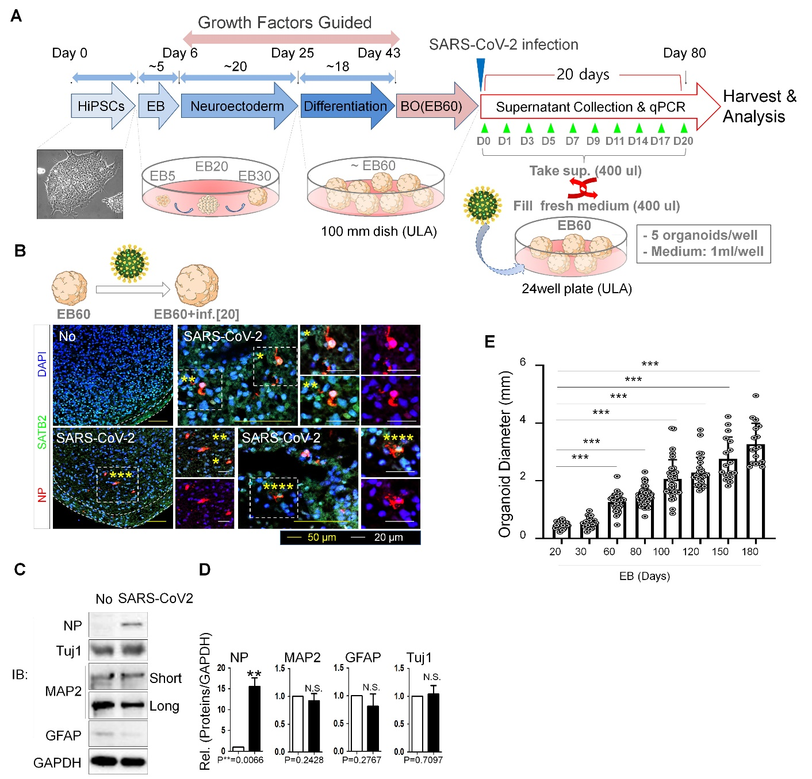
Supplementary Fig.1 Neurotropism potential of SARS-CoV-2 in human 3D cerebral organoid (CBO). (a) Schematic showing stepwise differentiation process to generate CBOs from HiPSCs. Embryoid bodies (EBs) were formed in ultra-low attachment plates. With the supplementation of the required growth factors, CBOs were driven to form neuroectoderm from day 6 to 25 of culture period (EB5-EB30) and start lineage differentiation from day 25 onwards (~EB60). For examination of SARS-CoV-2 infection, EB60 were exposed to SARS-CoV-2. After an hour, the medium was changed, and CBOs were monitored for 20 dpi. Culture media at specific time point were collected for viral titer analysis. (b) Immunostaining for antibodies against DAPI (blue), SATB2 (green), and NP (red) in infected and uninfected CBOs. Scale bar, 50 µm (yellow), 20 µm (white). (c) Detection of NP, Tuj1, MAP2, GFAP and GAPDH in the infected and non-infected CBOs by immunoblotting. (d) Relative expression of NP⁺, MAP2⁺, GFAP⁺, and Tuj1⁺ cells in the two groups. Data was quantified and analyzed using the two-tailed Student’s t-test to calculate statistical significance (**p<0.01). N.S; not significant. (e) CBO diameter was quantified by ImageJ Software, revealing a consistent increase over time (n > 10). Analysis of variance (One-way ANOVA) was conducted to calculate significance (***p<0.001). All data are presented as mean ± SD.

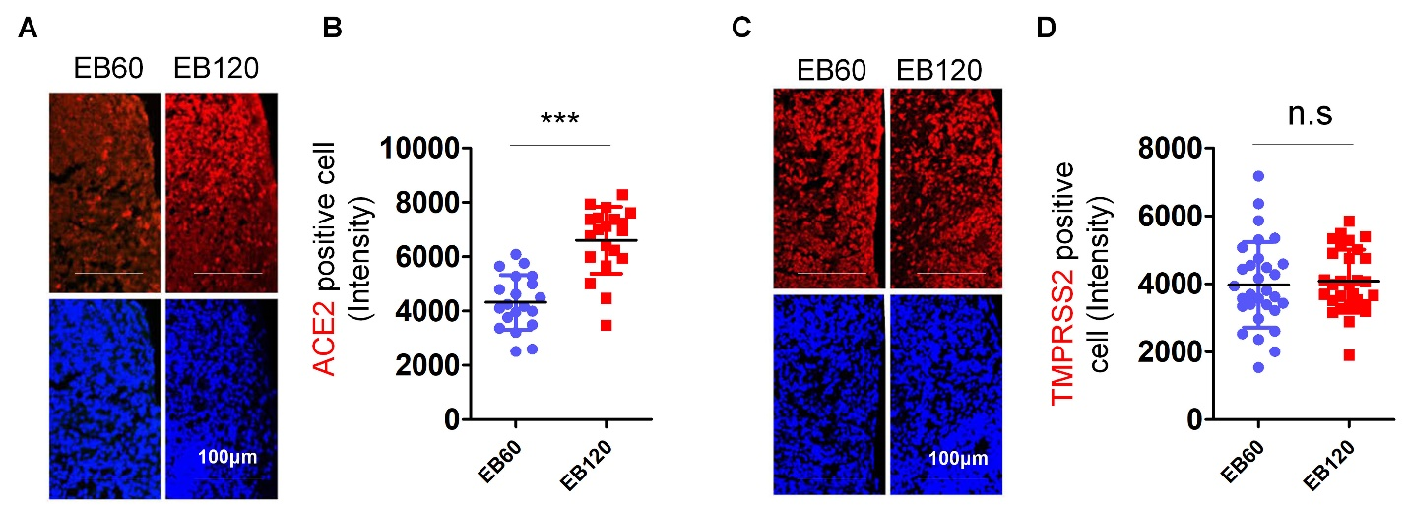

Supplementary Fig. 2 Expression of SARS-CoV-2 entry factors (ACE2, TMPRSS2) in EB60 and EB120. (a) Immunostaining for antibodies against DAPI (blue), ACE2 (red) in EB60 and EB120 demonstrates expression of ACE2 entrance receptor on day 60 and 120 of CBOs differentiation. (b) Dot plots displaying quantification for expression level of ACE2 in EB60 and EB120. Student’s t-test was performed to calculate significance (***p<0.001; n > 10). (c) Immunostaining for antibodies against DAPI (blue), TMPRSS2 (red) on day 60 and 120 of CBOs differentiation (n > 3). (d) Corresponding quantification for expression level of TMPRSS2 in EB60 and EB120. Student’s t-test was performed to calculate significance. n.s; not significant. All data are presented as mean ± SD.
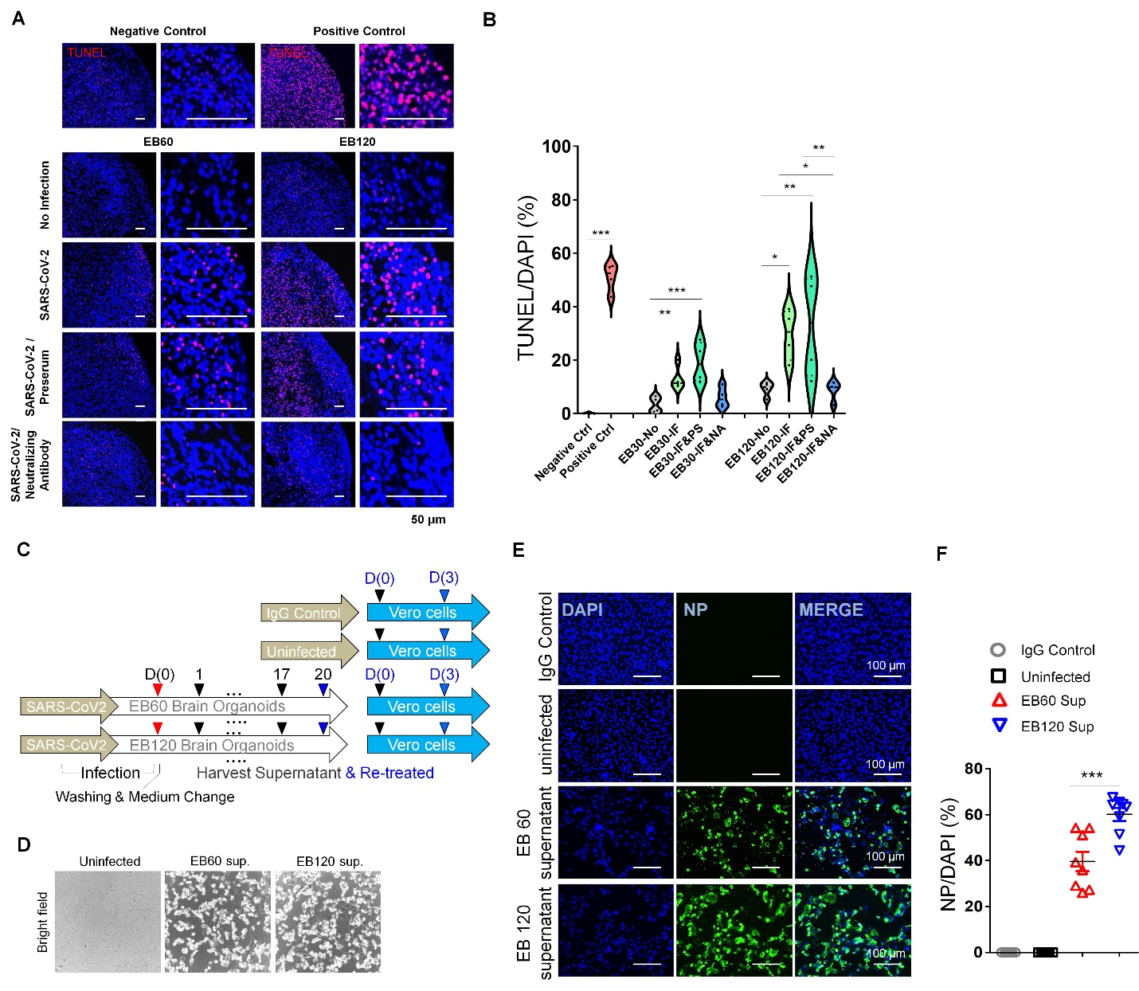 Supplementary Fig. 3 EB120 suffered more damage than EB60 after SARS-CoV-2 infection. (a) Organoids of each pre-treated groups were stained with TUNEL to evaluate cell death. Scale bar, 50 µm. (b) Violin plot showing quantification of apoptotic cells percentage (n > 3). Analysis of variance (One-way ANOVA) was performed to calculate significance (*p<0.05, **p<0.01, ***p<0.001). (c) Schematic of the experiment proving pathogenicity of SARS-CoV-2 progeny. The infected EB60 and EB120 were harvested for supernatant to treat the Vero cells, using IgG as the control. (d) Brightfield exhibits Vero cells population after 3 days treated with supernatant of SARS-CoV-2 infected CBO. EB120 showed the highest number of detached cells. Scale bar, 50 µm. (e) Immunostaining for DAPI (blue), NP (green) shows infection in Vero cells in each examined group. (f) Corresponding quantification for the percentage of infected cells (n>3). Data are presented as mean ± SD. Analysis of variance (One-way ANOVA) was performed to calculate significance (*p<0.05, **p<0.01, ***p<0.001).

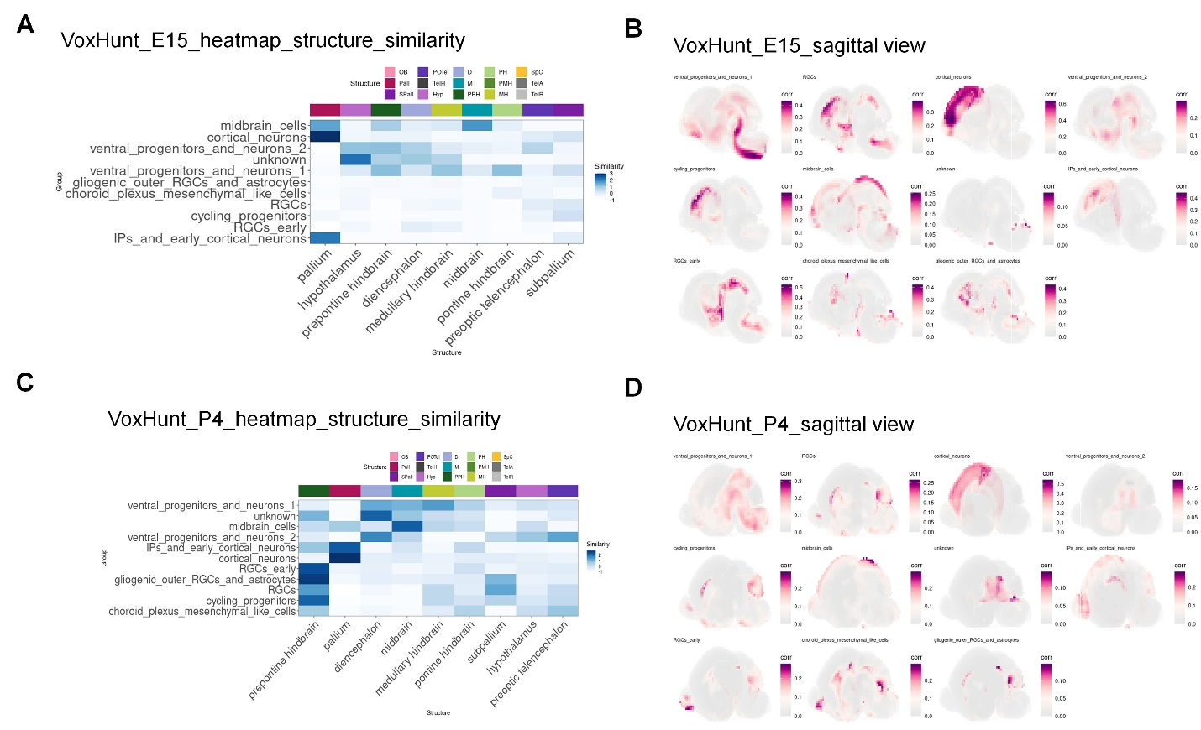
Supplementary Fig. 4 Comparing CBO cell populations to reference CBO atlas. (a) Heatmap showing the structural similarities between the defined clusters with the embryonic day 15 developing mouse brain ISH atlas. (b) Spatial similarity maps of the defined clusters to the embryonic day 15 developing mouse brain ISH atlas. (c) Heatmap showing the structural similarities between the defined clusters with the postnatal day 4 developing mouse brain ISH atlas. (d) Spatial similarity maps of the defined clusters to the postnatal day 4 developing mouse brain ISH atlas.

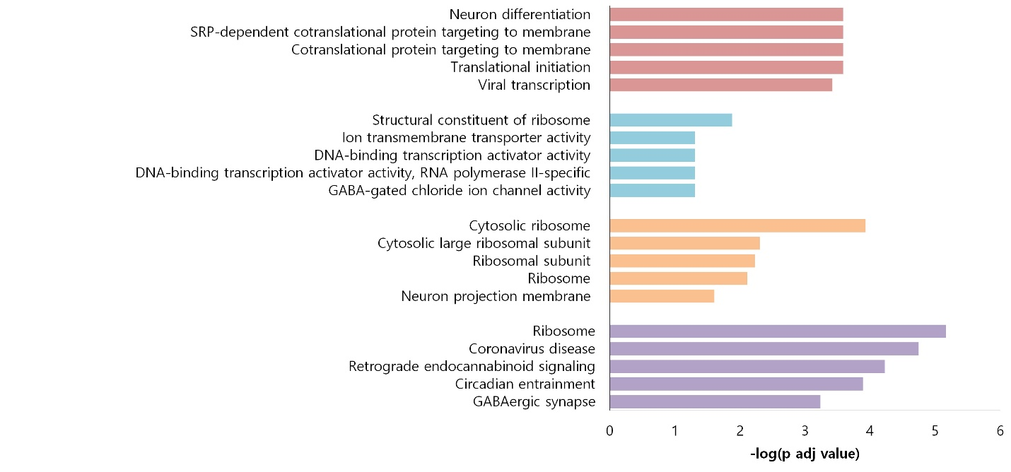
Supplementary Fig. 5 GO analysis of signatures enriched in differentially expressed genes upregulated in ventral progenitors and neurons 2 cluster of EB120 compared to EB60.

SUPPLEMENTARY TABLE
Supplementary Table 1 List of primer sequences used in the current study.
GAPDH_F | 5´-GGAGCGAGATCCCTCCAAAAT-3´
GAPDH_R | 5´-GGCTGTTGTCATACTTCTCACGG-3´.
NP | 5′-6-carboxyfluorescein (FAM)-ACAATTTGCCCCCAGCGCTTCAG-BHQ1

