Table 1. Characteristics of the sample depending on whether or not they obtained TO.
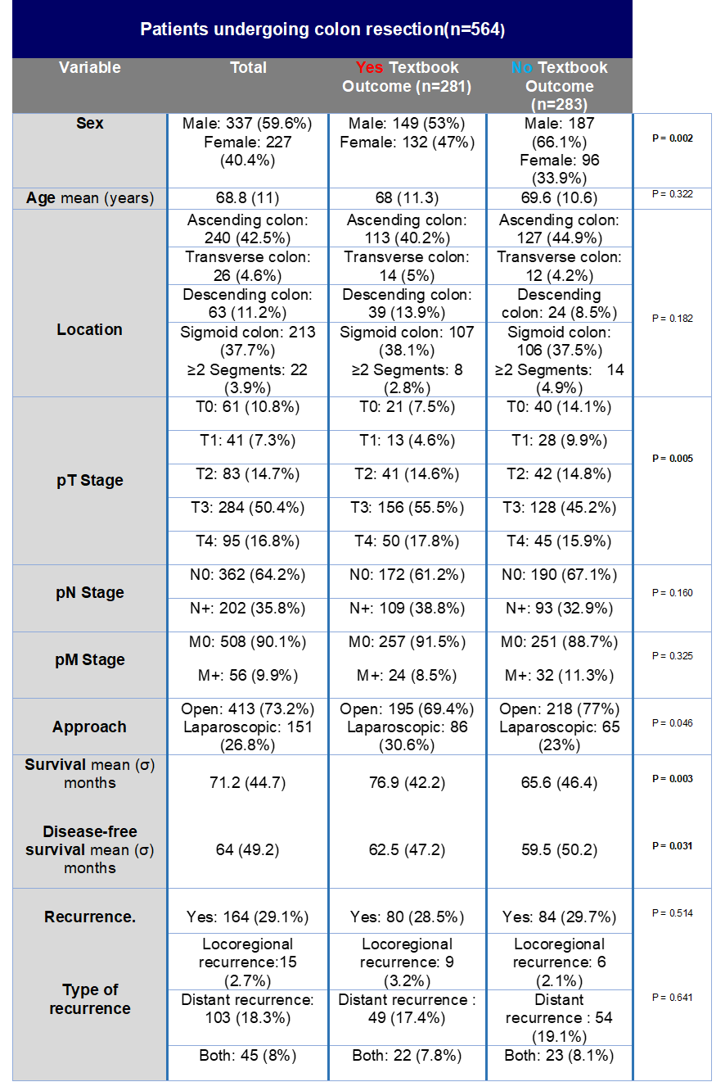

Table 2. Univariate analysis.

Table 3. Multivariate logistic regression.

