Ab Initio Calculations of BN/CC isosterism in Azulene: Structure and Stability

Mohamed A. Abdel-Rahman,^{a*} Kamal A. Soliman,^{b*} Safwat Abdel-Azeim,^{c} Ahmed M. El-Nahas,^{d} Tetsuya Taketsugu,^{e,f} Takahito Nakajima,^{g} Asmaa B. El-Meligy^{d}*
ªChemistry Department, Faculty of Science, Suez University, Suez, 43518, Egypt
^{b}Chemistry Department, Faculty of Science, Benha University, Benha 13518, Egypt
^{c} Center for Integrative Petroleum Research (CIPR), College of Petroleum Engineering and Geosciences, King Fahd University of Petroleum and Minerals (KFUPM), Dhahran 31261, Saudi Arabia
^{d} Chemistry Department, Faculty of Science, Menoufia University, Shebin El-Kom, 32512, Egypt
^{e}Department of Chemistry, Faculty of Science, Hokkaido University, Sapporo 060-0810, Japan
^{f}Institute for Chemical Reaction Design and Discovery (WPI-ICReDD), Hokkaido University, Sapporo 060-0810, Japan
^{g}RIKEN, Center for Computational Science, 7-1-26 Minatojima-minami, Chuo Kobe 650-0047, Japan

Corresponding author:
Mohamed.Abdel-Rahman@sci.suezuni.edu.eg (Mohamed A. Abdel-Rahman)
kamal.soliman@fsc.bu.edu.eg (Kamal A. Soliman)
asmaaphys@yahoo.com (Asmaa B. El-Meligy)

Table S1: The Cartesian coordinates of azulene and 11 isomers BN-doped azulene at B3LYP/6-311G(d,p) (optimization level of CBS-QB3 method)
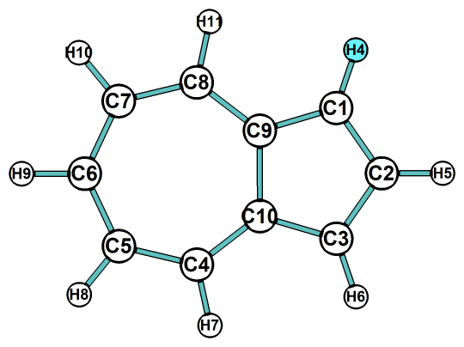 | AZ
  C | 1.913224 | 1.267476 | -9.5E-05
  C | 0.552611 | 1.59605 | -0.0001
  C | -0.55472 | 0.750175 | -6.7E-05
  C | -0.55469 | -0.75005 | 0.000045
  H | 3.595395 | 0.00016 | 0.000147
  H | 2.601116 | 2.109515 | -6.9E-05
  H | 0.324416 | 2.661473 | -7.4E-05
  H | 2.601042 | -2.1097 | 0.000129
  H | 0.324174 | -2.66134 | 0.000144
  C | -1.90437 | 1.150935 | 0.000147
  H | -2.251 | 2.177135 | 0.000259
  C | -2.71185 | -4.9E-05 | -7.1E-05
  H | -3.79623 | -0.00012 | -0.00011
  C | -1.90426 | -1.15099 | 0.000001
  H | -2.25083 | -2.17722 | -1.4E-05
  C | 2.506825 | -6E-06 | -7.8E-05
  C | 0.552623 | -1.59596 | 0.000095
  C | 1.913259 | -1.26757 | 0.000055
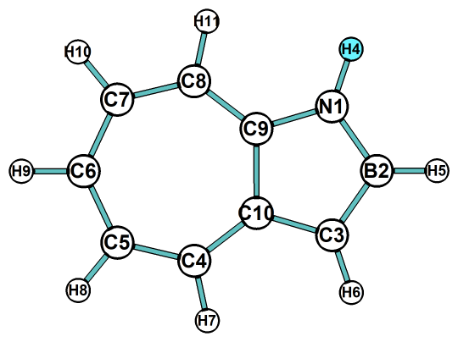 | AZ-1N2B
  C | 1.921042 | 1.240468 | -2.5E-05
  C | 0.592826 | 1.602013 | -3.9E-05
  C | -0.58035 | 0.790896 | -2.2E-05
  C | -0.57209 | -0.69581 | 0.00002
  H | 3.593123 | -0.07643 | -2.1E-05
  H | 2.630841 | 2.06492 | -2.6E-05
  H | 0.391427 | 2.671955 | -5.2E-05
  H | 2.527448 | -2.15295 | 0.000046
  H | 0.228977 | -2.63047 | 0.000048
  C | -1.89177 | 1.243509 | -1.4E-05
  H | -2.12742 | 2.302306 | -2.4E-05
  H | -3.98239 | -0.11691 | -9E-06
  H | -2.10326 | -2.08979 | -9E-06
  C | 2.505913 | -0.0554 | 0.000021
  C | 0.488032 | -1.57249 | 0.00004
  C | 1.876785 | -1.28129 | 0.00004
  N | -1.88555 | -1.10363 | -7E-06
  B | -2.80045 | 0.024275 | -4E-06
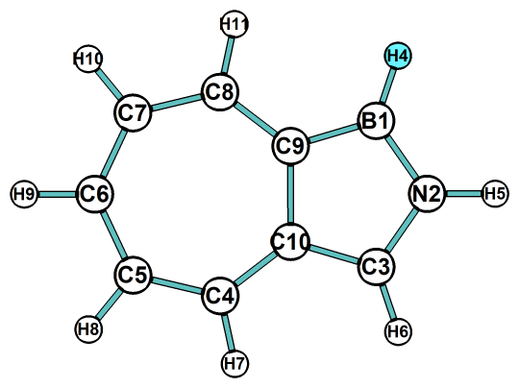 | AZ-1B2N
  C | 1.912293 | 1.284813 | -8.3E-05
  C | 0.574577 | 1.589557 | -0.00012
  C | -0.54212 | 0.703948 | -5.2E-05
  C | -0.52001 | -0.79343 | 0.000052
  H | 3.62266 | 0.017475 | -5.4E-05
  H | 2.598986 | 2.127454 | -0.00007
  H | 0.325452 | 2.651011 | -0.00011
  H | 2.6649 | -2.09818 | 0.000086
  H | 0.376515 | -2.67813 | 0.000088
  C | -1.85528 | 1.106869 | 0.000103
  H | -2.23994 | 2.119163 | 0.000155
  H | -3.71745 | 0.151696 | -0.00012
  H | -2.51327 | -2.3047 | -8.1E-05
  C | 2.534049 | -0.00752 | 0.000044
  C | 0.578539 | -1.60709 | 0.000092
  C | 1.972989 | -1.25908 | 0.000087
  B | -2.00397 | -1.22946 | -3.8E-05
  N | -2.71832 | 0.007586 | -6.4E-05
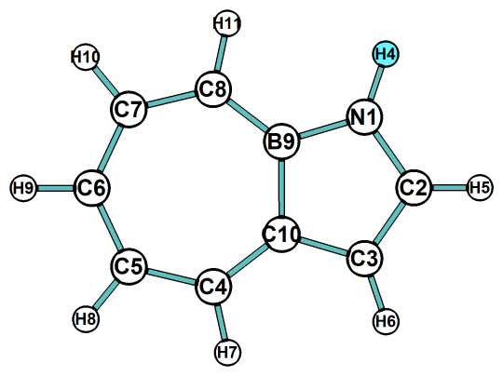 | AZ-1N9B
  C | 1.902515 | 1.294336 | 0.000001
  C | 0.534555 | 1.647875 | 0.000004
  C | -0.5472 | 0.781497 | 0.000008
  H | 3.610745 | 0.092383 | 0.000003
  H | 2.589046 | 2.139569 | -3.3E-05
  H | 0.331997 | 2.720389 | -3.5E-05
  H | 2.763891 | -2.04396 | 0.000025
  H | 0.541501 | -2.77479 | 0.000032
  C | -1.93653 | 1.14629 | -8.7E-05
  H | -2.34292 | 2.151231 | -0.00015
  H | -3.78036 | -0.06633 | 0.000003
  H | -2.35625 | -2.05745 | 0.000084
  C | 2.523311 | 0.049231 | 0.000016
  C | 1.996407 | -1.26865 | 0.000011
  C | -2.69788 | 0.000027 | -5E-06
  B | -0.51788 | -0.77903 | 0.000003
  N | -1.9256 | -1.14573 | 0.000042
  C | 0.676634 | -1.69158 | 0.000011
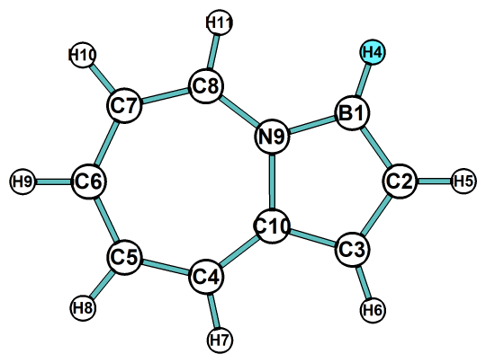 | AZ-1B9N
  C | -1.91183 | 1.28225 | 0.000001
  C | -0.49707 | 1.547656 | -0.00014
  C | 0.564476 | 0.695887 | -0.00016
  H | -3.60238 | 0.050606 | -0.00043
  H | -2.55354 | 2.158848 | 0.000232
  H | -0.21676 | 2.598755 | -8E-06
  H | -2.56405 | -2.09091 | 0.000016
  H | -0.3082 | -2.61509 | 0.000117
  C | 1.940941 | 1.104775 | 0.000144
  H | 2.212582 | 2.156053 | 0.000268
  H | 3.870913 | 0.134011 | -9.5E-05
  H | 2.175941 | -2.39641 | -0.0002
  C | -2.5146 | 0.059716 | 0.000025
  C | -1.8907 | -1.2393 | 0.000108
  C | 2.791583 | 0.027219 | -4.4E-05
  C | -0.5683 | -1.56016 | 0.000135
  N | 0.557779 | -0.76189 | 0.000027
  B | 1.91881 | -1.23417 | -0.0001
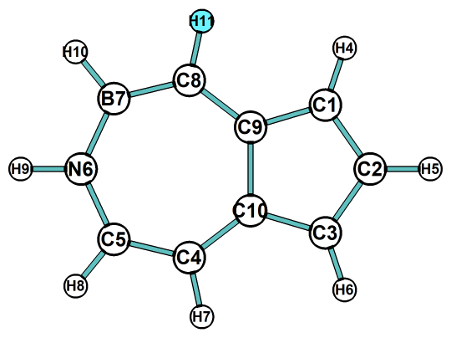 | AZ-6N7B
  C | -1.95821 | -1.19672 | -2.8E-05
  C | -0.64031 | -1.54921 | -2.4E-05
  C | 0.532203 | -0.73813 | -1.1E-05
  C | -0.42001 | 1.658325 | 0.000031
  C | 0.615892 | 0.76786 | 0.000011
  H | -3.51727 | 0.054216 | 0.000041
  H | -2.69568 | -1.99363 | -1.8E-05
  H | -0.45916 | -2.62187 | -3.5E-05
  H | -2.71808 | 2.27519 | 0.000049
  H | -0.11858 | 2.707614 | 0.000058
  C | 1.830246 | -1.20439 | -0.00004
  H | 2.125583 | -2.24706 | -7.1E-05
  C | 2.736659 | -0.08162 | 0.000011
  H | 3.817955 | -0.16593 | 0.000015
  C | 2.024368 | 1.092527 | 0.000016
  H | 2.420401 | 2.100066 | 0.000033
  B | -1.92917 | 1.376353 | 0.000026
  N | -2.50491 | 0.073967 | 0.000002
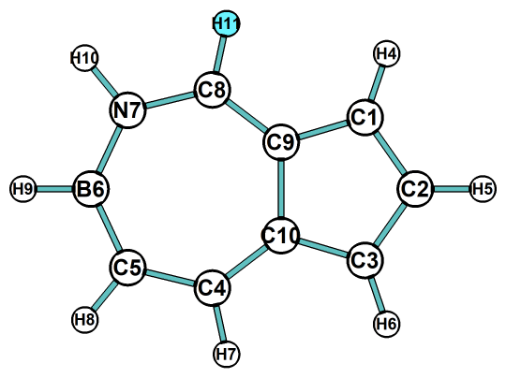 | AZ-6B7N
  C | -1.90563 | 1.363583 | -0.00014
  C | -0.56232 | 1.662974 | -0.00011
  C | 0.544612 | 0.769446 | 0.000004
  C | -0.54701 | -1.57157 | 0.000151
  C | 0.520007 | -0.71224 | 0.000106
  H | -3.76552 | -0.10866 | -6.8E-05
  H | -2.56779 | 2.22894 | -0.00021
  H | -0.27788 | 2.716925 | -4.7E-05
  H | -2.46751 | -2.08883 | 0.000077
  H | -0.32879 | -2.63794 | 0.000097
  C | 1.88532 | 1.139553 | 0.000348
  H | 2.24771 | 2.161171 | 0.000612
  C | 2.702887 | -0.033 | -0.0002
  H | 3.78645 | -0.03807 | -0.00028
  C | 1.890066 | -1.15045 | -0.00019
  H | 2.20919 | -2.18587 | -0.00033
  N | -1.87583 | -1.26722 | 0.000078
  B | -2.57453 | 0.002616 | -4.1E-05
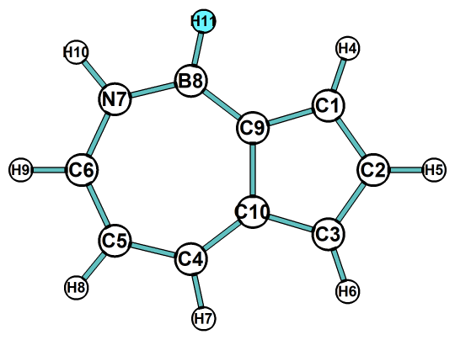 | AZ-7N8B
  C | 1.843627 | 1.304788 | 0.000079
  C | 0.444484 | 1.578779 | 0.000261
  C | -0.61725 | 0.704538 | 0.000225
  C | -0.57164 | -0.78089 | -3.8E-05
  H | 3.594612 | 0.144867 | 0.000504
  H | 2.494231 | 2.17453 | -0.00013
  H | 0.190015 | 2.638425 | 0.000124
  H | 2.726769 | -1.87375 | -0.00019
  H | 0.561136 | -2.86384 | -0.00022
  C | -2.0024 | 1.092905 | -0.00038
  H | -2.36131 | 2.11551 | -0.00069
  C | -2.76875 | -0.05484 | 0.000085
  H | -3.85216 | -0.09605 | 0.000184
  C | -1.89582 | -1.19666 | 0.000229
  H | -2.22439 | -2.23001 | 0.00046
  C | 2.507997 | 0.103861 | -7.4E-05
  B | 0.643666 | -1.67063 | -0.00021
  N | 2.001616 | -1.16734 | -0.00019
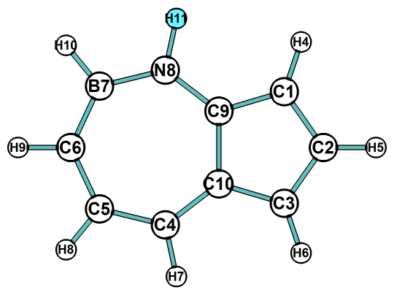 | AZ-7B8N
  C | -1.97751 | 1.260856 | 0.000043
  C | -0.57657 | 1.574065 | 0.000097
  C | 0.513496 | 0.744294 | 0.000077
  C | 0.567861 | -0.75263 | -3.5E-05
  H | -3.66454 | 0.052953 | 0.00017
  H | -2.62482 | 2.137797 | -8.6E-05
  H | -0.34382 | 2.638394 | 0.000052
  H | -2.60058 | -2.35071 | -6.8E-05
  H | -0.24472 | -2.56849 | -0.00012
  C | 1.886487 | 1.18419 | -1.6E-05
  H | 2.198101 | 2.220481 | -3.9E-05
  C | 2.69422 | 0.071438 | 0.000032
  H | 3.778369 | 0.078671 | 0.000055
  C | 1.88973 | -1.127 | 0.000009
  H | 2.265874 | -2.14297 | 0.000015
  B | -1.92646 | -1.36309 | -9.2E-05
  N | -0.52443 | -1.59285 | -9.5E-05
  C | -2.57448 | 0.027995 | -1.8E-05
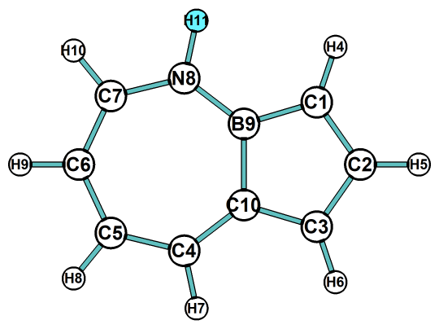 | AZ-8N9B
  C | -1.89514 | 1.292292 | 0.000013
  C | -0.57121 | 1.681285 | 0.000028
  C | 0.553684 | 0.820068 | 0.000019
  H | -3.56313 | -0.02959 | 0.000025
  H | -2.62641 | 2.097977 | 0.000023
  H | -0.38385 | 2.756041 | 0.000051
  H | -2.59352 | -2.11924 | -5.3E-05
  H | -0.42234 | -2.61128 | -5.4E-05
  C | 1.882085 | 1.177111 | 0.000034
  H | 2.268037 | 2.193527 | 0.000055
  H | 3.828542 | 0.081124 | 0.000025
  H | 2.538731 | -2.1586 | -2.4E-05
  C | -2.47604 | -0.01684 | -2.1E-05
  C | -1.91916 | -1.26779 | -0.00004
  C | 2.049175 | -1.19018 | -1.1E-05
  C | 2.743182 | -0.00448 | 0.000017
  B | 0.564454 | -0.77742 | -8E-06
  N | -0.58111 | -1.61024 | -3.6E-05
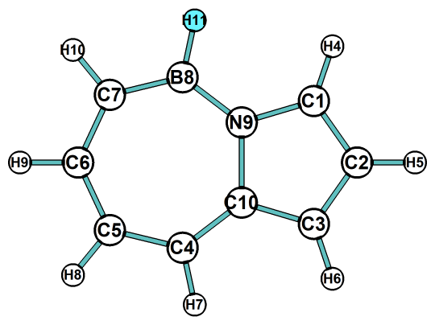 | AZ-8B9N
  C | 1.929598 | 1.251682 | -3.1E-05
  C | 0.589403 | 1.541607 | -5.4E-05
  C | -0.56065 | 0.706408 | -3.2E-05
  H | 3.659162 | 0.020493 | 0.000015
  H | 2.597727 | 2.109247 | -5.1E-05
  H | 0.331043 | 2.598844 | -8.2E-05
  H | 2.70407 | -2.10572 | 0.000078
  H | 0.18819 | -2.80151 | 0.000063
  C | -1.88492 | 1.14377 | -2.3E-05
  H | -2.19242 | 2.180886 | -3.3E-05
  H | -3.80322 | -0.00552 | 0.000078
  H | -2.15187 | -2.15503 | -0.00007
  C | 2.569606 | -0.02957 | 0.000032
  C | 1.996724 | -1.2767 | 0.000057
  C | -1.90189 | -1.10455 | -4.7E-05
  C | -2.72195 | 0.006956 | 0.000041
  N | -0.57855 | -0.71519 | 0.000014
  B | 0.524331 | -1.6546 | 0.00005
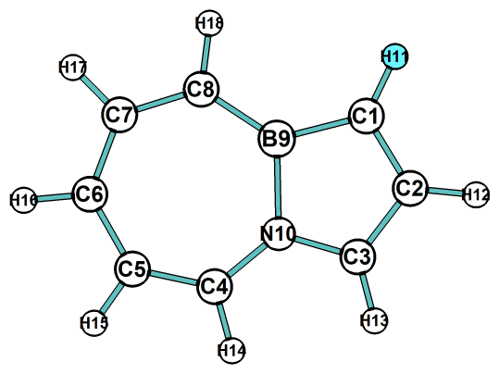 | AZ-9B10N
  C | -1.82142 | -1.29075 | -2.5E-05
  C | -0.47129 | -1.57588 | -4.5E-05
  H | -3.60735 | -0.16822 | -2.2E-05
  H | -2.44593 | -2.18066 | 0.000004
  H | -0.18293 | -2.62561 | -4.6E-05
  H | -2.80531 | 2.015487 | 0.000064
  H | -0.56231 | 2.74263 | 0.000071
  C | 1.87547 | -1.08357 | -5E-06
  H | 2.152691 | -2.13173 | -1.4E-05
  H | 3.815252 | -0.06436 | -8.6E-05
  H | 2.483094 | 2.203674 | 0.000048
  C | -2.5247 | -0.06518 | 0.000017
  C | -2.03899 | 1.24064 | 0.00005
  C | 2.734597 | 0.040668 | -5.5E-05
  C | -0.69931 | 1.660732 | 0.00005
  B | 0.542628 | 0.847242 | 0.00002
  C | 2.012278 | 1.227435 | 0.000023
  N | 0.577114 | -0.70742 | -2.5E-05

Table S2. Relative energies (298 K, kcal/mol) of 11 BN-doped azulene at CBS-QB3, G3MP2, and CBS-APNO methods.
Isomer | CBS-QB3 | G3MP2 | CBS-APNO
AZ-1N9B | 0.00 | 0.00 | 0.00
AZ-1N2B | 3.64 | 4.15 | 3.23
AZ-8B9N | 3.74 | 4.61 | 3.66
AZ-7N8B | 6.10 | 6.32 | 6.00
AZ-6B7N | 6.51 | 6.79 | 6.47
AZ-6N7B | 10.79 | - | 10.76
AZ-1B2N | 12.98 | 13.11 | 12.81
AZ-7B8N | 13.15 | 13.18 | -
AZ-8N9B | 14.33 | 13.61 | 14.45
AZ-1B9N | 19.36 | 19.37 | 19.25
AZ-9B10N | 19.82 | 20.62 | 19.82

Table S3. The Cartesian coordinates of BN-doped azulene 1N9B isomer at basis sets, functionals, and different dispersion methods.
1N9B | CAM-B3LYP/6-311G (d,p)
6 -2.236609000 1.476364000 0.000000000
7 -0.961394000 2.004018000 0.000000000
6 -2.240476000 0.117340000 0.000000000
5 0.000000000 0.930979000 0.000000000
6 -0.879827000 -0.347766000 0.000000000
6 1.495045000 1.028105000 0.000000000
6 -0.465064000 -1.652305000 0.000000000
1 1.976712000 2.004780000 0.000000000
1 -1.226929000 -2.430401000 0.000000000
6 2.348526000 -0.042426000 0.000000000
6 0.868462000 -2.115867000 0.000000000
1 3.414545000 0.176332000 0.000000000
6 2.059122000 -1.430692000 0.000000000
1 -3.129578000 -0.497288000 0.000000000
1 -0.812677000 2.998249000 0.000000000
1 -3.098752000 2.130541000 0.000000000
1 0.969991000 -3.197572000 0.000000000
1 2.941372000 -2.064176000 0.000000000
 | CAM-B3LYP/6-311+G(d,p)
6 -2.238302000 1.477081000 0.000000000
7 -0.962529000 2.005355000 0.000000000
6 -2.240741000 0.117362000 0.000000000
5 0.000000000 0.930789000 0.000000000
6 -0.879092000 -0.347599000 0.000000000
6 1.495283000 1.028346000 0.000000000
6 -0.465008000 -1.652886000 0.000000000
1 1.976576000 2.005045000 0.000000000
1 -1.227081000 -2.430668000 0.000000000
6 2.349620000 -0.042590000 0.000000000
6 0.868834000 -2.116966000 0.000000000
1 3.415429000 0.176655000 0.000000000
6 2.060193000 -1.431424000 0.000000000
1 -3.130028000 -0.497057000 0.000000000
1 -0.813596000 2.999890000 0.000000000
1 -3.100929000 2.130363000 0.000000000
1 0.970252000 -3.198630000 0.000000000
1 2.942363000 -2.064975000 0.000000000
 | CAM-B3LYP/cc-pVTZ
6 -2.233293000 1.472260000 0.000000000
7 -0.962209000 2.001338000 0.000000000
6 -2.235577000 0.115990000 0.000000000
5 0.000000000 0.929816000 0.000000000
6 -0.878062000 -0.347920000 0.000000000
6 1.493861000 1.026469000 0.000000000
6 -0.463614000 -1.649319000 0.000000000
1 1.975419000 2.000404000 0.000000000
1 -1.223414000 -2.426239000 0.000000000
6 2.345030000 -0.042230000 0.000000000
6 0.867185000 -2.110951000 0.000000000
1 3.408749000 0.175671000 0.000000000
6 2.055375000 -1.427167000 0.000000000
1 -3.122765000 -0.497440000 0.000000000
1 -0.817238000 2.993712000 0.000000000
1 -3.095332000 2.122752000 0.000000000
1 0.969376000 -3.190202000 0.000000000
1 2.935232000 -2.059895000 0.000000000
 | CAM-B3LYP/cc-pVQZ
6 -2.231685000 1.473612000 0.000000000
7 -0.960205000 2.000956000 0.000000000
6 -2.235294000 0.117555000 0.000000000
5 0.000000000 0.929269000 0.000000000
6 -0.877836000 -0.347595000 0.000000000
6 1.493304000 1.025522000 0.000000000
6 -0.464493000 -1.649055000 0.000000000
1 1.974533000 1.998918000 0.000000000
1 -1.224261000 -2.425090000 0.000000000
6 2.344225000 -0.043073000 0.000000000
6 0.866054000 -2.111255000 0.000000000
1 3.407317000 0.174536000 0.000000000
6 2.054246000 -1.427927000 0.000000000
1 -3.122608000 -0.494692000 0.000000000
1 -0.813430000 2.992382000 0.000000000
1 -3.092518000 2.124644000 0.000000000
1 0.967889000 -3.189902000 0.000000000
1 2.933390000 -2.060535000 0.000000000
 | CAM-B3LYP/Def2TZVPP
6 -2.232523000 1.474180000 0.000000000
7 -0.961126000 2.001778000 0.000000000
6 -2.235880000 0.117362000 0.000000000
5 0.000000000 0.929448000 0.000000000
6 -0.878328000 -0.347699000 0.000000000
6 1.493940000 1.025976000 0.000000000
6 -0.464449000 -1.649738000 0.000000000
1 1.975472000 2.000060000 0.000000000
1 -1.224747000 -2.426315000 0.000000000
6 2.345262000 -0.043171000 0.000000000
6 0.866376000 -2.111877000 0.000000000
1 3.409115000 0.174677000 0.000000000
6 2.055171000 -1.428247000 0.000000000
1 -3.123844000 -0.495335000 0.000000000
1 -0.814402000 2.993854000 0.000000000
1 -3.094219000 2.125409000 0.000000000
1 0.968227000 -3.191310000 0.000000000
1 2.934868000 -2.061451000 0.000000000
1N9B | CAM-B3LYP-BJ3/6-311G(d,p)
6 -2.236808000 1.475516000 0.000000000
7 -0.961825000 2.003103000 0.000000000
6 -2.240220000 0.116462000 0.000000000
5 0.000000000 0.930241000 0.000000000
6 -0.879423000 -0.348390000 0.000000000
6 1.494191000 1.028368000 0.000000000
6 -0.464049000 -1.652495000 0.000000000
1 1.976539000 2.004487000 0.000000000
1 -1.224632000 -2.431554000 0.000000000
6 2.347754000 -0.041527000 0.000000000
6 0.869129000 -2.114702000 0.000000000
1 3.413504000 0.177462000 0.000000000
6 2.058901000 -1.429025000 0.000000000
1 -3.129532000 -0.497777000 0.000000000
1 -0.814089000 2.997487000 0.000000000
1 -3.098719000 2.129901000 0.000000000
1 0.971646000 -3.196100000 0.000000000
1 2.941200000 -2.062080000 0.000000000
 | CAM-B3LYP-GD3/6-311G(d,p)
6 -2.236609000 1.476364000 0.000000000
7 -0.961394000 2.004018000 0.000000000
6 -2.240476000 0.117340000 0.000000000
5 0.000000000 0.930979000 0.000000000
6 -0.879827000 -0.347766000 0.000000000
6 1.495045000 1.028105000 0.000000000
6 -0.465064000 -1.652305000 0.000000000
1 1.976712000 2.004780000 0.000000000
1 -1.226929000 -2.430401000 0.000000000
6 2.348526000 -0.042426000 0.000000000
6 0.868462000 -2.115867000 0.000000000
1 3.414545000 0.176332000 0.000000000
6 2.059122000 -1.430692000 0.000000000
1 -3.129578000 -0.497288000 0.000000000
1 -0.812677000 2.998249000 0.000000000
1 -3.098752000 2.130541000 0.000000000
1 0.969991000 -3.197572000 0.000000000
1 2.941372000 -2.064176000 0.000000000
1N9B | B3LYP/6-311G(d,p)
6 -2.244638000 1.484485000 0.000000000
7 -0.970065000 2.013152000 0.000000000
6 -2.242723000 0.113140000 0.000000000
5 0.000000000 0.934488000 0.000000000
6 -0.884922000 -0.348569000 0.000000000
6 1.494846000 1.033533000 0.000000000
6 -0.462421000 -1.663991000 0.000000000
1 1.979358000 2.010168000 0.000000000
1 -1.222612000 -2.445022000 0.000000000
6 2.357986000 -0.044515000 0.000000000
6 0.869786000 -2.123778000 0.000000000
1 3.424153000 0.177620000 0.000000000
6 2.070420000 -1.430607000 0.000000000
1 -3.134187000 -0.499863000 0.000000000
1 -0.825535000 3.009394000 0.000000000
1 -3.108971000 2.136704000 0.000000000
1 0.975603000 -3.205966000 0.000000000
1 2.952645000 -2.065737000 0.000000000
 | B97d/6-311G(d,p)
6 -2.259097000 1.485520000 0.000000000
7 -0.985086000 2.022122000 0.000000000
6 -2.247954000 0.102282000 0.000000000
5 0.000000000 0.939543000 0.000000000
6 -0.888740000 -0.352369000 0.000000000
6 1.501019000 1.046393000 0.000000000
6 -0.460077000 -1.675723000 0.000000000
1 1.990529000 2.026804000 0.000000000
1 -1.222667000 -2.461815000 0.000000000
6 2.370355000 -0.039762000 0.000000000
6 0.875952000 -2.131066000 0.000000000
1 3.441431000 0.184216000 0.000000000
6 2.083476000 -1.428676000 0.000000000
1 -3.140723000 -0.518556000 0.000000000
1 -0.850421000 3.023150000 0.000000000
1 -3.130125000 2.137639000 0.000000000
1 0.987658000 -3.217664000 0.000000000
1 2.970317000 -2.065935000 0.000000000
 | CAM-B3LYP/6-311G(d,p)
6 -2.237204000 1.476245000 0.000000000
7 -0.962148000 2.003926000 0.000000000
6 -2.241195000 0.117283000 0.000000000
5 0.000000000 0.930942000 0.000000000
6 -0.880214000 -0.347983000 0.000000000
6 1.495364000 1.027926000 0.000000000
6 -0.464449000 -1.652481000 0.000000000
1 1.978659000 2.003793000 0.000000000
1 -1.224885000 -2.431926000 0.000000000
6 2.348868000 -0.042431000 0.000000000
6 0.869122000 -2.115370000 0.000000000
1 3.414798000 0.176389000 0.000000000
6 2.059538000 -1.430312000 0.000000000
1 -3.131089000 -0.496322000 0.000000000
1 -0.815028000 2.998527000 0.000000000
1 -3.099085000 2.130886000 0.000000000
1 0.970989000 -3.196991000 0.000000000
1 2.941698000 -2.063821000 0.000000000
 | HSEH1PBE (HSE06) /6-311G(d,p)
6 -2.234750000 1.482250000 0.000000000
7 -0.966805000 2.008024000 0.000000000
6 -2.236512000 0.113321000 0.000000000
5 0.000000000 0.931688000 0.000000000
6 -0.884049000 -0.347603000 0.000000000
6 1.493419000 1.031936000 0.000000000
6 -0.463727000 -1.660593000 0.000000000
1 1.979107000 2.008402000 0.000000000
1 -1.225112000 -2.441173000 0.000000000
6 2.352228000 -0.045295000 0.000000000
6 0.865123000 -2.118541000 0.000000000
1 3.419421000 0.174778000 0.000000000
6 2.063026000 -1.427354000 0.000000000
1 -3.129568000 -0.498349000 0.000000000
1 -0.821911000 3.002575000 0.000000000
1 -3.099336000 2.135660000 0.000000000
1 0.971654000 -3.201228000 0.000000000
1 2.944839000 -2.064008000 0.000000000
 | MN12/6-311G(d,p)
6 -2.229736000 1.485605000 0.000000000
7 -0.960108000 2.006591000 0.000000000
6 -2.235385000 0.118004000 0.000000000
5 0.000000000 0.931962000 0.000000000
6 -0.882902000 -0.344983000 0.000000000
6 1.491983000 1.028600000 0.000000000
6 -0.467767000 -1.659466000 0.000000000
1 1.981121000 2.007967000 0.000000000
1 -1.233660000 -2.441625000 0.000000000
6 2.350403000 -0.048002000 0.000000000
6 0.860767000 -2.119934000 0.000000000
1 3.422322000 0.169675000 0.000000000
6 2.058796000 -1.430440000 0.000000000
1 -3.132393000 -0.492506000 0.000000000
1 -0.809756000 3.004886000 0.000000000
1 -3.093273000 2.146488000 0.000000000
1 0.966588000 -3.206616000 0.000000000
1 2.942850000 -2.070524000 0.000000000
 | MN15/6-311G(d,p)
6 -2.238843000 1.482109000 0.000000000
7 -0.963877000 2.011362000 0.000000000
6 -2.242289000 0.116614000 0.000000000
5 0.000000000 0.932597000 0.000000000
6 -0.882156000 -0.346313000 0.000000000
6 1.497402000 1.032254000 0.000000000
6 -0.467476000 -1.660035000 0.000000000
1 1.981556000 2.008919000 0.000000000
1 -1.231904000 -2.437057000 0.000000000
6 2.354929000 -0.044703000 0.000000000
6 0.866664000 -2.123191000 0.000000000
1 3.421997000 0.173024000 0.000000000
6 2.063204000 -1.433207000 0.000000000
1 -3.132049000 -0.498797000 0.000000000
1 -0.815021000 3.008521000 0.000000000
1 -3.102105000 2.135999000 0.000000000
1 0.970989000 -3.205485000 0.000000000
1 2.945080000 -2.068816000 0.000000000
 | PBE0DH/6-311G(d,p)
6 -2.228438000 1.479496000 0.000000000
7 -0.962093000 2.003571000 0.000000000
6 -2.233752000 0.115230000 0.000000000
5 0.000000000 0.929898000 0.000000000
6 -0.881921000 -0.346181000 0.000000000
6 1.492938000 1.029534000 0.000000000
6 -0.465672000 -1.656095000 0.000000000
1 1.979048000 2.002316000 0.000000000
1 -1.225791000 -2.433562000 0.000000000
6 2.347562000 -0.045778000 0.000000000
6 0.862226000 -2.114732000 0.000000000
1 3.412059000 0.171898000 0.000000000
6 2.056747000 -1.426754000 0.000000000
1 -3.125224000 -0.493547000 0.000000000
1 -0.817001000 2.994731000 0.000000000
1 -3.089845000 2.132599000 0.000000000
1 0.968066000 -3.194430000 0.000000000
1 2.935196000 -2.062819000 0.000000000
 | wB97XD/6-311G(d,p)
6 -2.237149000 1.479199000 0.000000000
7 -0.962811000 2.007010000 0.000000000
6 -2.243518000 0.118001000 0.000000000
5 0.000000000 0.932809000 0.000000000
6 -0.882097000 -0.348403000 0.000000000
6 1.499590000 1.030300000 0.000000000
6 -0.467369000 -1.655739000 0.000000000
1 1.985098000 2.006127000 0.000000000
1 -1.228996000 -2.435287000 0.000000000
6 2.352520000 -0.043781000 0.000000000
6 0.867723000 -2.118608000 0.000000000
1 3.419868000 0.173203000 0.000000000
6 2.060526000 -1.432625000 0.000000000
1 -3.135386000 -0.493789000 0.000000000
1 -0.815931000 3.000666000 0.000000000
1 -3.099007000 2.134991000 0.000000000
1 0.970013000 -3.201175000 0.000000000
1 2.942664000 -2.067909000 0.000000000

Table S4: Computed absorption spectra (λ_{max}, nm/eV) of azulene and BN-doped azulene at TD-DFT(PCM) TD-CAM-B3LYP/6-31+G(d,p)// B3LYP/6-31+G(d,p)in acetone.
Compound | absorption energy |  | F | Transitions
Compound | (nm) | (eV) | F | Transitions
AZ | 257 | 4.83 | 1.3292 | H-1→L (54%), H→L+1 (44%)
AZ-1N2B | 264 | 4.70 | 0.4064 | H-1→L (71%), H→L+1 (14%)
AZ-1B2N | 235 | 5.27 | 0.3738 | H-1→L (43%), H→L+5 (41%)
AZ-1N9B | 201 | 6.16 | 0.3865 | H-2→L (78%)
AZ-1B9N | 261 | 4.76 | 0.8273 | H-1→L (60%), H→L+1 (14%)
AZ-6N7B | 248 | 5.00 | 0.8799 | H-1→L (48%), H→L+1 (38%),
AZ-6B7N | 253 | 4.90 | 1.0738 | H-1→L (42%), H-1→L+1 (31%), H→L+1 (20%)
AZ-7N8B | 234 | 5.29 | 0.6149 | H-1→L+1 (89%)
AZ-7B8N | 259 | 4.78 | 0.7867 | H-1→L (19%), H→L+1 (77%)
AZ-8N9B | 229 | 5.40 | 0.5649 | H-1→L+1 (90%)
AZ-8B9N | 236 | 5.25 | 0.5897 | H-1→L (79%),H→L+1 (17%)
AZ-9B10N | 280 | 4.43 | 0.5081 | H-1→L (63%), H→L+1 (31%)

Table S5. The calculated and experimental wavelength of S₀-S₁ and S₀-S₂ transitions for azulene ª
Level of calculation | S₀-S₁/nm | S₀-S₂/nm
B3LYP/6-31+G(d,p) (gas) | 523 (0.0073) | 344 (0.0032)
B3LYP/6-31+G(d,p) (acetone) | 516 (0.0107) | 342 (0.0058)
CAM-B3LYP/6-31+G(d,p) (acetone) | 507 (0.012) | 326 (0.0066)
Exp. (hexanes) [1] | 580 (0.0348) | 341(0.0401)
Exp. (ethanol) [1] | 576 (0.0362) | 340 (0.0420)
TD-PBE0/6-31G(d) [2] | 502 (0.008) | 329 (0.002)
ªValues in parentheses represent oscillator strength
[1] S. V Shevyakov, H. Li, R. Muthyala, A.E. Asato, J.C. Croney, D.M. Jameson, R.S.H. Liu, J. Phys. Chem. A. 107 (2003) 3295–3299. The experimental absorption spectra are performed in hexane and ethanol.
[2] K. Veys, D. Escudero, J. Phys. Chem. A 124.36 (2020): 7228-7237.

a)
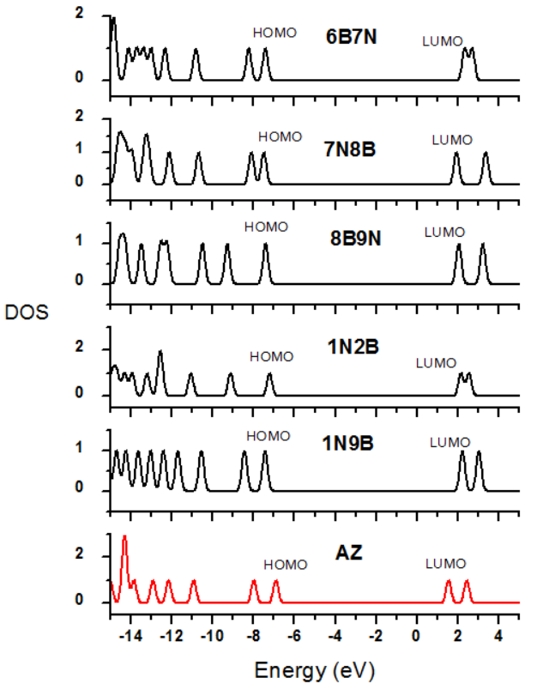
Figure S1. The Density of states (DOS) for a) the most stable BN-doped azulene and b) less stable BN-doped isomers at the G3MP2 level.

b)
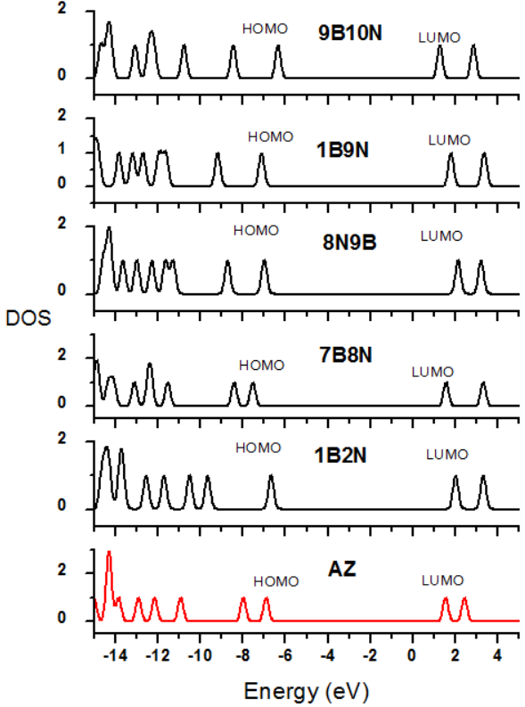
Figure S1. Continued.
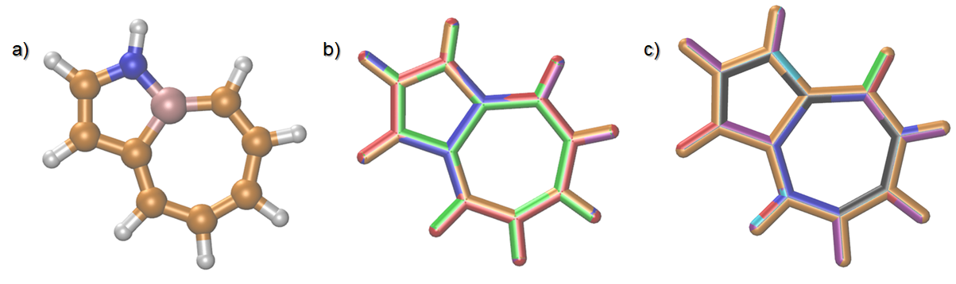
Figure S2: The effect of different dispersion corrections; GD3 and GD3BJ (a), basis sets (b), and different functionals (c) on the optimized geometries of the AZ-1N9B isomer. In a, the structure optimized using GD3 corrction is represented in sticks and the one optimized using BJ3 is shown in balls and sticks. The color code for the structures optimized at different basis sets; blue:6-311G(d,p), brown:6-311+G(d,p), green:cc-pVTZ, red:cc-pVQZ, and purple:Def2TZVPP. The color code for the different DFT functionals used in the optimizations benchmark is; blue:CAM-B3LYP, magenta:B3LYP, brown:wB97XD, green: HSEH1PBE (HSE06), red:PBE0DH, purple:MN15, cyan:MN12-SX, and black:B97D.

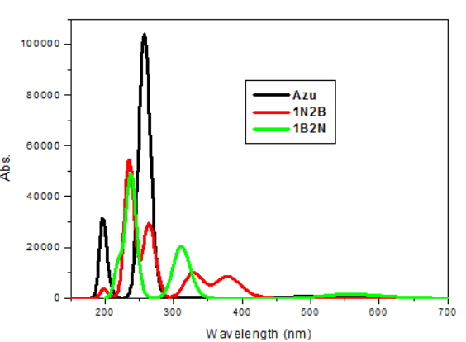 | 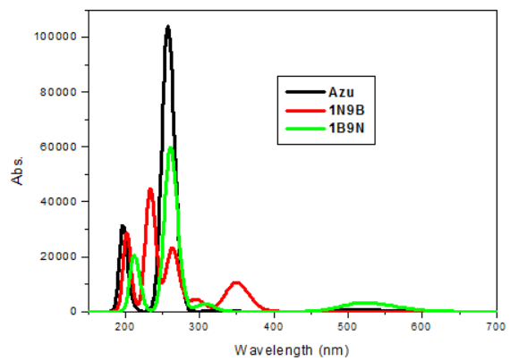
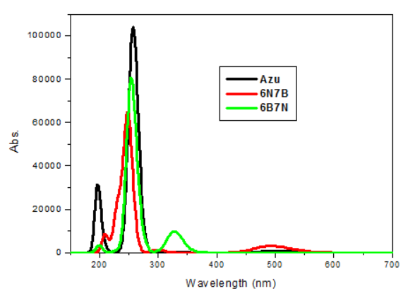 | 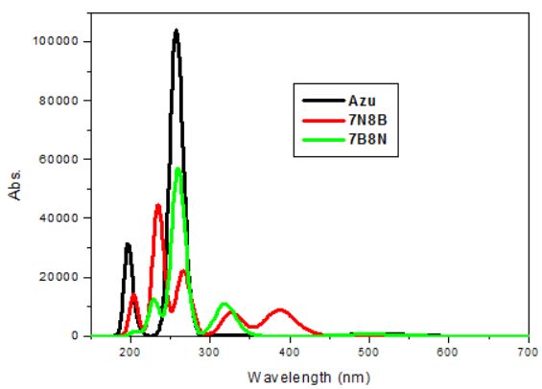
 | 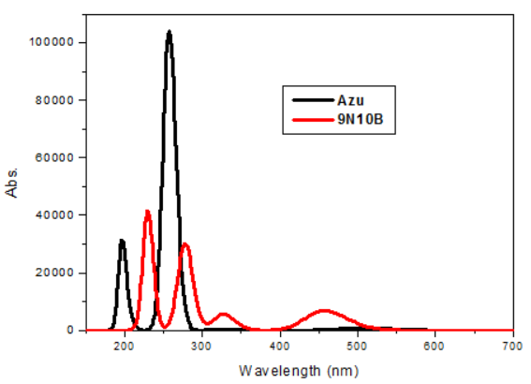

Fig.S3. UV-vis spectra for azulene and BN-doped azulene at TD-CAM-B3LYP/6-31+G(d,p)//B3LYP/6-31G(d,p) in acetone.

