Supporting Information
A novel strategy for efficient disaccharides synthesis from glucose by β-glucosidase
Kangle Niu,¹ Zhengyao Liu,¹ Yuhui Feng,¹ Tianlong Gao,¹ Zhenzhen Wang,¹ Piaopiao Zhang,² Zhiqiang Du,¹ Daming Gao,³ and Xu Fang^{1,4*}
¹ State Key Laboratory of Microbial Technology, Shandong University, Qingdao 266237, China
² Yantai Huakangrongzan Biotechnology Co., Ltd, Yantai 264006, China.
³ Department of Rehabilitation Science, Graduate School of Health Science, Kobe University, Kobe 6540142, Japan
⁴ National Glycoengineering Research Center, Shandong University, Qingdao 266237, China
* Corresponding author: fangxu@sdu.edu.cn

Contents
Fig. S1 The phylogenetic tree of TrCel1b and other GH1 family β-glucosidases
Fig. S2 The 3-D model of TrCel1b predicted by SWISS-MODEL (A) and I-TASSER (B) using β-glucosidase 6KHT as template
Fig. S3 Analysis of the disaccharides with HPLC
Fig. S4 The disaccharides synthesis of β-glucosidase and its variants under different concentrations of glucose
Fig. S5 SDS-PAGE analysis of purification of TrCel1b and its variants
Fig. S6 Effects of pH value on disaccharides synthesis
Fig. S7 The interaction profiles between TrCel1b (A), TrCel1b^{I177SI174SW173H} (B) or TrCel1b^{N240I} (C) and cellobiose analyzed by Discovery Studio 4.5, respectively
Fig. S8 the labeled original electropherogram
Table S1 The comparation of the production of laminaribiose and sophorose synthesized by β-glucosidase from different species
Table S2 Primers used in this study

Fig. S1 The phylogenetic tree of TrCel1b and other GH1 family β-glucosidases. Sequences were obtained from the following accession number: TrCel1b (EGR49111.1), ThBgl2 (5JBO), ThBgl1 (5JBK), HiBG (AII80277.1), NkBgl (BAB91145.1) and CaBglA (JX030398.1)

Fig. S2 The 3-D model of TrCel1b predicted by SWISS-MODEL (A) and I-TASSER (B) using β-glucosidase 6KHT as template

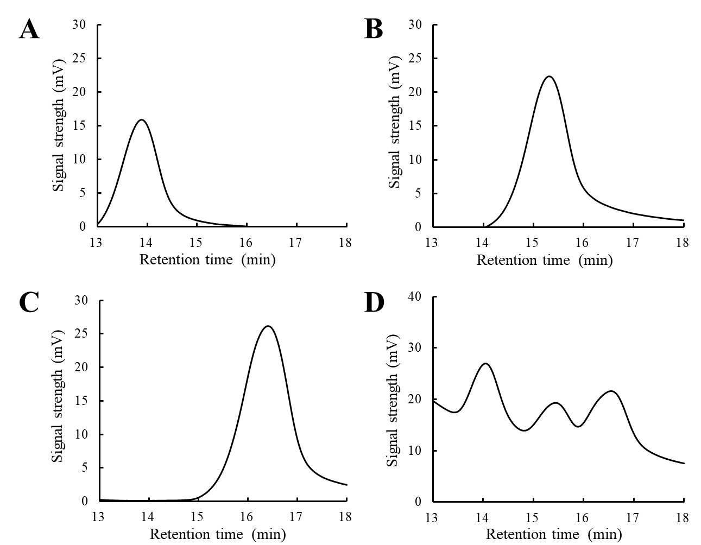
Fig. S3 Analysis of the disaccharides with HPLC. (A) Laminaribiose; (B) Cellobiose; (C) Sophorose; (D) Synthesized disaccharides by TrCel1b^{I177S/I174S/W173H}

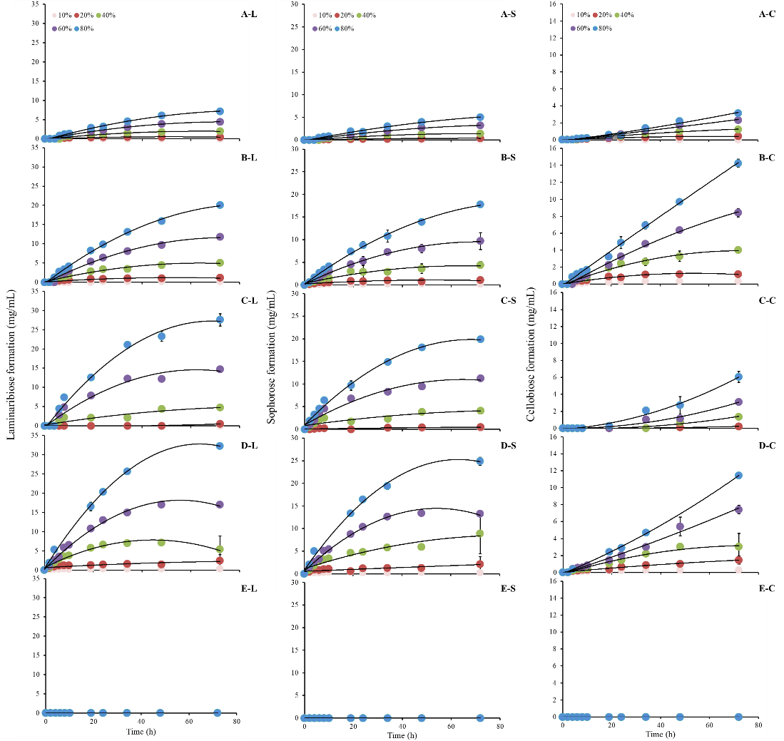
Fig. S4 The disaccharides synthesis of TrCel1b and its variants under different concentrations of glucose. L, S, C represent laminaribiose (L), sophorose (S) and cellobiose (C); A, B, C, D, and E represent TrCel1b (A), TrCel1b^{I177S} (B), TrCel1b^{I177S/I174S} (C), TrCel1b^{I177S/I174S/W173H} (D), and TrCel1b^{N240I} (E). The reactions were carried out in 50 mM phosphate buffer at pH 7.4. TrCel1b and its variants were incubated with 10%, 20%, 40%, 60%, and 80% glucose as substrate. Reaction samples were taken at 0, 2, 4, 6, 8, 10, 19, 24, 34, 48, and 72 h and then were analyzed by HPLC (for detailed explanation, see experimental section)

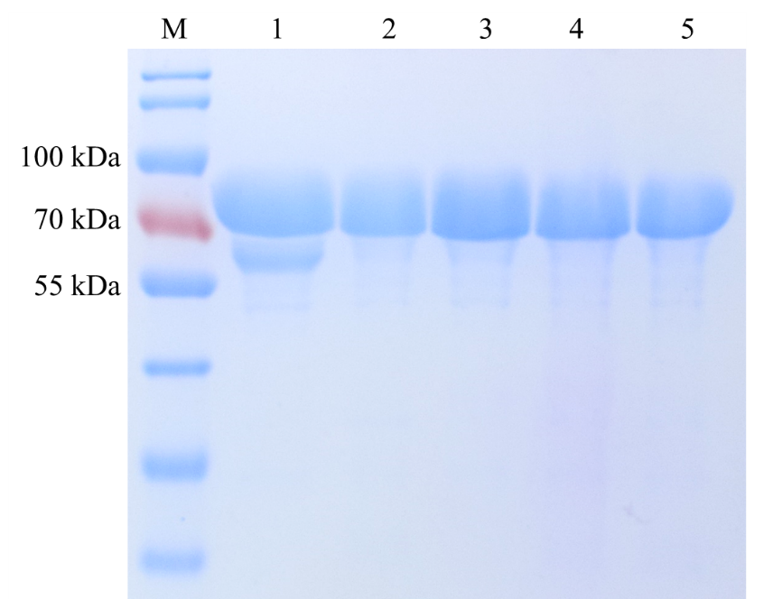
Fig. S5 SDS-PAGE analysis of purified TrCel1b and its variants. lane 1-5: purified TrCel1b, TrCel1b^{I177S}, TrCel1b^{I177S/I174S}; TrCel1b^{I177S/I174S/W173H}; TrCel1b^{N240I} with similar molecular masses of 74 kDa. M: Protein molecular weight marker

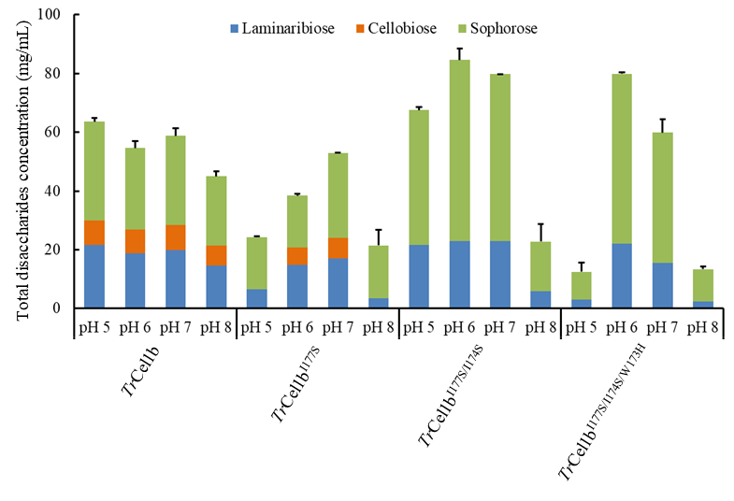
Fig. S6 Effects of pH value on disaccharides synthesis. Total disaccharides concentration represents the sum of production of laminaribiose, sophorose and cellobiose. The reactions were carried out with 40% glucose as substrate in 0.2 M sodium phosphate dibasic and 0.1 M citric acid buffer at 30 °C. Reaction samples were taken at 72 h and then were analyzed by HPLC

Fig. S7 The interaction profiles between TrCel1b (A), TrCel1b^{I177SI174SW173H} (B) or TrCel1b^{N240I} (C) and cellobiose analyzed by Discovery Studio 4.5, respectively

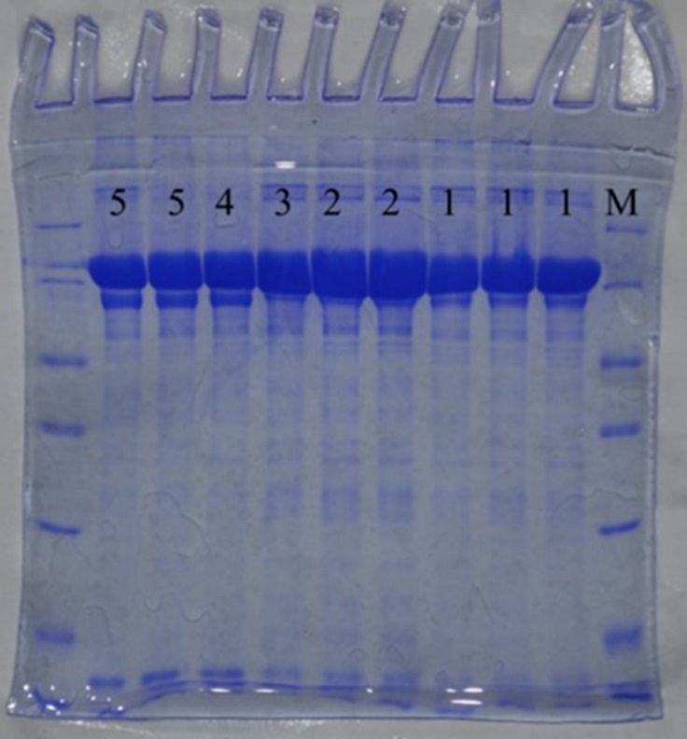
Fig. S8 The labeled original electropherogram
Notes: Lane 1-5: Purified TrCel1b, TrCel1 ^{I177S}, TrCel1b^{I177S/I174S}, TrCel1b^{I177S/I174S/W173H}, and TrCel1b^{N240I}. M: Protein molecular weight marker.

Table S1 The comparison of the production of laminaribiose and sophorose synthesized by β-glucosidase from different species
Enzyme | Temperature  (ºC) | Laminaribiose production  (mg/mL/mg enzyme) | Sophorose production  (mg/mL/mg enzyme) | Reference
TrCel1b^{I177S/I174S/W173H} | 30 | 92.3 | 71.1 | This studyª
AnBgl | 70 | 4.3 | 2.3 | M. V. Semenova, 2015^{b}
PvBgl | 70 | 1.9 | 1.2 | M. V. Semenova, 2015^{b}
TrBgl | 70 | 2.4 | 0.2 | M. V. Semenova, 2015^{b}
Corynascus sp. Bgl | 70 | 2.7 | 3.8 | M. V. Semenova, 2015^{b}
Almond Bgl | 55 | 6-9 | 6-9 | C. Ravet, 1993^{c}
ª: the reactions were carried out at 30 ºC for 72h using 800 g/L glucose as substrate.
^{b}: the reactions were carried out at 70 ºC for 48 h using 600 g/L glucose as substrate.
^{c}: the reactions were carried out at 55 ºC for 100 h using 900 g/L glucose as substrate.

Table S2 Primers used in this study
Name of Primer | Nucleotide Sequence
Cel1b-F | CCGGAATTCCCCGAGTCGCTAGCTCTG
Cel1b-R | CCCAAGCTTTGCCGCCACTTTAACCCTCTG
177S-F | AGCTATGGATATGCCACCGGCAGCAACGC
177S-R | GGCCTGAATCCAGGGTTCGTTGATGGTG
I177S/I174-F | AGTCAGGCCAGCTATGGATATGCCACCG
I177S/I174-R | CCAGGGTTCGTTGATGGTGATCCAGTTCT
I177S/I174/W173H-F | CACAGTCAGGCCAGCTATGGATATGCCACC
I177S/I174/W173H-R | GGGTTCGTTGATGGTGATCCAGTTCTGG
N240I-F | ATCGGCGACTACTATGAGCCCTGGGACAG
N240I-R | GAGCGAGATGCCGATCTGGCCCTTTTGC

