New record of larval-pupal endoparasitoid Exorista deligata parasitising Indian Tea looper Hyposidra talaca from India

Pooja V. Sharma¹, Tamal Das², Susmita Mukherjee², Ejaj K. Pathan³, Azizur Rahman², Ganesh B. Gathalkar^{1,4,*}

¹Laboratory of Entomology, Division of Organic Chemistry, CSIR-National Chemical Laboratory, Dr. Homi Bhabha Road, Pune 411008, India
²Tocklai Tea Research Institute, Cinnamara, Lichubari, Jorhat, Assam 785008, India
³Symbiosis School of Biological Sciences, Symbiosis International (Deemed University), Pune 412115, India
⁴Academy of Scientific and Innovative Research (AcSIR), Ghaziabad 201002, India

*Correspondance email: g.gathalkar@ncl.res.in Orcid ID: 0000-0002-7791-0788

Supporting Information 2
Morphology of Exorista deligata (Pandellé, 1896)
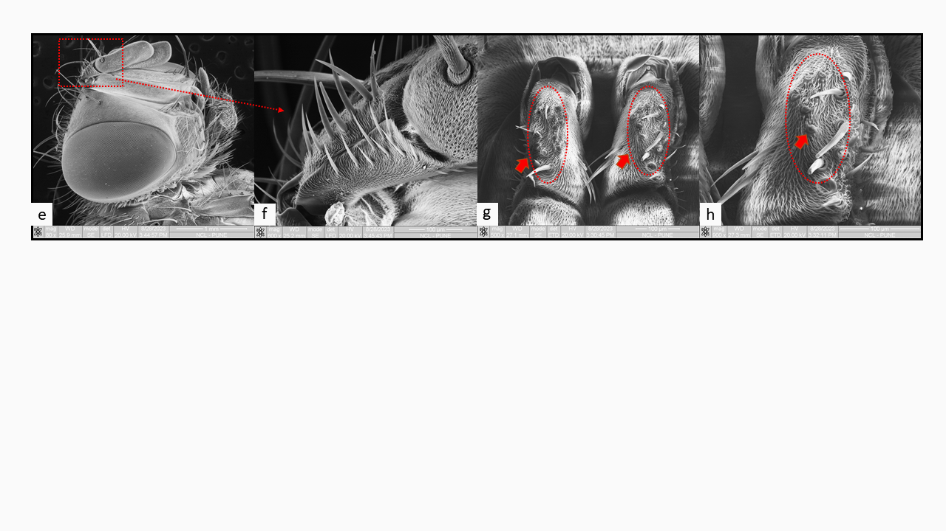
Fig. 1 Morphological characteristics and morphometry of Exorista deligata; a male, b female, c male head and d female head; e-h Scanning electron microscopy of Exorista deligata showing, species-specific characteristics: 2nd antennal segment with some dispersed bud-like marks besides irregular hairs and sensilla. Abbr: 1st flg-first flagellum, 2nd flg-second flagellum; wing venation: C-costal vein, c-costal cell, bc-basal costal cell, bm-basal medial cell, bm-m-basal medial cross vein, m-medial vein, dm-cu-discal medial cubital cross vein, cu-A-anterior branch of cubital vein, r-m-radial-medial cell, r¹-first radial cell, r₂₊₃-second+third radial cell, r₄₊₅-fourth+fifth radial cell, sc-subcostal cell, cs1-6-subcoatal veins.

Taxonomic Key: Exorista deligata (Pandellé, 1896)
Phylum - Arthropoda (von Siebold 1848)
Class - Insecta (Linnaeus 1758)
Order - Diptera (Linnaeus 1758)
Superfamily- Oestroidea (Latreille 1817)
Family- Tachinidae (Bigot 1853)
Keys for the genera
- Hypopleural bristles missing ................................................... Muscidae, Anthomyiidae, other families
- Hypopleural bristles present......................................................................................................................B
- Postscutellum strongly bolster-shaped ......................................................................................Tachinidae
- Postscutellum concave (viewed from the side), straight or only weakly convex ………………………C
- Ocellar bristles are about as strong as the posterior inner orbital bristles. Eyes bare or hairy………………………………………………………………………………………….…. Exorista
Keys for the species
- 3 dorsocentral bristles behind the suture. Syncercus of males dorsally hollowed, with yellow hairs in its hollow. Eyes bare……...…………………………………………………………………………..…….2
- 4 dorsocentral bristles behind the suture. Syncercus different; if formed as above, then eyes with dense hairs………………………………………………………………………………………………………6
- 2 outer orbital bristles ………………………………...................females of the Exorista rustica group
- No outer orbital bristles-Males of the Exorista rustica group.……………...…………………………...3
- 3 Lobes of sternite 5 indented.Tergite 3 almost without discal bristles………….……..Exorista mimula
- Lobes of sternite 5 not indented………………………...……………………………………………......4
- The Final section of the aedeagus is long, tube-like, on its tip scarcely broadened; the median strip is only a little sclerotized. Tergites 3 and 4 are mostly without discal bristles. The dorsal hollow of the syncercus elongated, triangular…...……………………...…………………………… Exorista tubulosa
- End section of aedeagus shorter widened at its tip; the median stripe is strongly sclerotized and tapered in a wedge shape. Tergites 3 and 4 almost always with strong discal bristles…………...……………....5
- Dorsal hollow of the syncercus oval. The angled final section of the aedeagus is about as long as the hollow in the syncercus. The inner area of the lobes of sternite 5 is covered to the edge with yellow pubescence…………………………………………………………………………....… Exorista rustica
- Dorsal hollowing of the syncercus elongated triangular. The final segment of the aedeagus is long and hollow. The edge as well as the predominant part of the inner area of the lobes of sternite 5 is bare……………………………………….………….………………………….……... Exorista cuneata
- Abdomen with a black central longitudinal stripe, which is visible at least at certain angles of lighting………………………………….………......................................................................................7
- Dusting of tergites in the centre a little extended posteriorly so that the impression of a white central longitudinal stripe predominates……………………………………………………………......………13
- Ocellar bristles at the level of the anterior ocellus or standing a little before them. Eyes with long, dense hairs. Tergites ventrally dusted to 2/3 - 5/6 of their length. Males: syncercus hollowed, with yellow hairs in its hollow. Females: tergite 5 with strong discal and marginal bristles……………………………….8
- Ocellar bristles behind the level of the anterior ocellus. Eyes bare or hairy. Tergites ventrally dusted to at most 1/2 of their length Males: syncercus different……………………………….………….………….9
- Dusting of the abdomen shows black iridescent spots at different lighting angles. Males: 3rd antennal segment as long as the 2nd; inner vertical bristles as long as the maximum eye diameter; 3rd wing edge section as long as the 2nd….……….……………………………….........……………. Exorista grandis
- The abdominal dusting shows practically no black iridescent spots at different lighting angles. Males: 3rd antennal segment as long as the 2nd; inner vertical bristles as long as the maximum eye diameter; 3rd wing edge section as long as the 2nd…………………………………….………. Exorista sorbillans
- Eyes with dense and long hairs…………………………………………………………………..…..…10
- Eyes bare or practically bare but tiny hair can be seen under high magnification…………….………. 11
- Bristlets above the vibrissa rise to the level of the lowest frontal bristle or further. Tergites ventrally dusted further than half. Males: surstyli at most half as long as the syncercus. Females: 2nd antennal segment black or dark brown; tergite 5 dusted to 2/3 - 4/5 of its length.…………..... Exorista segregate
- Bristlets above the vibrissa not rising to the level of the lowest frontal bristle. Tergites ventrally dusted at most to its half. Males: surstyli almost as long as the syncercus. Females: 2nd antennal segment as a rule yellow; tergite 5 shiny black, only dusted on its basal 1/3 – 1/2……...…….………...Exorista nova
- Tergite 5 with strong discal and marginal bristles; discal bristles are about as long as 2/3 of the marginal bristles of tergite 4. Scutellum black……………….………………...................… Exorista glossatorum
- Tergite 5 without or with only considerably weaker and shorter discal bristles, about 1/3 of the length of the marginal bristles of tergite; in females, marginal bristles of tergite 5 are shorter than the discal bristles or are practically missing altogether. Scutellum almost always at least partially reddish……………...12
- Dusting of the sides of tergite 3 above the ventral narrowing covers 3/4 - 5/6 of the segmental length. Dusting of the parafrontalia as a rule yellowish to golden yellow. The bristles above the vibrissa do not rise to the lower frontal bristle. Males: ventral hairs of tergite 4 are a little denser and shorter than those of tergite 3……………………………………………………………….…….............Exorista larvarum
- The dusting of the sides of tergite 3 covers only about 1/2 of the segmental length. Dusting of the parafrontalia grey-white. The bristles above the vibrissa reach the lower frontal bristle or a little further upwards. Males: ventral hairs of tergites 3 and 4 are not different from each other........Exorista fasciata
- Eyes hairy or practically bare but tiny hair can be seen under high magnification. Hairs of the peristome and the parafrontalia black. The 2nd antennal segment is with dispersed bud-like marks arranged beside several sensillae in an irregular fashion at half height (fig. 1 e-h). Frontal bristles reaching further down than to half the cheek height. Middle tibia with 2 anterodorsal bristles. Males: terminalia is covered by more setae than females, with a wider opening at the ventral side with male organs, aedeagus long-angled at the end section. (As long as in Exorista rustica). …….............................................…Exorista deligata

Key Reference: Access and modified from Pandellé, (1896) and Tschorsnig and Herting, (1994).

For morphometric measurements, we used an online tool at https://eleif.net/photomeasure

