New record of larval-pupal endoparasitoid Exorista deligata parasitising Indian Tea looper Hyposidra talaca from India

Pooja V. Sharma¹, Tamal Das², Susmita Mukherjee², Ejaj K. Pathan³, Azizur Rahman², Ganesh B. Gathalkar^{1,4,*}

¹Laboratory of Entomology, Division of Organic Chemistry, CSIR-National Chemical Laboratory, Dr. Homi Bhabha Road, Pune 411008, India
²Tocklai Tea Research Institute, Cinnamara, Lichubari, Jorhat, Assam 785008, India
³Symbiosis School of Biological Sciences, Symbiosis International (Deemed University), Pune 412115, India
⁴Academy of Scientific and Innovative Research (AcSIR), Ghaziabad 201002, India

*Correspondance email: g.gathalkar@ncl.res.in Orcid ID: 0000-0002-7791-0788

Supporting Information 3

Table 1 Percent parasitism by Exorista deligata, calculated as the number of E. deligata (emerged + inside host) to the total combined number of adults that emerged/observed of H. talaca and E. deligata.

Collection period: Sep 2021 to Oct 2022
Survey  (batches) | Date of collections | Temp/RH  (min-max) | H. talaca samples collected | H. talaca emerged  (a) | Parasitoid emerged/observed  (b) | Total  (a+b) | Rate of Parasitism  (%)
1 | 08-09-2021 | 25-27ºC/48-54% | 50 | 16 | 13 | 29 | 44.83
2 | 15-11-2021 | 24-26ºC/51-54% | 60 | 10 | 06 | 16 | 37.50
3 | 22-01-2022 | 19-24ºC/50-53% | 35 | 17 | 10 | 27 | 37.03
4 | 22-03-2022 | 25-27ºC/39-49% | 150 | 50 | 05 | 55 | 09.09
5 | 06-06-2022 | 26-30ºC/33-60% | 110 | 15 | 08 | 23 | 34.78
6 | 08-07-2022 | 28-34ºC/28-54% | 60 | 11 | 15 | 26 | 57.69
7 | 10-07-2022 | 27-33ºC/31-53% | 45 | 14 | 04 | 18 | 22.22
8 | 11-07-2022 | 28-32ºC/28-51% | 50 | 13 | 00 | 13 | 00.00
9 | 19-08-2022 | 27-30ºC/37-73% | 70 | 17 | 03 | 20 | 15.00
10 | 20-08-2022 | 28-31ºC/36-73% | 50 | 16 | 01 | 17 | 05.88
11 | 26-10-2022 | 25-28ºC/42-48% | 50 | 11 | 02 | 13 | 15.38

Table 2 Correlation statistics with collections (batches) vs host (H. talaca) emergence, parasitoid (E. deligata) emerged/observed, rate of parasitism, and host emergence vs parasitoid emerged/observed.

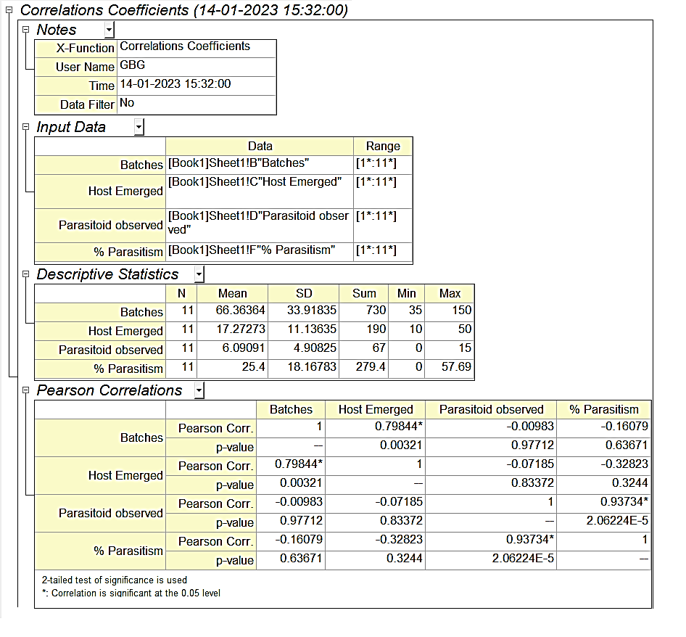

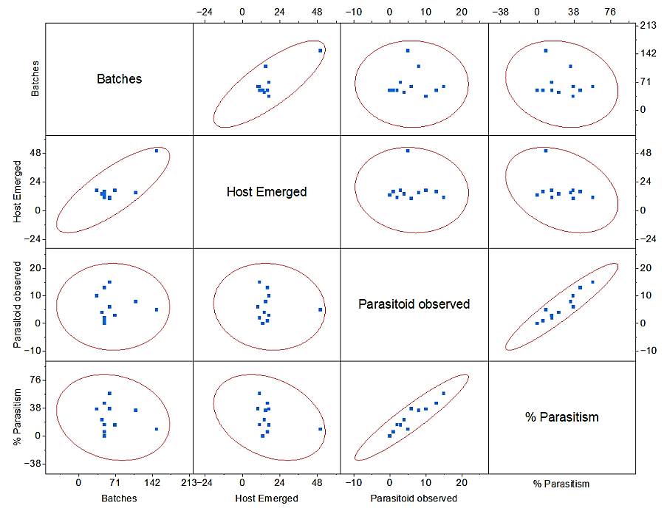
Fig. 1 Pearson correlation plot with collections (batches) vs host emergence, parasitoid observed, rate of parasitism, and host emergence vs parasitoid emerged/observed [@95% confidence level]

