Supplementary Material
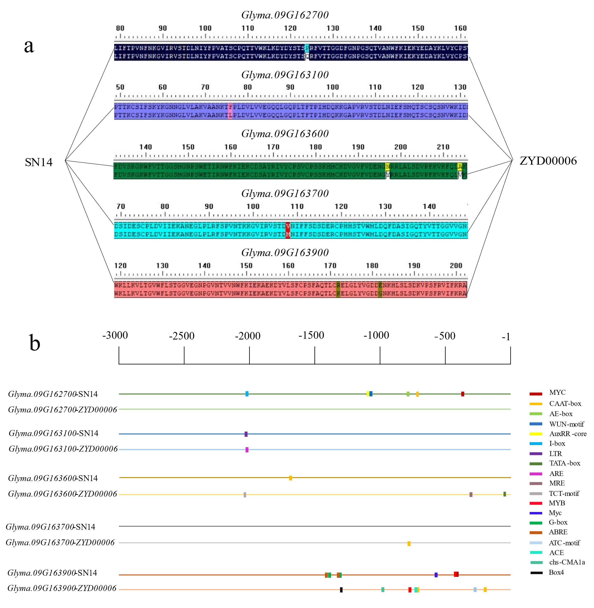
Fig. S1 Amino acid (a) and promoter cis element (b) variation of candidate genes between parents. a The difference in color indicates that the amino acid varies between the parents here. b Small squares of different colors represent different cis elements
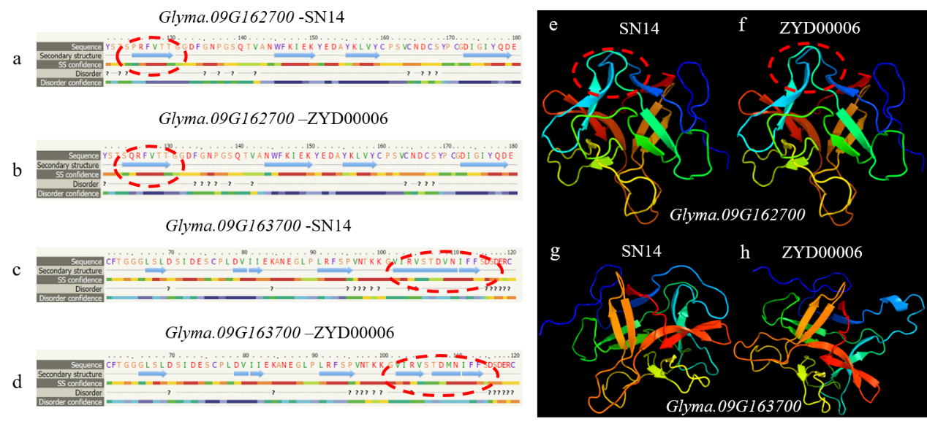

Fig. S2 Variation of protein secondary (a-d) and tertiary (e-h) structure of Glyma.09G162700 and Glyma.09G163700 between parents. a-d ? It represents disordered, green helix represents alpha helix, and blue arrow represents beta strand，the color scale under the secondary structure of protein represents the confidence of predicted protein secondary structure, with red being the highest and blue the lowest. The location of the red virtual coil in the secondary structure indicates that the amino acid variation of the gene causes the variation of the secondary structure. e-f The location of the red virtual coil in the secondary structure indicates the tertiary structure variation of the gene
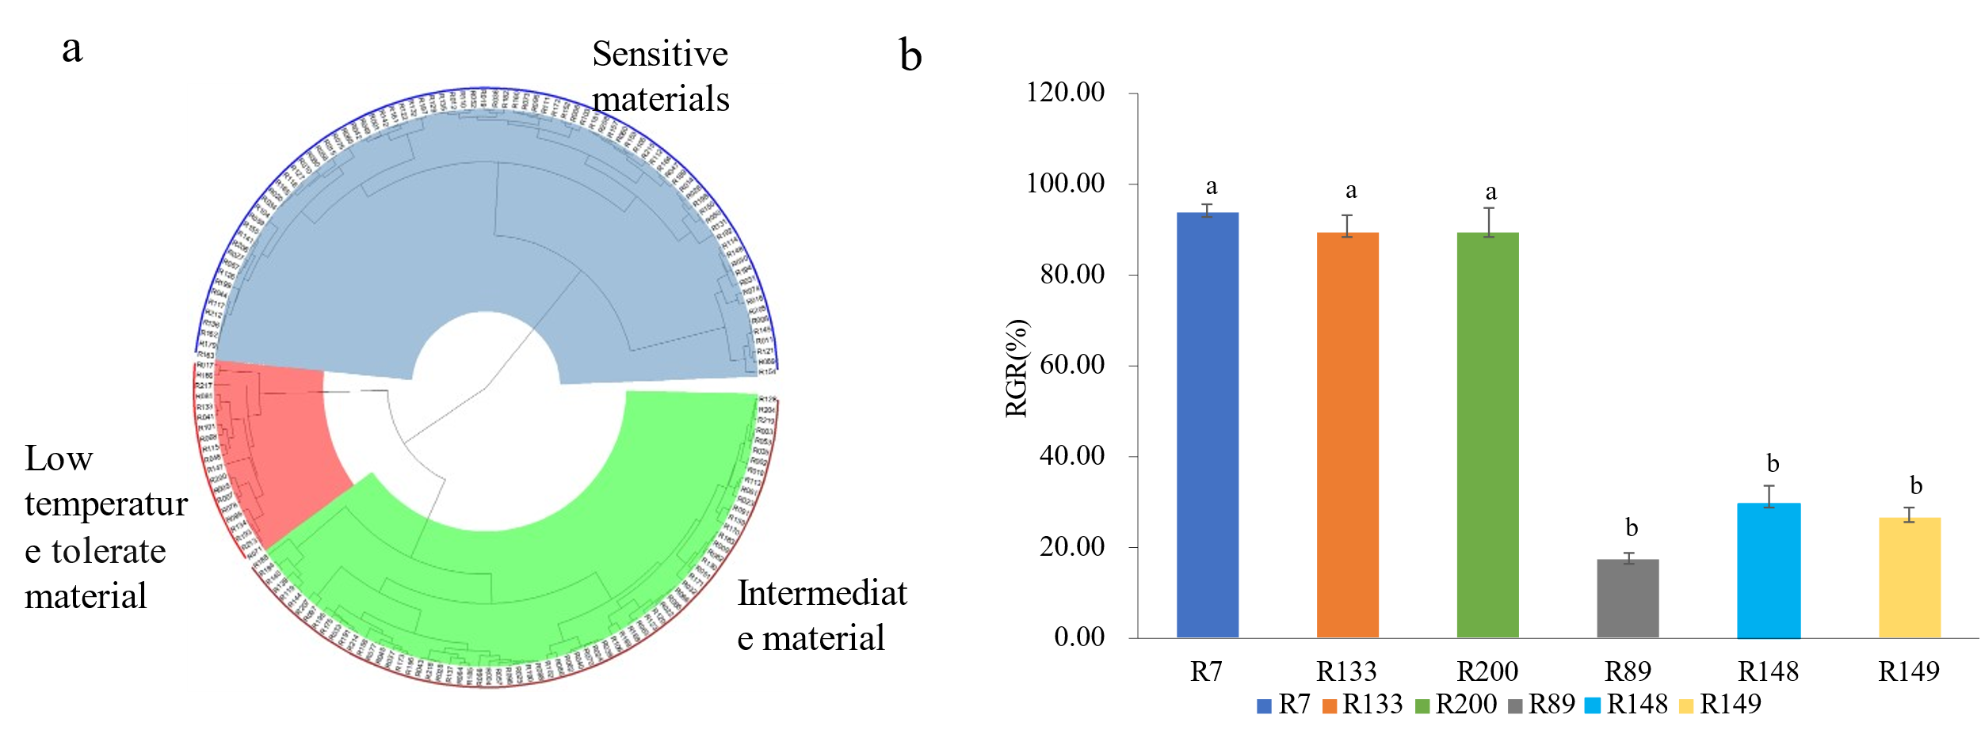

Fig. S3 CSSL population clustering plot (a) and RGR of real-time quantitative PCR materials (b). b The y-axis represents RGR(%) and x-axis represent fluorescent quantitative materials

