Supplementary information for

Metal Organic Framework Template-Guided Electrochemical Lithography

Youyou Lu¹, Xuan Zhang², Liyan Zhao¹, Kenji Mochizuki^{2*}, and Shikuan Yang^{1,3,4*}

¹Institute for Composites Science Innovation, School of Materials Science and Engineering, Zhejiang University, Hangzhou 310058, China
²Department of Chemistry, Zhejiang University, Hangzhou, 310058, P. R. China
³Department of Medical Oncology, The First Affiliated Hospital, Zhejiang University School of Medicine, Hangzhou 310003, China
⁴State Key Laboratory of Fluid Power and Mechatronic Systems, Zhejiang University, Hangzhou 310027, China
*Corresponding author. Email: Kenji_mochizuki@zju.edu.cn; shkyang@zju.edu.cn

Supplementary Figures
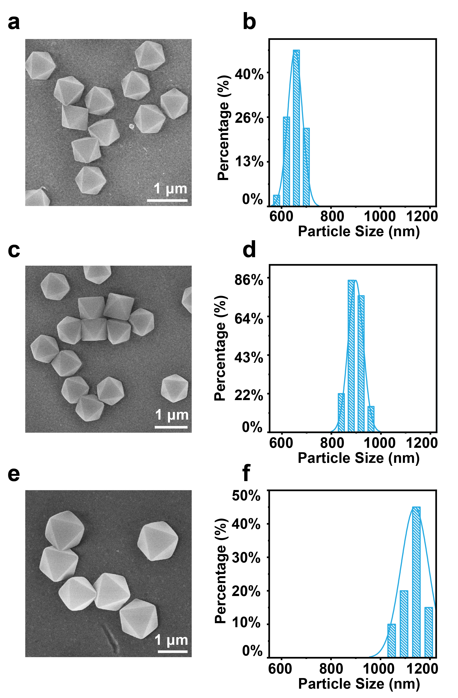
Supplementary Fig. 1. SEM images and the corresponding size distribution of UiO-66 octahedra prepared at different temperatures. (a and b) 125 ºC. (c and d) 120 ºC. (e and f) 115 ºC.

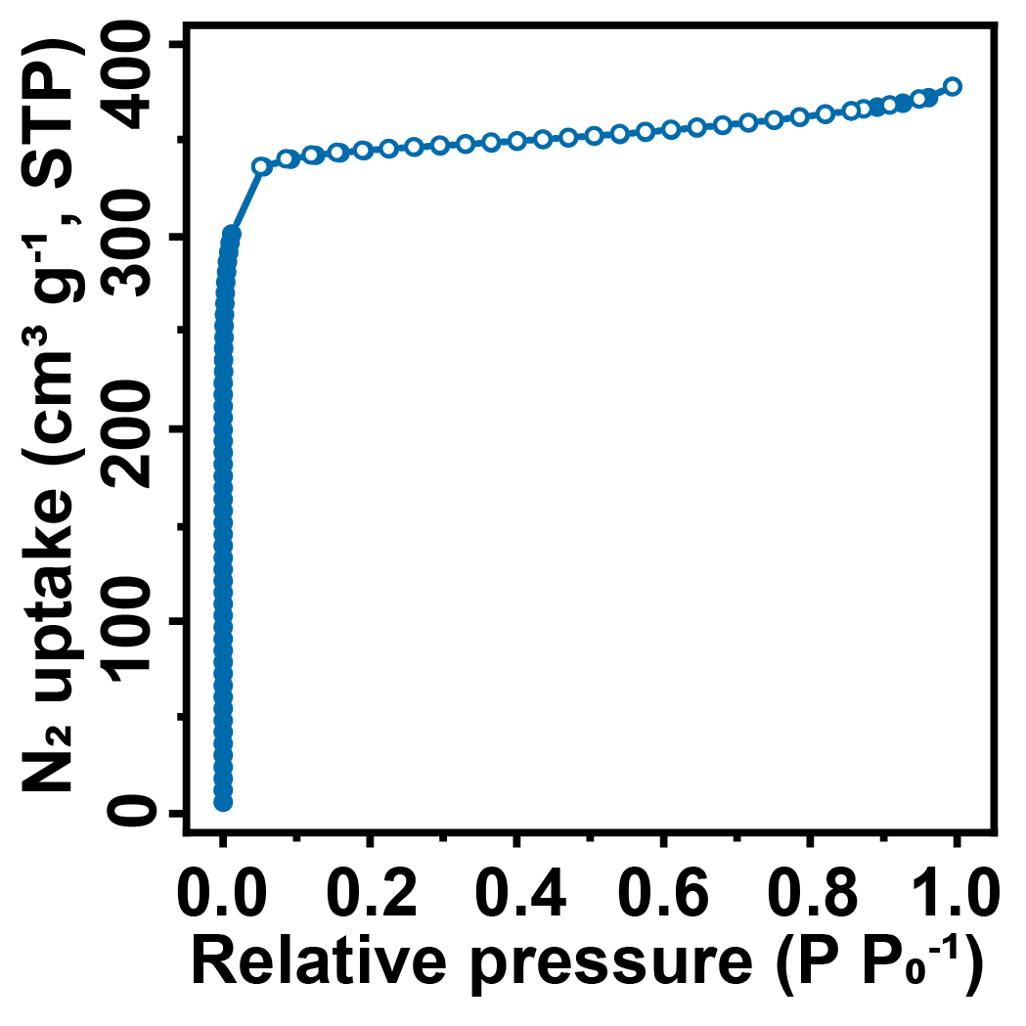
Supplementary Fig. 2. N₂ adsorption isotherms of UiO-66 octahedra at 77 K. The solid and empty symbols represent the adsorption and the desorption process.

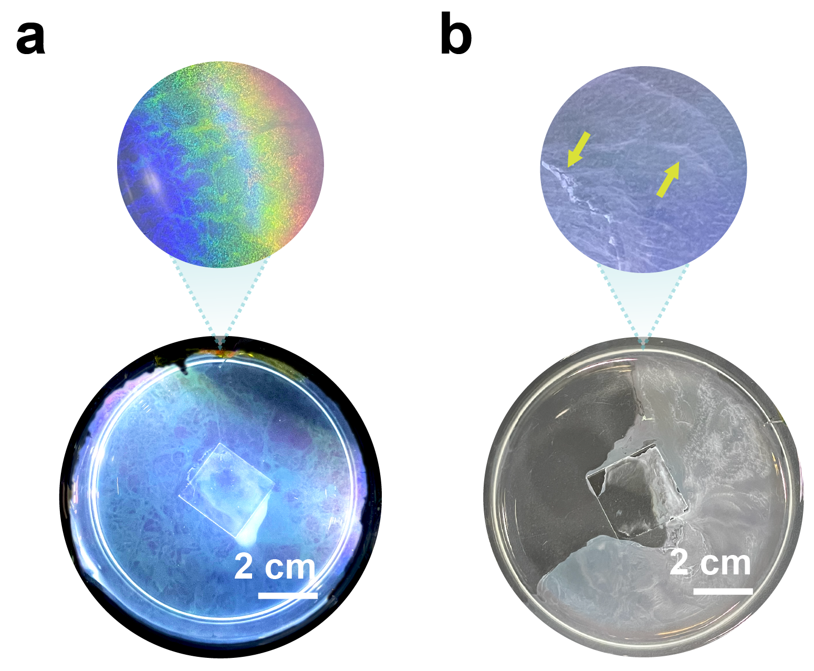
Supplementary Fig. 3. UiO-66 octahedra formed monolayer without and with defects. (a) The assembled monolayer of UiO-66 octahedra without defects. (b) The assembled monolayer of UiO-66 octahedra with defects. Yellow arrows pointed areas formed by multiple layers of UiO-66 octahedra.

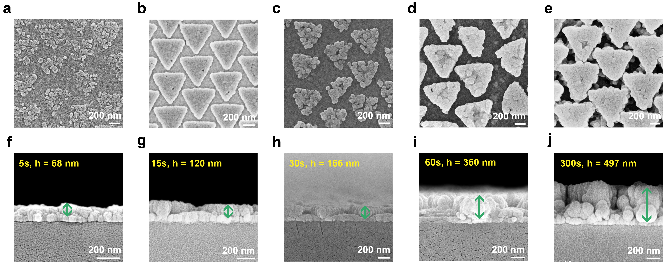
Supplementary Fig. 4. Morphology and thickness evolution of the Ag nanotriangles as electrodeposition proceeded. (a to e) 5 s, 15 s, 30 s, 60 s, and 300 s, respectively. (f to j) The corresponding cross-sectional view of the silver nanotriangle arrays. Electrodeposition was performed in the electrolyte composed of 300 mM AgNO₃ and 14 mM SDS.

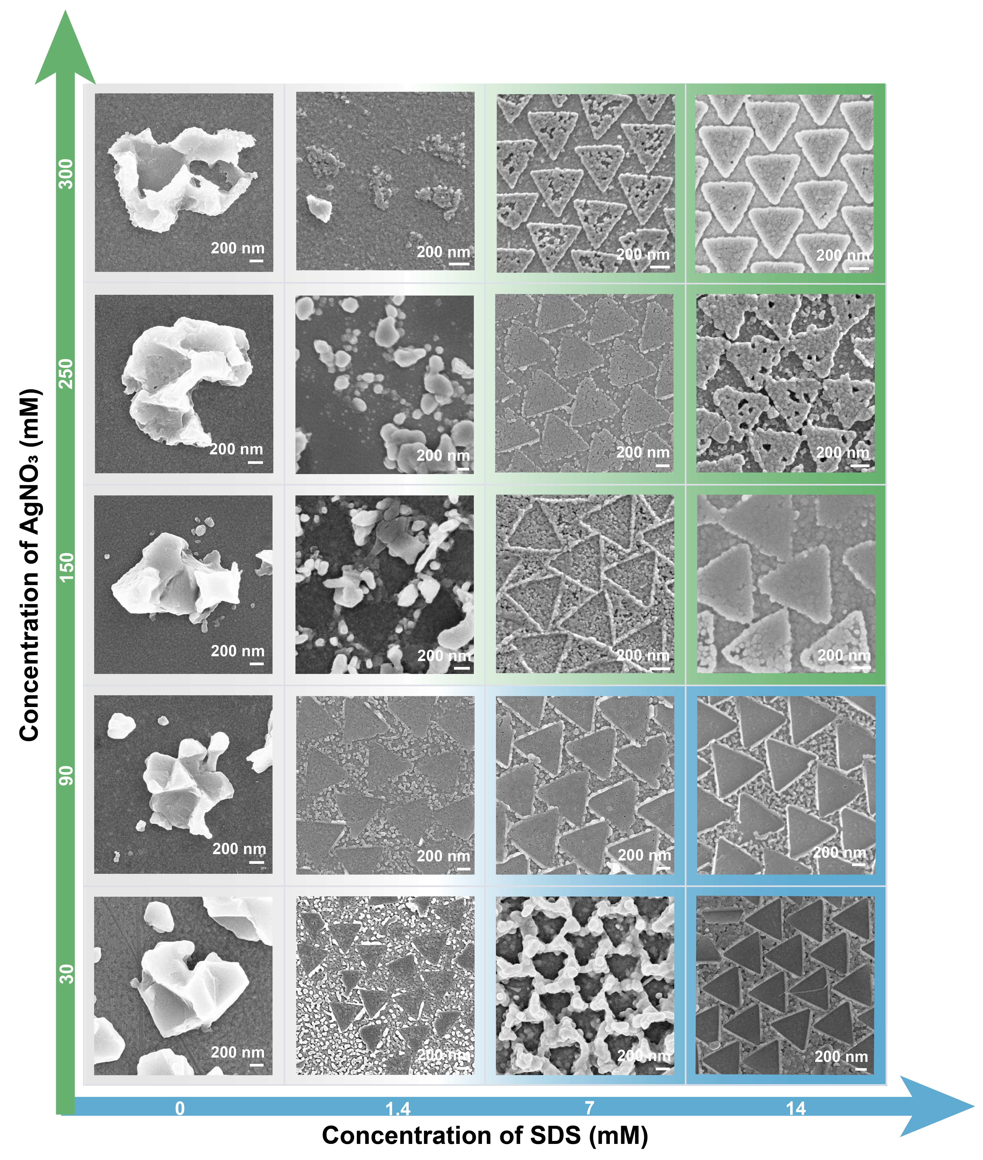
Supplementary Fig. 5. SEM images of Ag nanostructures obtained at different concentrations of AgNO₃ and SDS. The electrodeposition was performed at -1.2 V for 15 s except for (C_{AgNO3}, C_{SDS}) = (30 mM, 7 mM), where the electrodeposition time was 60 s.

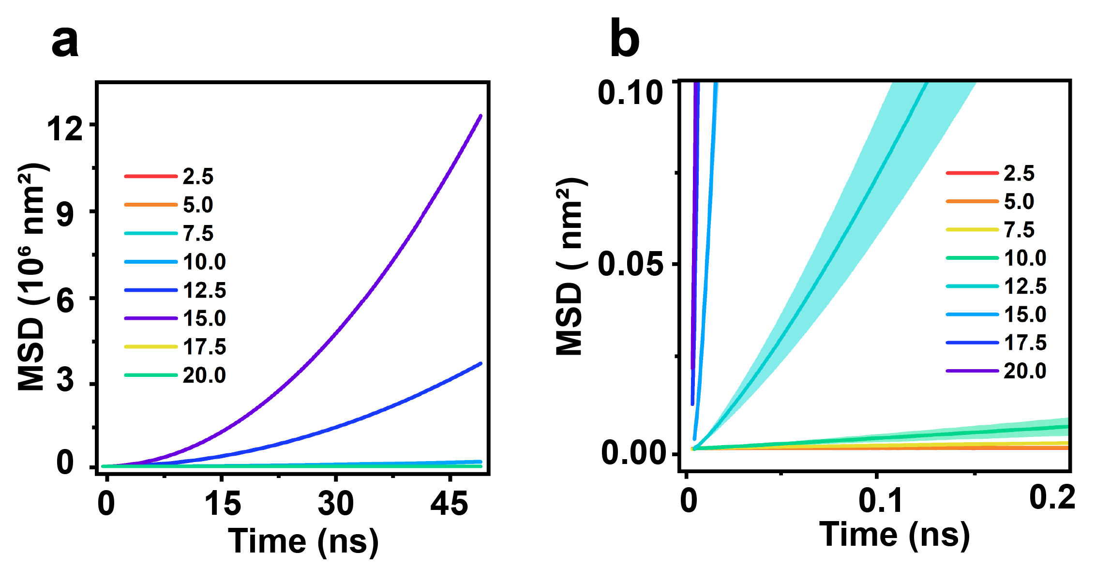
Supplementary Fig. 6. The calculated MSD. (a) Time evolution of the one-dimension MSD for silver ions in UiO-66 at different numbers of AgNO₃ per unit cell. (b) Enlarged observation in the first 0.2 ns.
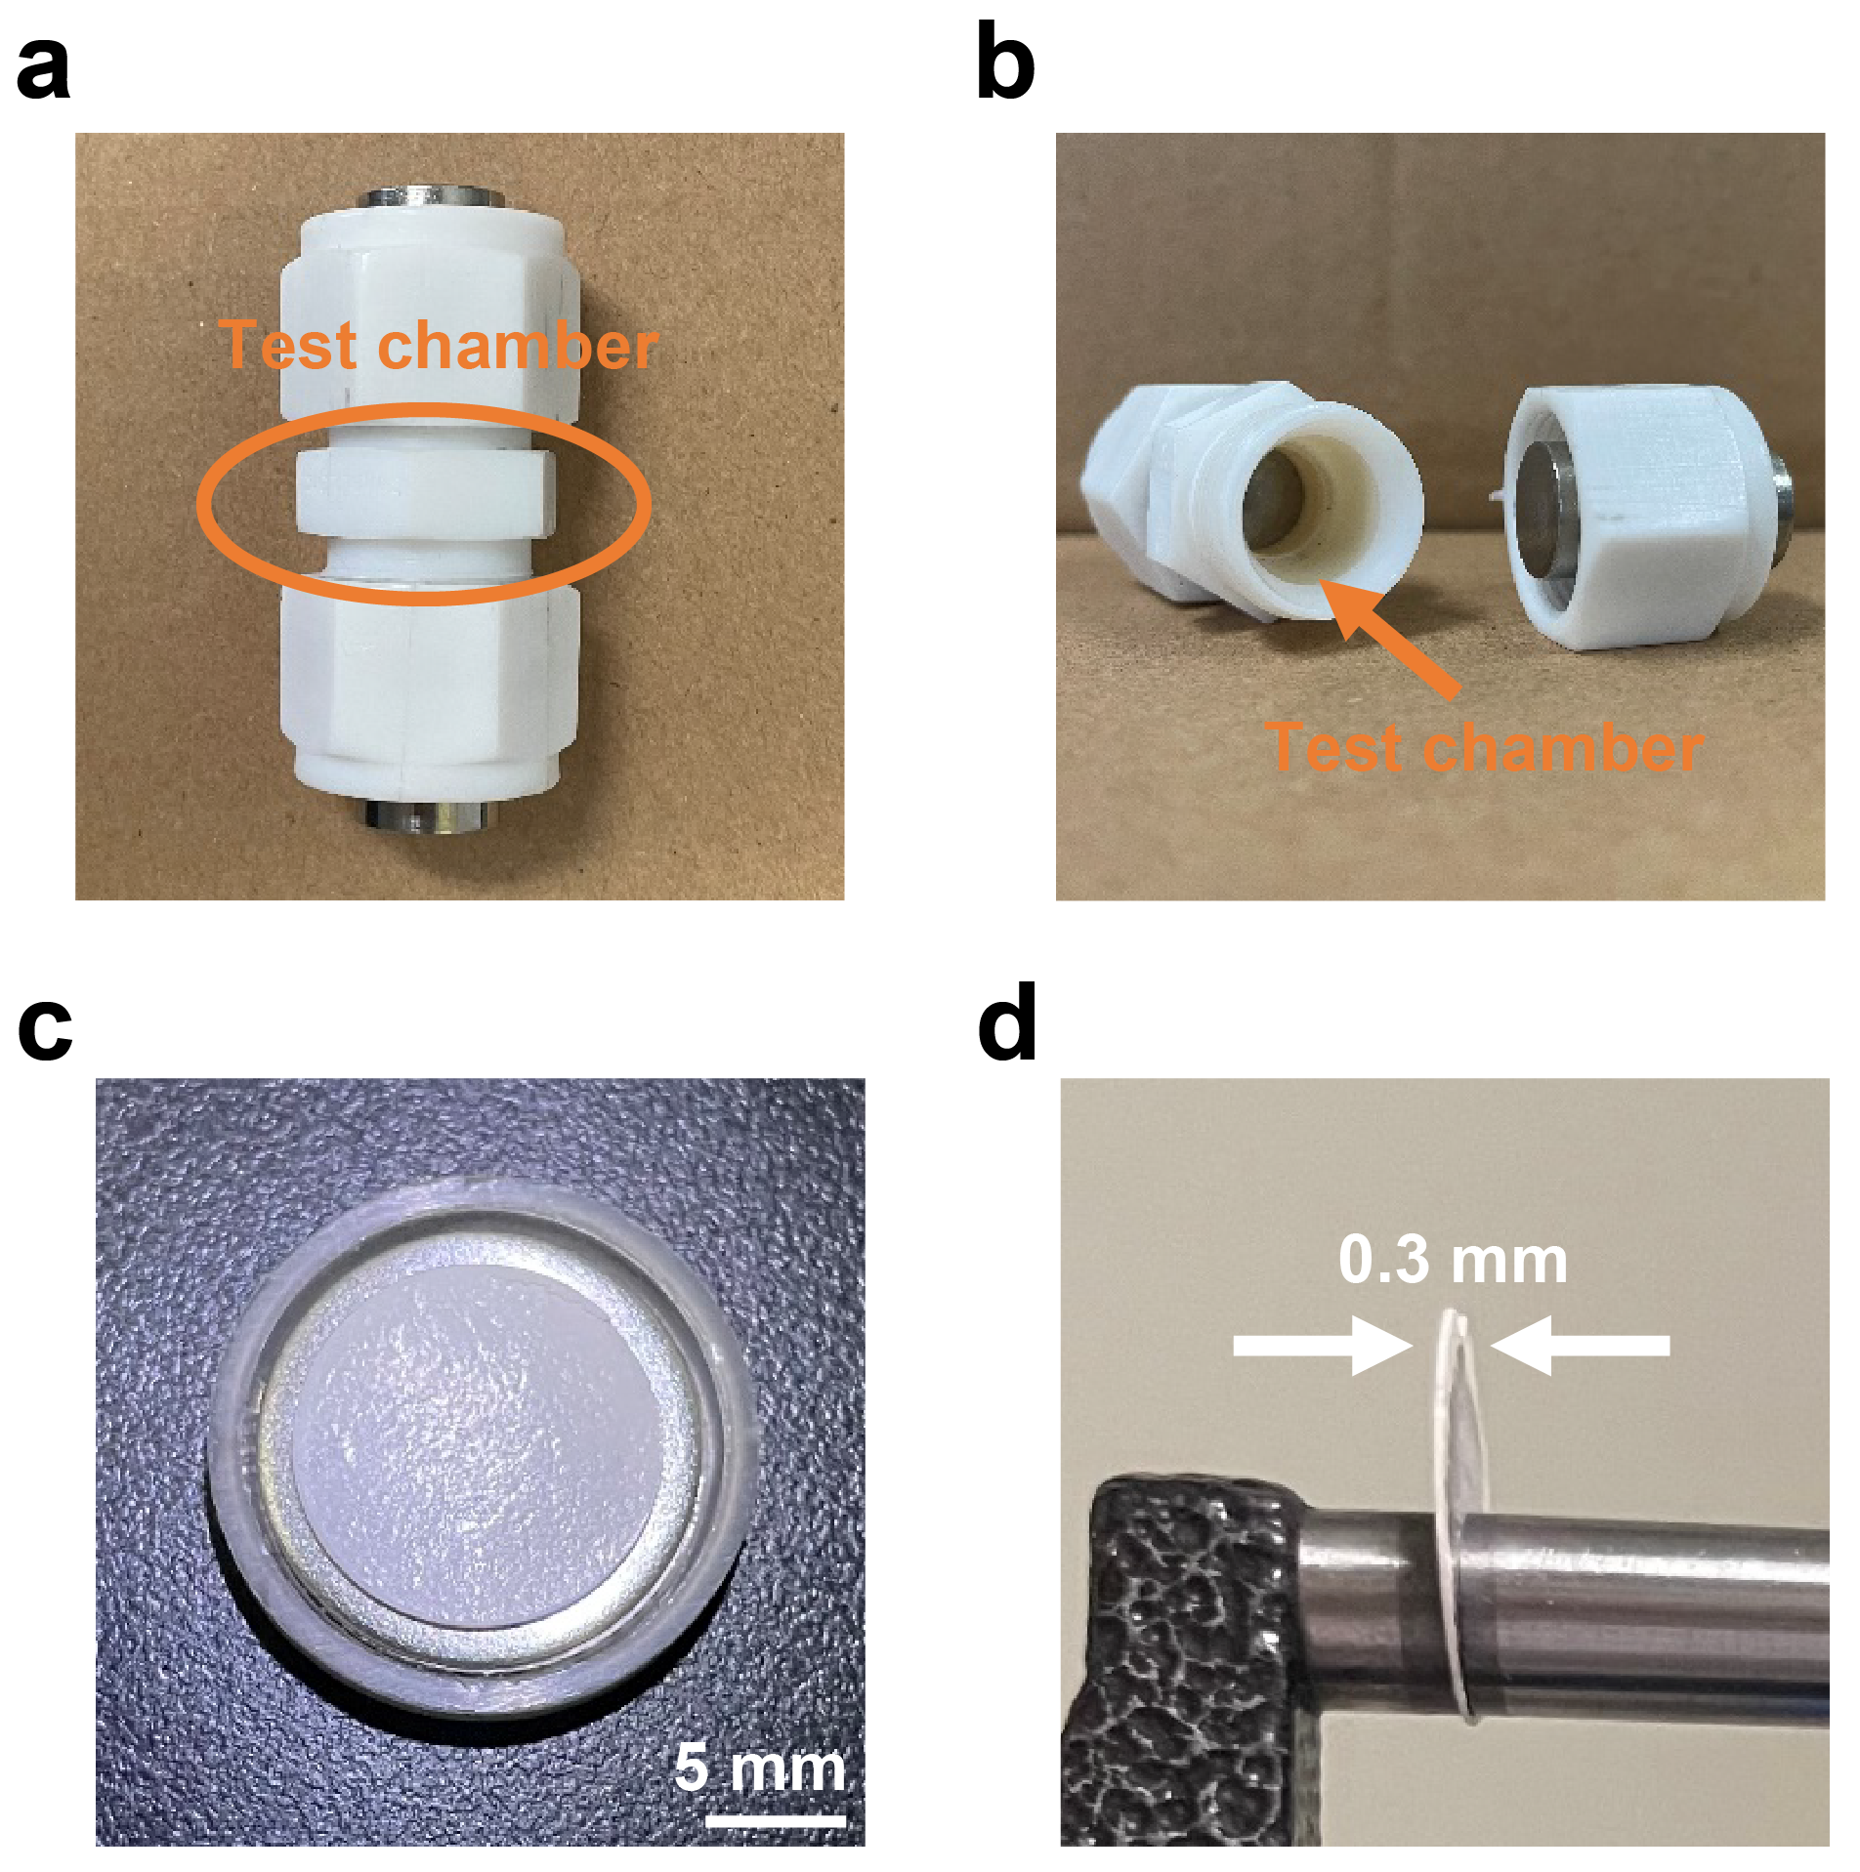
Supplementary Fig. 7. Equipment used for the electrochemical measurements. (a and b) The customized swagelok cell. The diameter and the thickness of the chamber were 0.73 cm and 0.51 cm, respectively. (c and d) The pressed UiO-66 octahedron pellet for EIS measurements. The diameter and the thickness of the pressed pellet were 0.65 cm and 0.03 cm, respectively.

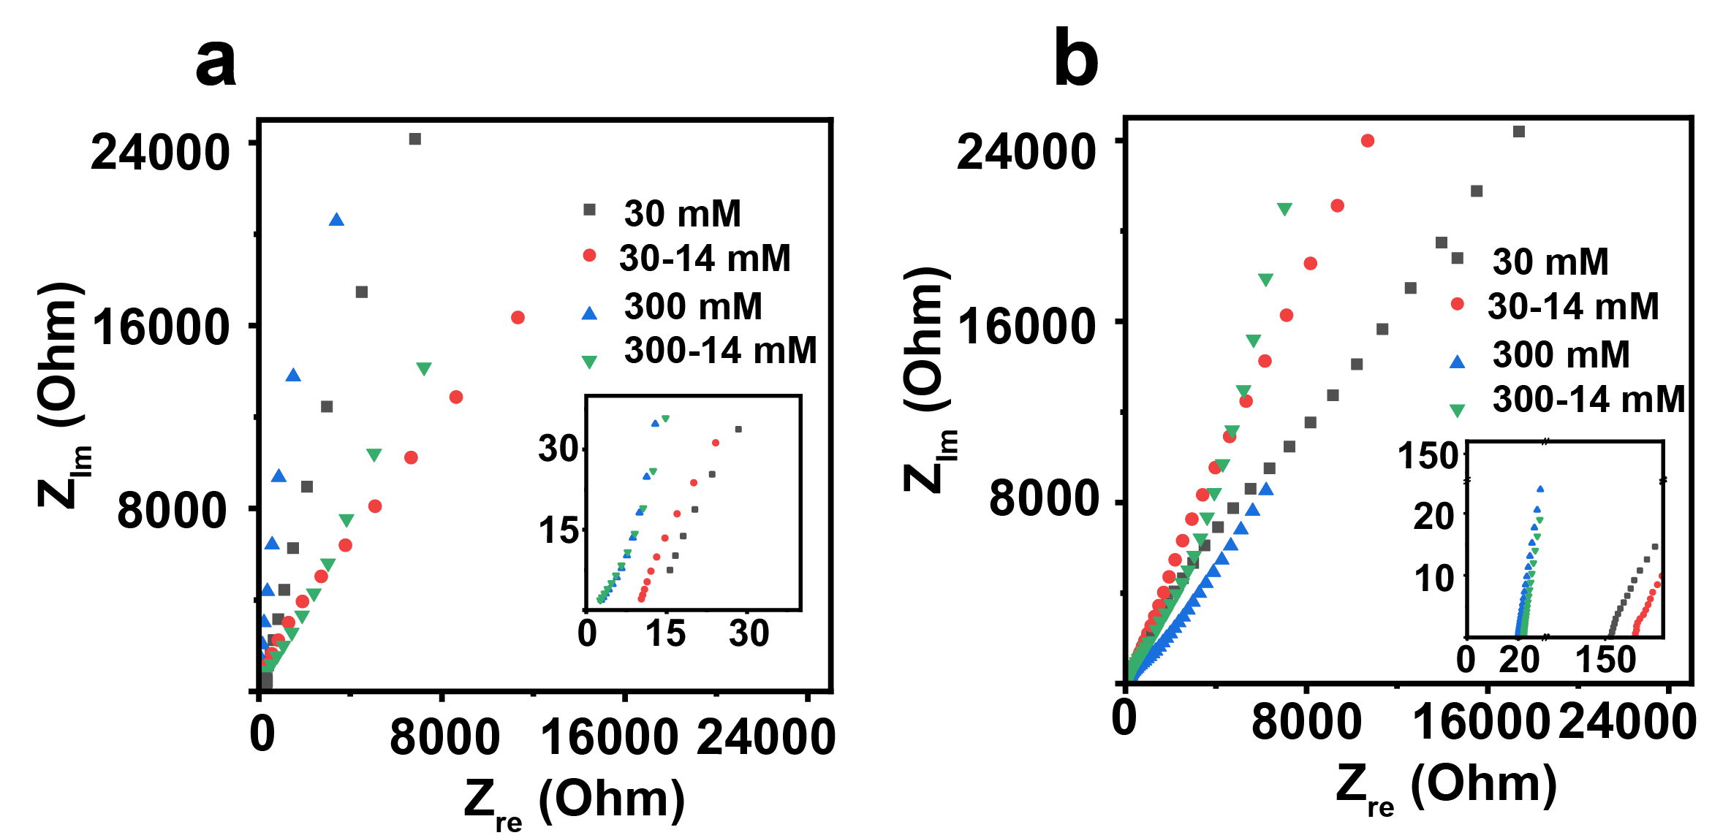
Supplementary Fig. 8. EIS plots of UiO-66 octahedron pallet and the electrolyte.
(a) UiO-66 octahedron pellet. (b) Electrolyte.
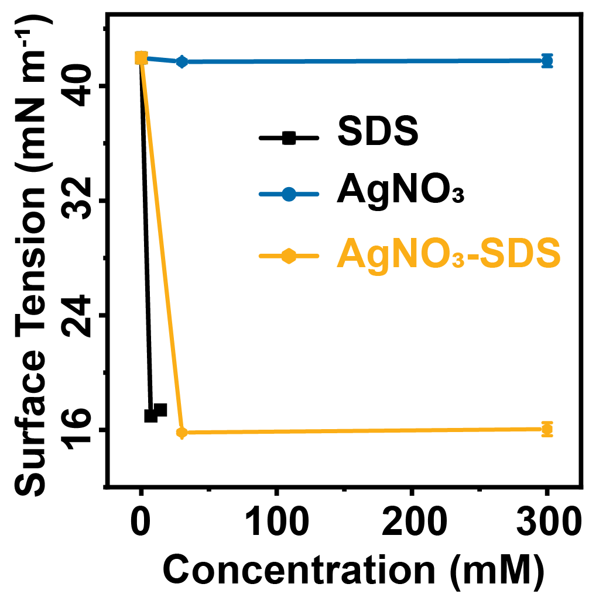
Supplementary Fig. 9. Surface tension of different solutions. Black curve: solutions composed of different concentrations of SDS. Blue curve: solutions composed of different concentrations of AgNO₃. Orange curve: solutions composed of SDS (concentration fixed at 14 mM) and different concentrations of AgNO₃.
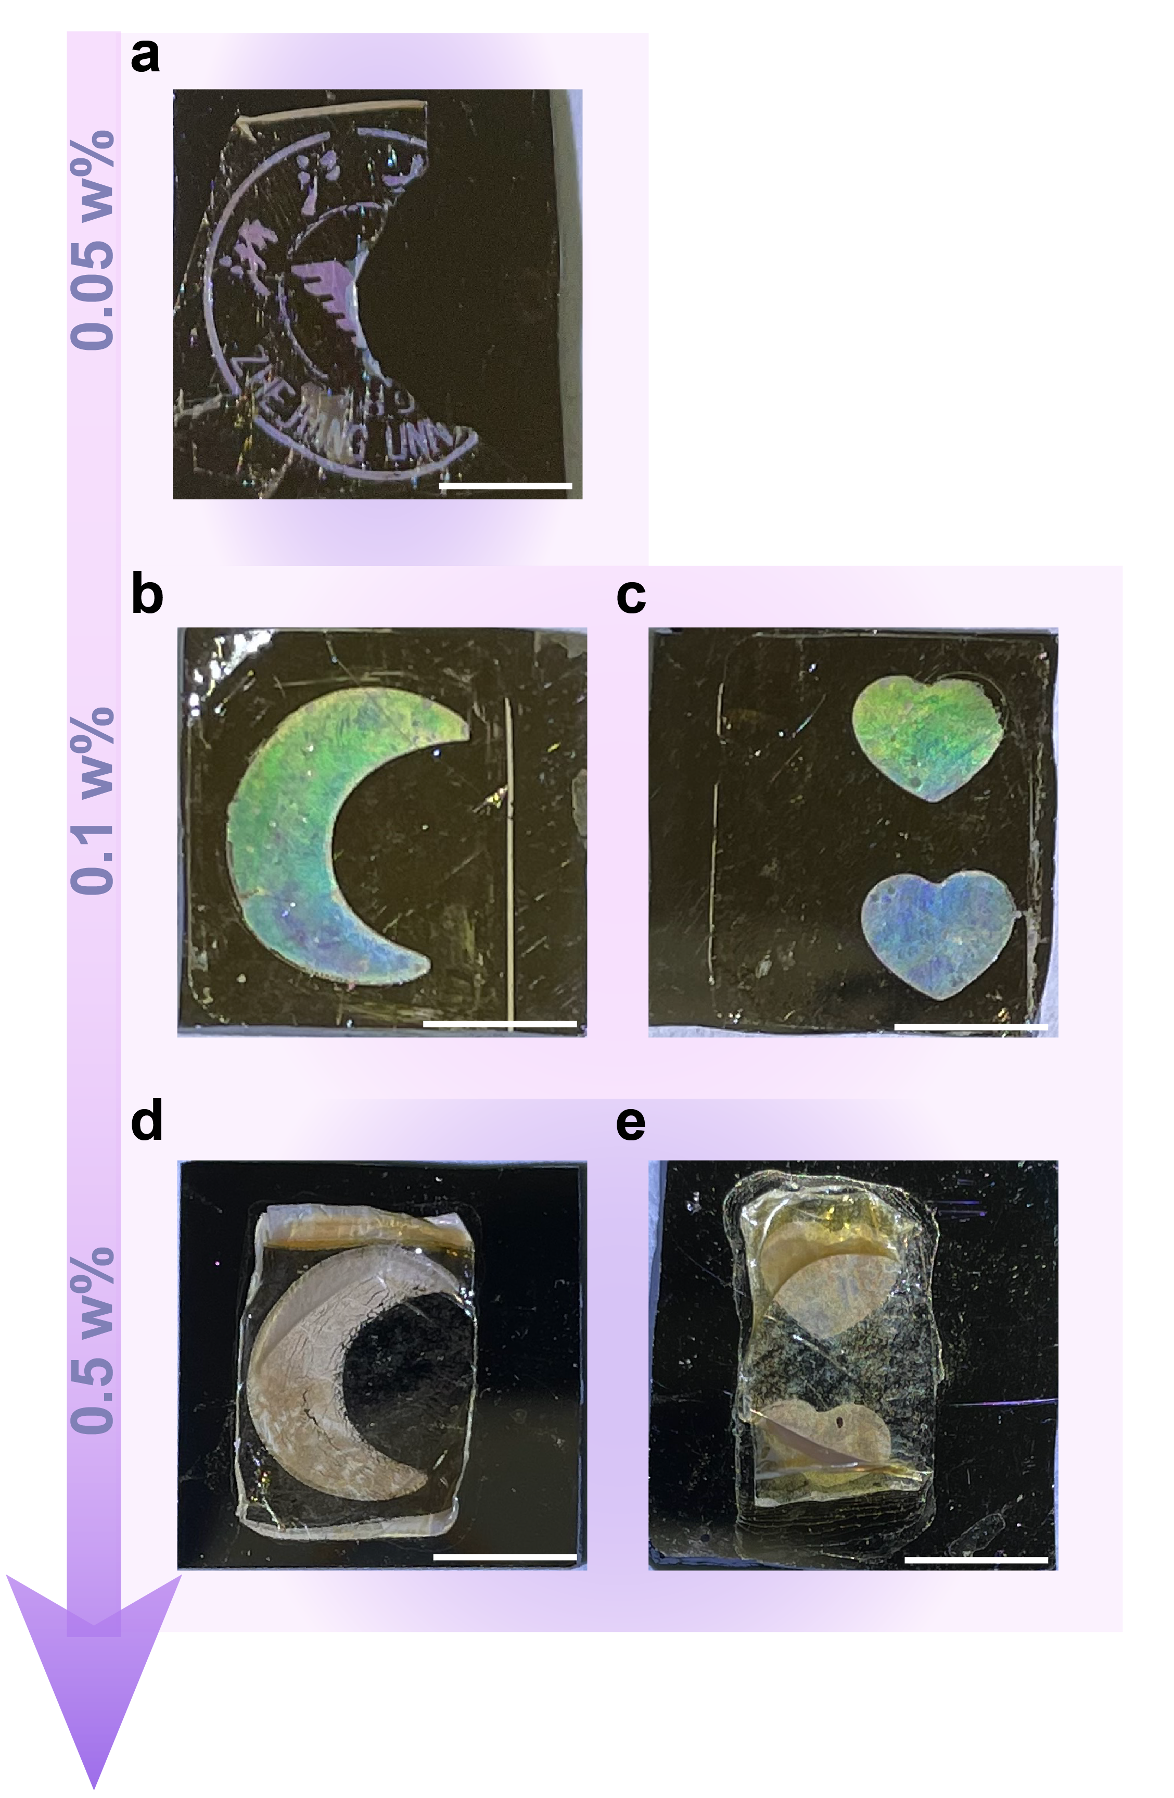
Supplementary Fig. 10. UiO-66@PBI composite film with different amounts of PBI. (a) The mass concentration of PBI was 0.05 wt.%. (b and c) The mass concentration of PBI was 0.1 wt.%. (d and e) The mass concentration of PBI was 0.5 wt.%. The mass concentration was the ratio of the mass of PBI to that of PBI and the solvent NMP. Scale bar: 5 mm.

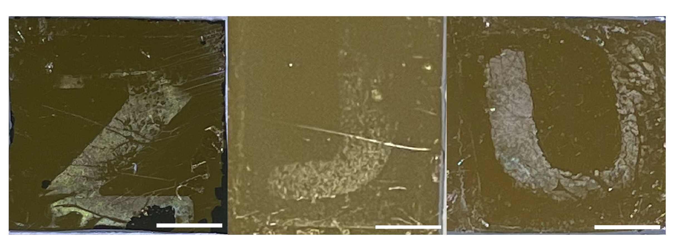
Supplementary Fig. 11. Electrodeposited letters using the UiO-66@PBI template. The letters were formed by Ag nanotriangles. Scale bar: 5 mm.
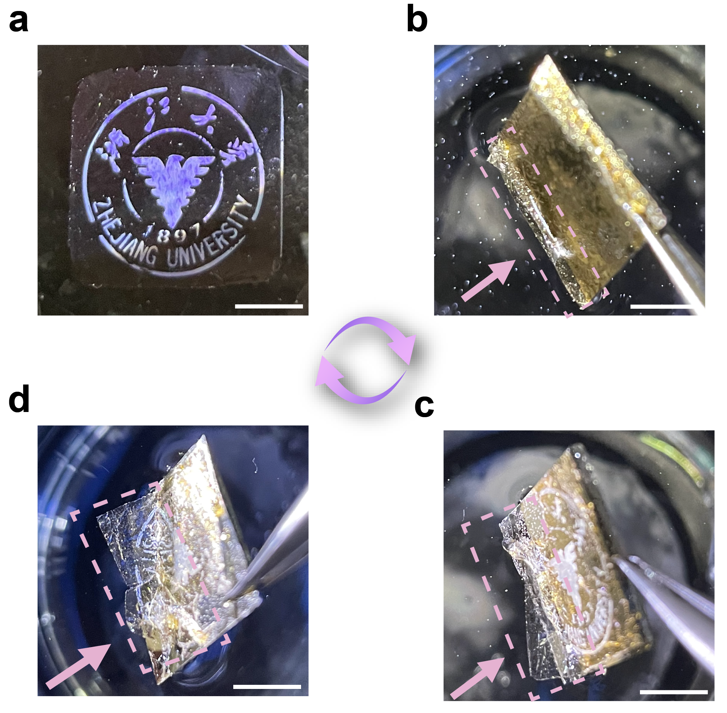
Supplementary Fig. 12. Peeling off the UiO-66@PBI template from the electrodeposited Ag nanotriangle array. (a) UiO-66@PBI template floated at the water surface. (b) Immersing the UiO-66@PBI template after Ag electrodeposition into ethanol and water in sequence. (c) The UiO-66@PBI template started to detach from the underneath Ag nanotriangles from the arrow pointed corner. (d) The UiO-66@PBI template was almost detached from the underneath Ag nanotriangles (see the arrow pointed area). Scale bar: 5 mm.

