Identification, Isolation, and Structural Characterization of Novel Forced Degradation Products of Ertugliflozin using Advanced Analytical Techniques UPLC-MS, PREP-HPLC, HRMS, FT-IR, and 2D-NMR.
Suresh Salakolusu^{a,b}, Ganapavarapu Veera Raghava Sharma^{b*}, Naresh Kumar Katari^{c*}, Muralidharan Kaliyaperumal ª, Umamaheshwar Puppalaª, Mahesh Rangaª.

Analytical data for Ertugliflozin API:

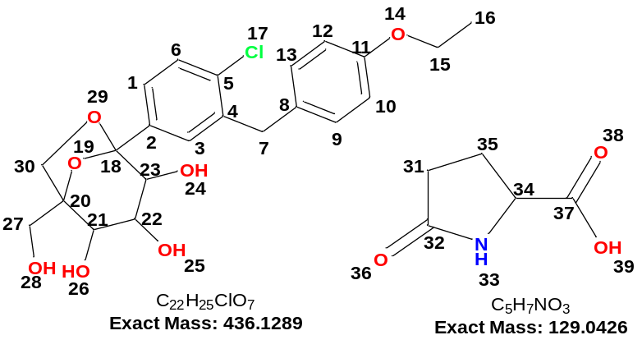

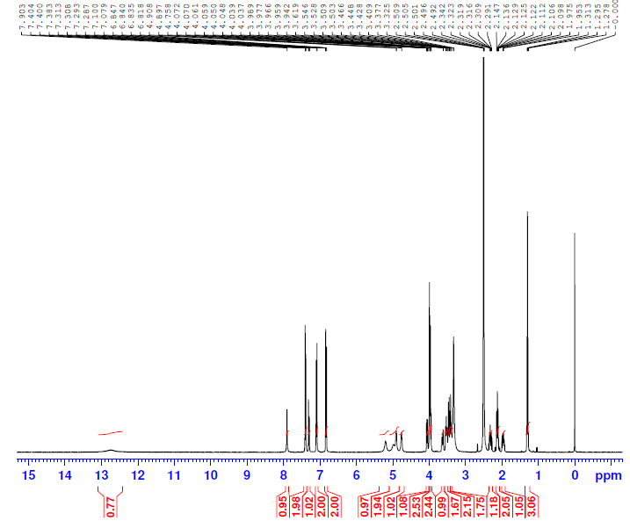
ERG- API ¹H NMR 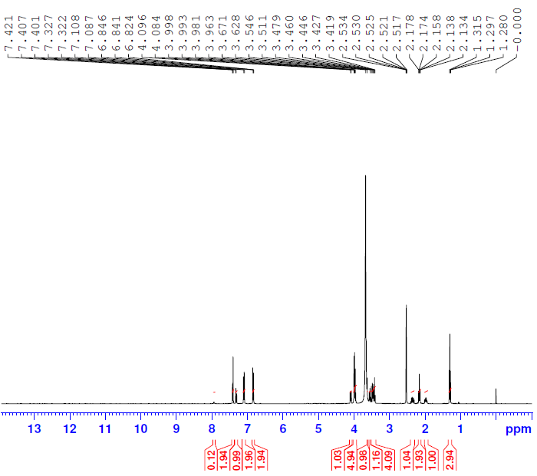
ERG-DP-05 ¹H NMR-1-D₂O
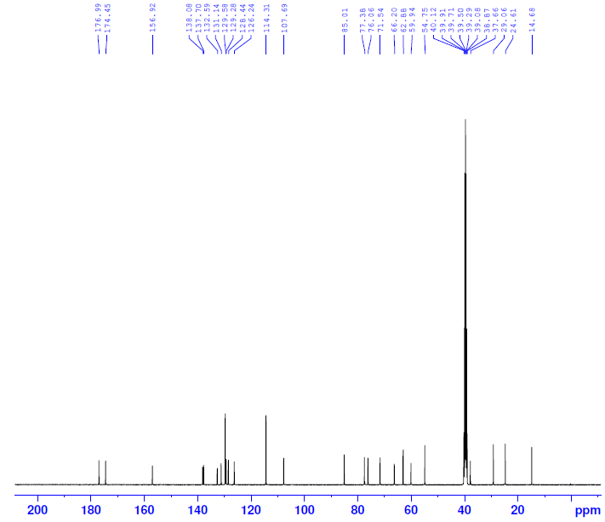
ERG- API ¹³C NMR
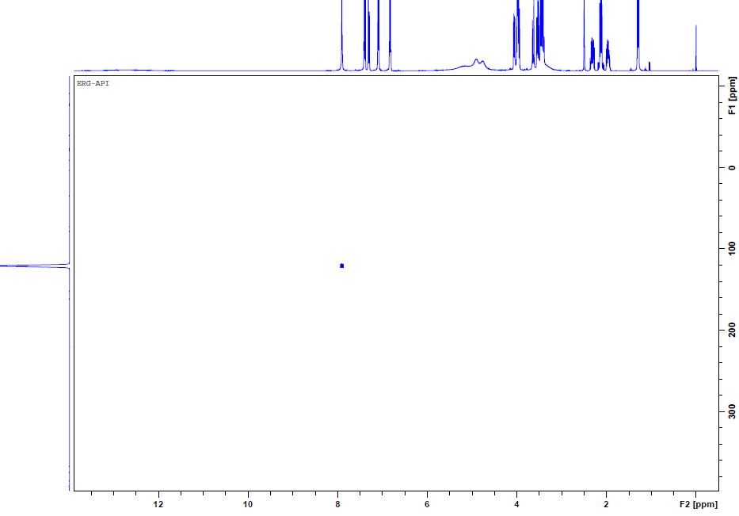
ERG- API ¹⁵N HSQC NMR
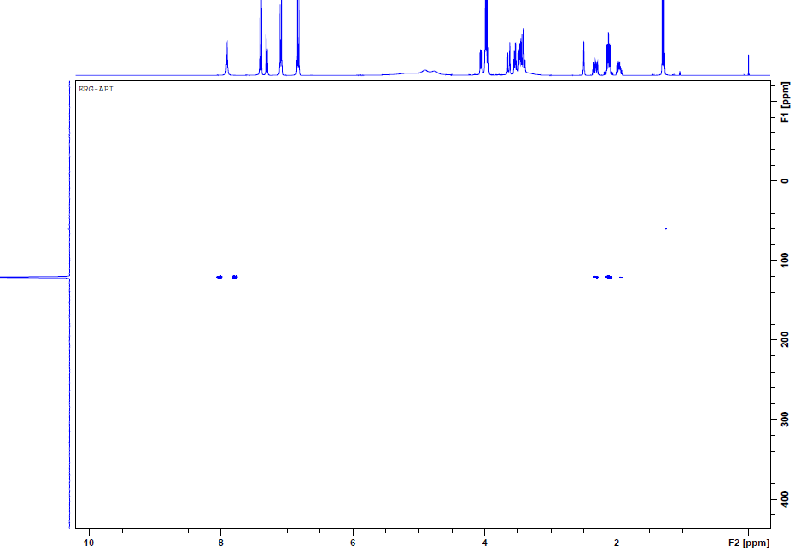
ERG- API ¹⁵N HMBC NMR-1
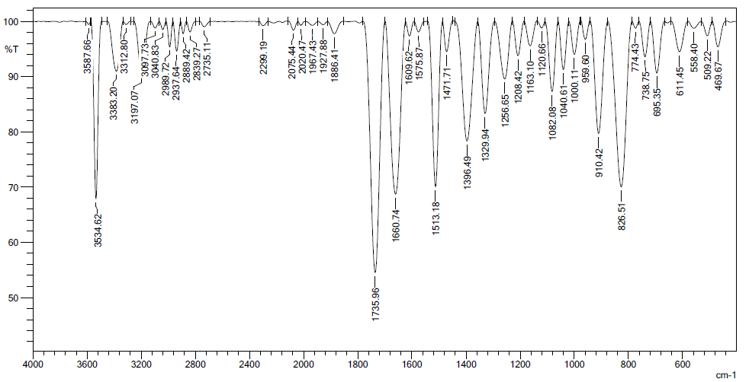
ERG- API -IR

