Identification, Isolation, and Structural Characterization of Novel Forced Degradation Products of Ertugliflozin using Advanced Analytical Techniques UPLC-MS, PREP-HPLC, HRMS, FT-IR, and 2D-NMR.
Suresh Salakolusu^{a,b}, Ganapavarapu Veera Raghava Sharma^{b*}, Naresh Kumar Katari^{c*}, Muralidharan Kaliyaperumal ª, Umamaheshwar Puppalaª, Mahesh Rangaª.

Analytical data for Ertugliflozin degradation product-4:
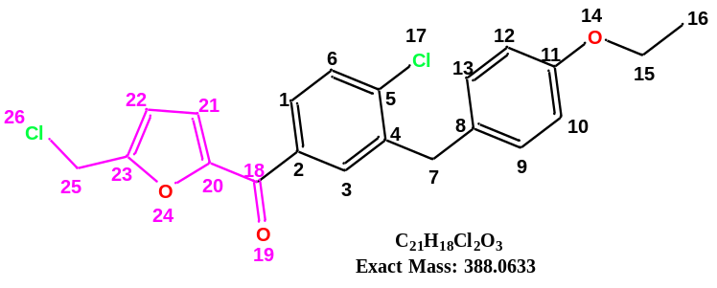

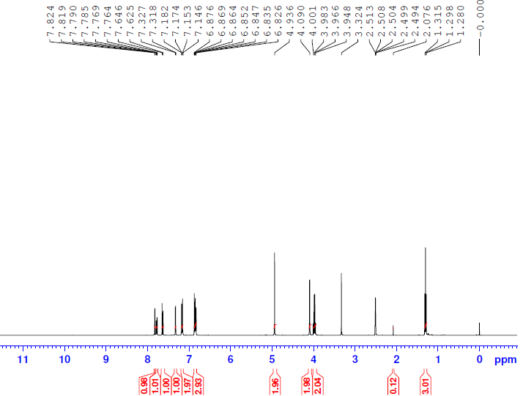
ERG-DP-04 ¹H NMR
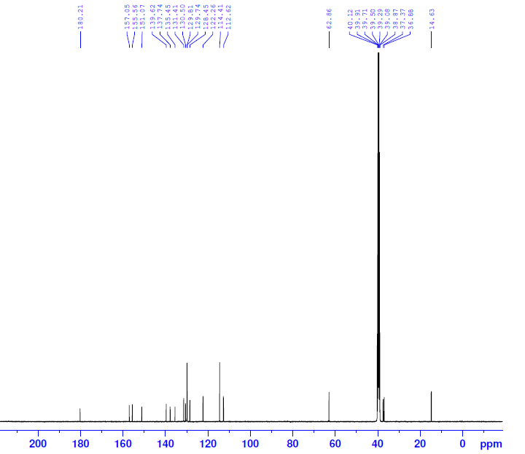
ERG-DP-04 ¹³C NMR
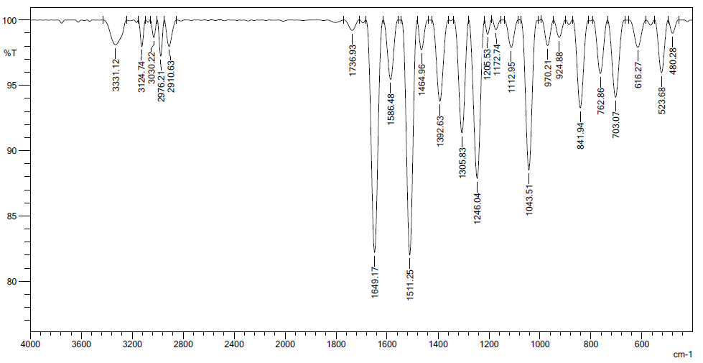
ERG-DP-04-IR

