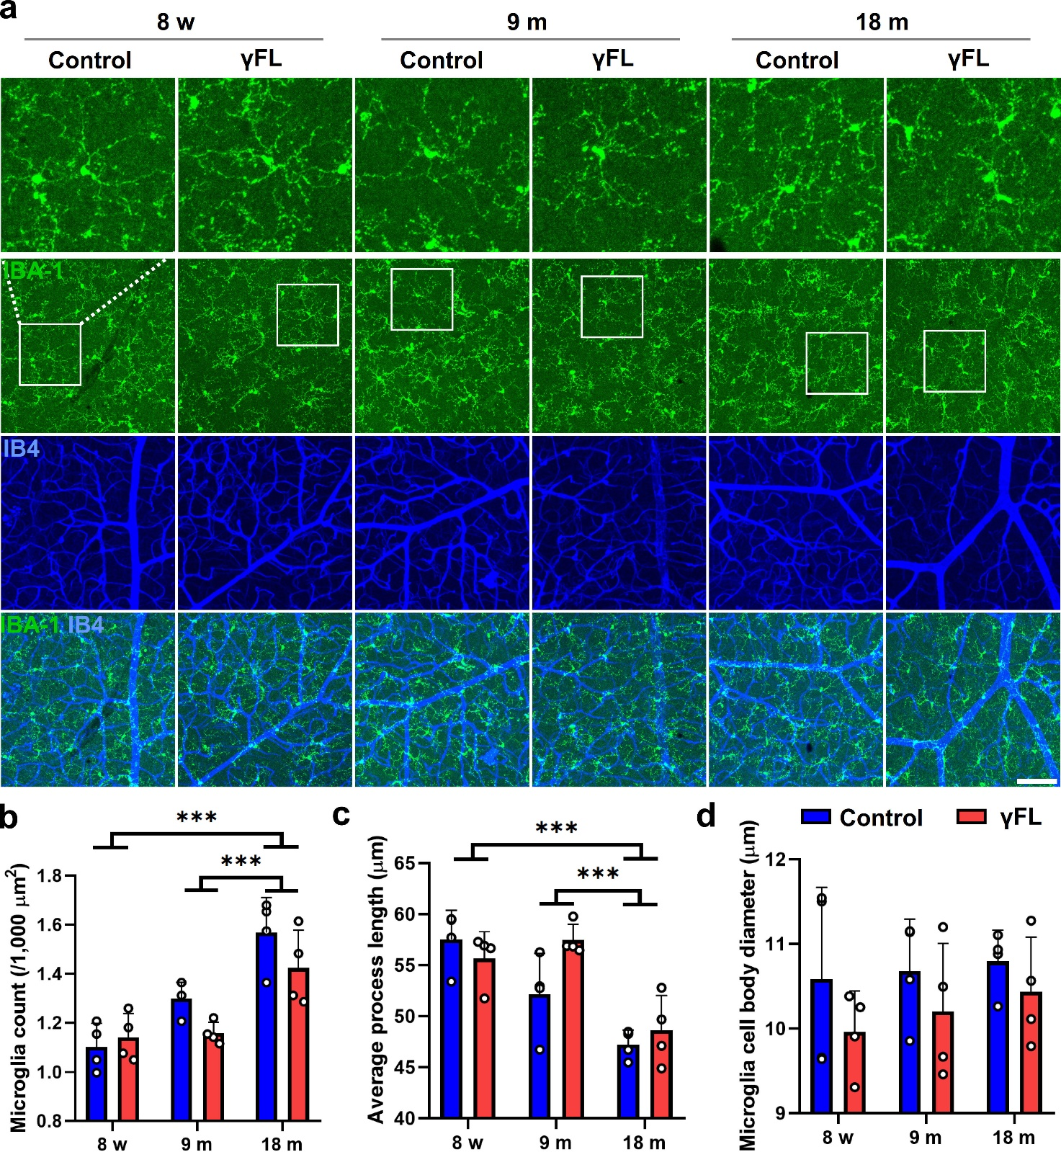

Fig. S1 Morphological structure changes of retinal superficial- and middle- layer microglia in mice aged 8 w, 9 m, and 18 m following γFL treatment. a Immunofluorescence of anti-IBA-1 antibody (green). The blood vessels were stained with IB4 (blue). The scale bar is 100 μm. b Microglia count. c Average process length d Microglia cell body diameter. Data are shown as the mean ± SD (n = 4 per group, two-way ANOVA with Turkey HSD test, ***P < 0.001).
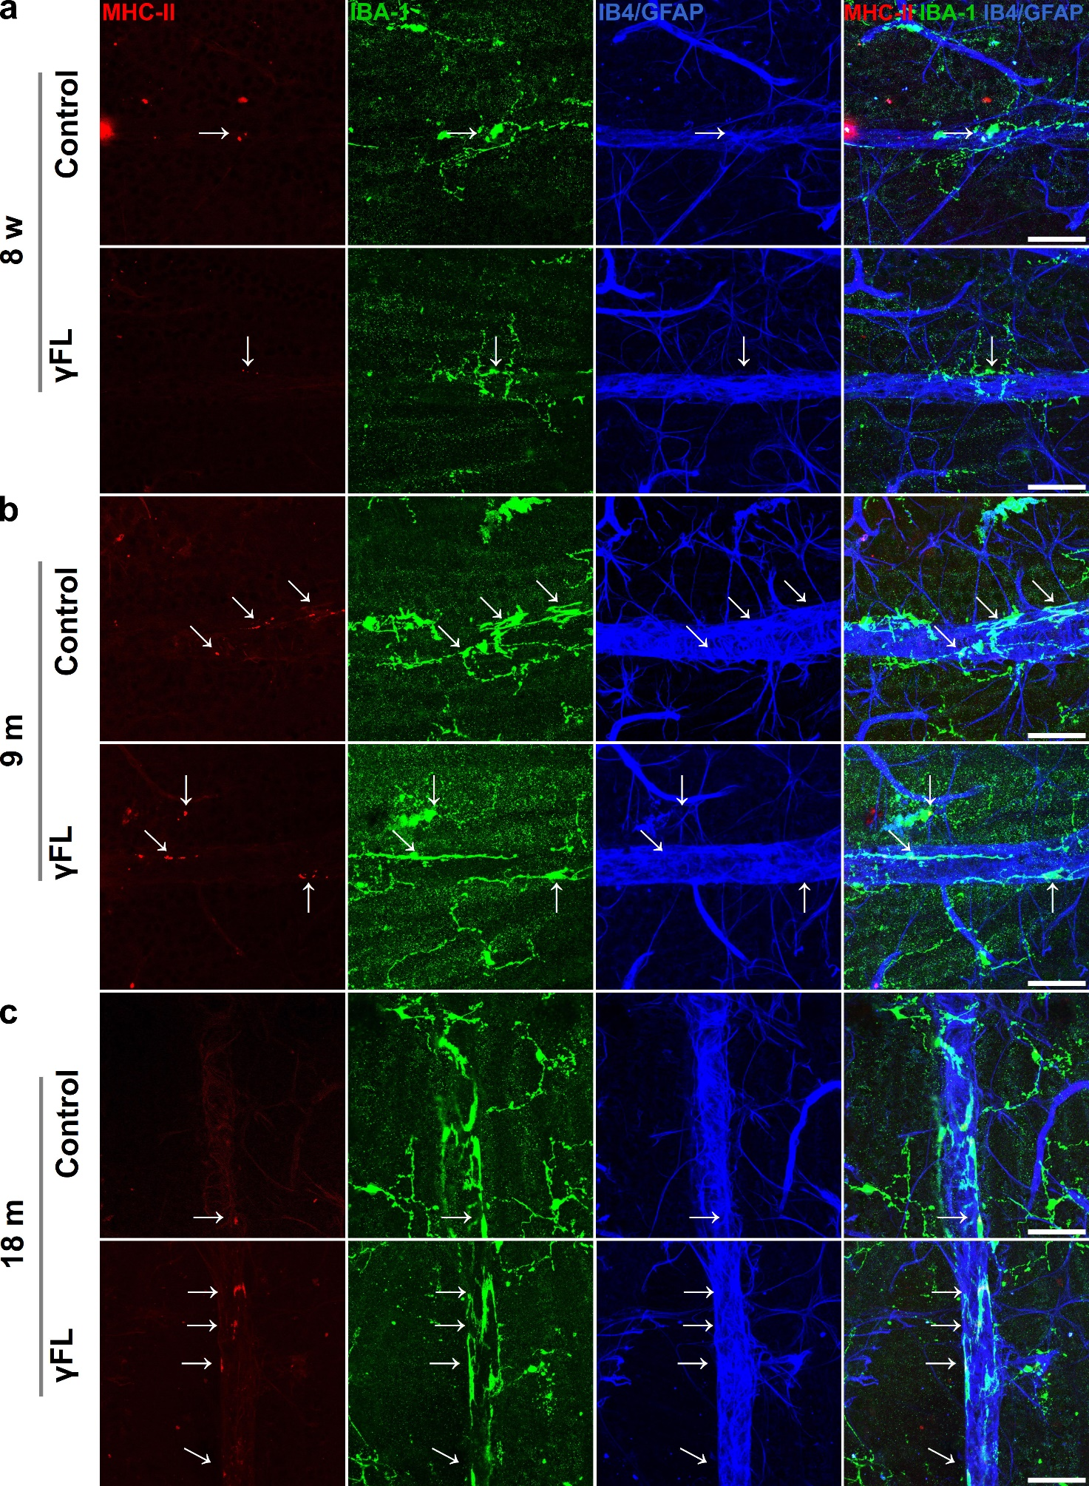

Fig. S2 Co-location of MHC-II positive dots with microglia around retinal veins in mice aged 8 w, 9 m, and 18 m following γFLor control light treatment. a Immunostaining of anti-MHC-II (red) and anti-IBA-1 (green) in the retinal flat-mount of 8-week-old mice. The blood vessels were stained with IB4 and anti-GFAP antibody (blue). The arrows mark the MHC-II positive spots. The scale bars are 50 μm. The whole retinal flat-mounts are showed in Fig. S3. b Same as (a) for 9-month-old mice. The whole retinal flat-mounts are showed in Fig. S4. c Same as (a) for 18-month-old mice. The whole retinal flat-mounts are showed in Fig. 4.

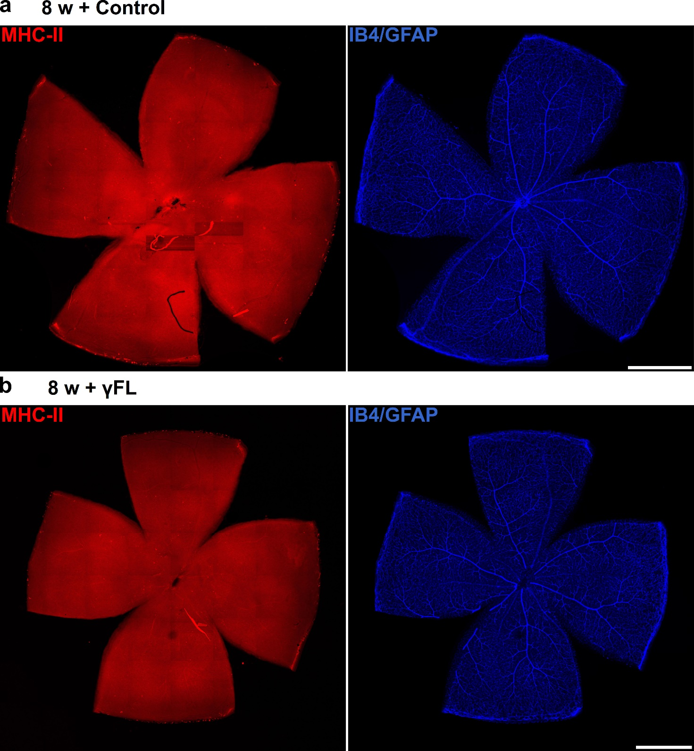

Fig. S3 Expression of MHC-II in the retinal whole flat-mount of 8-week-old mice after γFL. Red, MHC-II; blue, IB4 and GFAP. Scar bar, 1,000 μm.

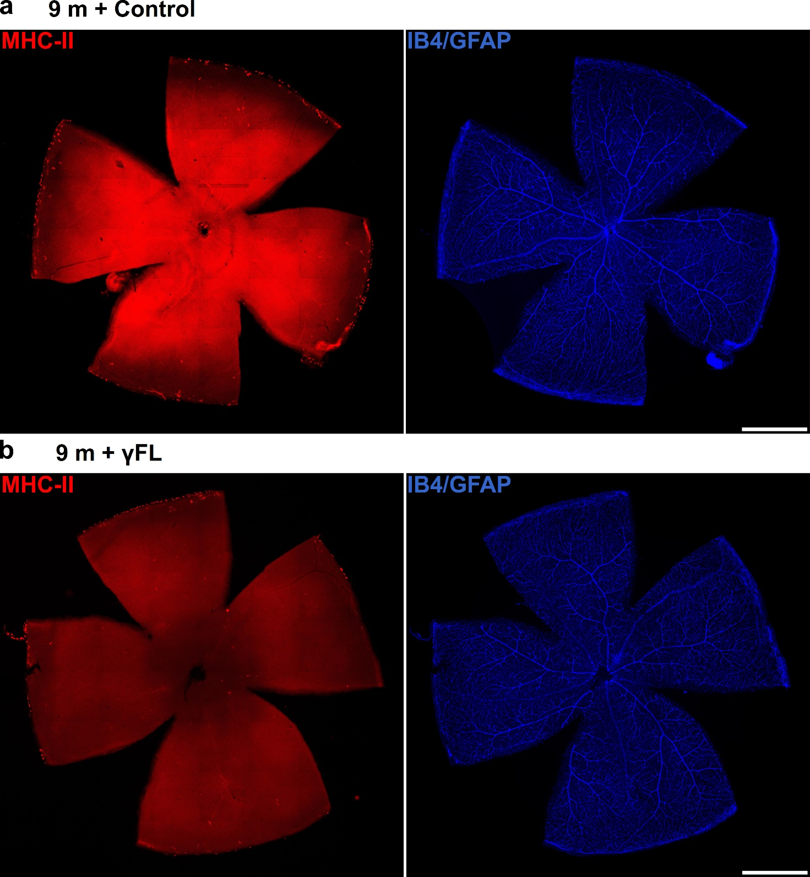
Fig. S4 Expression of MHC-II in the retinal whole flat-mount of 9-month-old mice after γFL. Red, MHC-II; blue, IB4 and GFAP. Scar bar, 1,000 μm.

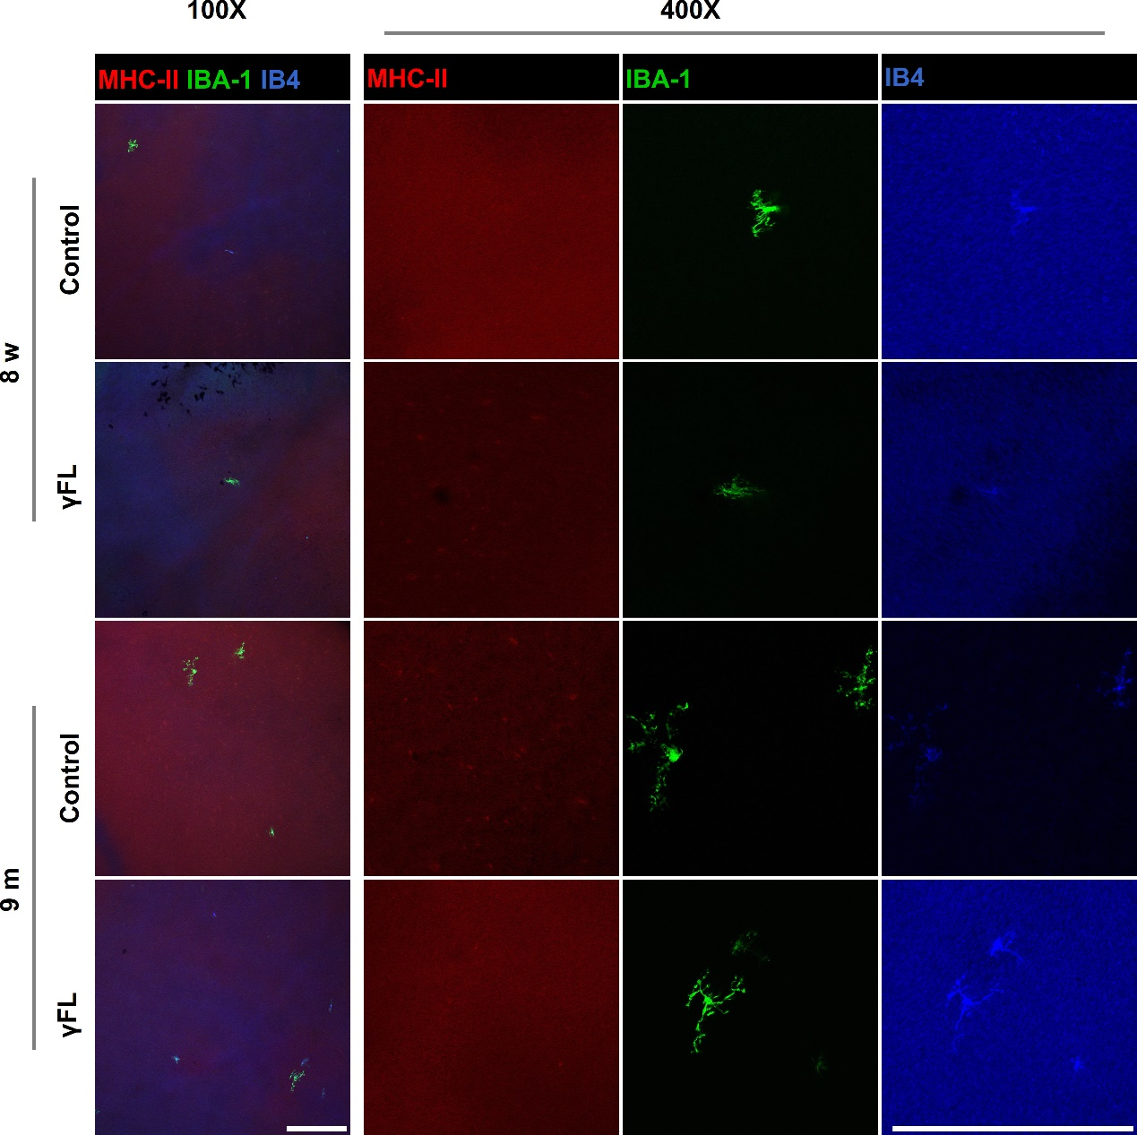

Fig. S5 Sub-retinal microglia changes of mice aged 8 w and 9 m following γFL treatment. Red, MHC-II; green, IBA-1; blue, IB4. Scar bar, 200 μm.

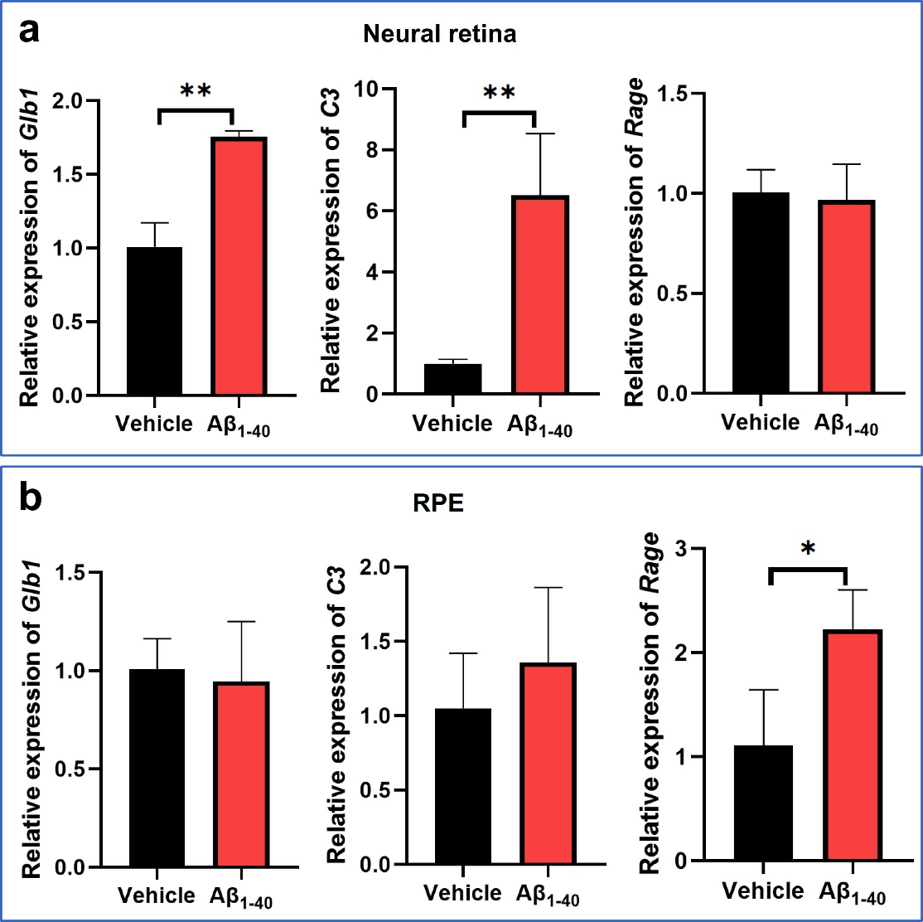

Fig. S6 Expression of Glb1, C3, and Rage in the neural retina and RPE on day 3 post intravitreal injection of Aβ. Data are shown as the mean ± SD (n = 3 per group, unpaired t test, *P < 0.05, **P < 0.01).

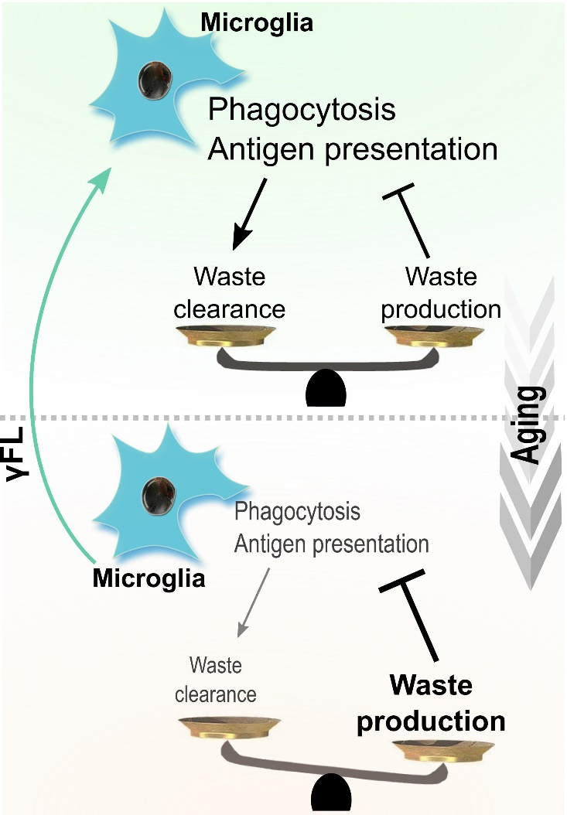

Fig. S7 A possible mechanism where γFL treatment regulates retinal microglia phagocytosis and MHC-II antigen presentation during aging. With aging, the increase of aging-related antigens and the decrease of microglia clearance ability formed a slow cycle with each other. However, the intervention of γFL modulates the microglia and enhances the phagocytosis and presentation of aging-related proteins, inducing a compensation for the clearance ability of microglia, thus interrupting the vicious cycle between aging waste accumulation and microglia inhibition.

