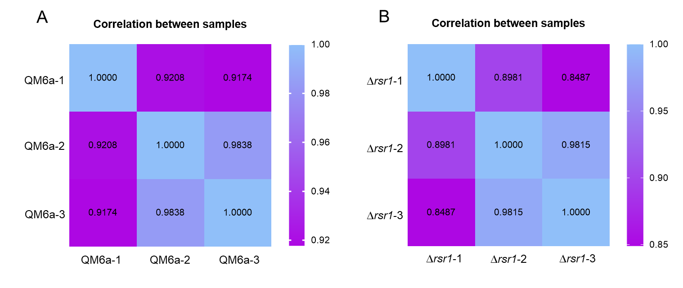
Figure S4. The correlation between the biological replicates of each sample. The following heat map is used to show the correlation. Each value in the grid is the correlation coefficient between two samples. The larger the value, the greater the correlation between the two samples and the closer they are. These results indicate that the transcriptome data is more credible.

