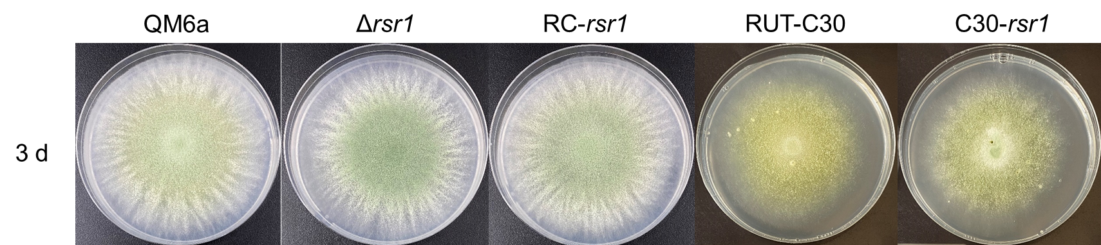
Figure S2. The effect of rsr1 on hyphal growth of T. reesei strains. Five strains (QM6a, Δrsr1, RC-rsr1, RUT-C30 and C30-rsr1) were cultured on PDA with 2% glucose at 28 °C in the dark and then photos were taken at 3 d.

