Table S1. The body weights of WT mice and APP/PS1 mice.
Days | WT | APP/PS1
Days | WT |  | FTS·B (mg/kg)
Days | WT |  | 10 | 40
1st | 42.9±2.5 | 43.6±2.3 | 43.7±1.5 | 42.6±3.6
7th | 43.4±3.3 | 43.3±3.2 | 44.1±4.2 | 41.2±3.5
14th | 42.9±3.2 | 43.7±1.9 | 43.7±3.8 | 41.7±4.2
21st | 42.2±2.9 | 43.1±3.7 | 44.2±4.3 | 41.7±4.2
28th | 43±5.9 | 43.5±3.5 | 44.1±6.1 | 43.4±1.1
Data are expressed as the mean ± S.D. (n=8).

Table S2. Details of the significantly up- or down-regulated proteins by FTS·B among experimental groups.
Symbol | Unique.  peptides | fc..APP/PS1  -WT | fc.. FTS·B  - APP/PS1 | Symbol | Unique.  peptides | fc..APP/PS1  -WT | fc..FTS·B- APP/PS1
Upregulated proteins by FTS·B (Number: 16)
Tmsb4x | 4 | 0.01 | 235.26 | S100a1 | 4 | 0.40 | 2.47
Pfdn1 | 7 | 0.05 | 20.74 | Wdfy1 | 6 | 0.41 | 2.43
Actc1 | 3 | 0.10 | 12.26 | Stk32c | 4 | 0.60 | 1.14
Praf2 | 2 | 0.14 | 8.26 | Vti1b | 5 | 0.76 | 1.24
Ech1 | 3 | 0.20 | 4.79 | Slc39a10 | 4 | 0.76 | 1.27
Kcnj10 | 5 | 0.29 | 1.92 | Ampd2 | 7 | 0.84 | 1.17
Ddt | 4 | 0.36 | 2.77 | mCG_6739 | 2 | 0.93 | 1.12
Baiap3 | 2 | 0.38 | 3.17 | Jam3 | 4 | 0.96 | 1.22
Downregulated proteins by FTS·B (Number: 7)
C1qb | 3 | 1.46 | 0.70 | Mapk8ip3 | 4 | 5.07 | 0.29
Gria3 | 2 | 1.70 | 0.14 | Metap2 | 3 | 5.36 | 0.28
Erc1 | 4 | 1.86 | 0.27 | Arpp21 | 3 | 6.63 | 0.09
Safb | 3 | 4.18 | 0.17

Figure S1. Chemical structure of FTS·B.

Figure S2. The process of the drug administration and behavioral tests.

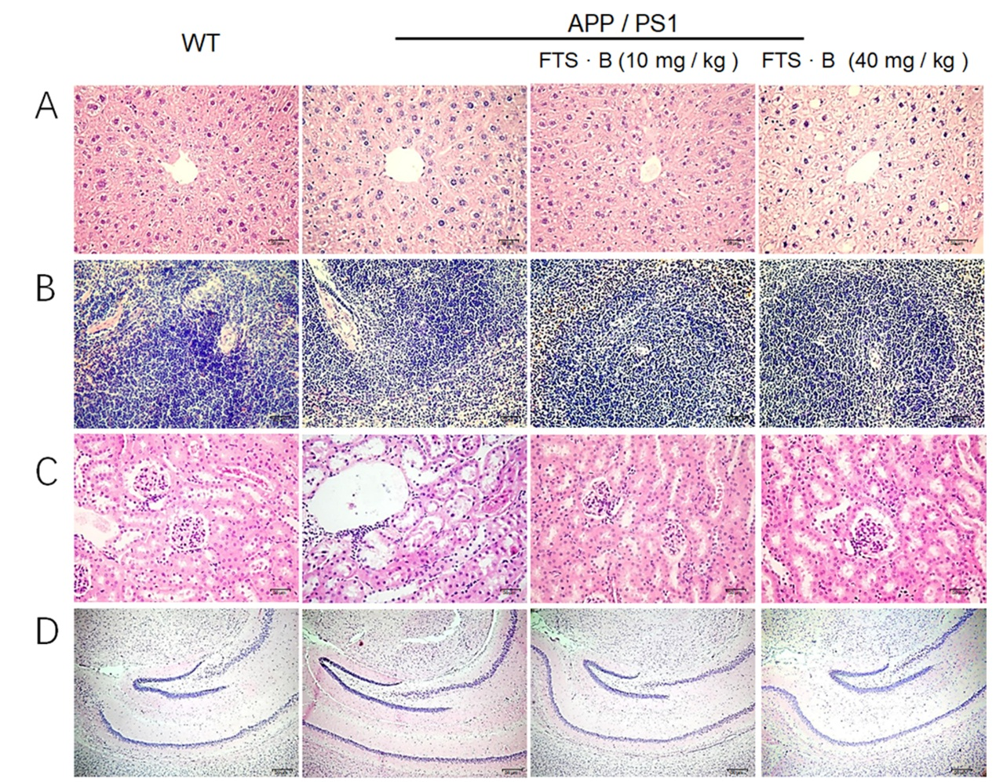
Figure S3. FTS·B caused no substantial changes in liver, spleen, kidney and brain tissues. (A) Liver, (B) heart, (C) kidney and (D) brain were detected by H&E staining (200×; scale bar = 50 μm). No substantial changes were noted among all experimental mice. FTS·B, Forsythoside B; H&E, hematoxylin and eosin.

