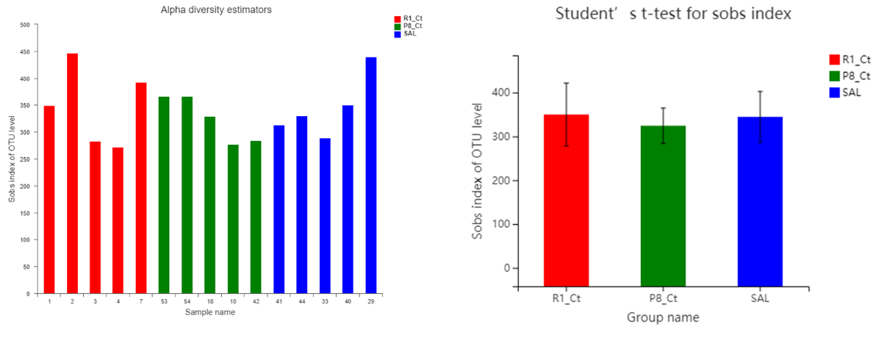
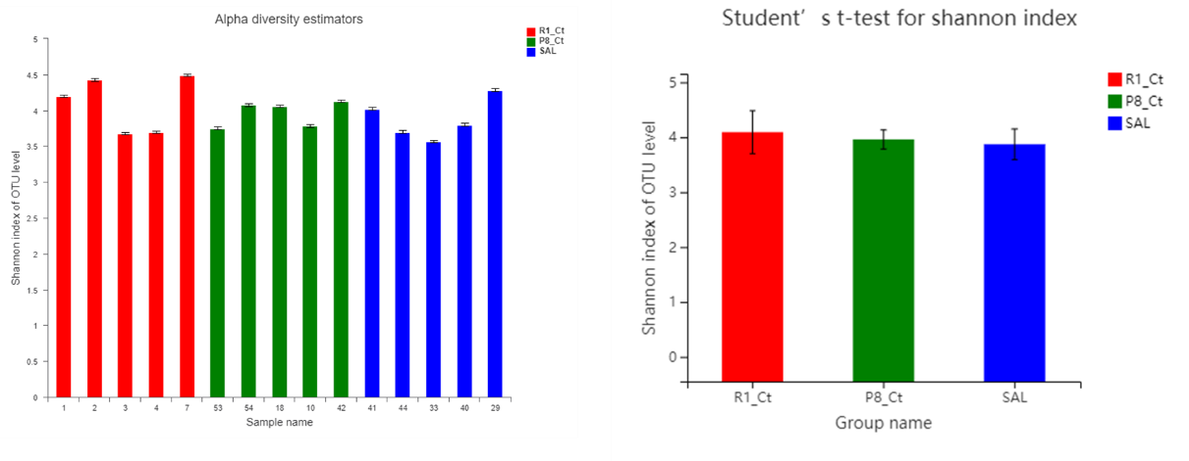
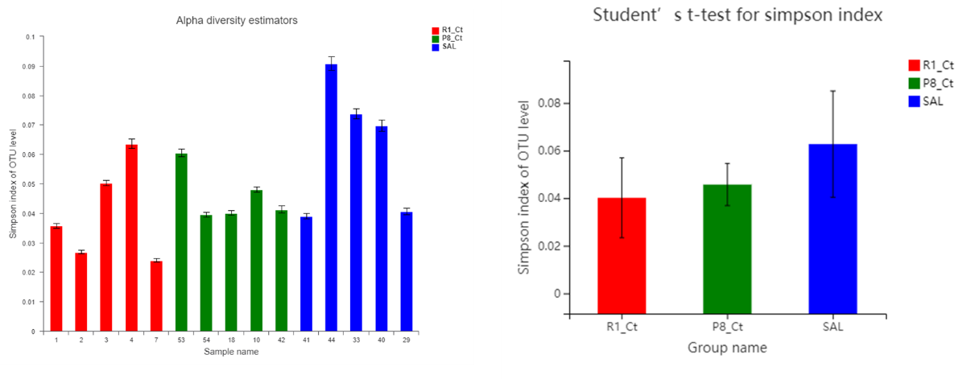
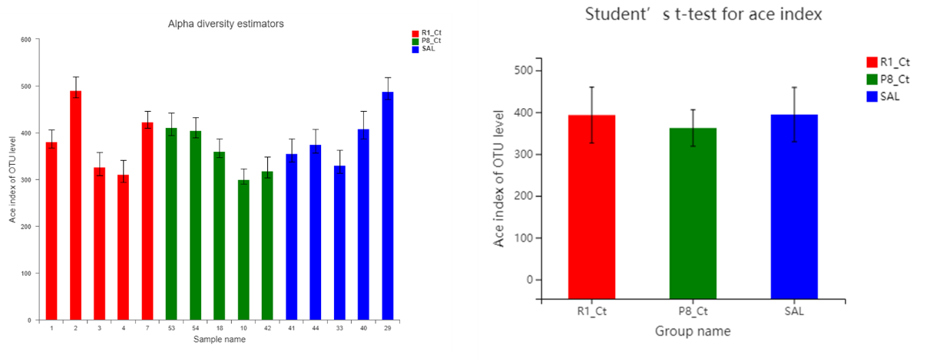
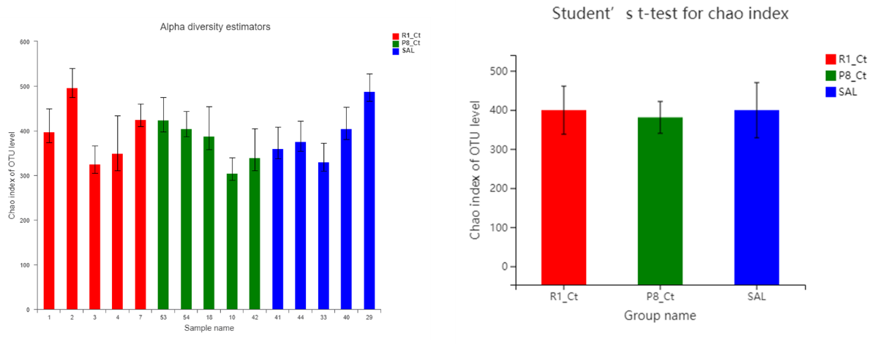
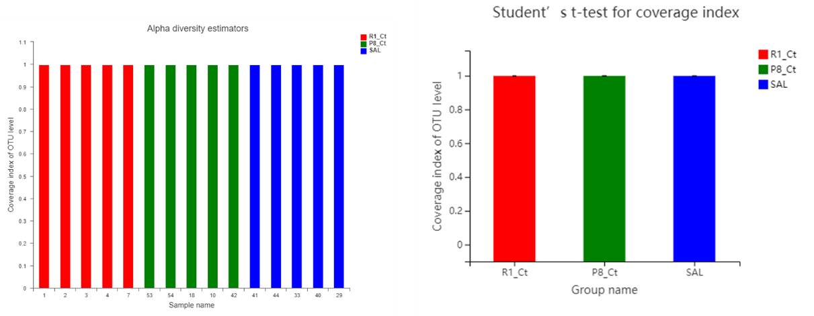
Figure S1 αdiversity index showed no significant changes

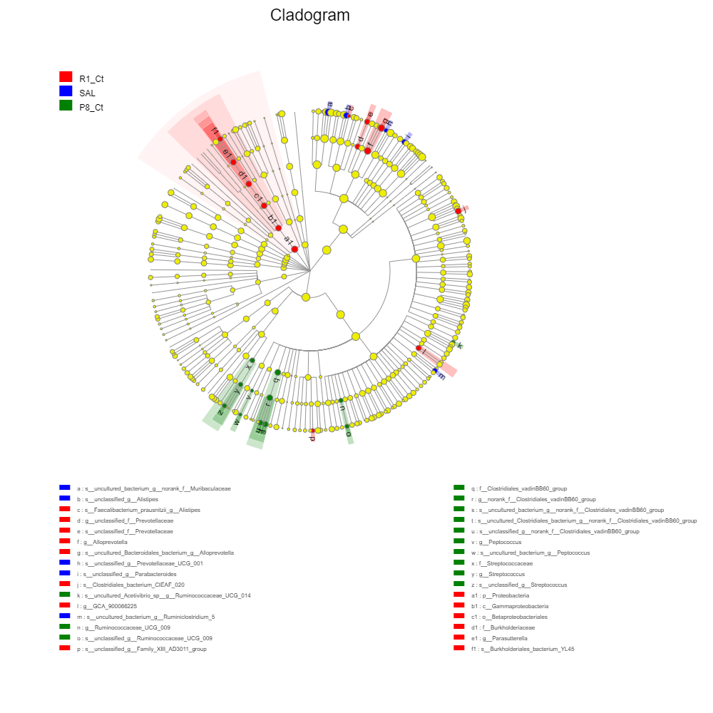
Figure S2

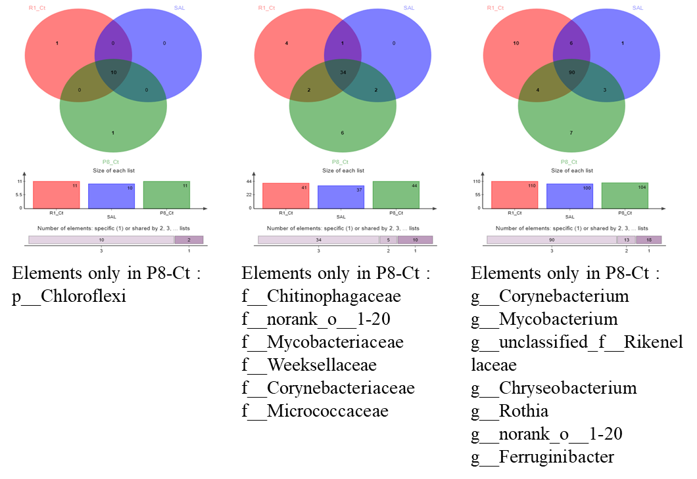
Figure S3. Venn diagram on the phylum, family, and genus levels. Analysis of species venn plots showed that salidroside has basically eliminated the Chloroflexi phylum in SAMP8, as well as 5 families and 7 genera, of which Corynebacterium has been confirmed to be associated with AD-Related pathological development.

Figure S4

Table S1

