Table 1. Model fit indices run with FIML
Model fit indices | Statistic
X² test of model fit | 80.058 (29) p <0.001
RMSEA | 0.038
CFI | 0.987
TLI | 0.960
X² test at baseline | 4040.060 (90) p <0.001
SRMR | 0.021

Table 2. Model standardised estimates of direct paths predicting pain and cognitive function at wave 6 and IADL at waves 6 and 7
Measure | Predictor | SD est. | S.E. | P
W5 Pain | W4 Gender | 0.059 | 0.028 | 0.034*
W5 Pain | W4 Age | -0.026 | 0.029 | 0.364
W5 Pain | W4 Education | -0.029 | 0.027 | 0.277
W5 Pain | W4 BMI | 0.058 | 0.028 | 0.042*
W5 Pain | W4 Chronic diseases | 0.185 | 0.029 | <0.001***
W5 Pain | W4 Alcohol | 0.007 | 0.034 | 0.847
W5 CF | W4 Gender | 0.039 | 0.027 | 0.145
W5 CF | W4 Age | -0.232 | 0.027 | <0.001***
W5 CF | W4 Education | 0.055 | 0.026 | 0.035*
W5 CF | W4 BMI | -0.010 | 0.027 | 0.712
W5 CF | W4 Chronic diseases | -0.087 | 0.028 | 0.002**
W5 CF | W4 Alcohol intake | -0.070 | 0.034 | 0.041*
W5 Anxiety | W4 Gender | 0.087 | 0.029 | 0.003**
W5 Anxiety | W4 Age | -0.004 | 0.030 | 0.906
W5 Anxiety | W4 Education | -0.048 | 0.028 | 0.089
W5 Anxiety | W4 BMI | 0.022 | 0.030 | 0.471
W5 Anxiety | W4 Chronic diseases | 0.160 | 0.030 | <0.001***
W5 Anxiety | W4 Alcohol intake | 0.009 | 0.037 | 0.799
W5 SD | W4 Gender | 0.079 | 0.030 | 0.008**
W5 SD | W4 Age | 0.134 | 0.031 | <0.001***
W5 SD | W4 Education | 0.003 | 0.028 | 0.919
W5 SD | W4 BMI | 0.023 | 0.030 | 0.452
W5 SD | W4 Chronic diseases | 0.117 | 0.031 | <0.001***
W5 SD | W4 Alcohol intake | -0.047 | 0.037 | 0.200
W5 IADL | W4 Gender | 0.046 | 0.026 | 0.085
W5 IADL | W4 Age | 0.233 | 0.026 | <0.001***
W5 IADL | W4 Education | 0.003 | 0.026 | 0.905
W5 IADL | W4 BMI | 0.024 | 0.027 | 0.370
W5 IADL | W4 Chronic diseases | 0.129 | 0.028 | <0.001***
W5 IADL | W4 Alcohol intake | -0.045 | 0.036 | 0.218
W6 CF | W5 CF | 0.659 | 0.018 | <0.001***
W6 CF | W5 Pain | -0.048 | 0.020 | 0.017*
W6 CF | W5 Anxiety | -0.014 | 0.021 | 0.500
W6 CF | W5 SD | -0.067 | 0.022 | 0.002**
W6 Pain | W5 Pain | 0.345 | 0.026 | <0.001***
W6 Pain | W5 CF | -0.070 | 0.028 | 0.013*
W6 Pain | W5 Anxiety | 0.034 | 0.028 | 0.226
W6 Pain | W5 SD | 0.059 | 0.029 | 0.042*
W6 IADL | W5 Pain | 0.047 | 0.022 | 0.034*
W6 IADL | W5 CF | -0.049 | 0.024 | 0.038*
W6 IADL | W5 IADL | 0.561 | 0.021 | <0.001***
W6 IADL | W5 Anxiety | 0.081 | 0.023 | <0.001***
W6 IADL | W5 SD | 0.039 | 0.025 | 0.122
W7 IADL | W6 Pain | 0.024 | 0.020 | 0.220
W7 IADL | W6 CF | -0.058 | 0.022 | 0.007**
W7 IADL | W6 IADL | 0.505 | 0.024 | <0.001***
W7 IADL | W5 Anxiety | 0.057 | 0.021 | 0.006**
W7 IADL | W5 SD | 0.011 | 0.022 | 0.604
W, wave; BMI, body mass index CF, cognitive function; SD, social deprivation; IADL, independent activities of daily living. * = p < .05, ** = p < .01, *** = p < .001. n = 1240

Table 3. Model 1 fit indices run with MI
Model fit indices | Statistic
X² test of model fit | 71.31 (29) p <0.001
RMSEA | 0.035
CFI | 0.987
TLI | 0.960
X² test at baseline | 3349.333 (90) p <0.001
SRMR | 0.022

Table 4. Comparison of unstandardized coefficients and standard errors (S.E.) from analyses based on two methods for handling missing data: full information maximum likelihood (FIML) and multiple imputation (MI)
 |  | FIML  (n = 1240) |  |  | MI  (m = 40)
Measure | Predictor | Coefficients | S.E. | P | Coefficients | S.E. | P
W5 Pain | W4 Gender | 0.146 | 0.069 | 0.034 | 0.146 | 0.072 | 0.042
W5 Pain | W4 Age | -0.003 | 0.003 | 0.365 | -0.003 | 0.004 | 0.414
W5 Pain | W4 Education | -0.004 | 0.004 | 0.278 | -0.004 | 0.004 | 0.294
W5 Pain | W4 BMI | 0.013 | 0.006 | 0.043 | 0.012 | 0.006 | 0.061
W5 Pain | W4 Chronic diseases | 0.133 | 0.021 | 0.000 | 0.133 | 0.022 | 0.000
W5 Pain | W4 Alcohol | 0.008 | 0.041 | 0.847 | 0.005 | 0.036 | 0.882
W5 CF | W4 Gender | 0.966 | 0.664 | 0.146 | 0.924 | 0.686 | 0.178
W5 CF | W4 Age | -0.283 | 0.034 | 0.000 | -0.285 | 0.035 | 0.000
W5 CF | W4 Education | 0.083 | 0.039 | 0.035 | 0.080 | 0.041 | 0.050
W5 CF | W4 BMI | -0.022 | 0.060 | 0.712 | -0.014 | 0.061 | 0.811
W5 CF | W4 Chronic diseases | -0.632 | 0.202 | 0.002 | -0.631 | 0.210 | 0.003
W5 CF | W4 Alcohol intake | -0.845 | 0.414 | 0.041 | -0.818 | 0.347 | 0.035
W5 Anxiety | W4 Gender | 0.549 | 0.184 | 0.003 | 0.537 | 0.191 | 0.005
W5 Anxiety | W4 Age | -0.001 | 0.009 | 0.906 | -0.002 | 0.010 | 0.866
W5 Anxiety | W4 Education | -0.019 | 0.011 | 0.090 | -0.019 | 0.011 | 0.090
W5 Anxiety | W4 BMI | 0.012 | 0.017 | 0.472 | 0.012 | 0.017 | 0.487
W5 Anxiety | W4 Chronic diseases | 0.294 | 0.056 | 0.000 | 0.293 | 0.058 | 0.000
W5 Anxiety | W4 Alcohol intake | 0.029 | 0.113 | 0.799 | 0.074 | 0.097 | 0.453
W5 SD | W4 Gender | 0.025 | 0.010 | 0.008 | 0.026 | 0.010 | 0.008
W5 SD | W4 Age | 0.002 | 0.000 | 0.000 | 0.002 | 0.000 | 0.000
W5 SD | W4 Education | 0.000 | 0.001 | 0.919 | 0.000 | 0.001 | 0.911
W5 SD | W4 BMI | 0.001 | 0.001 | 0.453 | 0.001 | 0.001 | 0.467
W5 SD | W4 Chronic diseases | 0.011 | 0.003 | 0.000 | 0.012 | 0.003 | 0.000
W5 SD | W4 Alcohol intake | -0.007 | 0.006 | 0.200 | -0.007 | 0.005 | 0.132
W5 IADL | W4 Gender | 0.084 | 0.049 | 0.086 | 0.089 | 0.050 | 0.078
W5 IADL | W4 Age | 0.021 | 0.002 | 0.000 | 0.021 | 0.003 | 0.000
W5 IADL | W4 Education | 0.000 | 0.003 | 0.905 | 0.000 | 0.003 | 0.904
W5 IADL | W4 BMI | 0.004 | 0.004 | 0.370 | 0.003 | 0.004 | 0.455
W5 IADL | W4 Chronic diseases | 0.069 | 0.015 | 0.000 | 0.069 | 0.016 | 0.000
W5 IADL | W4 Alcohol intake | -0.040 | 0.033 | 0.218 | -0.061 | 0.025 | 0.033
W6 CF | W5 CF | 0.632 | 0.021 | 0.000 | 0.627 | 0.021 | 0.000
W6 CF | W5 Pain | -0.461 | 0.193 | 0.017 | -0.473 | 0.200 | 0.018
W6 CF | W5 Anxiety | -0.053 | 0.078 | 0.500 | -0.059 | 0.081 | 0.470
W6 CF | W5 SD | -5.010 | 1.618 | 0.002 | -5.093 | 1.608 | 0.002
W6 Pain | W5 Pain | 0.328 | 0.026 | 0.000 | 0.328 | 0.027 | 0.000
W6 Pain | W5 CF | -0.007 | 0.003 | 0.013 | -0.007 | 0.003 | 0.017
W6 Pain | W5 Anxiety | 0.013 | 0.010 | 0.226 | 0.013 | 0.011 | 0.231
W6 Pain | W5 SD | 0.434 | 0.214 | 0.042 | 0.420 | 0.215 | 0.051
W6 IADL | W5 Pain | 0.056 | 0.026 | 0.034 | 0.056 | 0.027 | 0.042
W6 IADL | W5 CF | -0.006 | 0.003 | 0.038 | -0.006 | 0.003 | 0.038
W6 IADL | W5 IADL | 0.898 | 0.038 | 0.000 | 0.897 | 0.039 | 0.000
W6 IADL | W5 Anxiety | 0.038 | 0.011 | 0.000 | 0.038 | 0.011 | 0.001
W6 IADL | W5 SD | 0.354 | 0.229 | 0.121 | 0.368 | 0.222 | 0.098
W7 IADL | W6 Pain | 0.037 | 0.030 | 0.220 | 0.035 | 0.031 | 0.259
W7 IADL | W6 CF | -0.009 | 0.003 | 0.007 | -0.009 | 0.003 | 0.010
W7 IADL | W6 IADL | 0.621 | 0.032 | 0.000 | 0.623 | 0.033 | 0.000
W7 IADL | W6 Anxiety | 0.033 | 0.012 | 0.006 | 0.032 | 0.012 | 0.009
W7 IADL | W5 SD | 0.129 | 0.249 | 0.604 | 0.126 | 0.247 | 0.614
W, wave; CF, cognitive function; SD, social deprivation; IADL, independent activities of daily living. n = 1240

Table 5. Comparison of unstandardized coefficients and standard errors (S.E.) from analyses based on three methods for handling missing data: FIML and MI
Indirect paths | FIML coefficient | FIML S.E. | P | MI coefficient | MI  S.E. | P
W5CF W5A W6CF | -0.033 | 0.049 | 0.498 | -0.037 | 0.051 | 0.468
W5P W5A W6P | 0.004 | 0.003 | 0.221 | 0.004 | 0.003 | 0.223
W5CF W5A W6P | 0.000 | 0.000 | 0.251 | 0.000 | 0.000 | 0.236
W5P W5A W6CF | 0.024 | 0.036 | 0.495 | 0.028 | 0.034 | 0.422
W5CF W5P W6IADL | 0.000 | 0.000 | 0.119 | 0.000 | 0.000 | 0.135
W5CF W5A W6IADL | 0.000 | 0.000 | 0.056 | 0.000 | 0.000 | 0.048
W5P W5A W6IADL | 0.002 | 0.001 | 0.049 | 0.002 | 0.001 | 0.052
W6CF W6P W7IADL | 0.000 | 0.000 | 0.237 | 0.000 | 0.000 | 0.258
W6CF W5A W7IADL | 0.000 | 0.000 | 0.041 | 0.000 | 0.000 | 0.037
W6P W5A W7IADL | 0.001 | 0.001 | 0.249 | 0.001 | 0.001 | 0.244
W4E W5CF W6CF | 0.052 | 0.025 | 0.036 | 0.050 | 0.025 | 0.050
W4E W5CF W6P | -0.001 | 0.000 | 0.108 | -0.001 | 0.000 | 0.123
W4E W5CF W6IADL | 0.000 | 0.000 | 0.139 | 0.000 | 0.000 | 0.155
W4E W5A W6IADL | -0.001 | 0.000 | 0.126 | -0.001 | 0.000 | 0.122
W5SD W5A W6CF | 0.265 | 0.382 | 0.488 | 0.299 | 0.466 | 0.522
W5SD W5A W6P | 0.005 | 0.005 | 0.250 | 0.005 | 0.005 | 0.308
W5SD W5CF W6CF | -3.167 | 1.006 | 0.002 | -3.191 | 0.988 | 0.001
W5SD W5CF W6P | -0.003 | 0.002 | 0.072 | -0.003 | 0.002 | 0.092
W5SD W5P W6CF | 2.310 | 1.150 | 0.044 | 2.401 | 1.280 | 0.061
W5SD W5P W6P | 0.142 | 0.070 | 0.041 | 0.138 | 0.070 | 0.049
W, wave; A, anxiety; P, pain; CF, cognitive function; SD, social deprivation; IADL, independent activities of daily living. n = 1240

Table 6. Number of missing data per variable
Variable | Number of missing data
W4BMI | 43
W4CHR | 1
W4ALC | 369
W5SD | 103
W4E | 15
W4AGE | 0
W4SEX | 0
W5A | 4
W5CF | 4
W6CF | 8
W5P | 0
W6P | 0
W6IADL | 0
W7IADL | 7
W5IADL | 0
W, wave; BMI, body mass index; CHR, number of diagnosed chronic diseases; SD, social deprivation; E, education; A, anxiety; CF, cognitive function; P, Pain; IADL, independent activities of daily living. n = 1240

Table 7. Bivariate, zero order correlations between the variables entered into the model.
 | W5SD | W4E | W4AGE | W4SEX | W5A | W5CF | W6CF | W5P | W6P | W6IADL | W7IADL | W5IADL | W4BMI | W4CHR | W4ALC
W5SD | 1.00
W4E | -0.26 | 1.00
W4AGE | 0.16 | -0.19 | 1.00
W4SEX | 0.07 | -0.08 | 0.00 | 1.00
W5A | 0.29 | -0.15 | 0.03 | 0.12 | 1.00
W5CF | -0.32 | 0.45 | -0.32 | -0.01 | -0.24 | 1.00
W6CF | -0.32 | 0.45 | -0.35 | -0.05 | -0.20 | 0.74 | 1.00
W5P | 0.20 | -0.21 | 0.05 | 0.10 | 0.25 | -0.20 | -0.19 | 1.00
W6P | 0.18 | -0.20 | 0.06 | 0.06 | 0.18 | -0.20 | -0.20 | 0.41 | 1.00
W6IADL | 0.24 | -0.17 | 0.30 | 0.10 | 0.23 | -0.22 | -0.21 | 0.26 | 0.25 | 1.00
W7IADL | 0.23 | -0.21 | 0.36 | 0.07 | 0.23 | -0.29 | -0.27 | 0.22 | 0.23 | 0.59 | 1.00
W5IADL | 0.24 | -0.16 | 0.25 | 0.11 | 0.23 | -0.23 | -0.19 | 0.27 | 0.21 | 0.50 | 0.49 | 1.00
W4BMI | 0.09 | -0.16 | 0.02 | -0.09 | 0.02 | -0.05 | -0.05 | 0.10 | 0.15 | 0.09 | 0.11 | 0.09 | 1.00
W4CHR | 0.17 | -0.13 | 0.27 | 0.09 | 0.18 | -0.23 | -0.18 | 0.24 | 0.25 | 0.23 | 0.27 | 0.26 | 0.21 | 1.00
W4ALC | 0.03 | -0.07 | 0.18 | 0.19 | 0.02 | -0.11 | -0.13 | 0.06 | 0.05 | 0.04 | 0.09 | 0.02 | -0.10 | 0.10 | 1.00
W, wave; A, anxiety; E, education; BMI, body mass index; CHR, number of chronic diseases; ALC; alcohol intake; P, pain; CF, cognitive function; SD, social deprivation; IADL, independent activities of daily living. Significant correlations are in bold. n = 1240

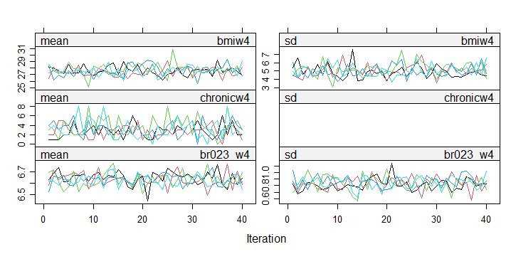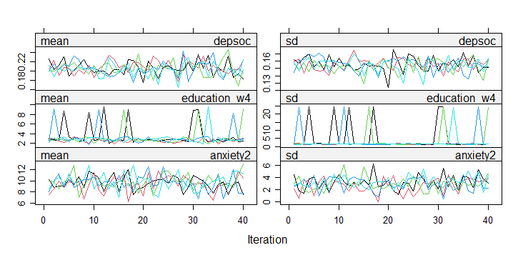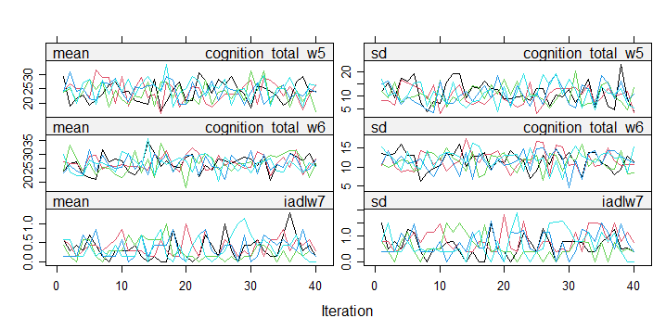
Figure 1. Convergence plots. The plots show the mean (left) and standard deviation (right) of the imputed values for each of the imputed variables. w, wave; bmi, body mass index; chronic, number of diagnosed chronic diseases; br023, alcohol intake; depsoc, social deprivation; iadl, independent activities of daily living. m=40
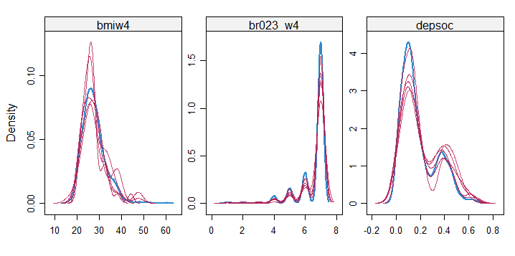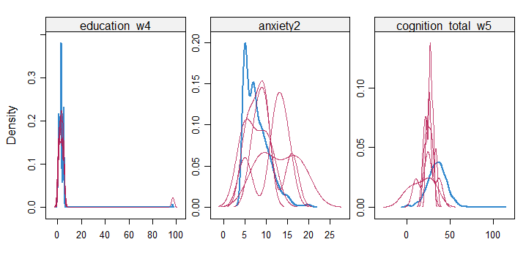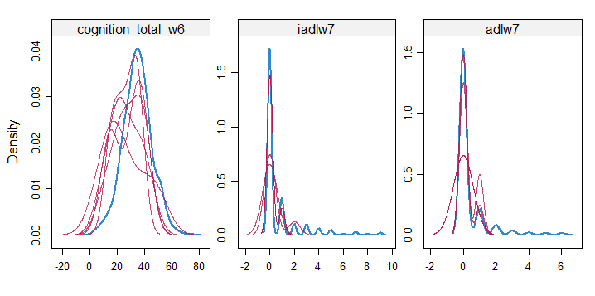
Figure 2. Density plots. Red lines depict imputed data while the blue line is the distribution of the original data. w, wave; bmi, body mass index; br023, alcohol intake; depsoc, social deprivation; iadl, independent activities of daily livin; adl, activities of daily living. m=40

