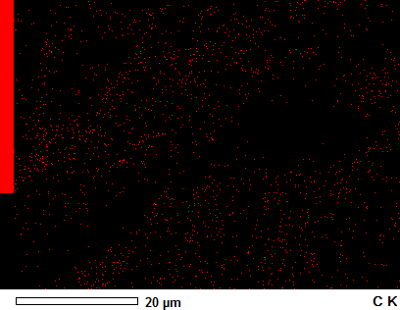
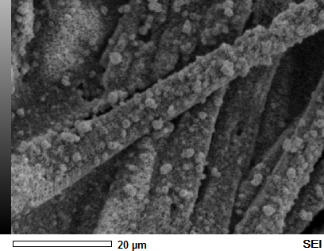
(f)
(e)

MAP 1
Anabel

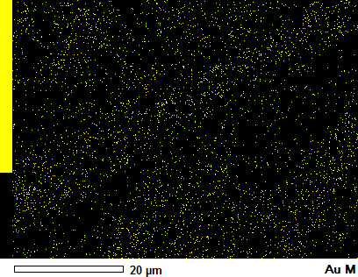
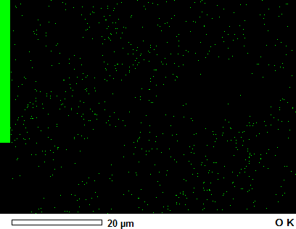
(h)
(g)

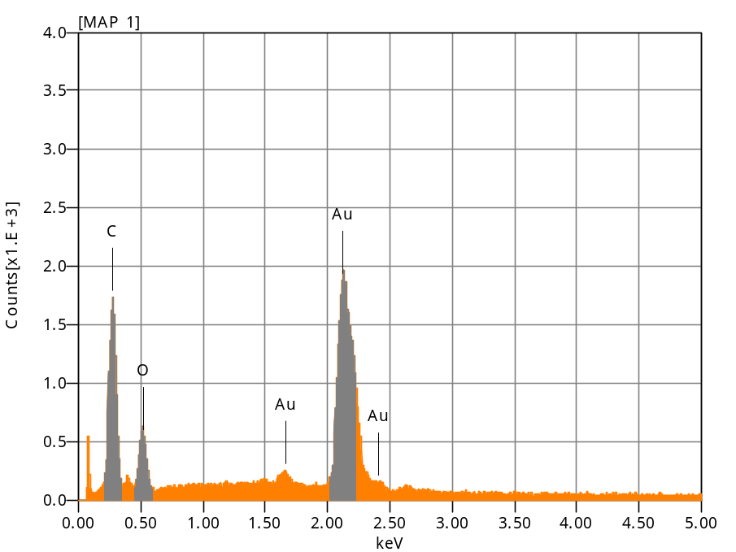
Chemical formula mass% Atom% Sigma Net K ratio Line
C 29.17 76.39 0.04 39734 0.0121737 K
O 6.81 13.39 0.05 13356 0.0120363 K
Au 64.01 10.22 0.41 108686 0.1991843 M
Total 100.00 100.00

Acquisition Condition
Instrument : 6010LA
Volt : 10.00 kV
Current : ---
Process Time : T3
Live time : 78.55 sec.
Real Time : 79.73 sec.
DeadTime : 1.00 %
Count Rate : 1893.00 CP

Anabel

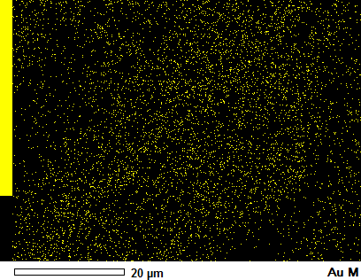
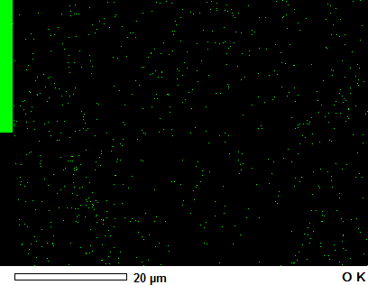
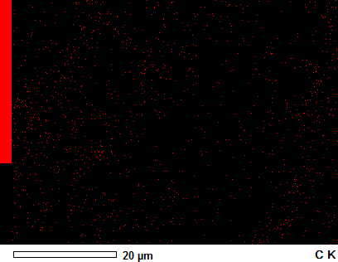
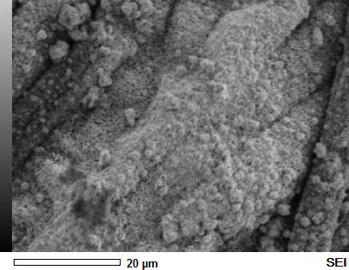
MAP 1
Anabel

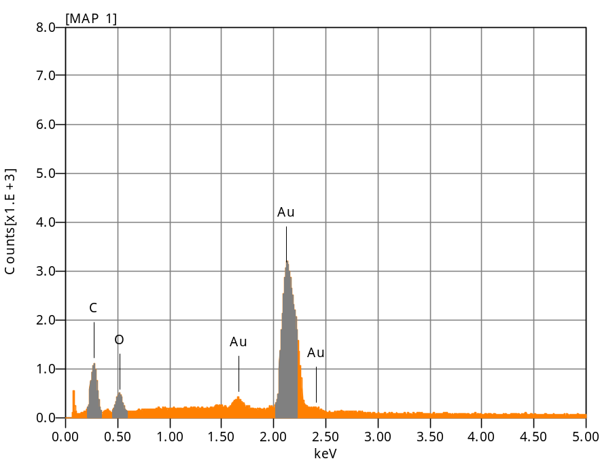
Chemical formula mass% Atom% Sigma Net K ratio Line
C 14.35 65.31 0.02 24173 0.0074070 K
O 3.48 11.88 0.04 9658 0.0087042 K
Au 82.17 22.80 0.39 185703 0.3403738 M
Total 100.00 100.00

Acquisition Condition
Instrument : 6010LA
Volt : 10.00 kV
Current : ---
Process Time : T3
Live time : 78.54 sec.
Real Time : 80.19 sec.
DeadTime : 2.00 %
Count Rate : 2069.00 CP

Anabel

