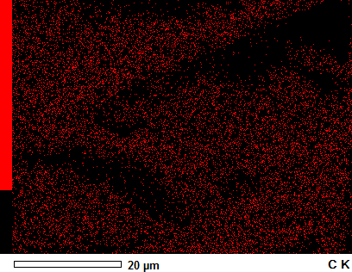
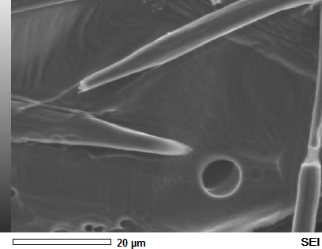
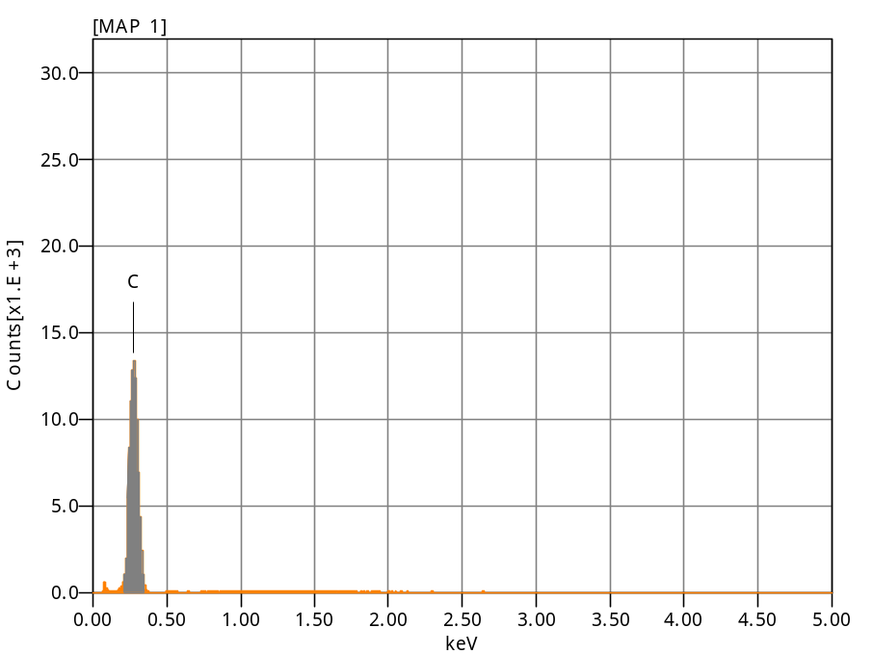
(b)
(a)
Chemical formula mass% Atom% Sigma Net K ratio Line
C 100.00 100.00 0.04 335680 0.1028321 K
Total 100.00 100.00

Acquisition Condition
Instrument : 6010LA
Volt : 10.00 kV
Current : ---
Process Time : T3
Live time : 78.56 sec.
Real Time : 79.74 sec.
DeadTime : 2.00 %
Count Rate : 1878.00 CP

MAP 1
Anabel

