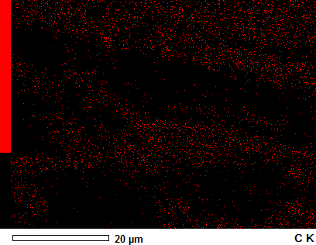
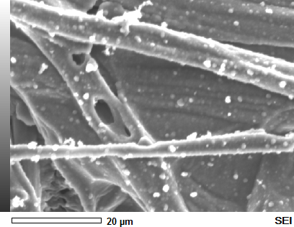
(d)
(c)


MAP 1
Anabel

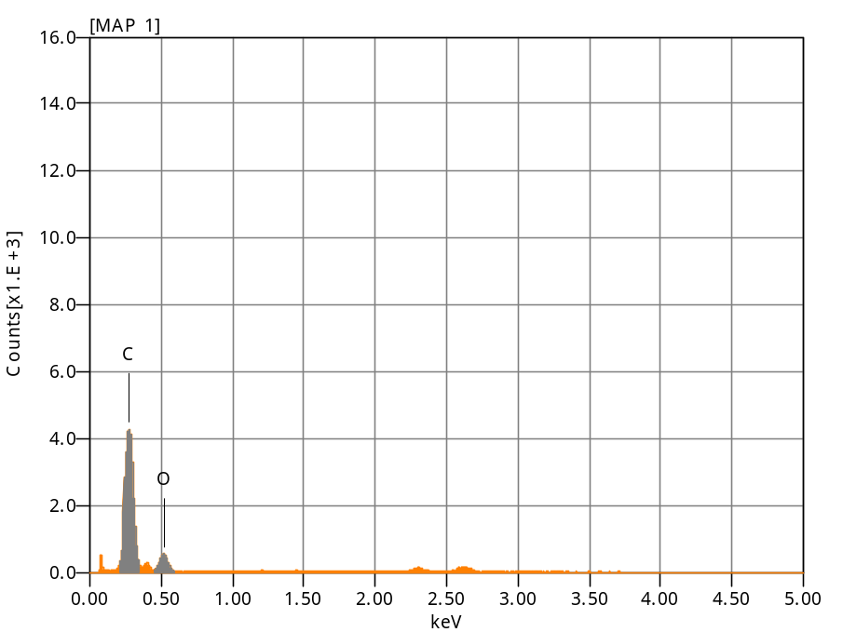
Chemical formula mass% Atom% Sigma Net K ratio Line
C 81.90 85.77 0.06 108287 0.0331767 K
O* 18.10 14.23 0.12 13956 0.0125770 K
Total 100.00 100.00

Acquisition Condition
Instrument : 6010LA
Volt : 10.00 kV
Current : ---
Process Time : T3
Live time : 78.55 sec.
Real Time : 79.22 sec.
DeadTime : 1.00 %
Count Rate : 1019.00 CP

Anabel

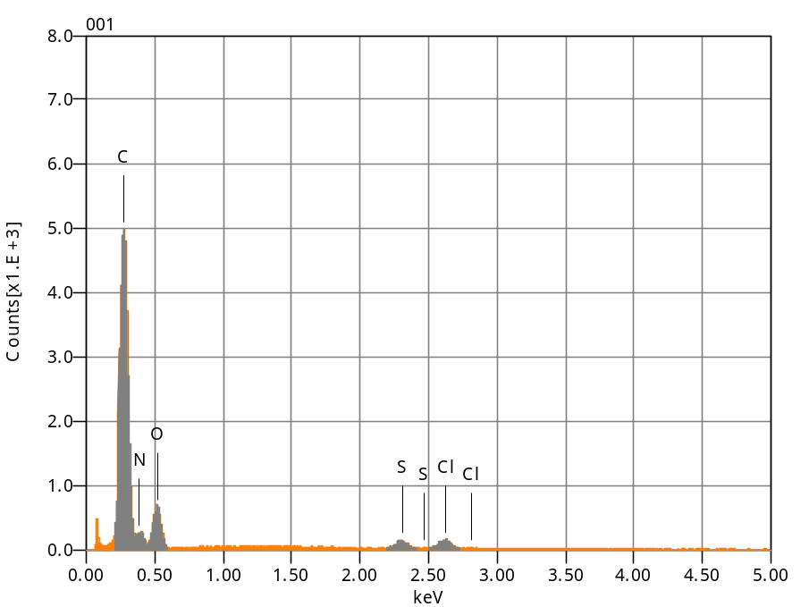
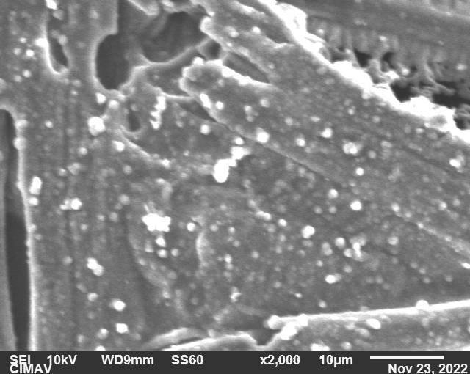
Chemical formula mass% Atom% Sigma Net K ratio Line
C 80.45 86.13 0.05 124376 0.0498874 K
N* 0.58 0.53 0.31 131 0.0004152 K
O 14.50 11.65 0.09 17161 0.0202455 K
S* 1.74 0.70 0.04 4759 0.0078419 K
Cl* 2.73 0.99 0.06 6488 0.0130695 K
Total 100.00 100.00

Acquisition Condition
Instrument : 6010LA
Volt : 10.00 kV
Current : ---
Process Time : T3
Live time : 60.00 sec.
Real Time : 60.60 sec.
DeadTime : 1.00 %
Count Rate : 1356.00 CP

Volt : 10.00 kV
Mag. : x 2,000
Date : 2022/11/23
Pixel : 640 x 480

001
Anabel

