Root system architecture and anatomical traits variability of alfalfa
at the seeding stage
Xinya Pan·Pengfei Wang·Xianwei Wei·Jinxin Zhang·Bingcheng Xu·Yinglong Chen·Gehong Wei·Zhi Wang

X. Pan·P. Wang·X. Wei·J. Zhang·B. Xu·Z. Wang
College of Grassland Agriculture, Northwest A&F University, 3 Taicheng Road, 712100 Yangling, China
e-mail: wangzhi712@nwafu.edu.cn

B. Xu·Y. Chen·Z. Wang
State Key Laboratory of Soil Erosion and Dryland Farming on the Loess Plateau, Northwest A&F University, 26 Xinong Road, 712100 Yangling, China

Y. Chen
The UWA Institute of Agriculture, School of Agriculture and Environment, The University of Western Australia, Perth, WA 6001, Australia

G. Wei
College of Life Sciences, Northwest A&F University, 22 Xinong Road, 712100 Yangling, China

Table S1 List of the 53 alfalfa genotypes used in this study (41 Introduced cultivars, 9 Chinese breeding lines, and 3 Chinese native cultivars)
Abbreviation | Genotypes | Origin | Characteristics
QT | Knight T | America | Fast regeneration rate, high productivity
DFH | Millionaire | Canada | Cold tolerant, fast regeneration rate,  high productivity
AND | Adrenalin | Canada | Disease resistant, fast regeneration rate
SD | Sardi 7 | Australia | Disease resistant, fast regeneration rate,  high productivity
BM | Blue moon | America | Hot tolerant, high productivity
CL | Central | Italy | Hot tolerant, high productivity
B310 | Bara 310 SC | America | Salt tolerant, rolling resistance
B218 | Bara 218 TR | America | Disease resistant, rolling resistance,  high productivity
PL | Paola | Italy | High quality
B420 | Bara 420 YQ | America | High quality, high productivity
B416 | Bara 416 WET | America | Humidity resistant, high productivity
QS2 | Knight No. 2 | America | Drought tolerant, cold tolerant,  fast regeneration rate
TZZ | Survivor | America | Cold tolerant, wind and sand resistant
DYH | Galaxie Max | France | Lodging resistant, high productivity
KS | Concept | America | Disease resistant
BB | Barricade | America | Salt tolerant
YS | Warrior | America | High productivity
WL319 | WL319HQ | America | Cold tolerant, high productivity
WL168 | WL168HQ | America | Drought tolerant, cold tolerant,  high productivity
WL298 | WL298HQ | America | Cold tolerant, salt tolerant, high productivity
WL354 | WL354HQ | America | Cold tolerant, disease resistant,  high productivity
WL363 | WL363HQ | America | Cold tolerant, high productivity
WL358 | WL358HQ | America | Cold tolerant, disease resistant,  high productivity
WL343 | WL343HQ | America | Cold tolerant, high productivity
WL366 | WL366HQ | America | Cold tolerant, salt tolerant, high productivity
Ca | Claudia | Italy | Disease resistant, lodging resistant,  fast regeneration rate
QJ | Vision | America | Lodging resistant, fast regeneration rate,  high productivity
LT | Instict | America | Cold tolerant, disease resistant
BJX | Gibraltar | America | Drought tolerant, cold tolerant,  barrenness resistant
XB | Xuebao | America | Cold tolerant
DY | DS310FY | America | Cold tolerant, disease resistant,  fast regeneration rate
MF | MF4020 | Canada | Cold tolerant, disease resistant,  high productivity
QTZ | Optimus | America | Disease resistant
SDL | Sanditi | France | Disease resistant, lodging resistant,  high productivity
PW | Power 4.2 | America | Disease resistant, high quality, high productivity
3010 | SK3010 | Canada | Cold tolerant, disease resistant,  high productivity
LW | 6010 | Canada | Disease resistant, high productivity
JG | Aurora | Australia | Cold tolerant, fast regeneration rate
5070 | 5070 | America | High quality, high productivity
MTW | Mattwi | America | Disease resistant, fast regeneration rate
Abbreviation | Genotypes | Origin | Characteristics
LB | Lobo | America | Disease resistant, fast regeneration rate,  high productivity
G1 | Gannong No.1 | China | Drought tolerant, cold tolerant
G3 | Gannong No.3 | China | Drought tolerant, cold tolerant, barrenness resistant
G4 | Gannong No.4 | China | High productivity
Z1 | Zhongmu No.1 | China | Salt tolerant
Z2 | Zhongmu No.2 | China | Flooding tolerant
Z3 | Zhongmu No.3 | China | Salt tolerant
G6 | Gannong No.6 | China | High productivity
CY3 | Caoyuan No.3 | China | Cold tolerant, drought tolerant
L801 | Longmu No.801 | China | Cold tolerant, salt tolerant
AH | Aohan | China | Drought tolerant, cold tolerant
LD | Longdong | China | Drought tolerant
XJDY | Xinjiang Daye | China | Large leaf, fast regeneration rate

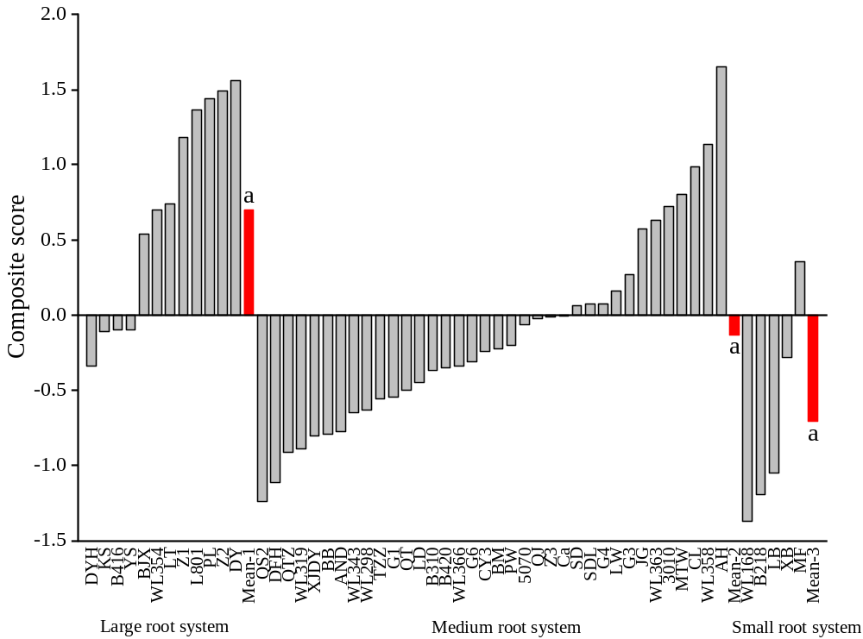
Fig. S1 The ranking of composite score based on principal component analysis of 53 alfalfa genotypes. Group means (red bars) with different letters differ significantly between genotype groups (P ≤ 0.05)

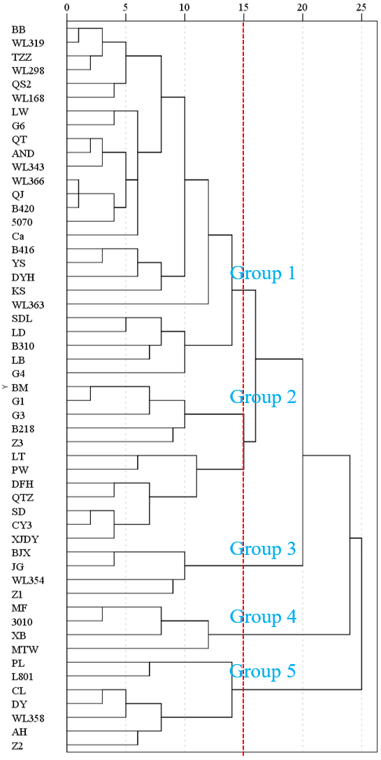
Fig. S2 Dendrogram of agglomerative hierarchical clustering for 53 alfalfa genotypes
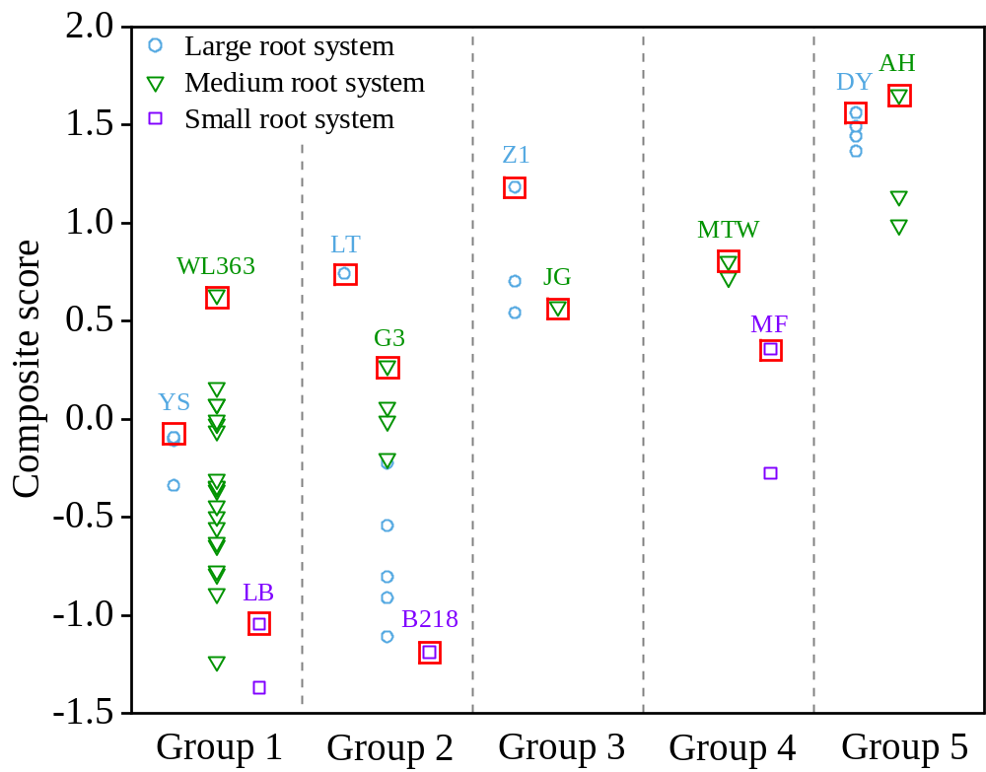
Fig. S3 The distribution of 53 alfalfa genotypes in five groups at a middle distance of 15 based on a combination of principal component analysis, hierarchical clustering analysis and composite score

Table S2 The ranking of 12 selected genotypes from 53 genotypes for each of 25 selected traits with CVs ≥ 0.25
Traits | Large root system |  |  |  | Medium root system |  |  |  |  | Small root system
Traits | YS | LT | Z1 | DY | WL363 | G3 | JG | MTW | AH | LB | B218 | MF
Global traits
NC | 34 | 12 | 43 | 32 | 31 | 48 | 8 | 3 | 9 | 24 | 50 | 5
PC | 24 | 5 | 50 | 22 | 39 | 44 | 3 | 1 | 31 | 16 | 49 | 6
RL | 9 | 11 | 3 | 10 | 20 | 47 | 17 | 46 | 22 | 49 | 52 | 50
RTN | 12 | 15 | 11 | 10 | 4 | 30 | 7 | 50 | 34 | 49 | 52 | 37
Local traits
RL-thin | 6 | 8 | 2 | 10 | 13 | 38 | 16 | 18 | 14 | 46 | 52 | 39
RTN-20 | 9 | 11 | 14 | 24 | 8 | 41 | 13 | 53 | 49 | 48 | 52 | 35
RTN-40 | 17 | 21 | 37 | 6 | 1 | 5 | 19 | 32 | 15 | 41 | 43 | 22
RTN-60 | 44 | 34 | 3 | 10 | 15 | 13 | 7 | 21 | 8 | 43 | 24 | 44
RL-20 | 6 | 7 | 9 | 12 | 25 | 51 | 22 | 52 | 45 | 42 | 53 | 48
RL-40 | 9 | 24 | 2 | 3 | 10 | 14 | 13 | 4 | 1 | 50 | 26 | 40
RL-60 | 44 | 28 | 1 | 19 | 20 | 15 | 8 | 32 | 4 | 39 | 30 | 44
RA-20 | 6 | 11 | 8 | 14 | 25 | 52 | 23 | 53 | 46 | 44 | 50 | 49
RA-40 | 15 | 29 | 2 | 4 | 8 | 10 | 9 | 13 | 1 | 49 | 21 | 39
RA-60 | 44 | 29 | 2 | 17 | 20 | 15 | 5 | 34 | 8 | 38 | 30 | 44
RV-20 | 8 | 11 | 9 | 17 | 34 | 52 | 31 | 53 | 49 | 45 | 48 | 50
RV-40 | 20 | 33 | 11 | 4 | 8 | 6 | 7 | 26 | 1 | 49 | 15 | 40
RV-60 | 44 | 29 | 4 | 16 | 24 | 15 | 3 | 34 | 11 | 38 | 31 | 44
Anatomical traits
TCA | 41 | 13 | 15 | 4 | 19 | 14 | 26 | 5 | 7 | 30 | 53 | 1
CCA | 34 | 11 | 22 | 3 | 12 | 18 | 29 | 2 | 5 | 35 | 52 | 1
CCF | 36 | 10 | 23 | 8 | 24 | 17 | 26 | 1 | 2 | 40 | 46 | 11
CCS | 33 | 49 | 6 | 44 | 35 | 22 | 9 | 43 | 46 | 3 | 40 | 37
CCC | 32 | 8 | 26 | 1 | 19 | 17 | 25 | 2 | 4 | 50 | 43 | 12
AA | 34 | 44 | 6 | 39 | 21 | 13 | 14 | 38 | 45 | 7 | 52 | 10
TSA | 10 | 34 | 23 | 7 | 1 | 36 | 33 | 40 | 49 | 21 | 48 | 20
XVA | 16 | 35 | 10 | 26 | 19 | 27 | 8 | 13 | 40 | 2 | 51 | 4
For a particular trait, the ranking values presented (from 1st to 53th) were based on the actual mean data for each trait with the lowest ranking (1st) being the least mean value among the 53 genotypes

