Supplementary data

A Box-Behnken design-based chemometric approach to optimize the photo-sono-Fenton degradation of hydroxychloroquine in water using the Fe(0)/$S_{2}O_{8}^{2-}$/UV system

H. Bendjeffal ª, H. Mamine ª, M. Boukachabia ^{b}, A. Aloui ª, T. Metidji ^{C}, A. Djebli^{d}, Y. Bouhedja ^{C}.

Table.S1. Main physical and chemical properties of hydroxychloroquine.
Chemical Structure | 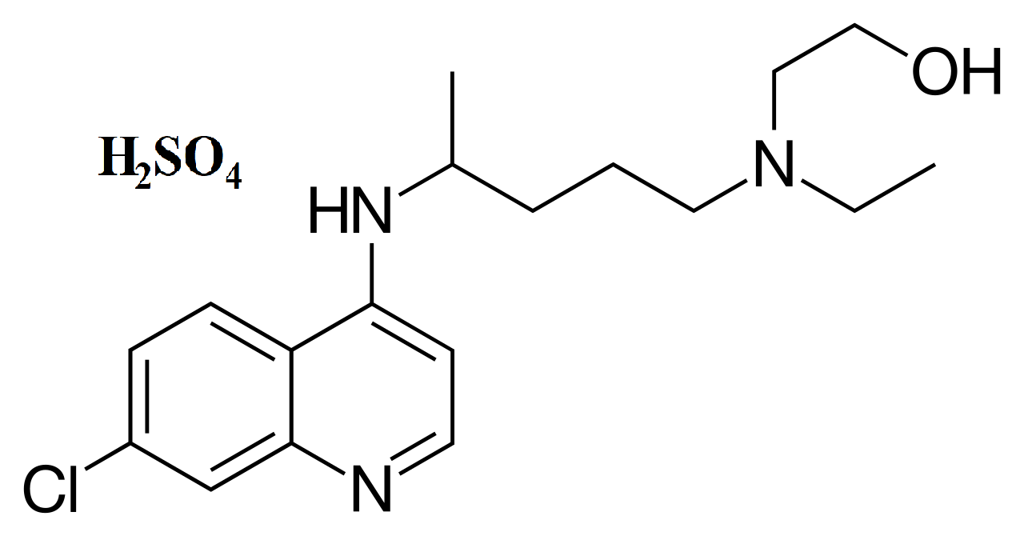
Chemical formula | C₁₈H₂₆Cl N₃ O * H₂ SO₄
Molecular Weight | 433.95 g mol⁻¹
Elimination half-life | Between 30 and 60 days
Solubility in Water at 25°C | 26.10 mg L⁻¹
pKa₁ /pKa₂ | 7.28 / 9.76
Main absorption wavelengths | 220, 257, 325, and (λ_{max}) 334 nm

Table S2. Coded Coefficients for the degradation of hydroxychloroquine using the Fe(0)/ $S_{2}O_{8}^{2-}$/UV system.
Term | Coef | SE Coef | T-Value | P-Value | VIF
Constant | 74.74 | 3.48 | 21.49 | 0.000
[Fe(0)] | 8.37 | 1.74 | 4.81 | 0.000 | 1.00
pH | -6.65 | 1.74 | -3.83 | 0.002 | 1.00
$${[S}_{2}O_{8}^{2-}]$$ | 8.26 | 1.74 | 4.75 | 0.000 | 1.00
[HCQ] | -22.03 | 1.74 | -12.67 | 0.000 | 1.00
[Fe(0)]*[Fe(0)] | -2.75 | 2.61 | -1.05 | 0.313 | 1.25
pH*pH | -8.55 | 2.61 | -3.28 | 0.007 | 1.25
$[S_{2}O_{8}^{2-}]$*${[S}_{2}O_{8}^{2-}]$ | -1.88 | 2.61 | -0.72 | 0.484 | 1.25
[HCQ]*[HCQ] | -10.40 | 2.61 | -3.99 | 0.002 | 1.25
[Fe(0)]*pH | -4.16 | 3.01 | -1.38 | 0.192 | 1.00
[Fe(0)]*${[S}_{2}O_{8}^{2-}]$ | 10.18 | 3.01 | 3.38 | 0.005 | 1.00
[Fe(0)]*[HCQ] | 3.70 | 3.01 | 1.23 | 0.243 | 1.00
pH*${[S}_{2}O_{8}^{2-}]$ | -4.96 | 3.01 | -1.65 | 0.125 | 1.00
pH*[HCQ] | -11.26 | 3.01 | -3.74 | 0.003 | 1.00
${[S}_{2}O_{8}^{2-}]$*[HCQ] | 15.62 | 3.01 | 5.18 | 0.000 | 1.00

