Supplementary information
For the paper
Biosorption of selected heavy metals on wild thyme to prepare antibacterial agents
Mária Kováčová ^{1,2}, Halyna Yankovych ^{1,2}, Adrian Augustyniak ^{3,4}, Mariano Casas Luna ⁵, Michaela Remešová ⁵, Lenka Findoráková ¹, Martin Stahorský ^{1,2}, Ladislav Čelko ⁵, Matej Baláž ^{1,*}
¹ Institute of Geotechnics, Slovak Academy of Sciences, Watsonova 45, 040 01 Košice, Slovakia
² Faculty of Materials, Metallurgy and Recycling, Technical University of Košice, Letná 9, 042 01 Košice, Slovakia
³ Chair of Building Materials and Construction Chemistry, Technische Universität Berlin, Gustav-Meyer-Allee 25, 13355 Berlin, Germany
⁴ Faculty of Chemical Technology and Engineering, The West Pomeranian University of Technology in Szczecin, Piastów Avenue 42, 71 065 Szczecin, Poland
⁵ Central European Institute of Technology, Brno University of Technology, Purkyňova 656/123, 612 00 Brno, Czech Republic
* corresponding author: balazm@saske.sk

Table S1 The results of preliminary experiment with model solution
Sample | Concentration of element (mg L⁻¹)
Sample | Fe | Cu | Zn | Co | Cd | Al | Pb
Model solution | 18.9 | 20.1 | 18.2 | 20.4 | 20.1 | 19.7 | 22.1
Thymus serpyllum L. | 5 | 11.6 | 14.3 | 16.4 | 16.2 | 14.7 | 7.5

Figure S1 shows the adsorption capacity (q_{t}) values for the adsorption of Cu(II) ions at three different concentrations. The obtained results were the most consistent at c = 200 mg L⁻¹. The q_{t} value at c = 1000 mg.L⁻¹ after 5 minutes was the highest of all samples (q_{t} = 42.25 mg g⁻¹), however, the rest of the results obtained at this concentration were not representative, most probably due to the additional dilution which created the error. The adsorption capacity was below 8 mg g⁻¹ for all samples at c = 20 mg L⁻¹. The highest q_{t} value for c = 200 mg L⁻¹ was acquired after 10 minutes of adsorption (q_{t} = 28.6 mg g⁻¹).

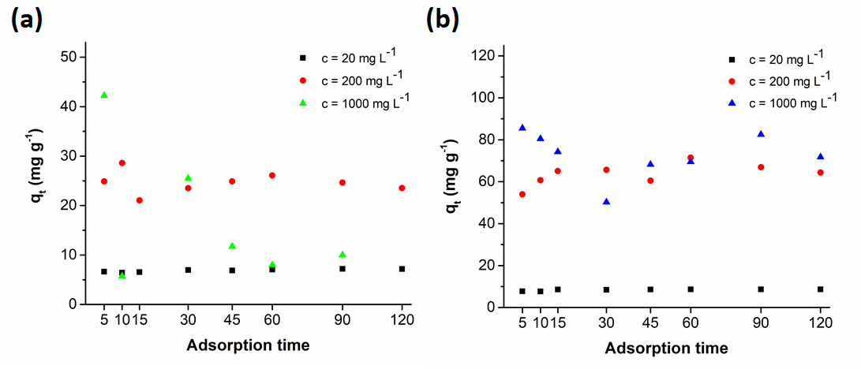

Figure S1 Adsorption of Cu(II) (a) and Pb (II) ions at three different concentrations
Figure S2 displays the q_{t} values for the adsorption of Pb(II) ions at three different concentrations. We obtained the lowest q_{t} values at c = 20 mg L⁻¹ (q_{t} < 9 mg g⁻¹) which was quite distinct from the other two concentrations. During first 15 minutes of the adsorption, the adsorption capacity was better at c = 1000 mg L⁻¹ but after 30 minutes, better q_{t} value (q_{t} = 65.65 mg g⁻¹) was achieved at c = 200 mg L⁻¹. The adsorption capacity for the samples after 45 minutes at concentrations 200 and 1000 mg L⁻¹ were not very different from the sample at c = 200 mg L⁻¹ after 30 minutes of adsorption. The slightly better adsorption capacities were achieved at c = 200 mg L⁻¹ after 60 minutes (q_{t} = 71.45 mg g⁻¹) and at c = 1000 mg L⁻¹ after 90 and 120 minutes of contact time and the adsorption capacities were 82.5 mg g⁻¹ and 71.75 mg g⁻¹, respectively.

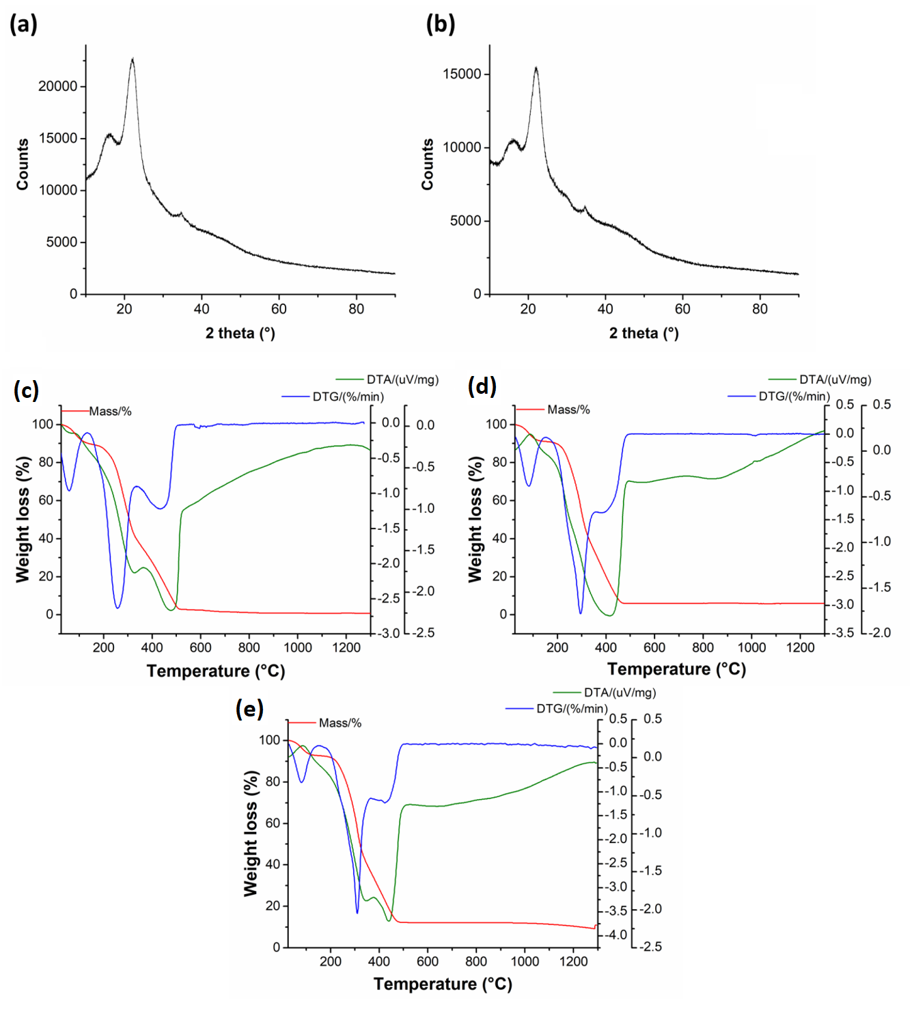
Figure S2 Characterization of metal-laden adsorbents: X-ray diffractograms of (a) Cu-SER and (b) Pb-SER samples; TG/DTG and DTA curves of (c) native Thymus serpyllum biosorbent and (d) Cu-SER and (e) Pb-SER samples.

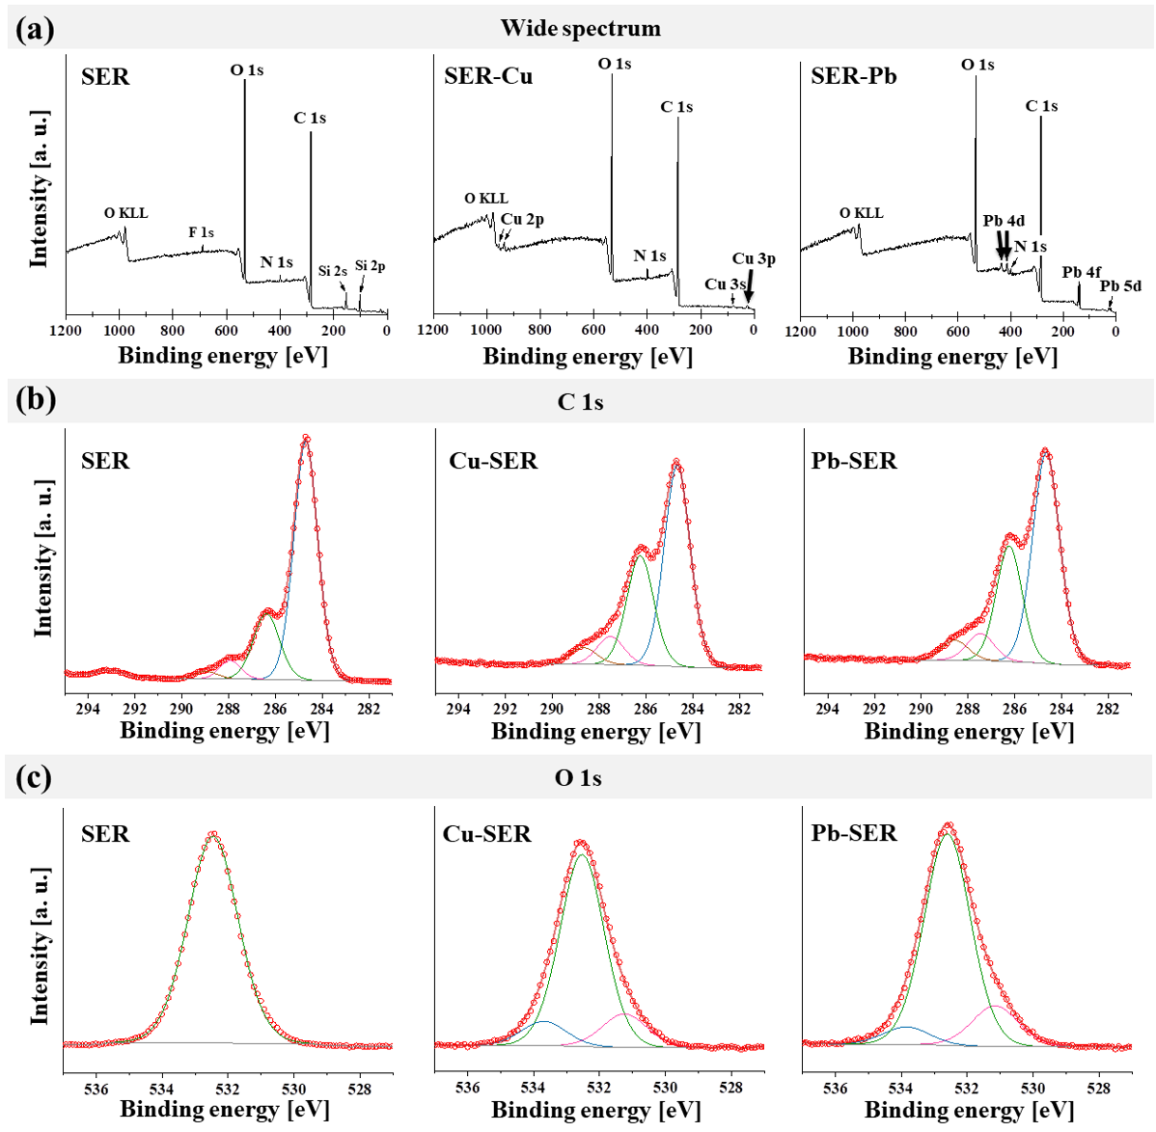
Figure S3 XPS spectra of pure SER biosorbent before and after Cu and Pb adsorption: a) survey spectra; b) high-resolution spectra and deconvolution of C 1s peak; c) high-resolution spectra and deconvolution of O 1s peak.

Table S2 The binding energies of C1s, O1s, N1s, Pb4f and Cu2p before and after adsorption
Element | SER | Pb-SER | Cu-SER | Assignment
O 1s | - | 531.2 eV | 531.4 eV | Metal carbonates, metal oxides, metal hydroxides
O 1s | 532.5 eV | 532.6 eV | 532.5 eV | Organic C-O-, C=O,
N 1s | 399.9 eV | 399.8 eV | 399.9 eV | -NH-; -NH₂
C 1s | 284.7 eV | 284.7 eV | 284.7 eV | Graphite, C-C, -CH-
C 1s | 286.4 eV | 286.2 eV | 286.2 eV | -C-O-C-, -C-OH, ether -C-O
C 1s | 287.9 eV | 287.5 eV | 287.5 eV | -C=O
C 1s | 288.9 eV | 288.6 eV | 288.2 | -C-F, O=C-OH
Pb 4f | - | 138.9 eV 4f_{7/2}  143.7 eV 4f_{5/2}  Δ=4.8 eV | - | Pb(OH)₂, PbCO₃
Cu 2p | - | - | 933.3 eV 2p_{3/2}  953.2 eV 2p_{1/2}  Δ=19.9 eV | CuO

Table S3 The release of alkali- Na(I), K(I) and alkaline earth- Ca(II), Mg(II) metals into the aqueous solution of pure Thymus serpyllum L. plant
 | Concentration of element (mEq g⁻¹)
Sample | Na | K | Ca | Mg | ∑
Cu concentration (mg L⁻¹)
10 | 0.10 | 12.12 | 2.01 | 3.44 | 17.67
50 | 0.12 | 11.26 | 2.02 | 3.35 | 16.75
75 | 0.12 | 11.69 | 2.42 | 3.82 | 18.05
100 | 0.10 | 12.12 | 3.05 | 4.29 | 19.56
150 | 0.15 | 11.41 | 4.26 | 4.51 | 20.34
250 | 0.20 | 13.07 | 8.33 | 6.42 | 28.02
500 | 0.12 | 12.25 | 8.07 | 6.23 | 26.68
750 | 0.14 | 12.67 | 8.44 | 6.60 | 27.84
1000 | 0.14 | 12.82 | 9.43 | 7.15 | 29.54
Thymus serpyllum L. | 0.11 | 11.02 | 1.63 | 2.86 | 15.62
Pb concentration (mg L⁻¹)
10 | 0.2 | 9.7 | 1.8 | 3.0 | 14.7
50 | 0.1 | 11.0 | 2.1 | 3.5 | 16.8
75 | 0.1 | 9.7 | 2.1 | 3.3 | 15.2
100 | 0.1 | 10.7 | 2.8 | 4.5 | 18.0
150 | 0.1 | 11.1 | 3.2 | 4.4 | 18.8
250 | 0.1 | 10.7 | 4.2 | 3.6 | 18.7
500 | 0.2 | 10.5 | 5.4 | 4.3 | 20.4
750 | 0.3 | 17.9 | 9.3 | 8.1 | 35.6
1000 | 0.1 | 10.4 | 7.2 | 4.8 | 22.5
Thymus serpyllum L. | 0.1 | 10.4 | 2.0 | 3.4 | 16.0

