Additional file 1 Change of HER2 status between primary tumor and metastasis in the HER2-negative cohort (n=127)

 |  | Metastasis
Primary tumor |  | HER2-zero  (n=31, 24.4%) | HER2-low  (n=86, 73.5%) | HER2 positive  (n=31, 24.4%)
Primary tumor | HER2-zero  (n=49, 38.6%) | 13 (10.2%) | 34 (26.8%) | 2 (1.6%)
Primary tumor | HER2-low  (n=78, 61.4%) | 18 (14.2%) | 51 (40.2%) | 9 (7.1%)

Additional file 2 Change of HER2 status between primary tumor and metastasis in the entire cohort (n=148)

 |  | Metastasis
Primary tumor |  | HER2-zero  (n=31, 20.9%) | HER2-low  (n=86, 58.1%) | HER2 positive  (n=31, 20.9%)
Primary tumor | HER2-zero  (n=49, 33.1%) | 13 (8.8%) | 34 (23.0%) | 2 (1.4%)
Primary tumor | HER2-low  (n=78, 52.7%) | 18 (12.2%) | 51 (34.5%) | 9 (6.1%)
Primary tumor | HER2 positive  (n=21, 14.2%) | 0 | 1 (0.7%) | 20 (13.5%)

Additional file 3 Change of HER2 status between primary tumor and metastasis in the entire cohort (n=148)
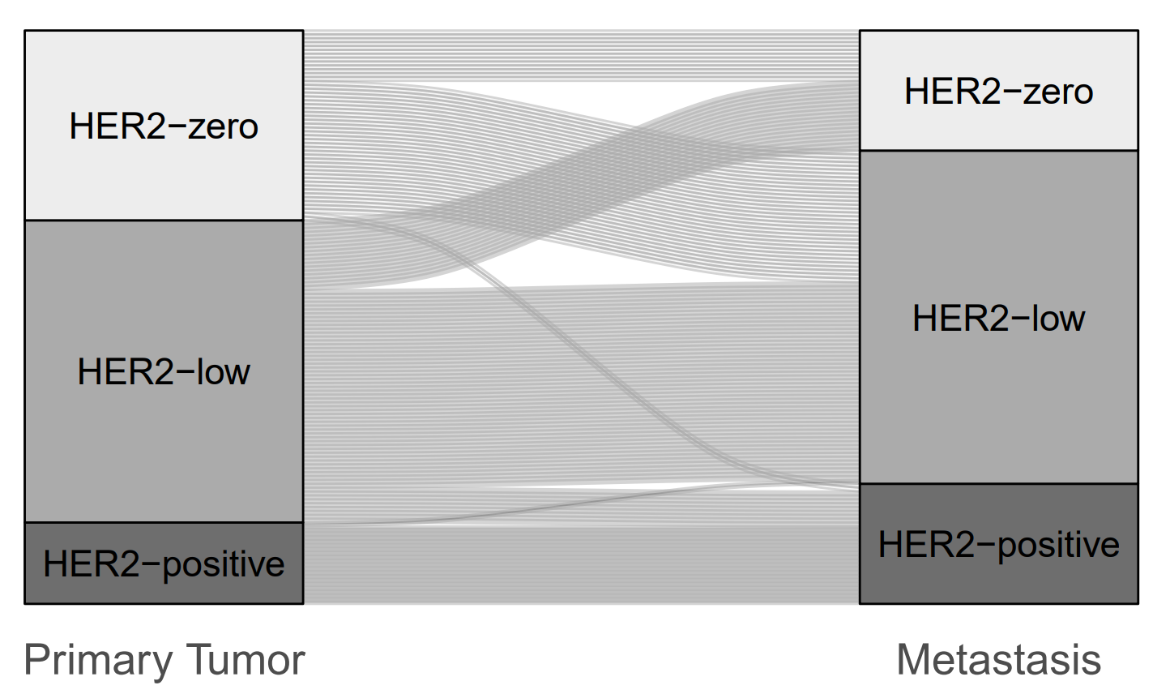

Additional file 4 Change of HER2 status in different metastatic sites in the HER2-negative cohort (n=127)
 | No change | HER2 change
 |  | Total | HER2-zero to HER2-low | HER2-low to HER2-zero | HER2-zero to HER2 positive | HER2-low to HER2 positive | Kappa (95% CI)
Bone metastasis  n=36 | 16 (44.4%) | 20 (55.6%) | 6 (16.7%) | 8 (22.2%) | 2 (5.6%) | 4 (11.1%) | 0.022  (-0.230 – 0.273)
Liver  n=44 | 26 (59.1%) | 18 (40.9%) | 13 (29.5%) | 3  (6.8%) | 0 | 2 (4.5%) | 0.048  (-0.195 – 0.291)
Lung / Pleura  n=6 | 6  (100.0%) | 0 | 0 | 0 | 0 | 0 | 1.0  (1.0 -1.0)
Skin / Soft tissue  n=16 | 9  (56.3%) | 7 (43.7%) | 4 (25.0%) | 2  (12.5%) | 0 | 1 (6.3%) | 0.082  (-0.363 – 0.527)
Lymph node  n=4 | 2  (50.0%) | 2 (50.0%) | 2 (50.0%) | 0 | 0 | 0 | 0.000  (0.000 – 0.000)
CNS  n=10 | 2  (20.0%) | 8 (80.0%) | 5 (50.0%) | 1  (10.0%) | 0 | 2 (20.0%) | -0.250  (-0.606 – 0.106)
Others  n=11 | 3  (27.3%) | 8 (72.2%) | 4 (36.4%) | 4 (36.4%) | 0 | 0 | -0.467  (-0.980 – 0.047)

Additional file 5 Change of HER2 status in different metastatic sites (n=148)
 | No change | HER2 change
 |  | Total | HER2-zero to HER2-low | HER2-low to HER2-zero | HER2-zero to HER2 positive | HER2-low to HER2 positive | Kappa (95% CI)
Bone metastasis  n=38 | 18 (47.4%) | 20 (52.6%) | 6 (15.8%) | 8 (21.1%) | 2 (5.3%) | 4 (10.5%) | 0.124  (-0.134 - 0.383)
Liver  n=50 | 32 (64.0%) | 18 (36.0%) | 13 (26.0%) | 3  (6.0%) | 0 | 2 (4.0%) | 0.332  (0.095 – 0.570)
Lung / Pleura  n=9 | 8  (88.9%) | 1 (11.1%) | 0 | 0 | 0 | 0 | 0.795  (0.418 – 1.0)
Skin / Soft tissue  n=18 | 11  (6.1%) | 7 (38.9%) | 4 (22.2%) | 2  (11.1%) | 0 | 1 (5.6%) | 0.315  (-0.095 – 0.725)
Lymph node  n=5 | 3  (60.0%) | 2 (40.0%) | 2 (40.0%) | 0 | 0 | 0 | 0.375  (-0.137 – 0.887)
CNS  n=15 | 7  (46.7%) | 8 (53.3%) | 5 (33.3%) | 1  (6.7%) | 0 | 2 (13.3%) | 0.221  (-0.099 – 0.540)
Others  n=13 | 5  (38.5%) | 8 (61.5%) | 4 (30.8%) | 4 (30.8%) | 0 | 0 | 0.000  (-0.538 – 0.538)

Additional file 6 Change of HER2 status in different metastatic sites (n=148)

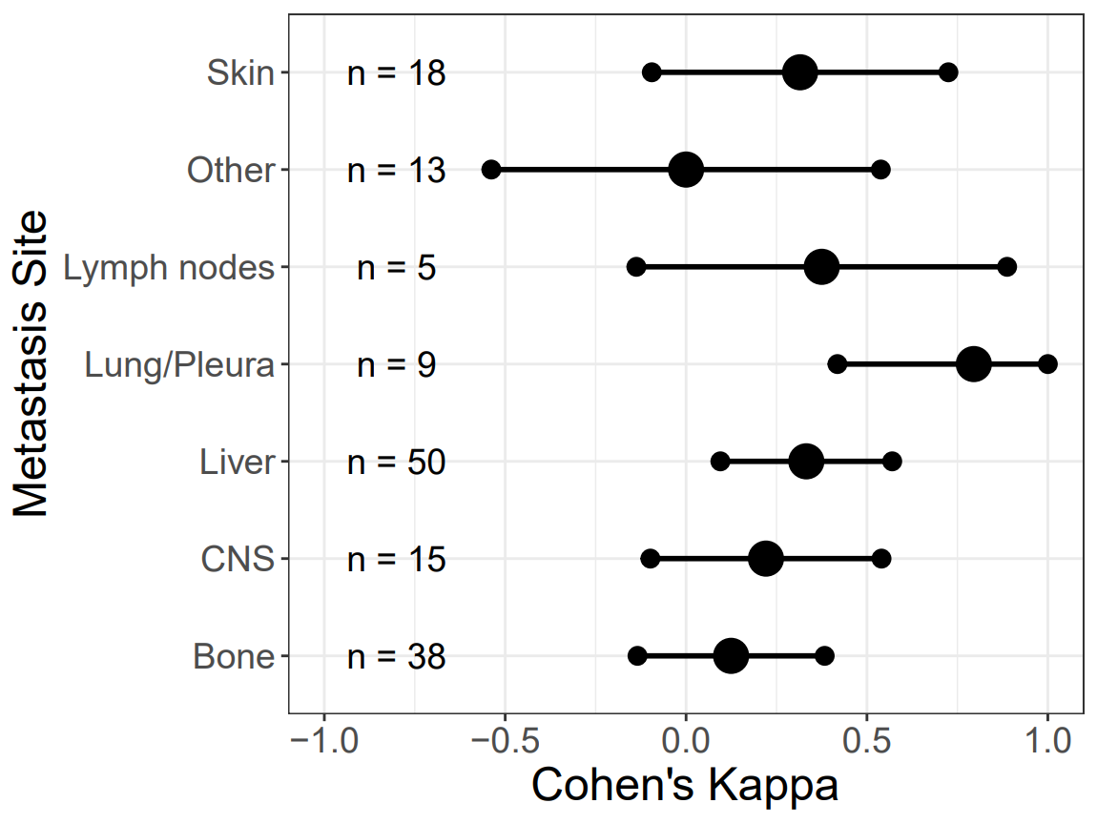

Additional file 7 Change of HER-2 in different molecular subtypes (luminal-like and triple-negative) (n=127)

 | No change | HER2 change
 |  | Total | HER2-zero to HER2-low | HER2-low to HER2-zero | HER2-zero to HER2 positive | HER2-low to HER2 positive | Kappa (95% CI)
Luminal A/B  n= 107 | 54 (50.5%) | 53 (49.5%) | 28 (26.2%) | 16 (15.0%) | 2 (1.9%) | 7 (6.5%) | -0.044  (-0.202 – 0.114)
Triple-negative  n= 20 | 10 (50.0%) | 10 (50.0%) | 6 (30.0%) | 2 (10.0%) | 0 | 2 (10.0%) | 0.107  (-0.247 – 0.461)

Additional file 8 Change of HER-2 in different molecular subtypes (luminal-like and triple-negative) (n=127)
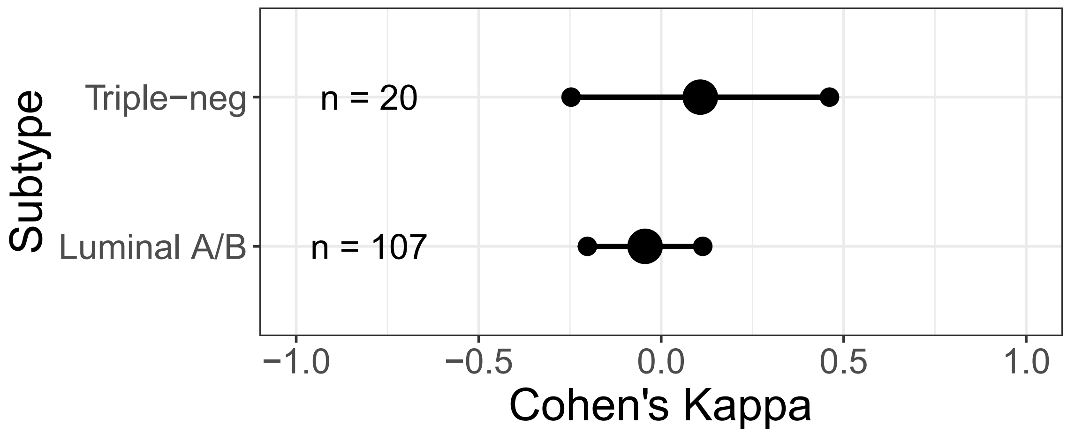

Additional file 9 Change of HER2 status between primary tumor and metastasis in the de-novo cohort (n=53)
 |  | Metastasis
Primary tumor |  | HER2-zero  (n=9, 17.0%) | HER2-low  (n=29, 54.7%) | HER2 positive  (n=15, 28.3%)
Primary tumor | HER2-zero  (n=8, 15.1%) | 2 (3.8%) | 6 (11.3%) | 0
Primary tumor | HER2-low  (n=31, 58.5%) | 7 (13.2%) | 22 (41.5%) | 2 (3.8%)
Primary tumor | HER2 positive  (n=14, 26.4%) | 0 | 1 (1.9%) | 13 (24.5%)

Additional file 10 Change of HER2 status between primary tumor and metastasis in the secondary metastatic breast cancer cohort (n=95)
 |  | Metastasis
Primary tumor |  | HER2-zero  (n=22, 23.2%) | HER2-low  (n=57, 60.0%) | HER2 positive  (n=16, 16.8%)
Primary tumor | HER2-zero  (n=41, 43.2%) | 11 (11.6%) | 28 (29.5%) | 2 (2.1%)
Primary tumor | HER2-low  (n=47, 49.5%) | 11 (11.6%) | 29 (30.5%) | 7 (7.4%)
Primary tumor | HER2 positive  (n=7, 7.4%) | 0 | 0 | 7 (7.4%)

