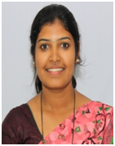
Sahana B has received her M.Tech in Computer Network Engineering from Dayananda Sagar College of Engineering. Currently, she is working as Assistant Professor in department of Electronics and Communication, RV College of engineering. She has 14 years of teaching experience. Her areas of interests are Communication Systems and Networking. She contributed to the research work in problem statements, identification, literature survey, modeling and preparing the manuscript.


Diksha Dinesh has received her B.Tech in department of Electronics and Communication from RV College of engineering, Banglore, India. His research area mainly includes Artificial Intelligence and Machine learning.


Deekshith K N has received her B.Tech in department of Electronics and Communication from RV College of engineering, Banglore, India. His research area mainly includes Artificial Intelligence and Machine learning.


A V Sruthi has received her B.Tech in department of Electronics and Communication from RV College of engineering, Banglore, India. His research area mainly includes Artificial Intelligence and Machine learning.

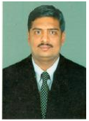
Dr Abhay Deshpande has received his PhD from VTU in the year 2012. Currently, he is working as Associate Professor in the department of Electronics and Communication, RV College of engineering. He has 11 years of teaching experience. His areas of interests are Robotics, Control Systems, Sensors and Networking. He has provided guidance for framing the article, indexing, and strategic of the work. This work was carried out under his co-supervision. He also supported in reviewing the manuscript.
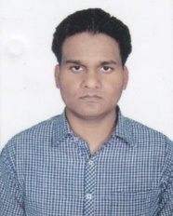
Rahul Priyadarshi Completed B.Tech degree in Electronics and Communication engineering from Amrita school of engineering, Bangalore in 2013. He also worked as Software Engineer in Cognizant Technology Solution from 2013-14. His M.Tech. degree in Communication System & Network from National Institute of Technology Hamirpur (H.P), India in 2018. He is Gold medalist at M.Tech Level. Recently he got featured in Stanford University’s list of top two per cent of researchers across the world. Currently, he is a research scholar and pursuing Ph.D. in department of Electronics and Communication Engineering from National Institute of Technology Patna (Bihar), India. He has published more than 40 research papers in internationally reputed journals and conferences. His research area mainly includes Wireless Sensor Networks.
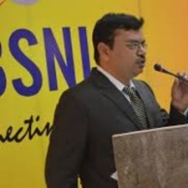
Dr Vijay Nath is working as Associate Professor in the Department of Electronics and Communication Engineering, BIT Mesra. He has 20 years of experience in teaching & research. His areas of interests are Low Power VLSI Design, Ultra Low Power Temperature Sensors for Missiles Applications, Micro-electronics Engineering, Mixed Signal Design, ASIC Design, Embedded System Design, Cardiac Pacemaker, Internet of Things, Artificial Intelligence & Machine Learning etc. He has guided 3 Ph.D. students in his discipline and 5 Ph.D. students are continuing work with him. He has also guided 20 M.Tech Students. He has completed two projects in which First Project funded by DST New Delhi & DRDL Hyderabad, Second Project funded by MHRD New Delhi, and Third Project Design of CMOS Temperature Sensor for Aerospace Applications is ongoing stage funded by RESPOND ISRO Bangalore, Govt. of India. He has more than 200 SCI and Scopus publications in his credit. He is Editor of NCCS, MCCS, MCMI, NMIC book series of LNEE, Springer. He has developed Pedagogy e-learning course on VLSI Design under NMICT Govt. of India. He is member of several professional Society ISVE, IETE, ISTE & IEEE etc. He provided many valuable feedbacks and suggestions to prepare this article. This work was carried out under his supervision. He also helped in reviewing and updating the manuscript.

