Design and implementation of the M4A trial: Supplementary figures

Supplementary Figure S1. Visual schedule used to facilitate scanning used in Bergen (example)

A trip to the MR

 | Drive car to Haukeland
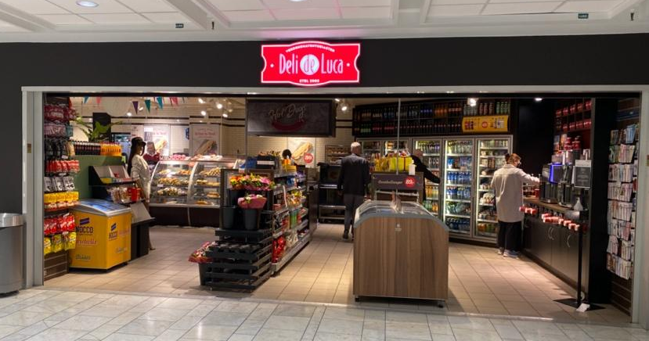 | Go to Deli de Luca and wait for Marianna
 | Meet Marianna
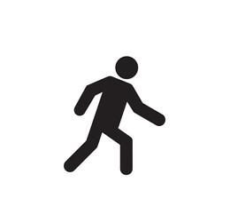 | Walk together to the MR U3 room
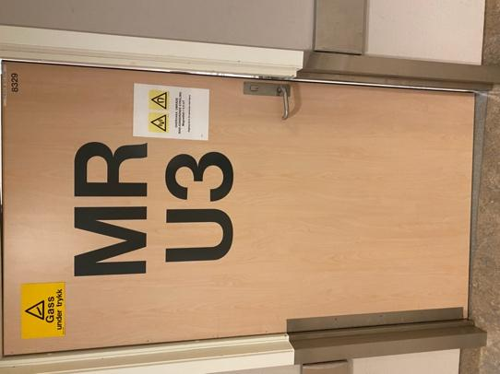 | Go in the door MR U3
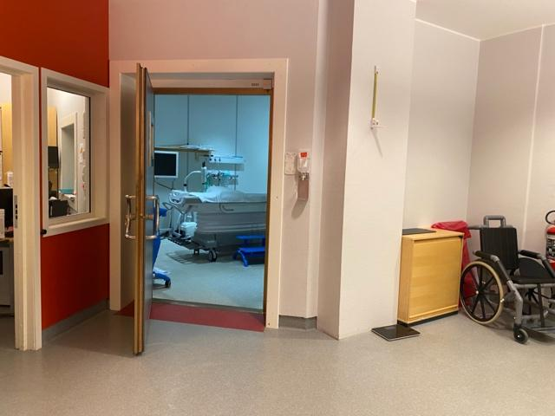 | Go in the room
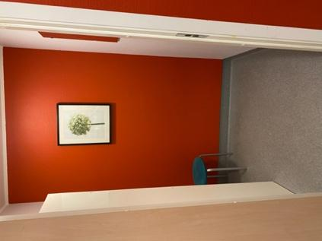 | Go in the closet and take off jacket
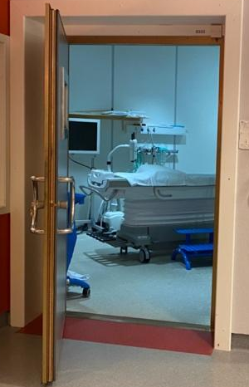 | Go in the door to the MR room
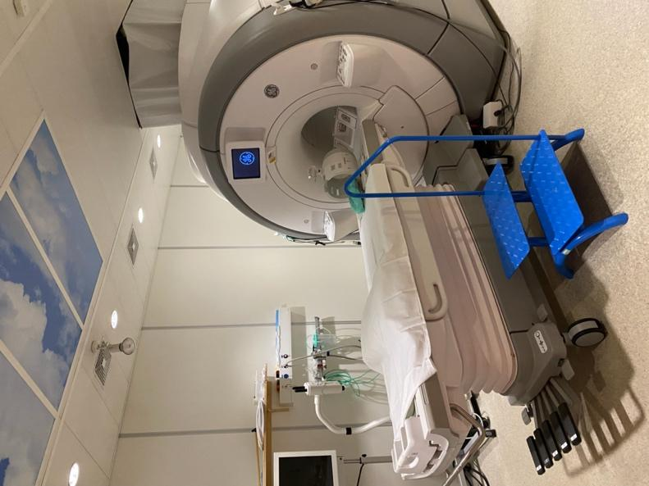 | Lay on bench
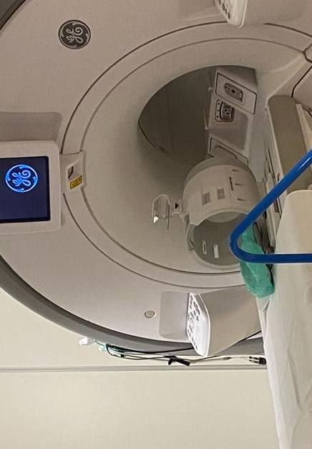 | Put head on the pillow in the machine
 | Watch Tom and Jerry
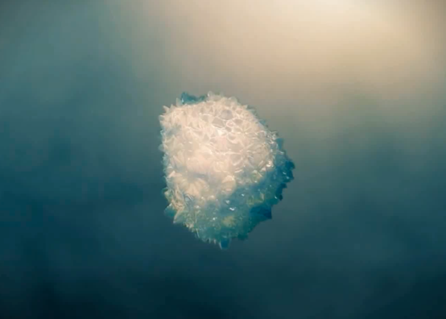 | Watch a film and listen to music
 | Watch Tom and Jerry one more time
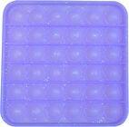 | Receive a prize
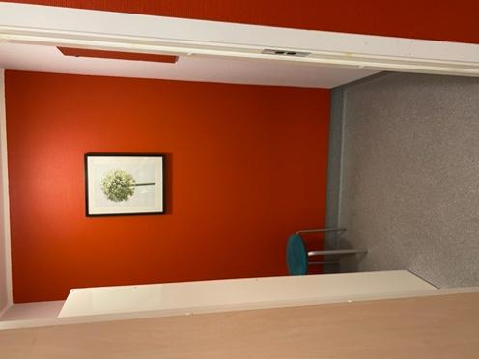 | Put clothes on
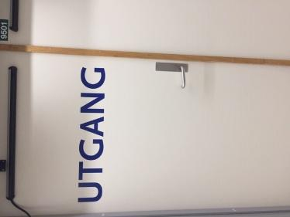 | Go out the door that says Exit
 | Go in the car

Note. Similar, individually adapted visual schedules were used for different children.

Supplementary Figure S2. Completeness of data
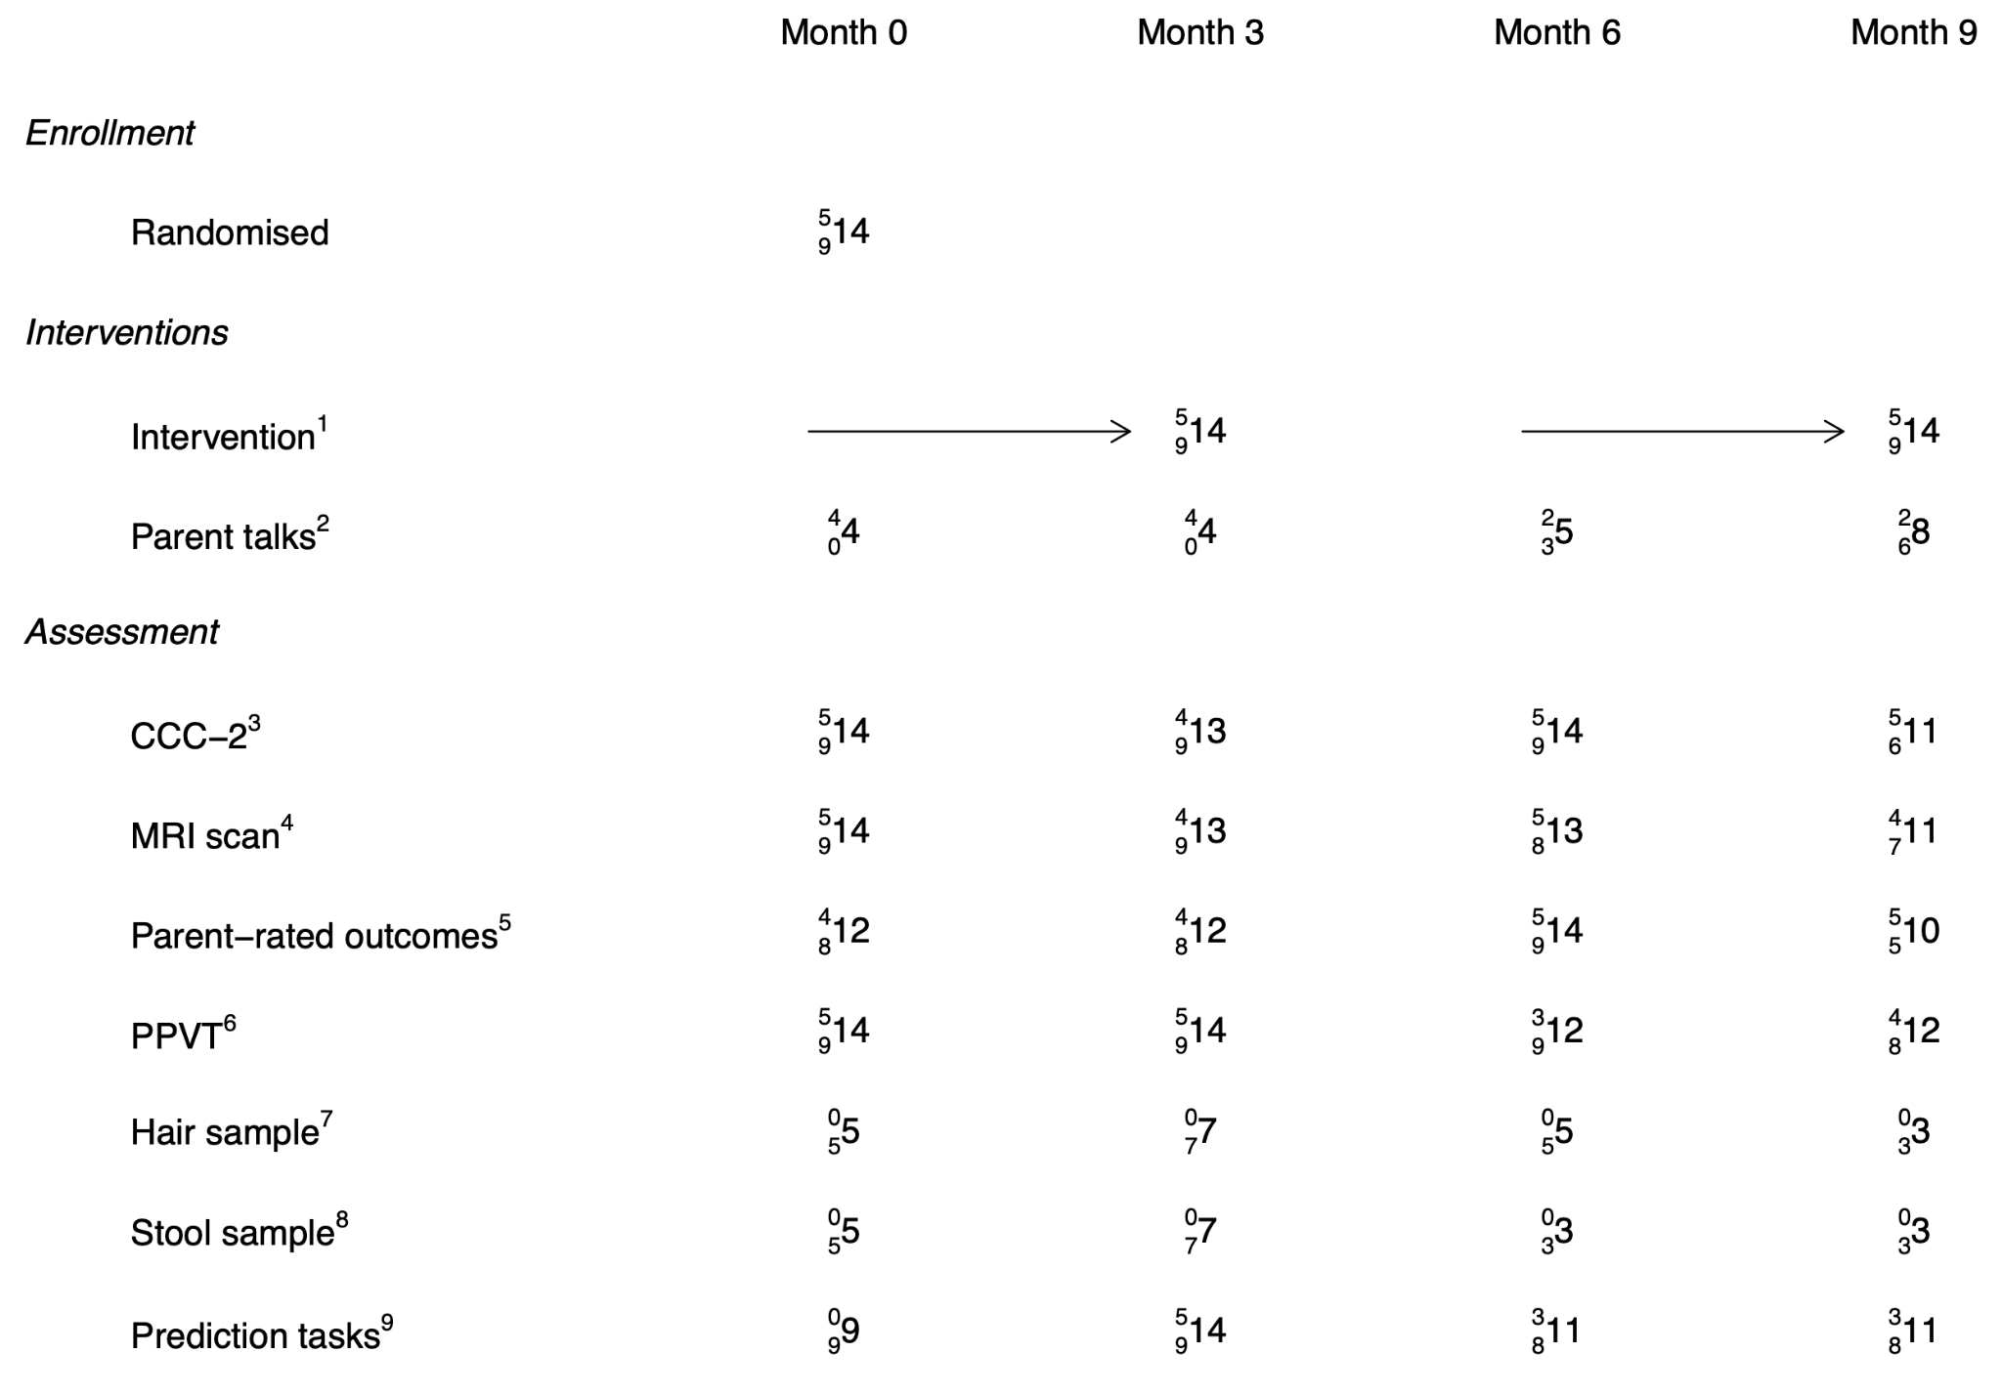
Note. This figure is based on the SPIRIT schedule of assessments and interventions (as Fig. 2), but shows in addition the numbers completed (large number = total; upper = Bergen; lower = Vienna). ¹The arrow indicates that interventions were offered continuously during the periods shown; the numbers indicate how many started the intervention, i.e. received at least one session. ²Parent talks offered by therapists were optional at each time point (beginning and end of each intervention period). ³Number of participants whose teachers completed the CCC-2 (Children’s Communication Checklist, primary outcome, blinded). ⁴Number of participants who completed a structural and functional MRI scan. ⁵Number of participants whose parents completed the questionnaires. ⁶Peabody Picture Vocabulary Test, completed with a blinded professional. ⁷Number of participants for whom parents provided hair samples. ⁸Number of participants for whom parents provided stool samples; not done in Bergen during first wave. ⁹Number of participants who completed prediction tasks.

Supplementary Figure S3. Framewise displacement during resting-state fMRI scan
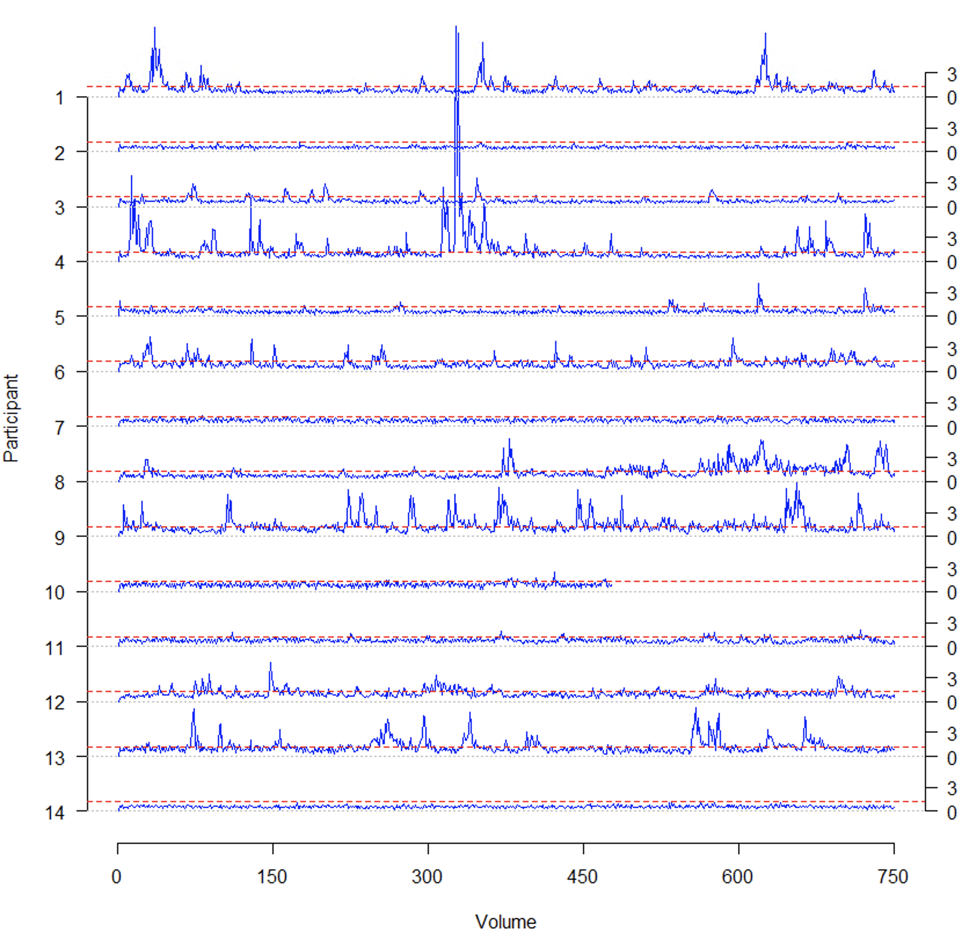

Plot of framewise displacement (FD) for each participant’s resting state data at baseline. On the x-axis the number of volumes is indicated and on the y-axis the participant is shown. FD is plotted in mm. The raw FD (square-root transformed for better visibility) is indicated in blue. An FD threshold (=0.5 mm) is shown in red.

