Table 1 Relevant clinical, laboratory and therapeutic data on patients
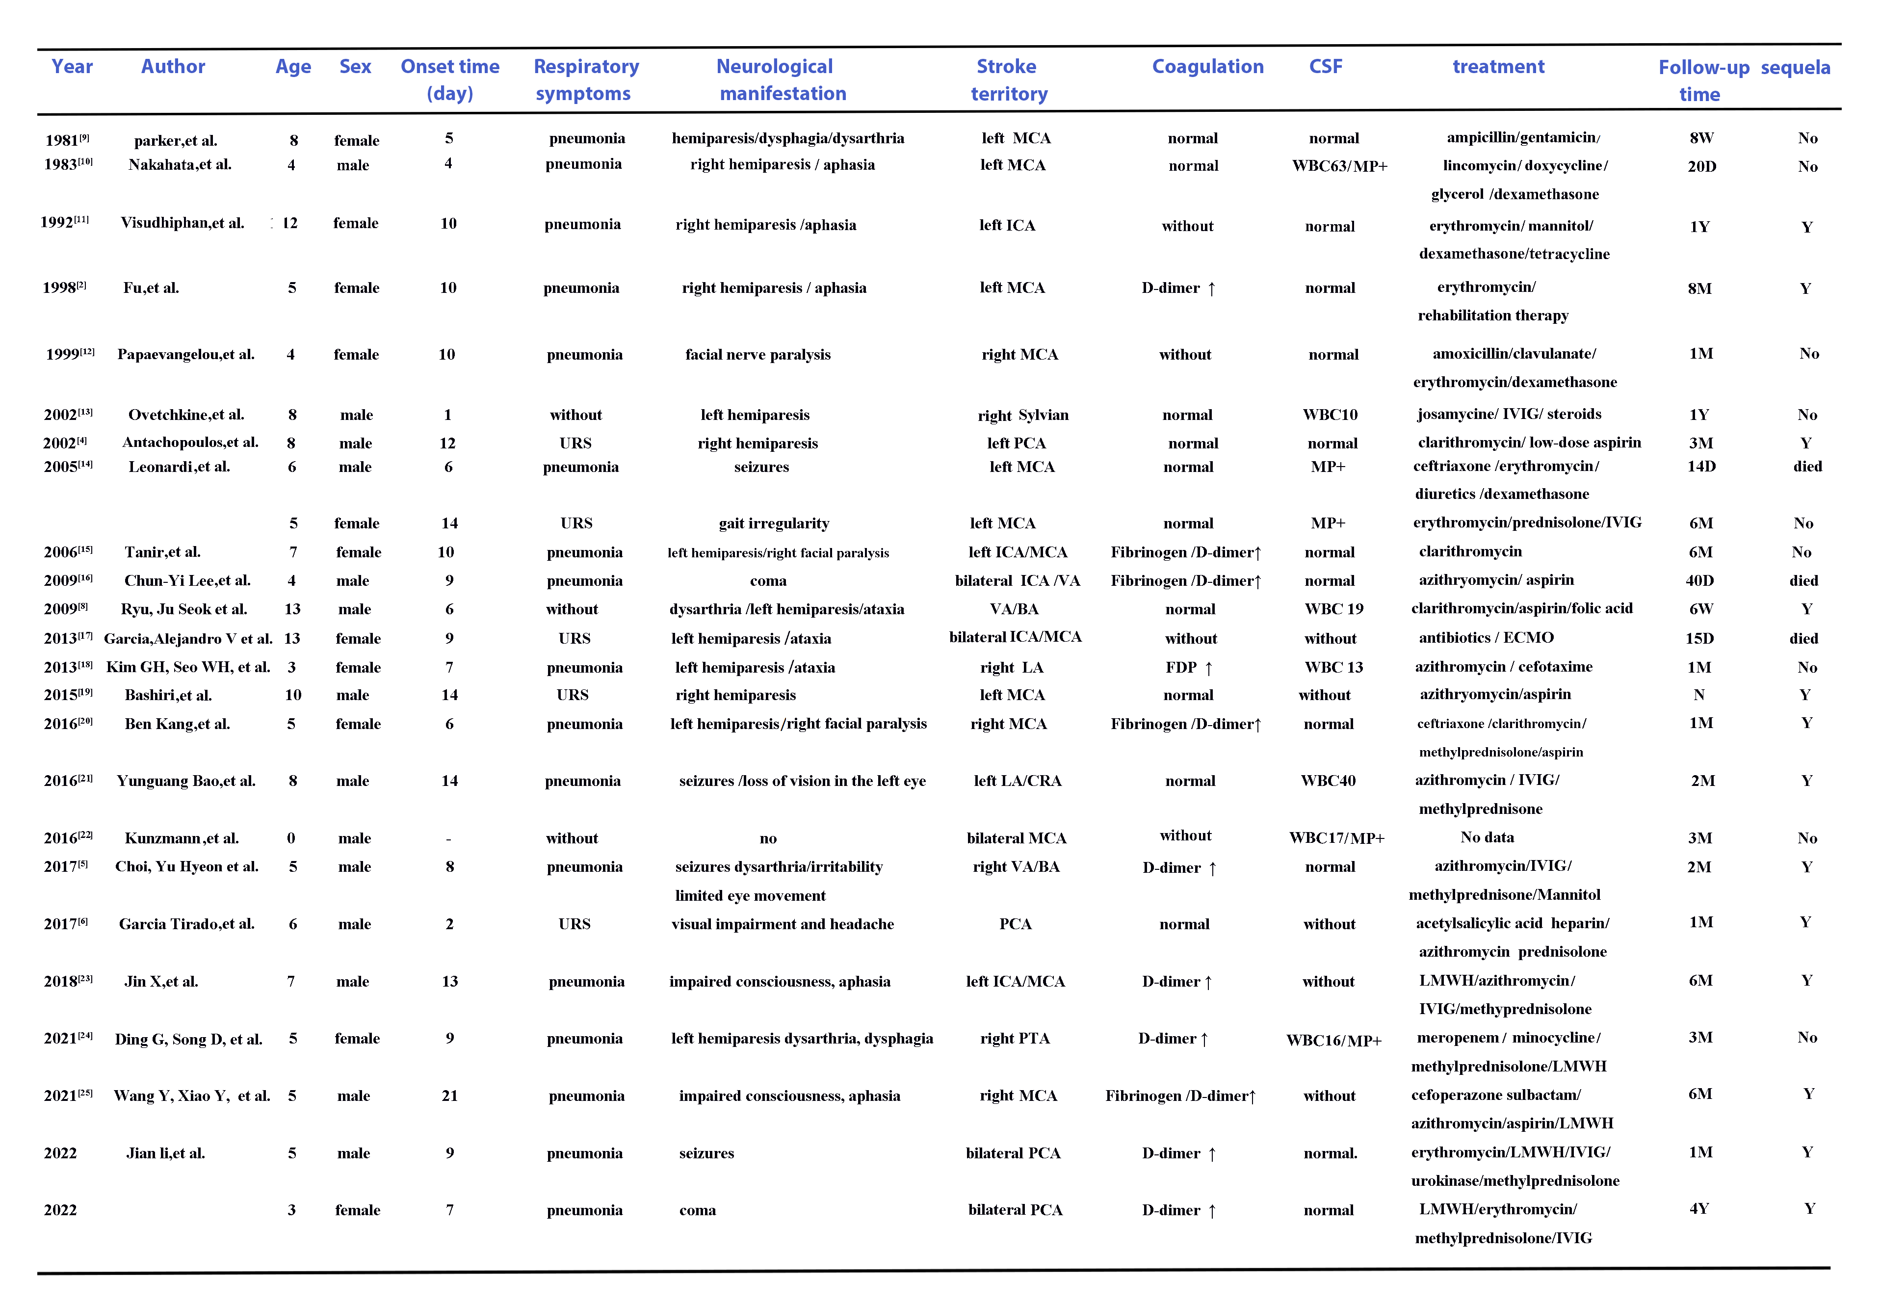

Abbreviations:
URS: Upper respiratory symptoms；MP: Mycoplasma; MCA:Middle cerebral artery; ICA:Internal Carotid Artery; PCA:Posterior cerebral arteries; VA:Vertebral arteries; BA: Basal arteries; LA:Lenticular artery; CRA:Central retinal artery ;PTA:Post Traffic Artery;FDP:Fibrin degradation product; IGIV: Intravenous Immunoglobulin; LMWH: low molecular weight heparin; PCR: Polymerase chain reaction
** Inclusion Criteria for Pediatric Patients with Mycoplasma Pneumoniae Associated Stroke: All patients developed ischemic stroke within 4 weeks of MP infection, and MP infection was demonstrated serologically with assays including ELISA, complement fixation, cold agglutinin assay, or PCR.

