Supporting information
Insights into oxygen mass transport mechanisms in high-temperature proton exchange membrane fuel cells with microelectrode
Sifan Chen ª, Jianchun Niu ª, Shuomeng Zhang ª, Qinghua Zhang ^{a, *}, Shiyuan Chen ^{b}, Liang Wu ^{c,*}, Jianlin Zhang ^{d}, Miao Wang ^{b}, Shanfu Lu ^{d}, Qinggang He ^{a,*}
ª College of Chemical and Biological Engineering, Zhejiang University, Hangzhou, Zhejiang, 310027, China
^{b} Zhejiang Province Key Laboratory of Quantum Technology and Device, Department of Physics, Zhejiang University, Hangzhou, 310027, China
^{c} Department of Chemical Engineering, Shanghai Jiao Tong University, Shanghai 200240, China
^{d} Beijing Key Laboratory of Bioinspired Energy Materials and Devices, School of Space and Environment, Beihang University, Beijing, 100191, China

CONTENTS
1. Material Synthesis S3
1.1 Preparation and pretreatment of PES-PVP membrane S3
2. Methods S3
2.1 Preparation of platinum disk microelectrode S3
2.2 Internal environment control of microelectrode test system S4
2.3 Surface state analysis of platinum disk microelectrode S4
2.4 Cyclic voltammetry (CV) S5
2.5 Potential-step chronoamperometry (CA) S6
2.6 Sampled-current voltammetry (SCV) S7
2.7 Electrochemical surface area (ECSA) S7
3. Theories S9
3.1 The all-atom TEAM force fields S9
3.2 “Sphere-cage” diffusion model S10
3.3 Dual-mode solubility model S12
4. Results S15
5. References S19

Material Synthesis

1.1 Preparation and pretreatment of PES-PVP membrane
Commercial Polyethersulfone (PES，M_{w}≈480,000) and Polyethersulfone (PVP， M_{w}≈1,300,000) of a certain mass ratio (PES: PVP =4: 6) were dissolved in N, N-dimethylformamide (DMF), where the total mass fraction of the polymer was 5wt%, and then stirred at room temperature for 12h to obtain a homogeneous solution. The membrane solutions were poured on clean and dry glass plates, and then dried at 70℃ for 24 hours to obtain PES-PVP polymer films with a thickness of about 50 μm, as measured by a micrometer.
After that, the prepared PES-PVP-60 film was completely immersed in 85wt% PA and soaked at room temperature for 12h. And then the residual PA parts from the solution is removed and pre-treated membrane was placed in a dryer for use.

Methods

2.1 Preparation of platinum disk microelectrode
The preparation methods of platinum-disk microelectrodes were referred to the literature. ^{[1-3]} Briefly, a 25-μm-diameter Pt wire purchased from Goodfellow (Coraopolis, PA, USA) was annealed and placed in the middle of a clean and dry borosilicate capillary (outer diameter: 1.5 mm, inner diameter: 0.86 mm) purchased from Sutter (Novato, CA, USA). A commercial PC-10 puller (Narishige, Japan) was used to evenly stretch the glass tube so that the platinum wire fitted the glass tube tightly, till the glass tube broken evenly in the middle to obtain two Pt electrodes. Then the surface of the Pt electrode was polished with silicon carbide paper (grit P800, P1000, P1500, P2000, P3000 and P5000) and then polished with alumina compound (1, 0.3 and 0.05 μm, CHI, USA).

2.2 Internal environment control of microelectrode test system
In order to achieve the measurement conditions of high temperature and low humidity, the experiment uses silicon oil circulation heating to ensure the temperature of the membrane is uniform and controllable. Meanwhile, the system is closed and the silica gel desiccants are built in, and then the dry gas was pumped into the vacuum operation for three consecutive times and continuous ventilation for 12 h. The setup is connected to electrochemical workstation which is controlled by a computer through GPIB-to-USB cables by means of a software suite.

2.3 Surface state analysis of platinum disk microelectrode
The surface state of Pt disk microelectrode is observed under metallographic microscope, and the obtained microscope picture is shown in Figure S1, in which the highlighted area of the middle circle is metal Pt disk microelectrode and the surrounding circular area is borosilicate glass. In Figure S1a, the surface of Pt disk microelectrode is smooth and regular in shape, and the inner wall of borosilicate glass tube is closely fitted to the outer diameter of Pt wire without defects. In order to further confirm the surface state and response performance of the electrode, a three-electrode system consists of the 25 μm Pt disk microelectrode as the working electrode, 1 cm*1 cm Pt grid electrode as the counter electrode, and the Ag/AgCl electrode (saturated KCl solution) as the reference electrode to test cyclic voltammetry (CV) curves in 1 mM hydroxymethylferrocene (FcMeOH) and 0.1 M KCl electrolyte solution. The whole testing process is completed in the electromagnetic shielding box, the scanning potential window is -0.1~ 0.4V, and the scanning speed is 10 mV s⁻¹. In Figure S1b, it can be seen from the CV curve that the curve presents a typical smooth S-shape, indicating that the surface of the 25 μm Pt disk microelectrode is smooth, without defects and in good response state.
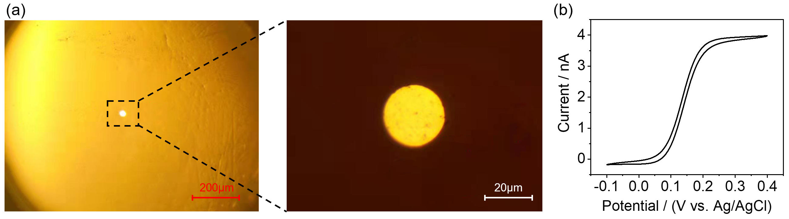
Figure S1. (a) Microscopic images of the 25 μm Pt disk microelectrode. (b) Cyclic voltammetry curve of the 25 μm Pt disk microelectrode in 1 mM hydroxymethylferrocene (FcMeOH) at the presence of 0.1 M KCl

2.4 Cyclic voltammetry (CV)
In this experiment, the cyclic voltammetry (CV) in O₂ and Ar atmosphere is used to determine the potential range of the ORR at the Pt/membrane interface under experimental conditions. Continuous ventilation for 12h allowed the gas to dissolve in the membrane to reach equilibrium. Then circulation oil bath is used to evenly heat the electrochemical test system until the system temperature reached the specified temperature and stabilized for 10 minutes before the electrochemical test began. Then, the test system is continuously heated by the heating device, and after a period of time, the system temperature reaches the specified temperature and stabilize for 10 minutes before starting the electrochemical test. Meanwhile, the electrochemical surface area (ECSA) of the microelectrode surface is obtained by calculating the area of hydrogen underpotential deposition combined with CV curve, and the details are described in support information.

2.5 Potential-step chronoamperometry (CA)
A potential-step chronoamperometry (CA) is used to obtain the mass transport coefficients of O₂ in the binder by changing the current response of the ORR reaction with time under experimental conditions. In an O₂ atmosphere, the CA measurement is performed by applying an initial potential V_{i} (at which no electrochemical reaction occurs) to the system for 5 s, followed by a step to a final potential V_{f} for 5 s (at which the ORR occurs). The potential-step CA measurement is repeated by changing the final potential V_{f} gradually in 25 mV increments while keeping the initial potential Vi constant with a potentiostat (Autolab PGSTAT204) equipped with an ultralow current precision channel.

2.6 Sampled-current voltammetry (SCV)
In order to avoid complex numerical solutions or approximations in the calculation of diffusivity and solubility process, the potential range of ORR under mass-transfer-limited control, in which the electrolytic current is no longer influenced by the potential, is determined first. Sampled-current voltammetry (SCV) is performed by sampling the resulting current at fixed time τ from the I-τ curve obtained by CA at a set time and plotting I(τ) versus V_{f}. Then the current plateau on the I(τ) -V_{f} curve are substituted into the equation to obtain solubility coefficient and diffusion coefficient.

2.7 Electrochemical surface area (ECSA)
The ideal electrode surface is strictly flat, atomically flat and with regular boundaries. However, the real electrode surface have many defects, for example, the line dislocation density is at least 10⁵~10⁷ cm⁻². Figure S2a defines two types of electrode area : ⅰ)Microscopic area referring to the total area of the electrode surface at atomic level, which needs to take into account the fluctuations of the electrode surface at atomic level. ⅱ) Geometric area, or projection area. Mathematically, the geometric area is the orthographic area of the electrode boundary. Therefore, the microscopic area of the electrode surface Am is always larger than the geometric area of the electrode surface Ag, and the ratio Am/Ag is called roughness factor ρ:
$ρ={A_{m}}/{A_{g}}$ (S2-1)
Generally, the roughness factor can reach 2~3 for the metal surface that has been carefully polished, 1.5 for the high-quality single crystal surface, and the surface of liquid metal electrode (e.g. mercury) can reach atomic smooth level. There are two methods to measure the microscopic area of the electrode: i) Calculate the microscopic area according to the measured double layer capacitance; ii) Measure the amount of charge required to adsorb or desorbed monolayers on the electrode surface.
In particular, the Electrochemical Surface Area (ECSA) of platinum or gold electrodes is usually obtained by calculating the amount of charge flowing through the electrode when the adsorbed layer of H atoms is desorbed. For platinum electrode, the charge required for adsorbed hydrogen desorption on the surface is 210 μC cm⁻²,^{[4]} while for gold electrode, the charge required for adsorbed oxygen reduction on the surface is 390 μC cm⁻².^{[5]} Taking the platinum electrode as an example, Figure S2b shows the classical CV curve of the platinum electrode, which is divided into five regions: the Pt oxidation region of surface platinum, the Pt-O reduction region of platinum oxide, the electrical double layer region, the H adsorption region and the H desorption region. According to the H desorption zone in CV curve, the ECSA of platinum electrode can be calculated as follows:
$ECSA=Q/C$（S2-2）
$Q=S/v$ （S2-3）
Where Q is the total electric quantity required for H desorption after deducting the electrical double layer ( C); C is the adsorbed electric quantity per unit area of hydrogen adsorbed by monolayer on the surface of Pt electrode (210 μC cm⁻²); 𝑆 is the integral area of H desorption region (A·V); 𝑣 is the sweep speed of CV.

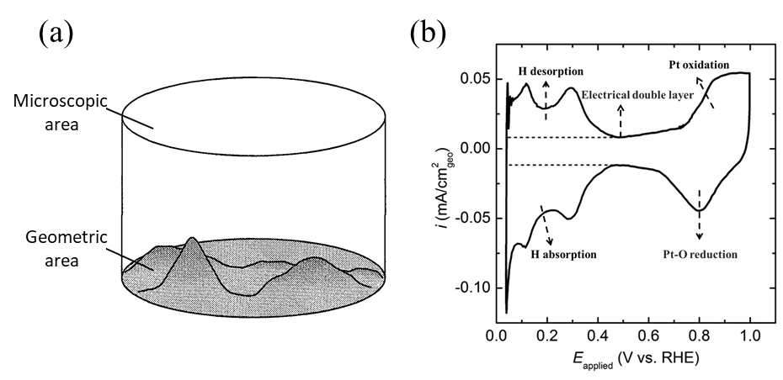
Figure S2. (a) Microscopic and geometrical areas of electrodes^{[6]}. (b) Typical cyclic voltammetry curves of platinum electrodes^{[5]}

Theories

3.1 The all-atom TEAM force fields
The all-atom TEAM force fields used, which is validated over wide ranged of organic and inorganic molecules. TEAM force field is composed of bonding and nonbonding interaction, and the coupling terms of bond length -bond length:
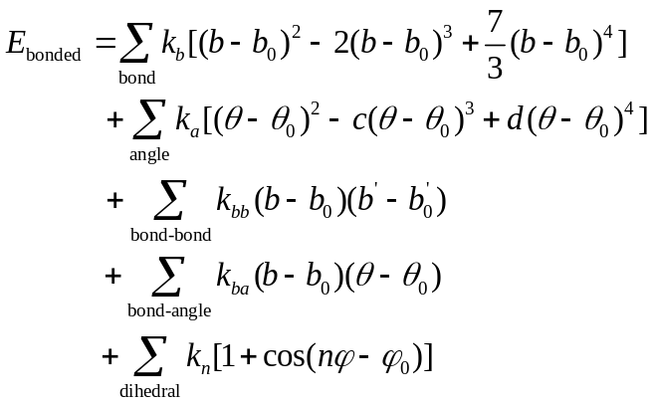 (S3-1)
Where $k_{b}$、$k_{a}$ are respectively force constants for bond lengths and bond angles; $b_{0}$、$θ_{0}$ represent the corresponding equilibrium bond length and equilibrium bond angle; $k_{bb}$ and $k_{ba}$ are the coupling between bond length and bond length, and bond length and bond angle; $k_{n}$ is the constant of the torsion term of the dihedral angle, and $φ_{0}$ corresponds to the equilibrium position of the dihedral angle; The value of $φ_{0}$ is 0 when n is 1,3 or 5, and π when n is 2,4 or 6. For the bond Angle terms, the force constants c and d of the cubic and quartic terms are derived from the first derivative of the equation value 0 when $θ_{0}$ respectively equals 0 and π：
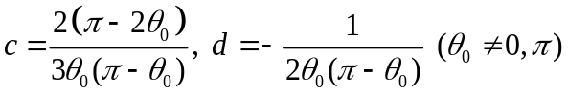 (S3-2)
The nonbonding interaction of TEMA field is expressed as the combination of van der Waals interaction calculated in LJ-12-6 function form and electrostatic term expressed by Coulomb equation:
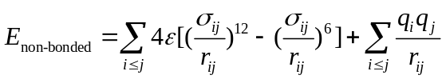 (S3-3)
Where $ε$ is potential well parameter, $σ$ is atomic radius parameter; $q_{i}$ is the point charge of the i-th atom. Van der Waals interactions between different atomic types are derived from the Lorentz-Berthelot mixing rule. In addition, the Coulomb interaction coefficient of terms 1-4 in TEAM-MS force field is 0.5.

3.2 “Sphere-cage” diffusion model
In order to better describe the molecular diffusion process, a diffusion model is established based on the following assumptions in combination with the literature:ⅰ)polymer molecules crosslink with each other to form a “cage”, or molecular holes;ⅱ) most of the time gas molecules are confined to a cage with the gas kinetic velocity u;ⅲ) molecular diffusion is achieved by migration between adjacent "cages".
According to free volume theory ^{[7]} , the free volume v is defined as the residual volume in the “cage”, which is the volume of “cage” minus the volume of the gas molecule. At the same time, the literature mentioned that below the critical temperature, the “cage” is fixed and the change of the polymer volume is due to the expansion of polymer molecules, which is independent of the free volume.
Since the area of microelectrode is much smaller than that of membrane, the diffusion process can be regarded as a one-dimensional axial diffusion mass transfer process. In the absence of external interference, the gas molecules move forward or backward in the polymer cage with the same probability at each step, so after N steps, the molecule can be anywhere.^{[8]}
-N，-N+1,…,-1,0,+1,…,N-1,N (S3-4)
It is not difficult to see that, for a given N steps, the probability of the molecule appearing at a certain point is $({\frac{1}{2})}^{N}$. Therefore, the probability W(m, N) of taking N steps to reach point m can be defined as the product of the probability of occurrence $({\frac{1}{2})}^{N}$ and the number of different paths to reach the point.( m is any position, but for any position m, there are different constraints on the value of N)
$W(m,N)=\frac{N!}{\left(\frac{N+m}{2}\right)!\left(\frac{N-m}{2}\right)!}({\frac{1}{2})}^{N}$ (S3-5)
According to Stirling's approximation
$\ln{N!=}(N+\frac{1}{2})\ln{N}-N+\frac{1}{2}\ln{2π}+O(N^{-1})(N→∞)$ (S3-6)
When N is large, the Eq. S3-5 can be reduced to
$W(m,N)={(\frac{2}{Nπ})}^{\frac{1}{2}}exp(\frac{-m^{2}}{2N})$ (S3-7)
Assuming that the distance between "cages" is 𝑙, the molecular displacement x can be expressed as:
$x=ml$ (S3-8)
Therefore, the probability of the molecule moving to the region of (x, x+ δ x) is:
$W\left(x,N\right)∆x=W\left(m,N\right)\left(\frac{∆x}{2l}\right)={(\frac{1}{2Nπl^{2}})}^{\frac{1}{2}}exp(\frac{-m^{2}}{2N})∆x$ (S3-9)
Assuming that the distance between the "cages" is l and the molecule migrates n times per unit time, the probability of finding molecules in the interval (x, x+ δ x) after time t is
$W\left(x,t\right)∆x=\frac{1}{{(4πDt)}^{\frac{1}{2}}}exp(\frac{-x^{2}}{4Dt})∆x$ (S3-10)
Therefore, the following equation can be obtained by comparing Eq. S3-9 and Eq. S3-10
$D=\frac{1}{2}nl^{2}$ (S3-11)
Where n is the the migration frequency.

3.3 Dual-mode solubility model
The gas solubility in polymer is a complex process, as the solubility not only depends on the experimental conditions, but also on the chemical structure of polymer (the function group, the chain length and the degree of polymerization).^{[25]} At present, there are three common methods to correlate and predict solubility, namely theoretical equations of state, dual-mode model and statistical methods. Based on this assumption, the following equation are proposed:
$C=k_{d}p+\frac{C_{H}bp}{1+bp}$ (S3-12)
Where k_{d} is effective Henry’s law solubility constant, C_{H} is the hole saturation constant, b is the hole affinity constant, p is the gas pressure.
Below glass transition temperature Tg, the hole is considered to be frozen, that is, hole saturation constant is independent of temperature, giving
$C_{H}=C_{0}exp(-{∆H}_{h}/RT_{g})$ (S3-13)
Where ${∆H}_{h}$ is the enthalpy of hole formation, $C_{0}$ is a pre-exponential factor, and R is the gas constant. At moderate temperature ranges, b is expected to satisfies the Van’t Hoff form, ^{[9]} giving
$b=b_{0}exp(-{∆E}_{ad}/RT)$ (S3-14)
Where ${∆E}_{ad}$ is the energy change of hole filling, $b_{0}$is a pre-exponential factor and R is the gas constant. According to the literature, based on the assumption that holes are frozen below glass transition temperature Tg, Pace and Datyner deduced that the Henry constant $k_{d}$satisfies the following form from the perspective of thermodynamic equilibrium, giving
$k_{d}=C_{0}b_{0}exp[-({∆E}_{ad}+{∆H}_{h})/RT]$ (S3-15)
Substituting Eq. S3-13, S3-14 and S3-15 into Eq. S3-12, the following equation is obtained:
$C=C_{0}b_{0}exp[-\frac{{∆E}_{ad}+{∆H}_{h}}{RT}]p+\frac{C_{0}b_{0}exp(-\frac{{∆H}_{h}}{RT_{g}}+-\frac{{∆E}_{ad}}{RT})p}{1+b_{0}exp(-\frac{{∆E}_{ad}}{RT})p}$ (S3-16)
As shown in Eq. S3-19, the solubility model could be formed as a function of temperature and pressure. Since the pressure is constant during the experiment, the influence of pressure change on the solubility is not taken into account. In Eq. S3-16, the solubility becomes a function only related to temperature. Due to complex parameters (e.g. $C_{0}$,$b_{0},{ ∆E}_{ad}$, ${∆H}_{h}$,), these are difficult to fit and solve, so Taylor expansion is used for such parameters below.
$k_{d}=C_{0}b_{0}\sum_{n=0}^{∞}{\frac{1}{n!}[{\frac{-({∆E}_{ad}+{∆H}_{h})}{RT}]}^{n}}$ (S3-17)
$b=b_{0}\sum_{n=0}^{∞}{\frac{1}{n!}({\frac{-{∆E}_{ad}}{RT})}^{n}}$ (S3-18)
Combined with the Eq.S3-17 and Eq.S-18, the Eq. S3-16 can be changed into the following form
$C=C_{0}b_{0}p\sum_{n=0}^{∞}{\frac{1}{n!}[{\frac{-({∆E}_{ad}+{∆H}_{h})}{RT}]}^{n}}+C_{H}-C_{H}\sum_{n=0}^{∞}{{(-1)}^{n}{[b_{0}p\sum_{n=0}^{∞}{\frac{1}{n!}({\frac{-{∆E}_{ad}}{RT})}^{n}}]}^{n}}$ (S3-19)
By combining temperature variables of the same order, Equations S3-19 are further simplified
$C=\sum_{n=0}^{∞}{a_{n}{(\frac{1}{T})}^{n}}$ (S3-20)
The coefficient of the first term$({\frac{1}{T})}^{0}$is
$a_{0}=C_{0}b_{0}p+C_{H}-C_{H}{\sum_{n=0}^{∞}{{(-1)}^{n}}(b}_{0}p)^{n}$ (S3-21)
The coefficient of the second term$({\frac{1}{T})}^{1}$ is
$a_{1}=\frac{{-C}_{0}b_{0}p({∆E}_{ad}+{∆H}_{h})}{R}+C_{H}\sum_{n=1}^{∞}{{(-1)}^{n}}\frac{{{n(b}_{0}p)}^{n}({-∆E}_{ad})}{2R}$ (S3-22)
The coefficient of the third term$({\frac{1}{T})}^{2}$ is
$$a_{2}=\frac{C_{0}b_{0}p({{∆E}_{ad}+{∆H}_{h})}^{2}}{2R^{2}}+C_{H}\sum_{n=2}^{∞}{{(-1)}^{n}}\frac{{{(b}_{0}p)}^{n}{(\frac{n}{3!}+\frac{n-1}{2!})({-∆E}_{ad})}^{2}}{R^{2}}$$
(S3-23)
The coefficient of the fourth term$({\frac{1}{T})}^{3}$ is
$$a_{3}=\frac{{-C}_{0}b_{0}p({{∆E}_{ad}+{∆H}_{h})}^{3}}{2R^{3}}+C_{H}\sum_{n=3}^{∞}{{(-1)}^{n}}\frac{{{(b}_{0}p)}^{n}{(\frac{n}{4!}+\frac{n-1}{3!}+\frac{n-2}{2!})({-∆E}_{ad})}^{3}}{R^{3}}$$
(S3-24)
The coefficient of the k term$({\frac{1}{T})}^{k}$ is
$$a_{k}=\frac{{-C}_{0}b_{0}p({{∆E}_{ad}+{∆H}_{h})}^{k}}{2R^{k}}+\frac{C_{H}{\left({-∆E}_{ad}\right)}^{k}}{R^{k}}\sum_{n=k}^{∞}{{\left(-1\right)}^{n}}{{(b}_{0}p)}^{n}(\frac{n}{\left(k+1\right)!}+\frac{n-1}{k!}$$
$+\frac{n-2}{(k-1)!}+...+\frac{n-k}{2!})$ (S3-25)
Since ${∆E}_{ad}$ is always negative and ${∆H}_{h}$ is always positive, and the absolute of ${∆E}_{ad}$ and ${∆H}_{h}$ for O₂ is 10~20 kJ/mol,^{[10]} it can be considered in the experimental temperature range
${(\frac{{∆E}_{ad}+{∆H}_{h}}{RT})}^{4}≪(\frac{{∆E}_{ad}+{∆H}_{h}}{RT})$) (S3-26)
${(\frac{{∆E}_{ad}}{RT})}^{4}≪(\frac{{∆E}_{ad}}{RT})$ (S3-27)
At the same time, for the power series terms of the coefficients $\frac{{{n(b}_{0}p)}^{n}}{2}>{{(b}_{0}p)}^{n}\left(\frac{n}{3!}+\frac{n-1}{2!}\right)>{{(b}_{0}p)}^{n}\left(\frac{n}{4!}+\frac{n-1}{3!}+\frac{n-2}{2!}\right)>{{(b}_{0}p)}^{n}(\frac{n}{(k+1)!}+\frac{n-1}{k!}+\frac{n-2}{(k-1)!}+...+\frac{n-k}{2!})$, ignoring the numbers after the fourth term, the original expression can be expressed as follows
$C=a+b/T+c/T^{2}+d/T^{3}$ (S3-28)
In Eq. S3-28, the expressions of a,b,c and d are as follows
$a=C_{0}b_{0}p+C_{H}-C_{H}{\sum_{n=0}^{∞}{{(-1)}^{n}}(b}_{0}p)^{n}$ (S3-29)
$b=\frac{{-C}_{0}b_{0}p\left({∆E}_{ad}+{∆H}_{h}\right)}{R}+\frac{C_{H}({-∆E}_{ad})}{R}\sum_{n=1}^{∞}{{(-1)}^{n}}\frac{{{n(b}_{0}p)}^{n}}{2}$ (S3-30)
$c=\frac{C_{0}b_{0}p({{∆E}_{ad}+{∆H}_{h})}^{2}}{2R^{2}}+\frac{C_{H}{({-∆E}_{ad})}^{2}}{R^{2}}\sum_{n=2}^{∞}{{(-1)}^{n}{{(b}_{0}p)}^{n}(\frac{n}{3!}+\frac{n-1}{2!})}$ (S3-31)
$$d=\frac{{-C}_{0}b_{0}p({{∆E}_{ad}+{∆H}_{h})}^{3}}{2R^{3}}+\frac{C_{H}{({-∆E}_{ad})}^{3}}{R^{3}}\sum_{n=3}^{∞}{{(-1)}^{n}}{{(b}_{0}p)}^{n}(\frac{n}{4!}+\frac{n-1}{3!}+\frac{n-2}{2!})$$
(S3-32)

Results
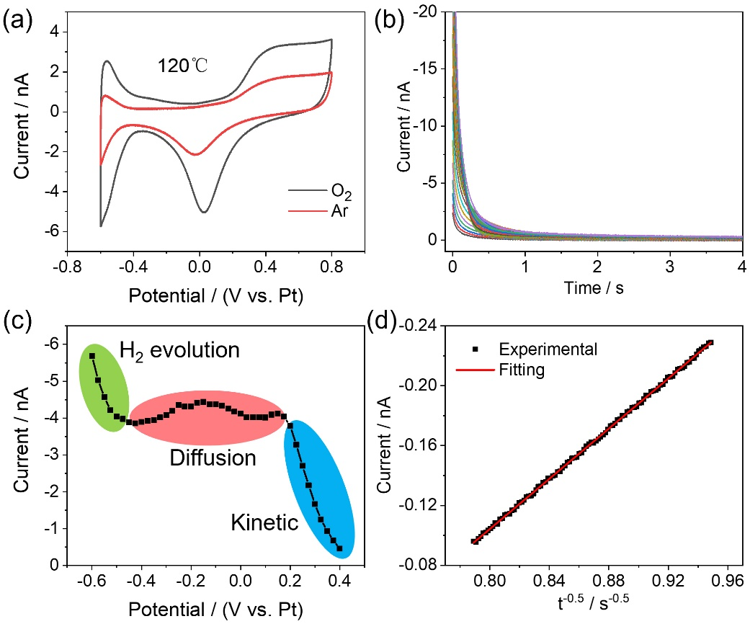
Figure S3. Electrochemical test results of the saturated PA doped PES-PVP-60 binder under 120℃. (a) Cyclic voltammetry curves obtained in Ar and O₂ atmospheres. (b) Potential-step chronoamperometry curves with a constant initial potential V_{i} = 0.62 V and various final potential V_{f} in O₂ atmosphere. (c) Sampled-current voltammograms. (d) Fitting plots of I-t^{-0.5} with modified Cottrell equation

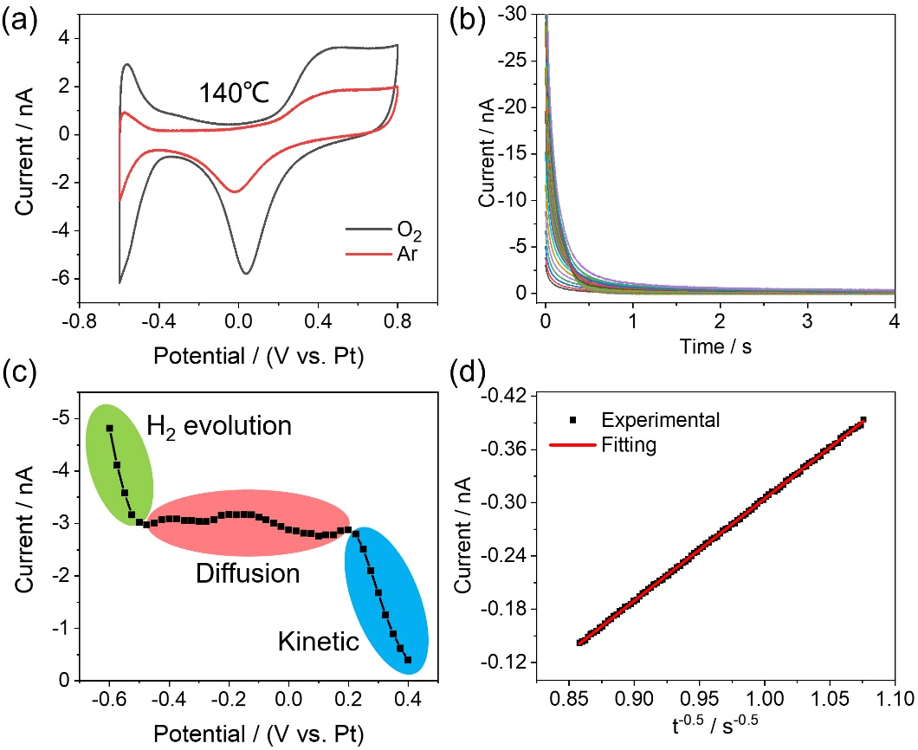
Figure S4. Electrochemical test results of the saturated PA doped PES-PVP-60 binder under 140℃. (a) Cyclic voltammetry curves obtained in Ar and O₂ atmospheres. (b) Potential-step chronoamperometry curves with a constant initial potential V_{i} = 0.62 V and various final potential V_{f} in O₂ atmosphere. (c) Sampled-current voltammograms. (d) Fitting plots of I-t^{-0.5} with modified Cottrell equation
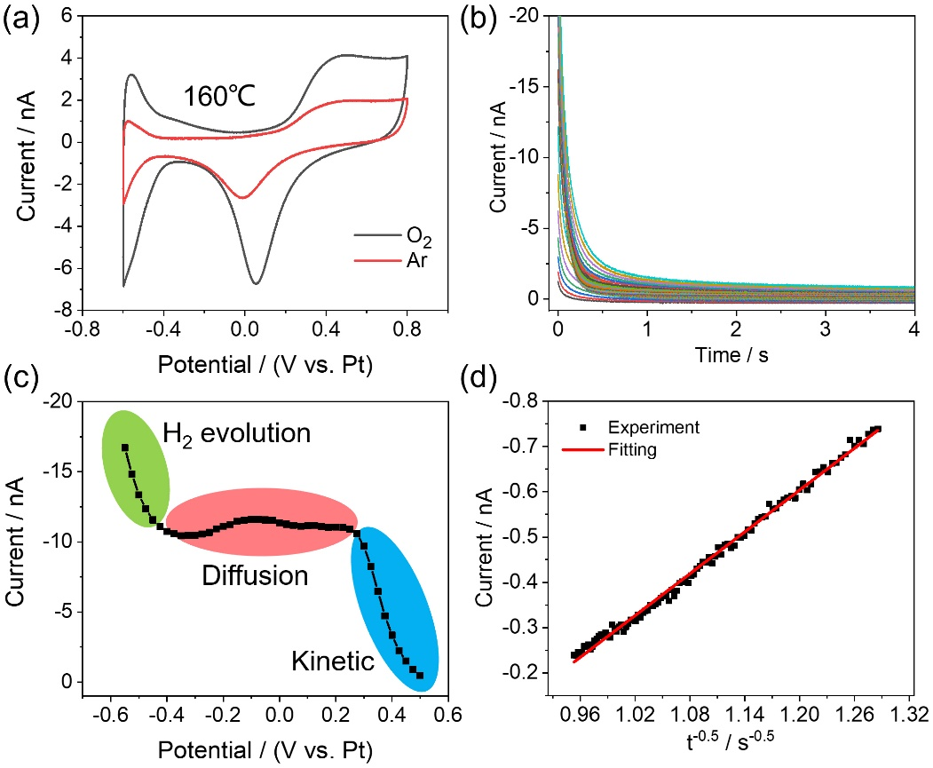
Figure S5. Electrochemical test results of the saturated PA doped PES-PVP-60 binder under 160℃. (a) Cyclic voltammetry curves obtained in Ar and O₂ atmospheres. (b) Potential-step chronoamperometry curves with a constant initial potential V_{i} = 0.62 V and various final potential V_{f} in O₂ atmosphere. (c) Sampled-current voltammograms. (d) Fitting plots of I-t^{-0.5} with modified Cottrell equation
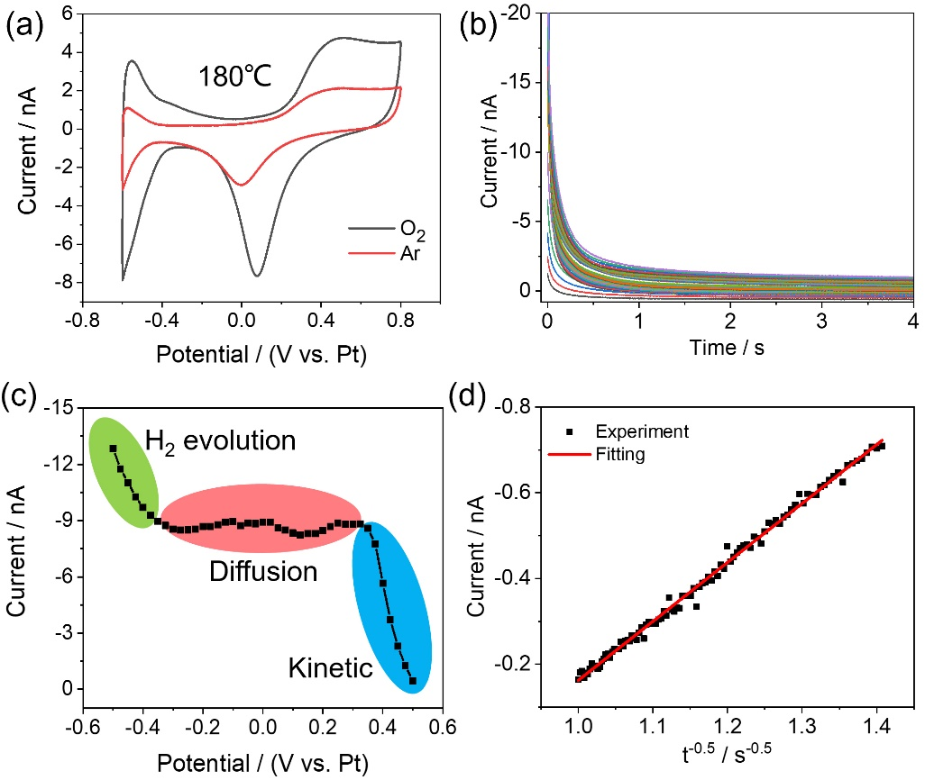
Figure S6. Electrochemical test results of the saturated PA doped PES-PVP-60 binder under 180℃. (a) Cyclic voltammetry curves obtained in Ar and O₂ atmospheres. (b) Potential-step chronoamperometry curves with a constant initial potential V_{i} = 0.62 V and various final potential V_{f} in O₂ atmosphere. (c) Sampled-current voltammograms. (d) Fitting plots of I-t^{-0.5} with modified Cottrell equation

References
1. Zhu, Z.; Liu, X.; Ye, Z.; Zhang, J.; Cao, F.; Zhang, J. A fabrication of iridium oxide film pH micro-sensor on Pt ultramicroelectrode and its application on in-situ pH distribution of 316L stainless steel corrosion at open circuit potential. Sensors and Actuators B: Chemical 2018, 255, 1974-1982.
2. Zhang, Q.; Ye, Z.; Zhu, Z.; Liu, X.; Zhang, J.; Cao, F. Separation and kinetic study of iron corrosion in acidic solution via a modified tip generation/substrate collection mode by SECM. Corrosion Science 2018, 139, 403-409.
3. Cao, F.; Kim, J.; Bard, A. J. Detection of the Short-Lived Cation Radical Intermediate in the Electrochemical Oxidation of N,N-Dimethylaniline by Scanning Electrochemical Microscopy. J. Am. Chem. Soc. 2014, 136, 18163–18169.
4. Sheng, W., et al., Correlating the hydrogen evolution reaction activity in alkaline electrolytes with the hydrogen binding energy on monometallic surfaces. Energy & Environmental Science, 2013, 6, 1509-1512.
5. Wei, C., et al., Approaches for measuring the surface areas of metal oxide electrocatalysts for determining their intrinsic electrocatalytic activity. Chemical Society Reviews, 2019, 48, 2518-2534.
6. Bard, A.J. and L.R. Faulkner, Electrochemical Methods, Fundamental Applications. 2001.
7. Forsyth, M.; Meakin, P.; MacFarlane, D. R.; Hill, A. J. Free volume and conductivity of plasticized polyether-urethane solid polymer electrolytes. J. Phys.: Condens. Matter 1995, 7, 7601.
8. Chandrasekhar, S. Stochastic Problems in Physics and Astronomy. Rev. Mod. Phys 1943, 15, 1-89.
9. Flory, P.J., Principles of polymer chemistry. 1953: Cornell University Press.
10. Vieth, W. R.; Alcalay, H. H.; Frabetti, A. J. Solution of gases in oriented poly(ethylene terephthalate). Journal of Applied Polymer Science 1964, 8, 2125-2138.

