Support information
Inhibition mechanism of MRTX1133 on KRAS^{G12D}: a molecular dynamics simulation and Markov state model study
Fanglin Liang¹ · Zhengzhong Kang² · Xianqiang Sun² · Jiao Chen⁴ · Xuemin Duan¹ · Hu He³ · Jianxin Cheng¹
Received: xx xxxx 2022 / Accepted: xx xxxx 2022
© The Author(s) 2022

* Jianxin Cheng
chengjx567@mail.ecust.edu.cn
* Xianqiang Sun
xianqiang.sun@autodrug.ai
* Hu He
hehu@synrx.cn
1 Jiangxi Provincial Key Laboratory of Drug Design and Evaluation, School of Pharmacy, Jiangxi Science & Technology Normal University, Nanchang, China
2 AutoDrug Biotech Co. Ltd, No. 58 XiangKe Rd., Pudong New Area, Shanghai, China
3 Synrx therapeutics (Hanghzou) CO. Ltd, No. 1309 CangQian Rd., Yuhang Area, Hangzhou, China
4 Affiliated Hospital of Integrated Traditional Chinese and Western Medicine, Nanjing University of Chinese Medicine, Nanjing, Jiangsu 210028, China

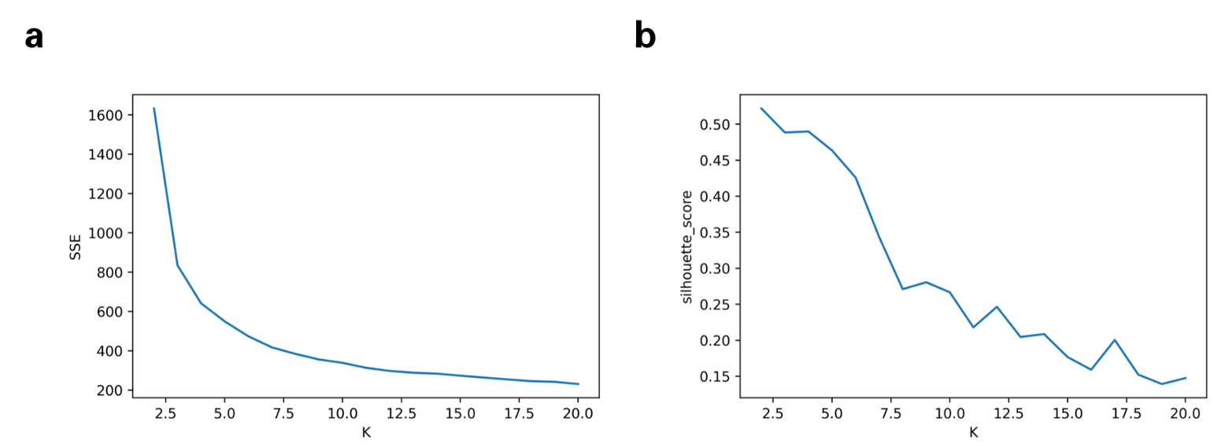
Fig. S1 Cluster analysis. The K value represents the number of clusters. (a) Sum of the Squared Errors (SSE). (b) The distribution Silhouette Coefficient according to the number of clusters.

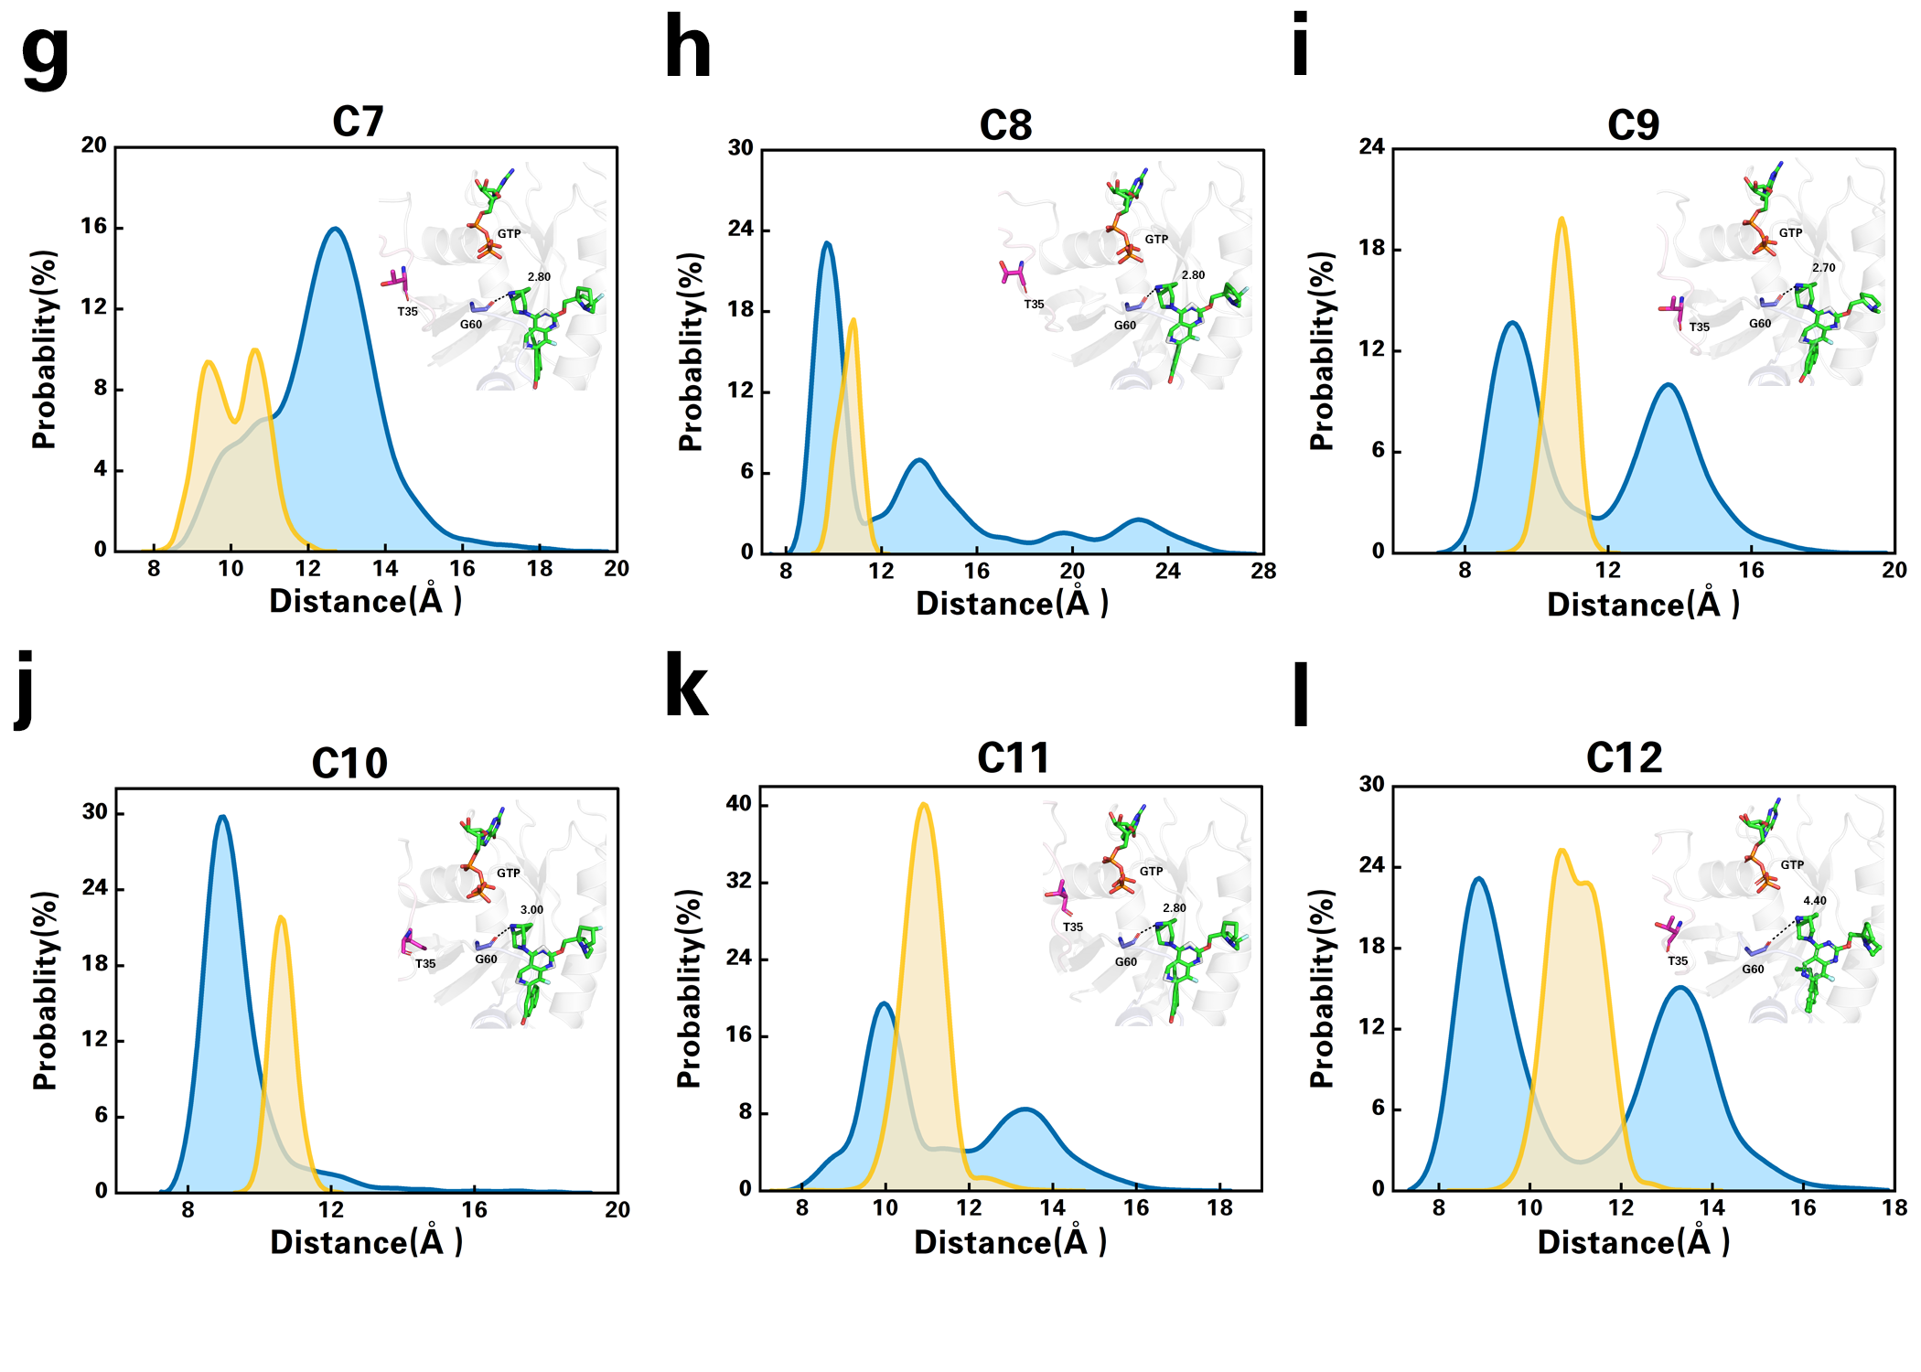
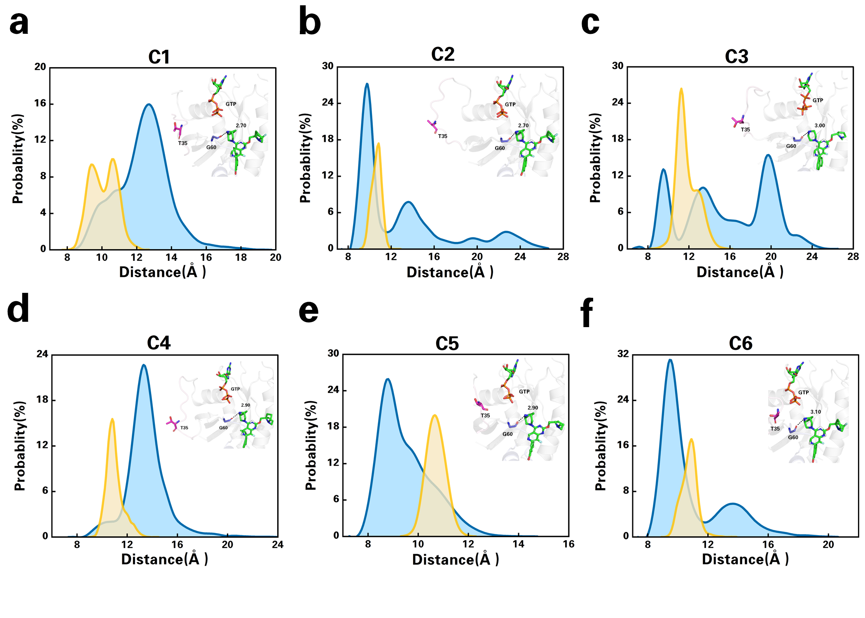

Fig. S2 The distributions of distances and the detailed representative structure of C1-12 clusters in GTP-bound KRAS^{G12D} with MRTX1133. d₁ is the distance between C_{α} of G60 and P_{β} of GTP, and d₂ is the distance between C_{α} of T35 and P_{β} of GTP. Sticks of residue T35 and G60 are colored in magenta and purple. Hydrogen bonds are marked with black dashed lines. GTP, MRTX1133 and its analogs are shown in green sticks. The distance for C1-12 are shown in (a) to (l), respectively.

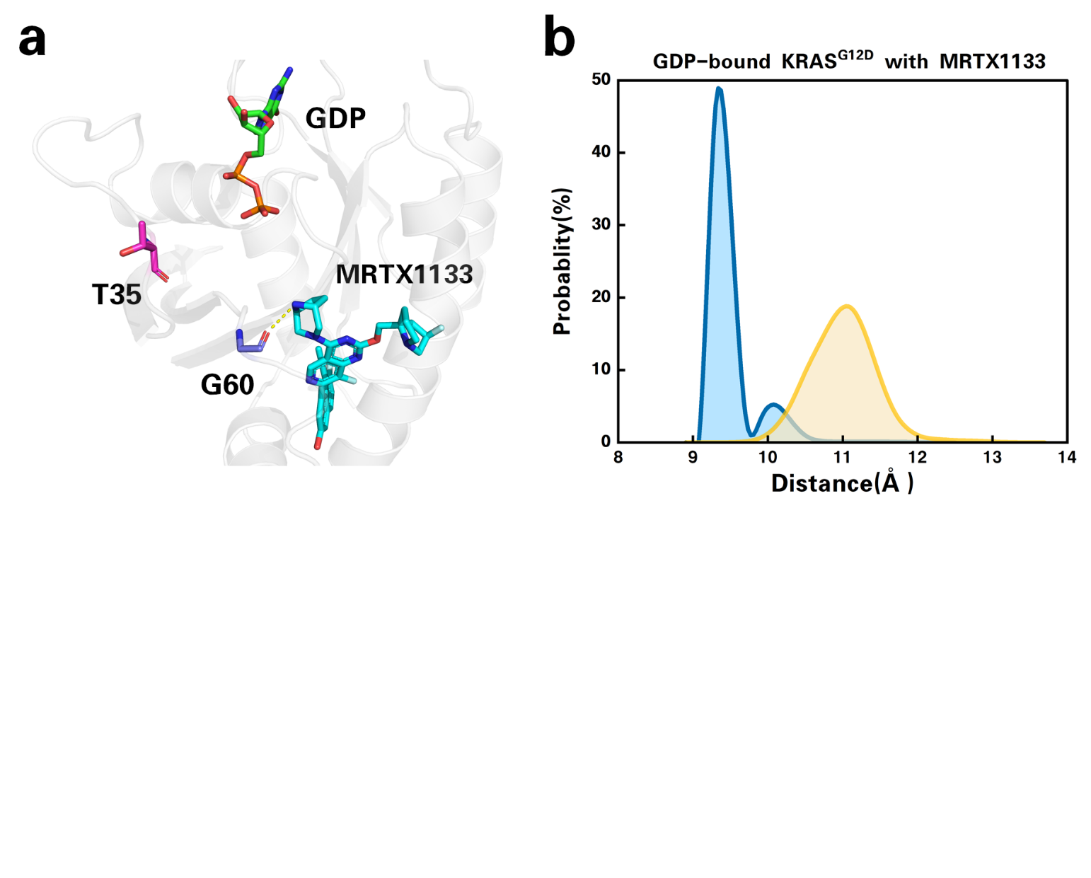
Fig. S3 The GDP-bound KRAS^{G12D} with MRTX1133. (a) is the representative structure of cluster C12 in GDP-bound KRAS^{G12D} with MRTX1133. Sticks of residue T35 and G60 are colored in magenta and purple. Hydrogen bonds are marked as yellow dashed lines. Sticks of GTP and MRTX1133 are green and cyan, respectively. (b) The distributions of distances of C1-12 clusters in GDP-bound KRAS^{G12D} with MRTX1133. d₁ is the distance between C_{α} of G60 and P_{β} of GDP, and d₂ is the distance between C_{α} of T35 and P_{β} of GDP.

