Supporting information
Ultra-low friction and stiffness dependence of interlayer friction in graphite flakes under various rotation angles
Kang Yu†, Peipei Xu†, Yitian Peng*, Yao Huang, Haojie Lang, Shuyang Ding
College of Mechanical Engineering, Donghua University, Shanghai 201620, China
†These authors contributed equally to this work
*Correspondence: yitianpeng@dhu.edu.cn

1. Micromanipulator and rotation stage for preparation of graphite-coated microsphere probe and friction measurements
Silica microspheres with a mean particle diameter of 5μm were purchased from Nano-micro Technology (Suzhou) as a colloid particle for microsphere probe. The silica particle powder was cleaned and dispersed in high-purity ethanol in the ultrasonic bath for 30min. About 5μL upper suspension was pipetted onto a precleaned slide glass. The microspheres on slide glass dried in the clean culture dish. Firstly, attach the glass slide with microspheres, UV glue (Norland Products Inc) and graphite sample on PDMS to the XYZ stage. A tipless cantilever was positioned to the XYZ stage in a homemade holder fixed by the magnet. Secondly, the microsphere was picked up on a cantilever with UV glue and then exposed to UV light for at least 2h. Thirdly, the graphene flake on PDMS was picked on microsphere tip to achieve graphite coated microsphere probe (see figure 1(b)). The graphite-coated microsphere probe was left to harden in a clean box for at least 24h before use.

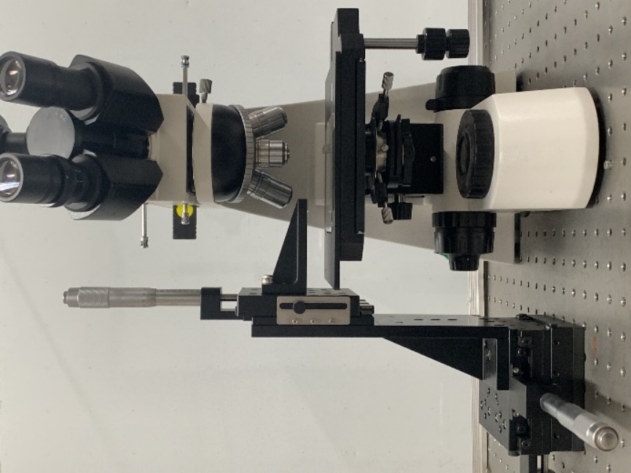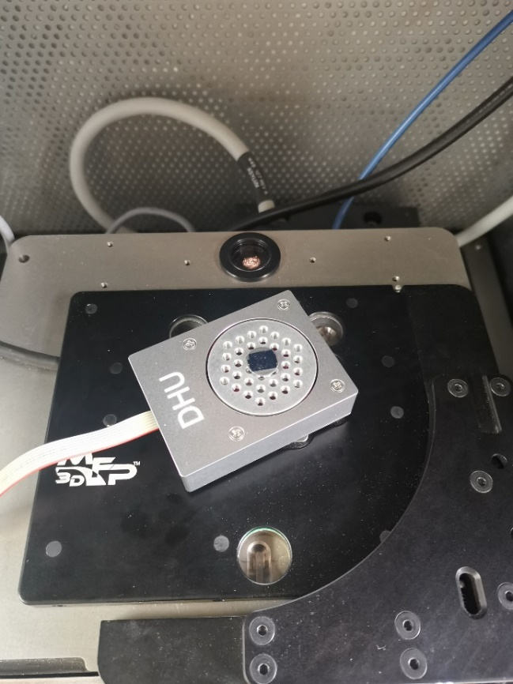
(a)
(b)
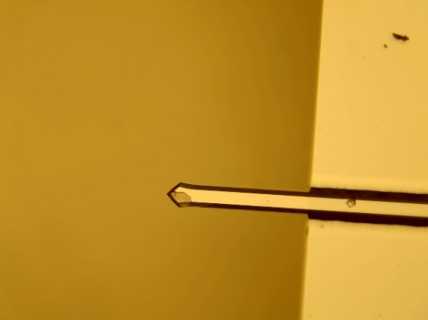
(c)
Figure S1 (a) Optical image of homemade micromanipulator used in pick-up method for preparation of graphite coated microsphere probe. (b) Optical image of rotation stage fixed on the scanner of atomic force microscopy. The minimum incremental motion is 0.002°, and the maximum bidirectional accuracy is 0.4°. The encoder resolution is 0.0025°/count. (c) Optical image of graphite coated microsphere probe (GMP) in red circle. (d) Enlarged Raman spectra of graphite-coated probe. Raman spectrum of graphite-coated probe after friction tests by using a Renishaw spectrometer (inVia Reflex) with a 532nm wavelength laser. D peak (~1350cm⁻¹), G peak (~1581cm⁻¹), and 2D peak (~2720cm⁻¹). D peak was usually resulted from defects or boundaries in graphite.

2. Raman spectrum of graphite and hexagonal boron nitride (h-BN)
(a)
(c)
(e)
(g)
Figure S2. Raman spectrum and height profiles of graphite and hexagonal boron nitride deposited on SiO₂/Si substrate. (a) AFM topography of graphite for friction tests by tapping mode. (b) Raman spectra for the point highlighted in (a) with a green circle. The absence of D peak (~1350cm⁻¹) indicated the graphite was defect-free graphite used in our measurements¹. (c) AFM topography of h-BN for friction tests by tapping mode. (d) Raman spectra for the point highlighted in (c) with the blue circle. The Raman peak of h-BN is near 1365 cm⁻¹, the peak at 1366.6 cm⁻¹ in (c) is consistent with the literature². All measurements were performed with 10% incident power with a 532nm wavelength laser. (e) AFM topography of graphite. (f) Height profile of graphite along the white line in (e). (g) AFM topography of h-BN. (h) Height profile of h-BN along the white line in (g).

3. Friction characteristics of graphite coated microsphere probe
Figure S3. Friction force as a function of the normal load for different relative rotation angles between graphite coated microsphere probe and graphite surface. The friction tests were conducted by MFP3D (Asylum Research) in contact mode with decreasing normal load from 500nN to -8nN. The scan rate and scan size were 1Hz and 500×500nm² respectively.

4. Flowchart for research structure of this manuscript.
Fabrication of graphite-coated microsphere probe by pick-up method
High-precision rotation stage
Angle-dependence ultralow friction experimental study
Density functional theory (DFT) calculation
Atomic-scale friction loops of Gr/Gr interlayer
Single-crystalline contact, nanometer-sized(~0.8nm)
Comparison
Absence of the second peak in experimental study
Friction hysteresis
Abnormal pull-off curves
Long jumps in stick-slip
PT model description
Change of stiffness of the system during friction measurements
Elastic contact
Rigid contact
Fig. 1, Fig. S1
Fig. 2
Fig. 4
Fig. 3
Fig. 5, Fig. 6, Fig. S3
Fig. 6
Fig. 7
Figure A1 Flowchart for research structure of this manuscript.

References
[1] A.C. Ferrari, J.C. Meyer, V. Scardaci, C. Casiraghi, M. Lazzeri, F. Mauri, S. Piscanec, D. Jiang, K.S. Novoselov, S. Roth, Raman spectrum of graphene and graphene layers, Physical review letters 97(18) (2006) 187401.
[2] M.S. Amin, T.E. Molin, C. Tampubolon, D.E. Kranbuehl, H.C. Schniepp, Boron Nitride Nanotube Impurity Detection and Purity Verification, Chemistry of Materials 32(21) (2020) 9090-9097.

