Supplementary materials for:
Exposed Population to Hot and Cold Extremes in MENA for Paris Climate Agreement Temperature Goals
Mohammed Magdy Hamed ^{1,2}, Zulfiqar Ali ², Mohamed Salem Nashwan ³ and Shamsuddin Shahid ^{2,*}

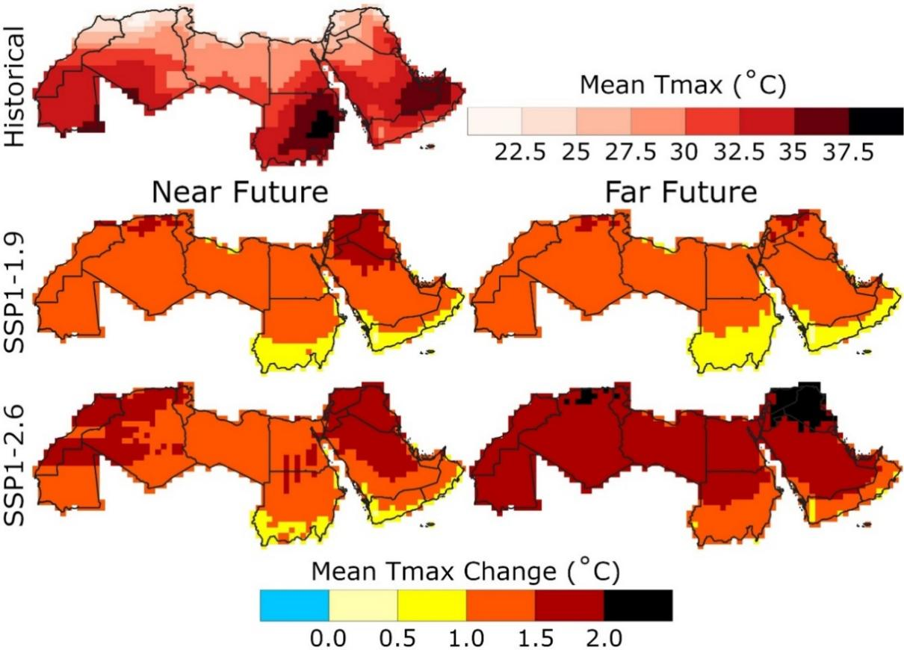
Figure S1 Spatial distribution of the annual Mean of Tmax (MeanT_{max}) for the reference period and the projected changes in the near and far futures for two SSPs.

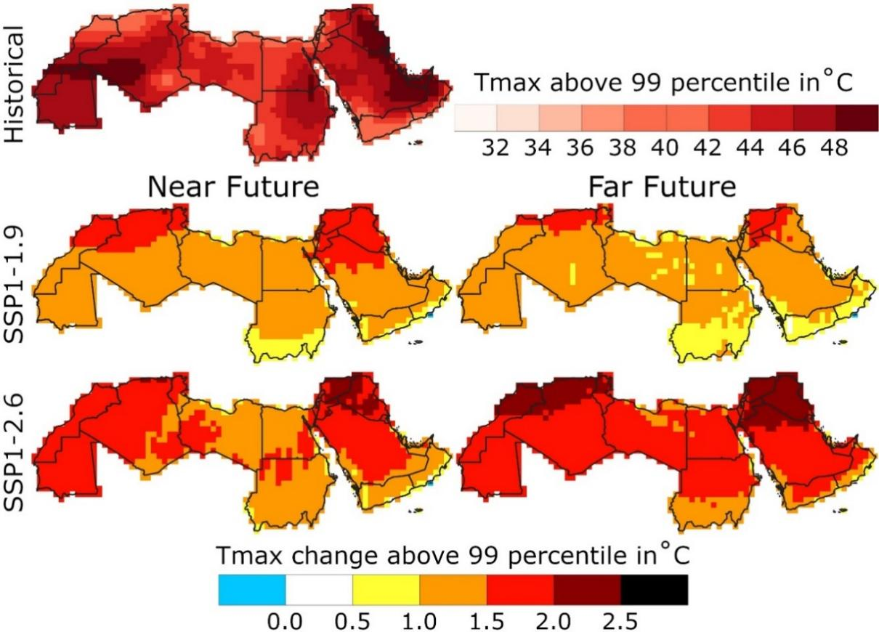
Figure S2 Same as Figure S1, but for T_{max} above 99-th percentile.

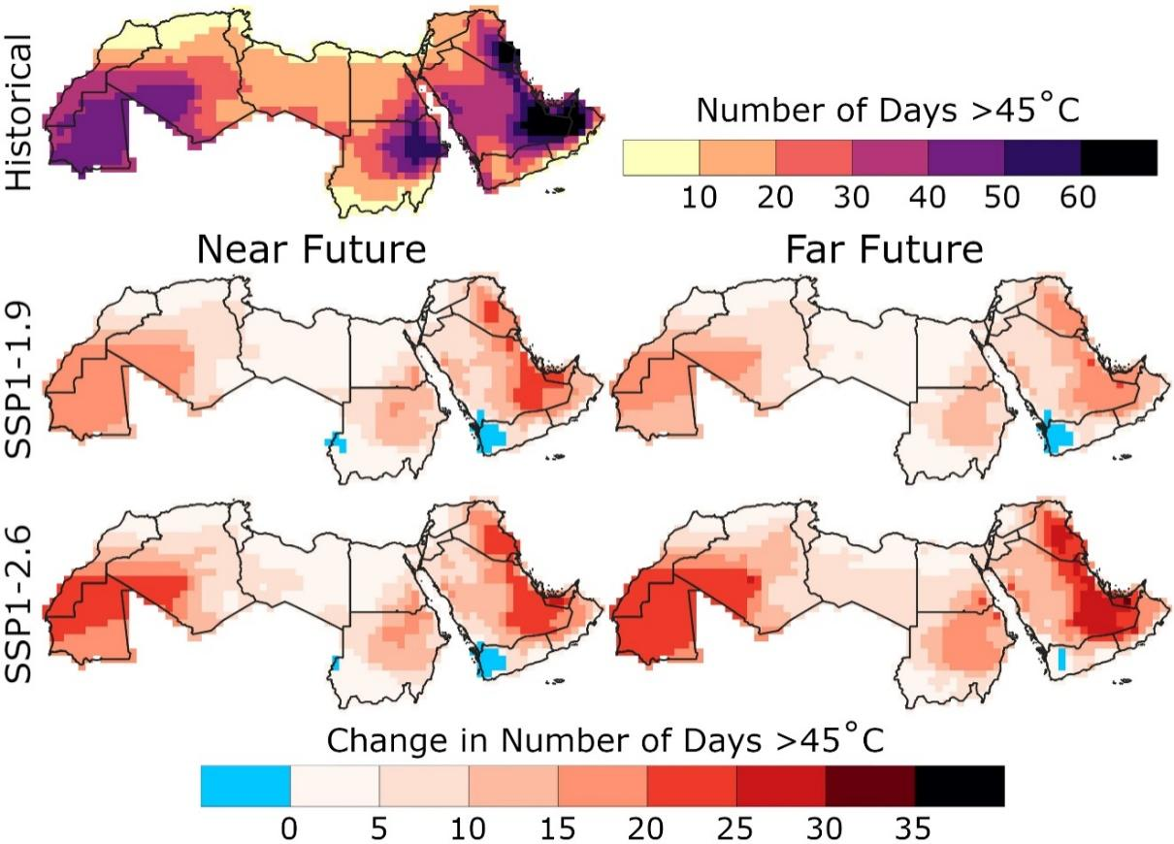
Figure S3 Same as Figure S1, but the days with a temperature higher than 45℃
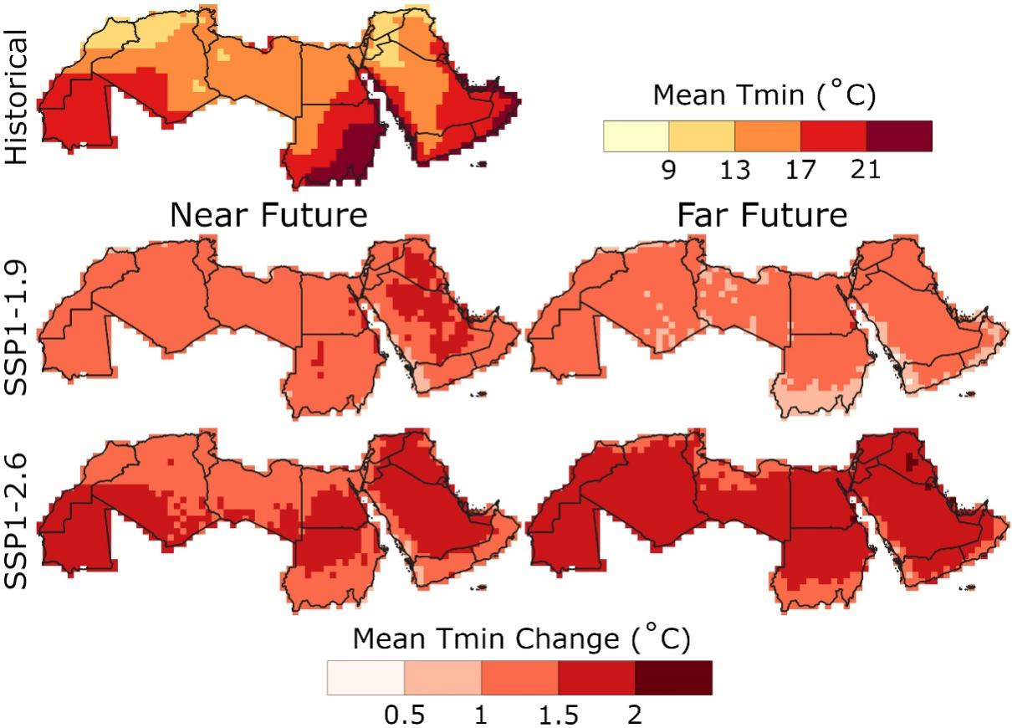
Figure S4. Same as Figure S1, but for the annual mean of T_{min}.

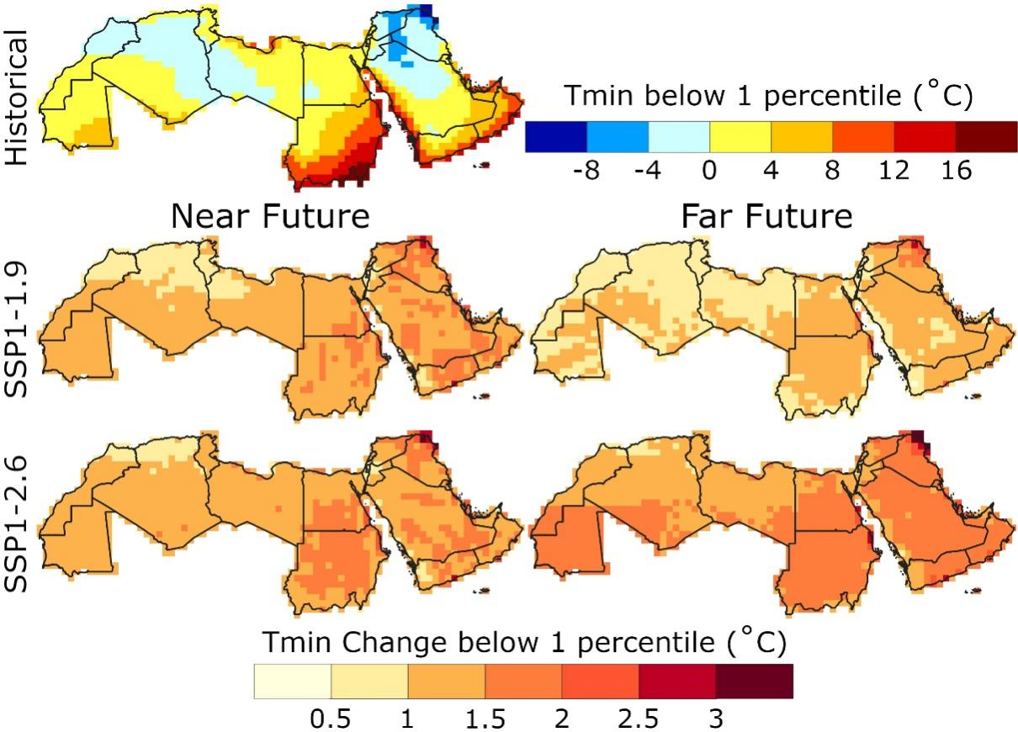
Figure S5. Same as Figure S1, but for T_{min} below 1-th percentile

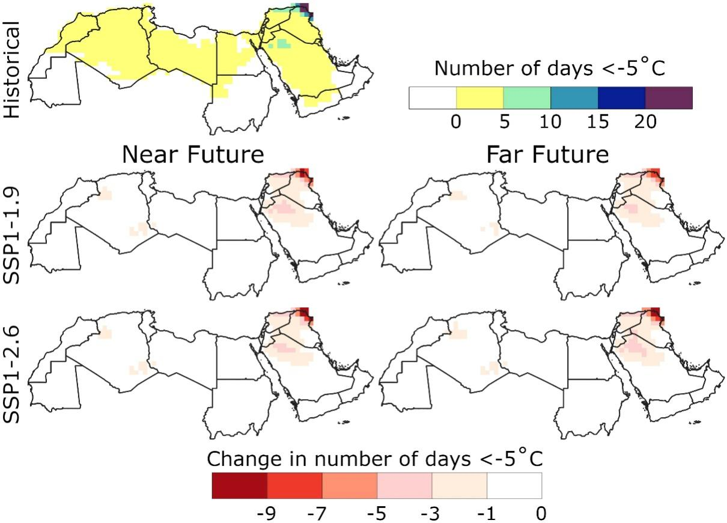
Figure S6. Same as Figure S1, but the days with a minimum temperature less than -5 °C (D-5T_{min})

Table S1 General circulation models (GCMs) used in this study.
No | Model name | Institution | Country | Resolution
1 | CanESM5 | Canadian Centre for Climate Modelling and Analysis | Canada | 2.79°×2.81°
2 | EC-Earth3-Veg | EC-Earth Consortium | Netherlands | 0.35°×0.35°
3 | EC-Earth3-Veg-LR | EC-Earth Consortium | Netherlands | 0.35°×0.35°
4 | FGOALS-g3 | Chinese Academy of Sciences Flexible Global Ocean-Atmosphere–Land System model | China | 2°×2°
5 | GFDL-ESM4 | Geophysical Fluid Dynamics Laboratory | USA | 1.00°×1.25°
6 | IPSL-CM6A-LR | Institute Pierre Simon Laplace (IPSL) | France | 2.5°×1.27°
7 | MIROC6 | Japan Agency for Marine-Earth Science and Technology (JAMSTEC) | Japan | 1.4°×1.4°
8 | MRI-ESM2-0 | Meteorological Research Institute | Japan | 1.125°×1.125°

Table S2. Definition of the hot and cold indices used in this study
Index | Definition | Unit
MaxT_{max} | Annual highest maximum temperature | °C
MeanT_{max} | Annual mean maximum temperature | °C
p95T_{max} | Temperature above 95-th percentile during the base years | °C
p99T_{max} | Temperature above 99-th percentile during the base years | °C
D40T_{max} | Days with temperatures more than 40 °C | Days
D45T_{max} | Days with temperatures more than 45 °C | Days
MinT_{min} | Annual lowest minimum temperature | °C
MeanT_{min} | Annual mean minimum temperature | °C
p05T_{min} | Temperature below 5-th percentile during the base years | °C
p01T_{min} | Temperature below 1-th percentile during the base years | °C
D0T_{min} | Days with temperature less than 0 °C | Days
D-5T_{min} | Days with temperature less than -5 °C | Days

