Supplementary Materials

Improved metamodels for predicting high-dimensional outputs by accounting for the dependence structure of the latent variables: application to marine flooding
Jeremy Rohmer¹, Charlie Sire^{1,2,3}, Sophie Lecacheux¹, Deborah Idier¹, Rodrigo Pedreros¹
[1]{BRGM, 3 av. C. Guillemin - 45060 Orléans Cedex 2 - France}
[2]{LIMOS - Laboratoire d'Informatique, de Modélisation et d'Optimisation des Systèmes}
[3]{IRSN/PSE-ENV/SCAN/BEHRIG - Bureau d'expertise en hydrogéologie, risques Inondation, météorologiques et géotechniques IRSN/PSE-ENV/SCAN - Service de caractérisation des sites et des aléas naturels}
Correspondence to: Jeremy Rohmer (j.rohmer@brgm.fr)

- Supplementary Materials A Design of experiments
- Supplementary Material B Analysis for real case 2

Supplementary Material A Design of experiments

A.1 Real case 1
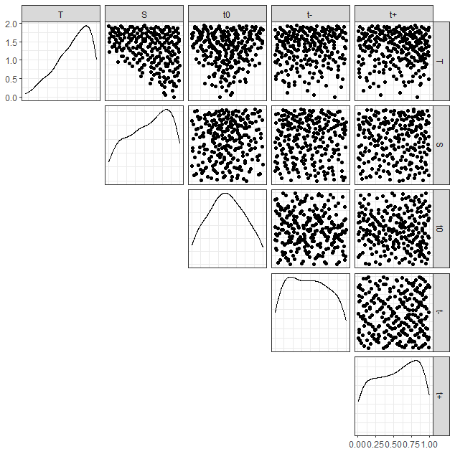
Figure A1. Design of experiments for real case 1. Only the 243 cases that have led to flooding are displayed. All variables are normalised between 0 and 1.

A.2 Real case 2
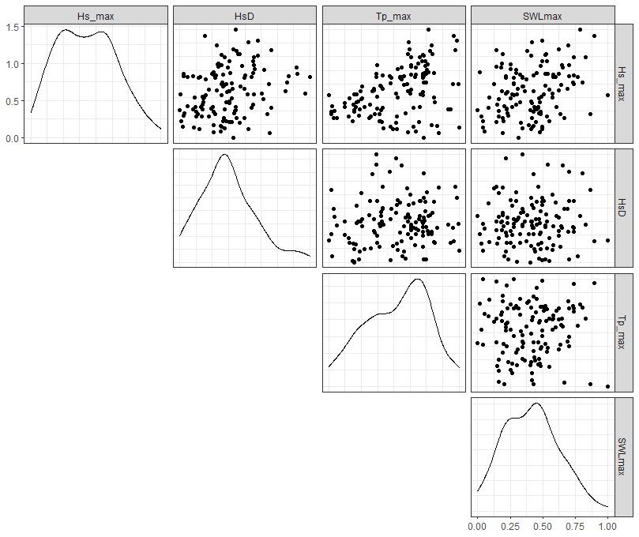
Figure A2. Design of experiments for real case 2. Only the 136 cases that have led to flooding are displayed. All variables are normalised between 0 and 1.

Appendix B: Analysis for real case 2
Figure B1 depicts the eigenvectors derived from the PCA. Like for real case 1, the first eigenvector has positive values over the whole territory, which means that this first mode of spatial variability induces maximum water depths that are shifted above the spatial mean over the whole domain. The magnitude of the positive deviation is heterogeneous over space (as marked by the colour brightness in Fig. B1); in particular with a higher intensification in the southeastern part of the territory. Figure B1(a, b) show distinct modes of spatial variability with some regions exhibiting positive (negative) changes, outlined with warm colours (respectively negative values outlined with cold colours) leading to water levels shifted above (or below) the spatial mean. The second mode induces strong water levels in the central regions where the main urban area is located and where the water depths are the highest (see Fig. 5(a)), whereas the third mode induces strong water depths mostly in the southeastern part of the territory.
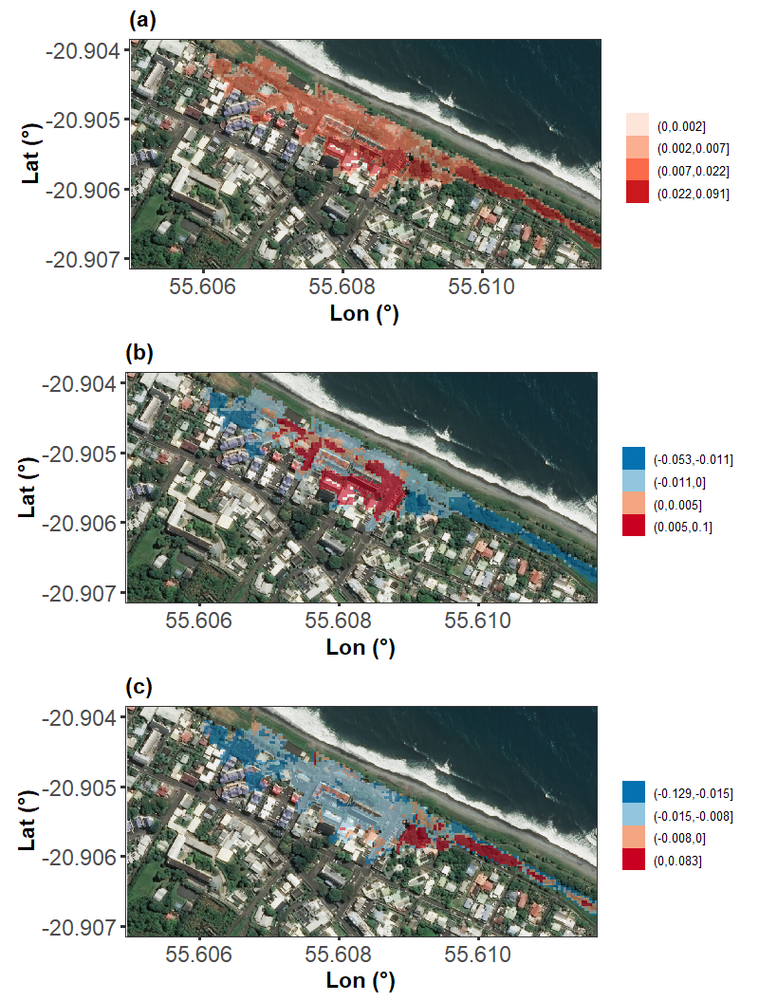
Figure B1. Map related to the first three eigenvectors (a - c) derived from PCA (with mean pre-centering) for the set of flood maps of the real case application. Backgrounds of the maps are extracted from Bing map dataset via OpenStreetMap.

The application of the k-means clustering algorithm with 3 clusters allows to identify subspaces of simplified structure (coloured dots in Fig. B2, left). For instance, the grey cluster is here associated to a quasi-linear relation between the latent variables. The spatial distributions of water depth (measured with respect to the spatial mean) that are the closest to the k-means-derived centroids of each cluster are plotted in Fig. B2, right. This shows that Case (a) is related to a flood that is mainly located in the northwestern part of the territory i.e. related to the second mode of spatial variability which is in agreement with a high z₂ value. Case (b) presents a large spatial extension, which reflects a high contribution of the first mode of variability (i.e. high z₁ value) together with quasi-nil z₂ and z₃ value. Case (c) is related to a flood that has small spatial extent, which is in agreement with its position in the z domain of variation.

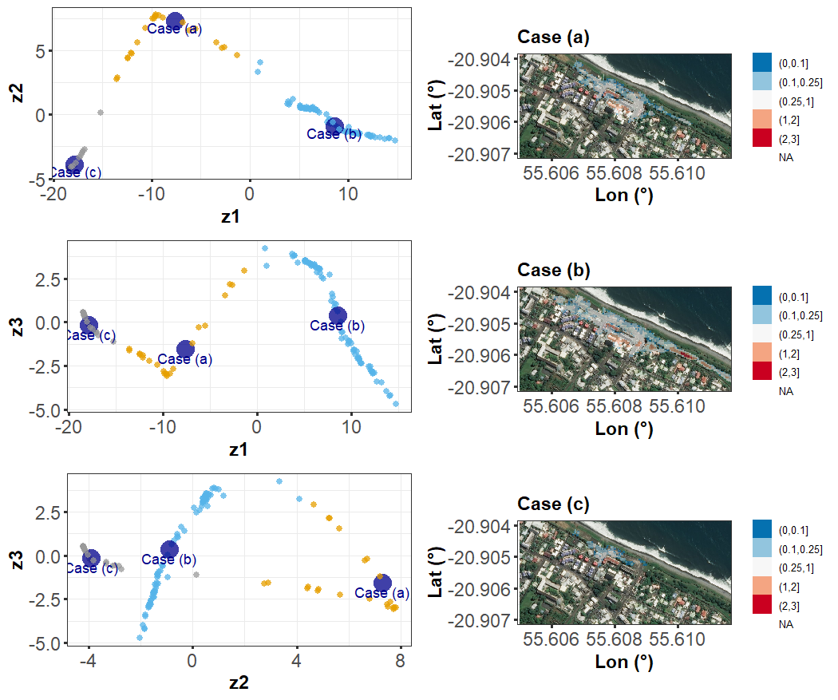
Figure B2. Map of water depth (measured with respect to the spatial mean in meters) for the cases close to the centroid of each cluster (a to c) defined in the latent variables’ space (left panels). Backgrounds of the maps are extracted from Bing map dataset via OpenStreetMap. NA indicates nil values.

The analysis of the performance Q² indicator (Fig. B3) shows strong similarities with the one for case 1:
- z₂ and z₃ are the more difficult to predict;
- Combining any metamodelling approach described in Table 1 with clustering improves the predictive performance;
- Co-kriging metamodelling approaches allows a clear predictive improvement for z₂, but the Q² results remain highly disperse for z₂ and even more for z₃;
- Ind-C and MoP-C appear to be the best performing approaches with a slight higher performance for Ind-C in this case.
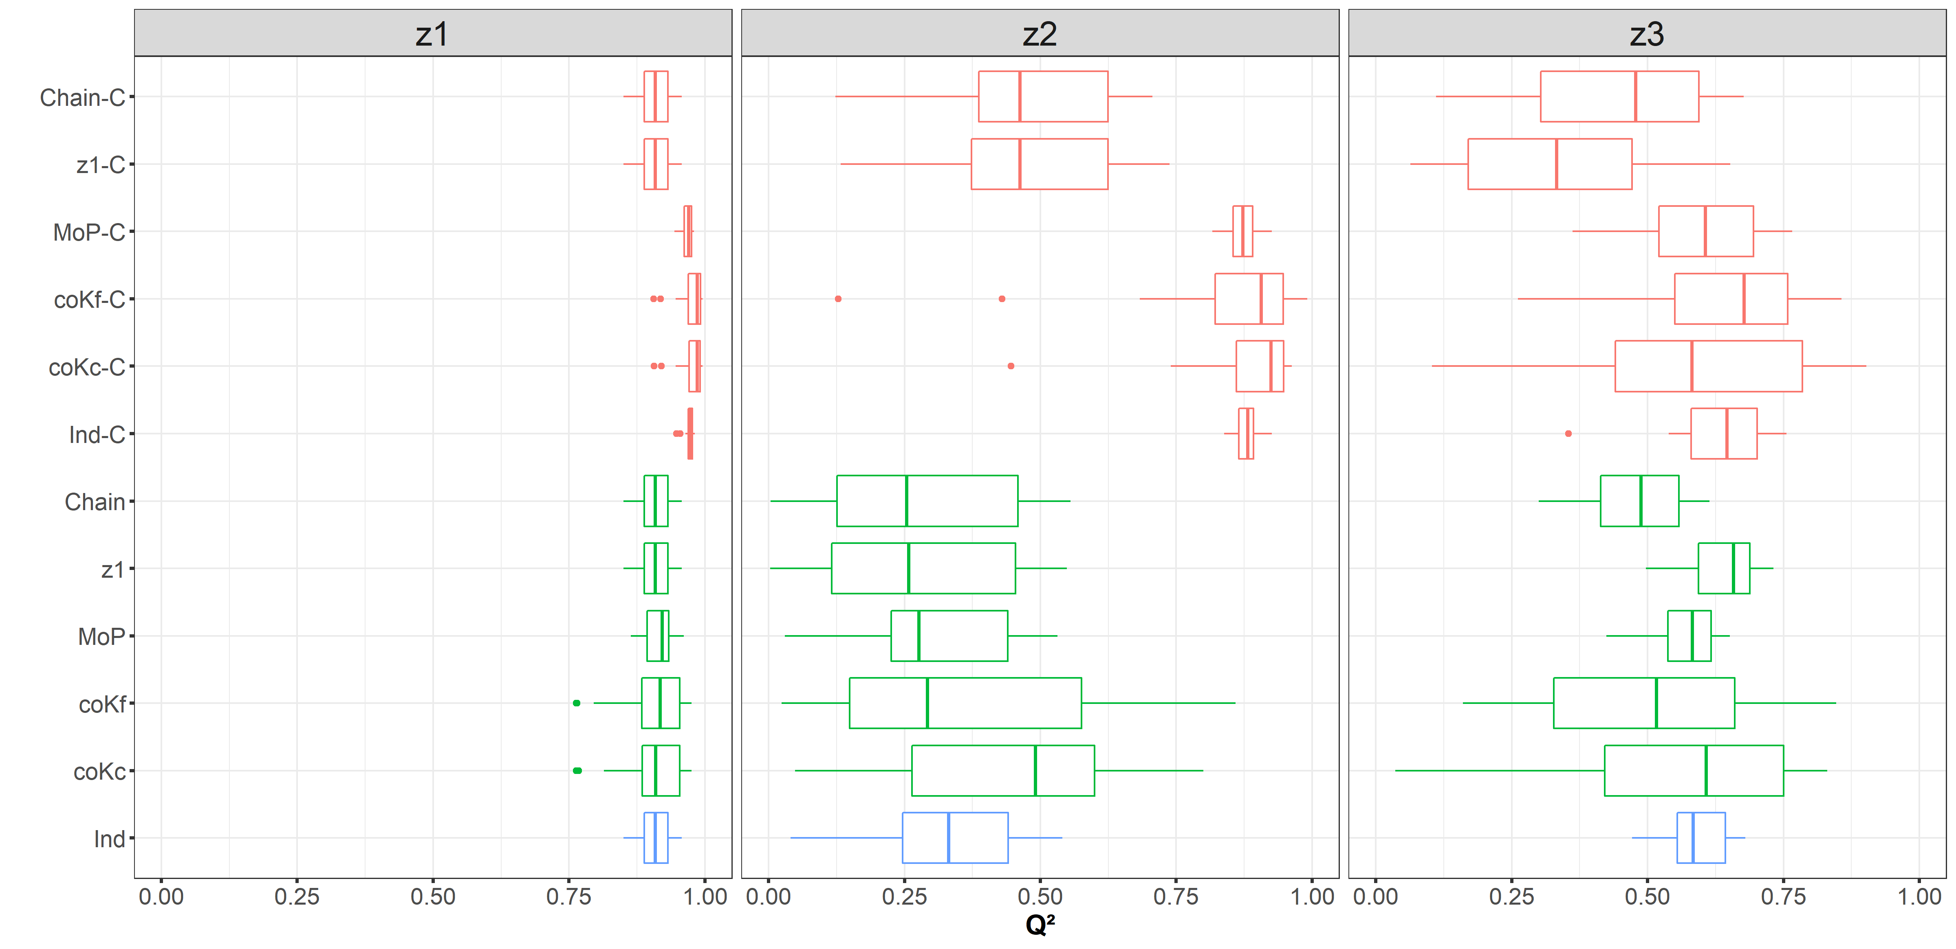
Figure B3. Boxplots of the Q² performance indicator (computed by repeating 25 times the 10-fold cross-validation procedure) for the prediction of the first three latent outputs, namely z₁ (a), z₂ (b), and z₃ (c), for real case 2 considering different PCA- kriging metamodel procedures described in Table 1. The blue, green and red colours indicate the reference solution (Ind approach), the solutions without and with clustering (using 3 clusters) respectively.

Finally, the analysis of MRAE over space (Fig. B4) confirms the higher performance of MoP-C and Ind-C.
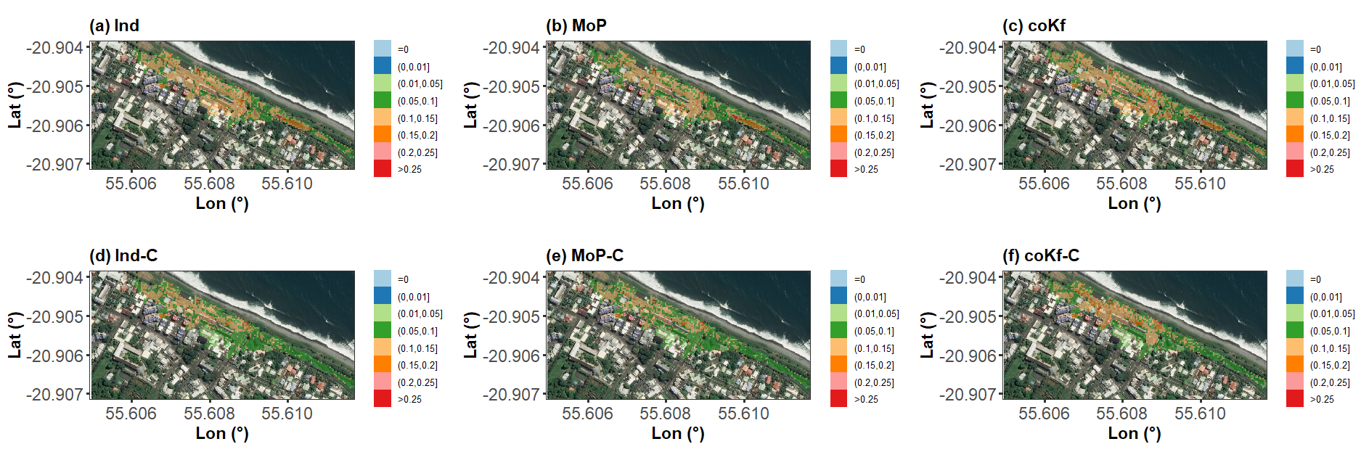
Figure B4. Map of MRAE (average value across 25 repetitions of the cross-validation procedure) for 6 metamodelling approaches (described in Table 1) applied to real case 2. Backgrounds of the maps are extracted from Bing map dataset via OpenStreetMap.

