Appendix
Table 1. Distribution of Sociodemographic Characteristics (n = 389)
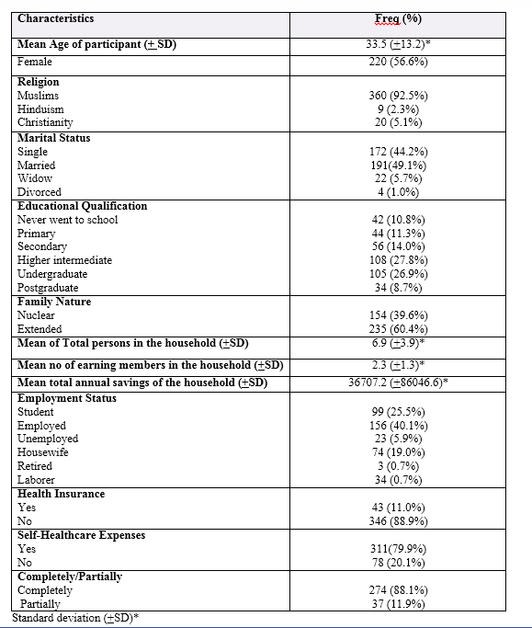

Table 2. Table for descriptive of Physical health awareness experiences (PH) domain based on [responses 1= yes & 0 = no].
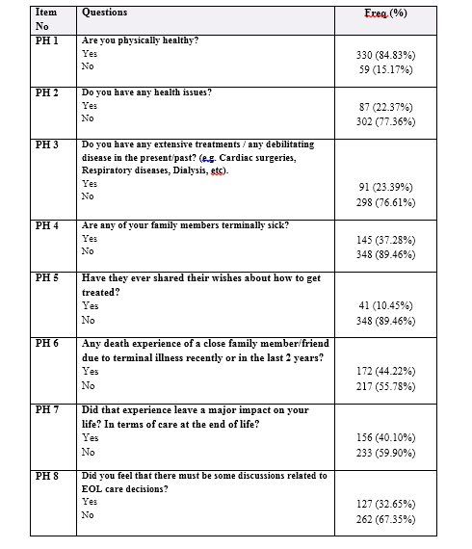
Table 3. Internal Consistency Reliability of knowledge of sociodemographic domains on Advance directives.
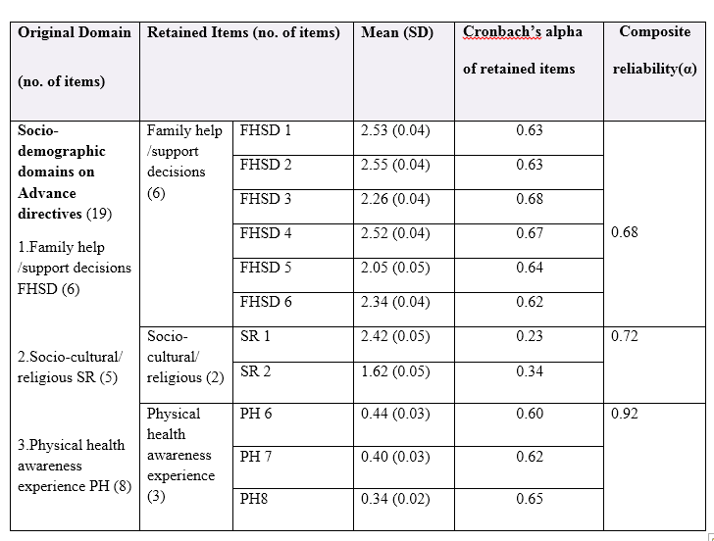
Table 4. Internal Consistency Reliability of overall KAP (knowledge, attitude, perceptions) tool on Advance directives

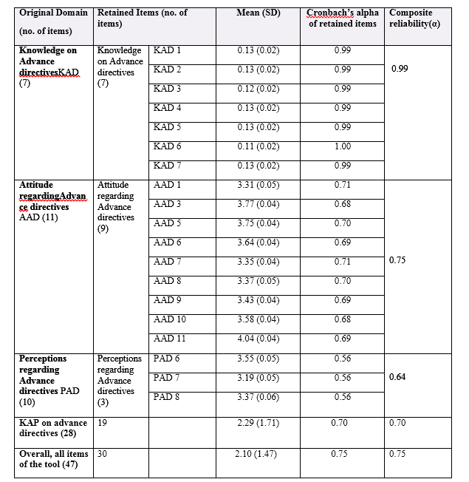

Table no 5.Exploratory factor analysis and distribution of factor loadings (Rotated varimax) of five factors retained with Cronbach's alpha of each component (items n= 23)

