Effect of (4R, 5S) 4-hydroxy-7-angeloyloxycarvatoneacetone from Blumea axillaris (Lam.) DC. plant against An. stephensi and Cx. quinquefasciatus vector mosquitoes (Diptera: Culicidae) and expression of different functional genes

V. Edwin Hillary^{1#}, S. Sivanandhan²*#, S. Antony Ceasar^{3*}, K. Ayyavoo⁴, C. Tamilselvan⁵, M. Ravi Kumar⁶ Osamu shirotta⁷, K. Balakrishna¹

¹Entomology Research Institute, Loyola College (University of Madras), Chennai, Tamilnadu, India.
²Department of Entomology, Bioscience Research Foundation, Kandamangalam, Kanchipuram District, Tamil Nadu, India.
³Department of Biosciences, Rajagiri College of Social Sciences, Cochin, Kerala, India.
⁴Department of Chemistry, Bioscience Research Foundation, Kandamangalam, Kanchipuram District, Tamil Nadu, India.
⁵Test Facility Management, Bioscience Research Foundation, Kandamangalam, Kanchipuram District, Tamil Nadu, India.
⁶Human Resources Manager, Bioscience Research Foundation, Kandamangalam, Kanchipuram District, Tamil Nadu, India.
⁷Laboratory of Pharmacognosy and Natural Products Chemistry, Kagawa School of Pharmaceutical Sciences, Tokushima Bunri University, Japan.

# First two authors have equally contributed

Corresponding authors:

* Dr. S. Subramaniyan Sivanandhan (ORCID ID: 0000-0002-9423-7839): sivanandhan2691@gmail.com
Department of Entomology, Bioscience Research Foundation, Kandamangalam, Kanchipuram District, Tamil Nadu, India

&

*Dr. S. Antony Ceasar (ORCID ID: 0000-0003-4106-1531): antony_sm2003@yahoo.co.in
Department of Biosciences, Rajagiri College of Social Sciences, Cochin - 683 104, Kerala, India.

Supplementary figures

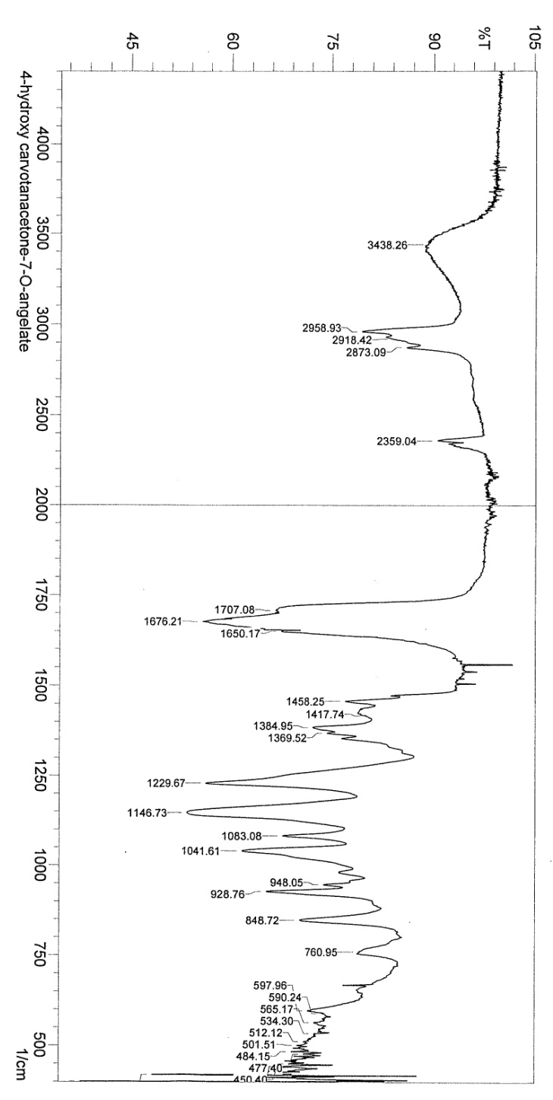

Fig. S1. FT-IR spectrum of compound 1

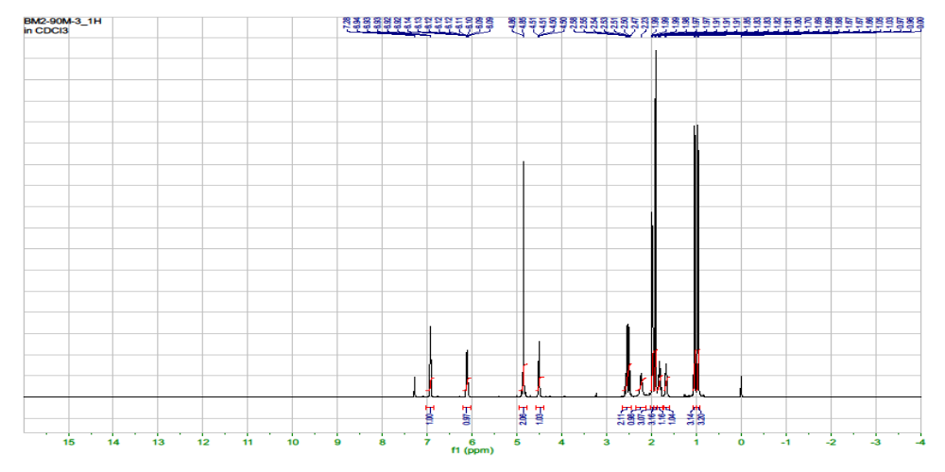
Fig S2. ¹H NMR spectrum of compound 1

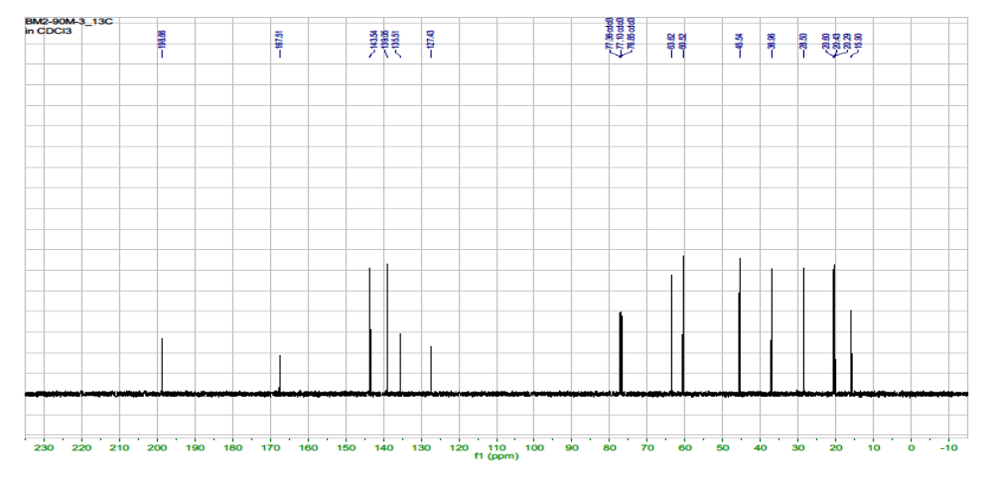
Fig. S3. ¹³C NMR spectrum of compound 1

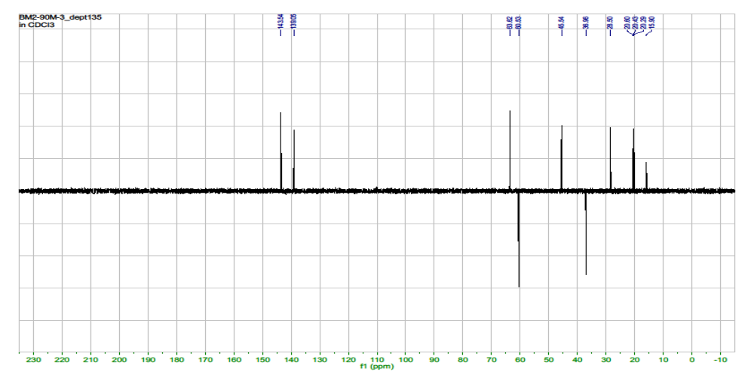 Fig. S4. ¹³C NMR (DEPT) NMR spectrum of compound 1

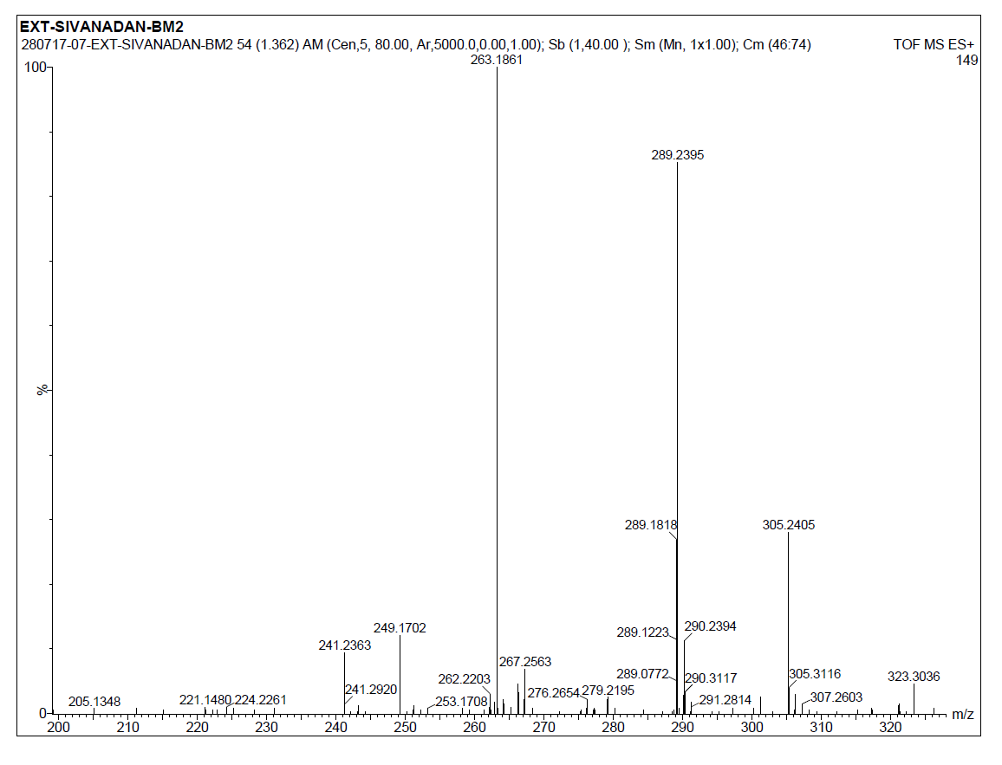
Fig. S5. ESI- MS (+mode) of compound 1

