Supporting Information

Computer-aided affinity enhancement of a cross-reactive antibody against dengue virus envelope domain III

Nisha Amarnath Jonniya, Sayan Poddar, Subhasmita Mahapatra, Parimal Kar*
Department of Biosciences and Biomedical Engineering, Indian Institute of Technology Indore, Khandwa Road, MP 453552, India.

*Corresponding author: Parimal Kar | Email: parimal@iiti.ac.in

Table S1. The average root-mean-square-deviations (RMSD) and radius of guyration (RoG) and solvent-accessible surface area (SASA) of each dengue isoform obtained from the combined trajectories of replica MD simulations.
System | Whole | Antigen | Antibody
Average RMSD (Å)
DENV1 | 2.04 ± 0.13 | 1.03 ± 0.07 | 2.21 ± 0.19
DENV2 | 2.86 ± 0.40 | 2.34 ± 0.40 | 2.80 ± 0.40
DENV3 | 2.85 ± 0.20 | 1.93 ± 0.07 | 2.90 ± 0.25
DENV4 | 2.94 ± 0.25 | 0.99 ± 0.07 | 3.35 ± 0.29
Average RoG (Å)
DENV1 | 20.96 ± 0.06 | 12.76 ± 0.02 | 18.11 ± 0.10
DENV2 | 21.16 ± 0.13 | 13.40 ± 0.09 | 17.76 ± 0.18
DENV3 | 21.22 ± 0.10 | 13.48 ± 0.02 | 17.97 ± 0.05
DENV4 | 20.68 ± 0.04 | 12.83 ± 0.01 | 17.87 ± 0.07
Average SASA ( Å²)
DENV1 | 13256.55 | 4166.99 | 9089.56
DENV2 | 14419.57 | 5126.24 | 9293.33
DENV3 | 13940.58 | 4553.84 | 9386.74
DENV4 | 13438.32 | 4308.89 | 9129.43

Table S2. The average RMSD of different strand regions of the antigen of each isoform obtained from the combined trajectories of replica MD simulations. Also, the RMSD of epitope, paratope, and the interface regions.
System | DENV1 | DENV2 | DENV3 | DENV4
Average RMSD (Å)
A-strand | 0.41 ± 0.01 | 0.45 ± 0.01 | 0.38 ± 0.02 | 0.48 ± 0.02
B-strand | 0.35 ± 0.01 | 0.48 ± 0.05 | 0.38 ± 0.02 | 0.47 ± 0.03
C-strand | 0.31 ± 0.03 | 0.59 ± 0.08 | 0.57 ± 0.02 | 0.27 ± 0.01
E-strand | 0.32 ± 0.01 | 0.39 ± 0.03 | 0.53 ± 0.02 | 0.41 ± 0.02
F-strand | 0.44 ± 0.01 | 0.45 ± 0.05 | 0.50 ± 0.02 | 0.36 ± 0.01
G-strand | 0.37 ± 0.01 | 0.58 ± 0.16 | 0.48 ± 0.12 | 0.39 ± 0.02
Average RMSD (Å)
Epitope | 1.52 | 2.00 | 3.11 | 1.60
Paratope | 1.47 | 1.59 | 1.58 | 1.45
Interface | 1.55 | 1.84 | 2.45 | 1.59

Table S3. Estimation of binding free energy between the antigen and antibody obtained from the MM/PBSA for each dengue WT and its mutant variants.
System | ΔE_{elec} | ΔE_{vdW} | ΔG_{np} | ΔG_{pol} | ΔE_{MM} | ΔG_{solv} | ΔG_{bind}
WT
DENV1 | -394.48  (0.31) | -93.15  (0.04) | -9.99  (0.0) | 414.12  (0.27) | -487.63  (0.31) | 404.13  (0.27) | -83.49  (0.08)
DENV2 | -401.92  (0.72) | -81.73  (0.04) | -9.56  (0.0) | 437.74  (0.62) | -483.65  (0.72) | 428.18  (0.62) | -55.47  (0.09)
DENV3 | -372.76  (0.36) | -85.49  (0.04) | -9.71  (0.0) | 399.86  (0.32) | -458.25  (0.36) | 390.15  (0.32) | -68.10  (0.08)
DENV4 | -365.18  (0.39) | -97.30  (0.06) | -10.23  (0.0) | 396.59  (0.33) | -462.48  (0.39) | 386.36  (0.33) | -76.13  (0.09)
DENV1-Mutants
Y106R | -462.82  (0.23) | -95.26  (0.04) | -9.94  (0.0) | 478.87  (0.20) | -558.08  (0.23) | 468.87  (0.20) | -89.15  (0.08)
N166M | -387.45  (0.23) | -102.75  (0.05) | -10.25  (0.0) | 409.94  (0.20) | -490.20  (0.23) | 399.69  (0.20) | -90.50  (0.09)
N166E | -374.78  (0.24) | -94.73  (0.04) | -9.99  (0.0) | 394.59  (0.22) | -469.51  (0.24) | 384.6  (0.22) | -84.91  (0.07)
K31E | -390.11  (0.27) | -93.34  (0.04) | -10.01  (0.0) | 407.90  (0.22) | -483.45  (0.27) | 397.89  (0.22) | -85.57  (0.08)
Y106R
DENV2 | -387.99  (0.31) | -82.90  (0.04) | -9.53  (0.0) | 429.79  (0.29) | -470.89  (0.31) | 420.26  (0.29) | -50.63  (0.07)
DENV3 | -502.74  (0.57) | -72.12  (0.06) | -9.23  (0.0) | 512.87  (0.54) | -574.86  (0.57) | 503.64  (0.54) | -71.22  (0.12)
DENV4 | -425.28  (0.31) | -93.51  (0.06) | -10.13  (0.0) | 457.67  (0.27) | -518.79  (0.31) | 447.54  (0.27) | -71.25  (0.12)
N166M
DENV2 | -376.74  (0.27) | -83.64  (0.04) | -9.42  (0.00) | 407.25  (0.24) | -460.38  (0.27) | 397.83  (0.24) | -62.55  (0.08)
DENV3 | -282.52  (0.44) | -80.80  (0.07) | -8.84  (0.0) | -363.32  (0.50) | -363.32  (0.45) | 305.25  (0.43) | -58.07  (0.09)
DENV4 | -280.88  (0.24) | -87.07  (0.04) | -9.51  (0.00) | 331.65  (0.24) | -367.95  (0.24) | 322.15  (0.24) | -45.80  (0.07)
Y106R-N166M
DENV1 | -493.07  (0.20) | -95.89  (0.04) | -9.85  (0.0) | 500.19  (0.17) | -588.96  (0.20) | 490.34  (0.17) | -98.62  (0.07)
DENV2 | -391.93  (0.34) | -88.30  (0.04) | -9.66  (0.0) | 430.38  (0.31) | -480.2  (0.34) | 420.72  (0.31) | -59.51  (0.07)
DENV3 | -479.81  (0.27) | -94.34  (0.04) | -10.43  (0.0) | 503.37  (0.24) | -574.15  (0.27) | 492.94  (0.24) | -81.21  (0.08)
DENV4 | -313.32  (0.59) | -78.27  (0.09) | -8.89  (0.01) | 345.31  (0.58) | -391.59  (0.60) | 336.42  (0.35) | -55.16  (0.13)
Calculated values are averages estimated from three MD trials for the WT and in parenthesis, the standard error of the mean (SEM) is given.

Tabe S4. The percentage of hydrogen-bond formed between the antigen and antibody in MD.
Acceptor | Donor | Fraction (%)
DENV1
Lys388@O | Asn166@ND2 | 78.49
Phe306@O | Arg186@NH2 | 73.85
Glu309@OE1 | Arg99@NH2 | 65.48
Glu362@O | Arg99@NH1 | 63.69
Glu362@OE1 | Tyr106@OH | 62.69
Tyr164@O | Ser390@N | 57.16
Glu102@OE1 | Leu308@N | 55.46
DENV1 (MT-Tyr106R)
Glu362@O | Arg99@NH1 | 83.73
Phe306@O | Arg186@NH2 | 81.24
Lys388@O | Asn166@ND2 | 79.54
Glu309@OE2 | Arg99@NH2 | 77.14
Glu102@OE2 | Leu308@N | 68.74
Glu309@OE2 | Thr33@OG1 | 59.73
Tyr164@O | Ser390@N | 57.87
Asp32@O | Gln323@NE2 | 51.03
DENV1 (MT-Asn166M)
Glu102@OE2 | Leu308@N | 88.10
Glu362@O | Arg99@NH1 | 76.89
Phe308@O | Arg186@NH2 | 63.17
Glu309@OE1 | Arg99@NH2 | 56.35
Glu309@OE1 | Thr33@OG1 | 53.03
Glu362@O | Arg99@NH2 | 52.29
Tyr164@O | Ser390@N | 48.01
DENV2
Phe306@O | Arg186@NH2 | 93.05
Lys388@O | Asn166@ND2 | 83.24
Glu102@OE2 | Ile308@N | 70.00
Tyr164@O | Asn390@N | 61.54
DENV3
Phe378@O | Arg186@NH2 | 96.62
Glu102@OE2 | Leu308@N | 80.53
Lys388@O | Asn166@ND2 | 79.41
Glu362@OE2 | Arg99@NH2 | 68.22
Glu362@OE1 | Arg99@NH1 | 57.79
Tyr164@O | Asn390@N | 54.83
DENV4
Glu102@OE1 | Ser307@OG | 91.13
Thr388@O | Asn166@ND2 | 73.14
Asn362@O | Arg99@NH1 | 71.36
Phe306@O | Arg186@NH2 | 70.73
Tyr164@O | His390@N | 55.96
Asp309@OD2 | Arg99@NH2 | 54.45
H-bond occupancy (> 50%,) between Mab and DIII Ag, antibody are shown in bold
Table S5. The list of hydrogen bond and salt-bridge interactions between the dengue antigen and antibody E11 reported in the crystal structures. (Antigen is in bold; salt-bridge interaction is in green; hydrogen-bond interaction is in blue)
DENV1 (PDB:3UZQ) | DENV2 (PDB:3UZV) | DENV3 (PDB:3UZE) | DENV4 (PDB:3UYP)
Phe306@O-Arg186@NH2 | Phe306@O-Arg186@NH2 | Phe306@O-Arg186@NH2 | Lys305@NZ-Asn189@OE1
Lys307@NZ-Glu191@OE1 | Lys307@NZ-Glu191@OE1 | Leu308@N-Glu102@OE2 | Phe306@O-Arg186@NH2
Leu308@N-Glu102@OE2 | Lys307@NZ-Glu191@O | Lys309@O-Thr33@OG1 | Ile308@N-Glu102@OE2
Glu309@OE1-Arg99@NH2 | Ile308@N-Glu102@OE2 | Lys310@NZ-Asp53@OD1 | Asp309@OD1-Arg99@NH2
Glu309@OE2-Arg99@NE | Val309@O-Thr33@OG1 | Lys310@NZ-Lys31@O | Asp309@OD2-Arg99@NE
Lys310@NZ-Asp53@OD1 | Lys310@NZ-Asp53@OD1 | Glu311@N-Tyr34@OH | Lys310@NZ-Asp53@OD1
Lys310@NZ-Lys31@O | Lys310@NZ-Lys31@O | Glu311@OE2-Arg163@NH1 | Lys310@NZ-Lys31@O
Glu311@N-Tyr34@OH | Glu311@N-Tyr34@O11 | Glu311@OE2-Arg163@NH2 | Lys310@NZ-Thr33@O
Glu311@OE2-Arg163@NH1 | Glu311@OE2-Arg163@NH1 | Val312@N-Tyr164@OH | Glu311@N-Tyr34@O
Val312@N-Tyr164@OH | Glu311@OE2-Arg163@NH2 | Glu325@OE1-Arg99@NH2 | Glu311@OE2-Arg163@NH1
Gln323@NE2-Asp32@O | Ile312@N-Tyr164@OH | Lys327@NZ-Glu191@OE1 | Glu311@OE2-Arg163@NH2
Glu362@OE2-Tyr106@OH | Asp362@OD1-Tyr106@OH | Lys388@O-Asn166@ND2 | Met312@N-Tyr164@OH
Glu362@O-Arg99@NH2 | Lys388@O-Asn166@ND2 | Asn390@N-Tyr164@O | Thr362@O-Tyr106@OH
Glu362@O-Arg99@NH1 | Asn390@N-Tyr164@O |  | Asn362@OD1-Tyr106@OH
Lys388@O-Asn166@ND2 |  |  | Asn362@O-Arg99@NH2
Ser390@N-Tyr164@O |  |  | Asn362@O-Arg99@NH1
 |  |  | Asn366@ND2-Asp32@OD1
 |  |  | Thr388@O-Asn166@ND2
 |  |  | His390@N-Tyr164@O

Table S6. The stability check of the selected mutations of the E11 antibody from the DynaMut server for each dengue isoform.
Mutation | Stabilization/Destabilization score (kcal/mol)
DENV1
Lys31Glu | -0.27 kcal/mol (Destabilizing)
Tyr34Arg | -1.81 kcal/mol (Destabilizing)
Tyr106Arg | 0.53 kcal/mol (Stabilizing)
Asn166Glu | -0.75 kcal/mol (Destabilizing)
DENV2
Lys31Glu | -0.18 kcal/mol (Destabilizing)
Tyr34Arg | -0.72 kcal/mol (Destabilizing)
Tyr106Arg | -0.43 kcal/mol (Destabilizing)
Asn166Glu | -0.49 kcal/mol (Destabilizing)
DENV3
Lys31Glu | -0.28 kcal/mol (Destabilizing)
Tyr33Glu | -0.99 kcal/mol (Destabilizing)
Tyr34Arg | -2.03 kcal/mol (Destabilizing)
Asn166Glu | -0.41 kcal/mol (Destabilizing)
DENV4
Lys31Glu | -0.22 kcal/mol (Destabilizing)
Thr33Glu | -0.82 kcal/mol (Destabilizing)
Tyr34Arg | -1.94 kcal/mol (Destabilizing)
Asn189Glu | -0.54 kcal/mol (Destabilizing)

Table S7. Effect of all possible mutations at Asn166 in binding affinity calculated by the mSCM from the DUET server.

Mutational Residues |  | mCSM predicted ΔΔG (kcal/mol)
Asn166Arg | -0.18
Asn166Pro | -0.503
Asn166Asp | -1.016
Asn166Phe | -0.864
Asn166Ile | -0.17
Asn166His | -1.095
Asn166Met | 0.189
Asn166Tyr | -0.294
Asn166Lys | -0.078
Asn166Ala | -1.255
Asn166Val | -0.503
Asn166Leu | -0.17
Asn166Gly | -1.663
Asn166Ser | -1.132
Asn166Trp | -0.543
Asn166Thr | -0.706
Asn166Gln | -0.785
Asn166Glu | -0.815
Asn166Cys | -0.385

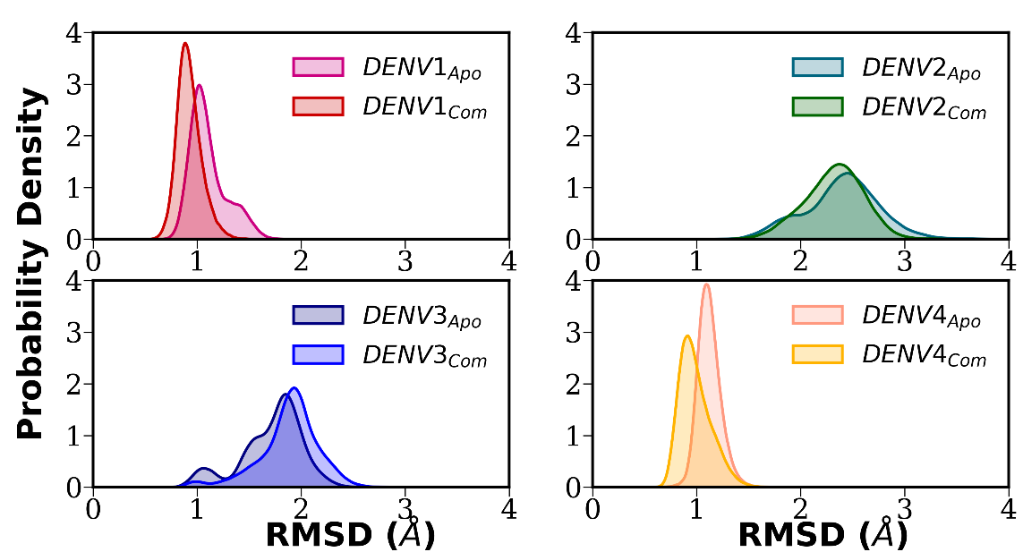
Fig. S1. The probability distribution of the RMSD of dengue E protein DIII of each serotype in its apo and complex with the antibody from the MD simulations.

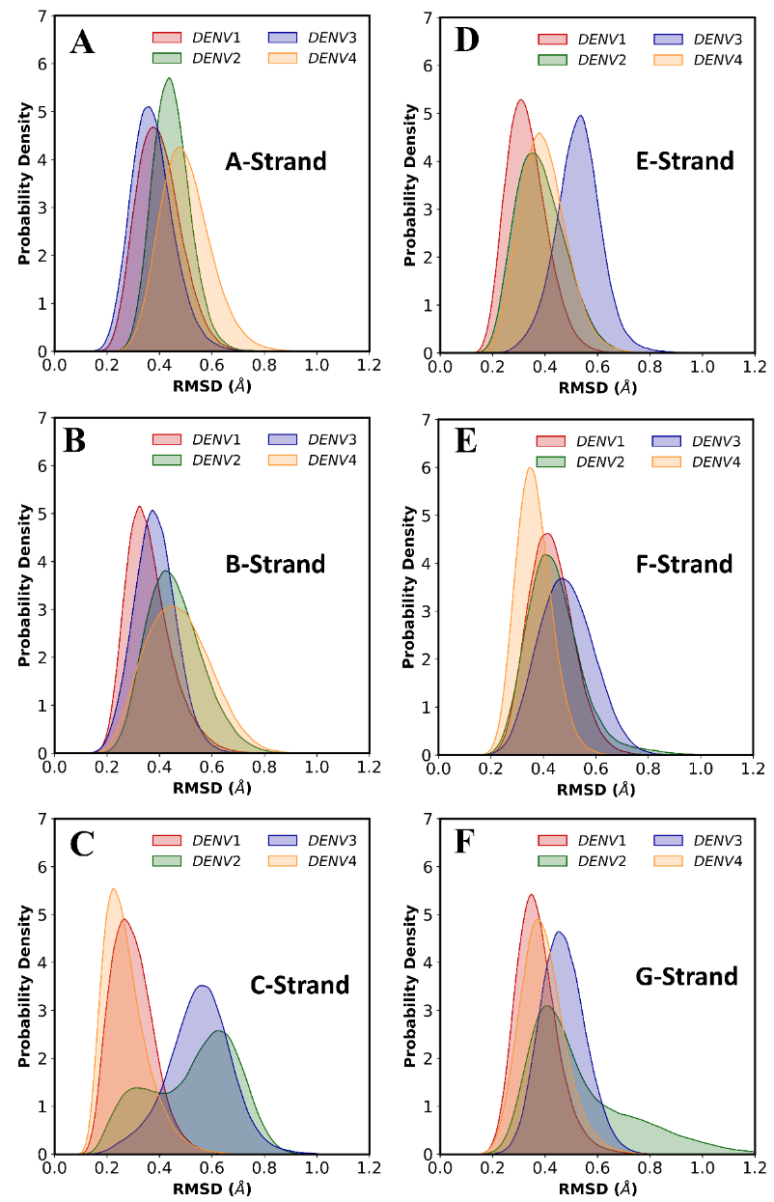
Fig. S2. The probability distribution of RMSD of different strand regions of the antigen of each complex.

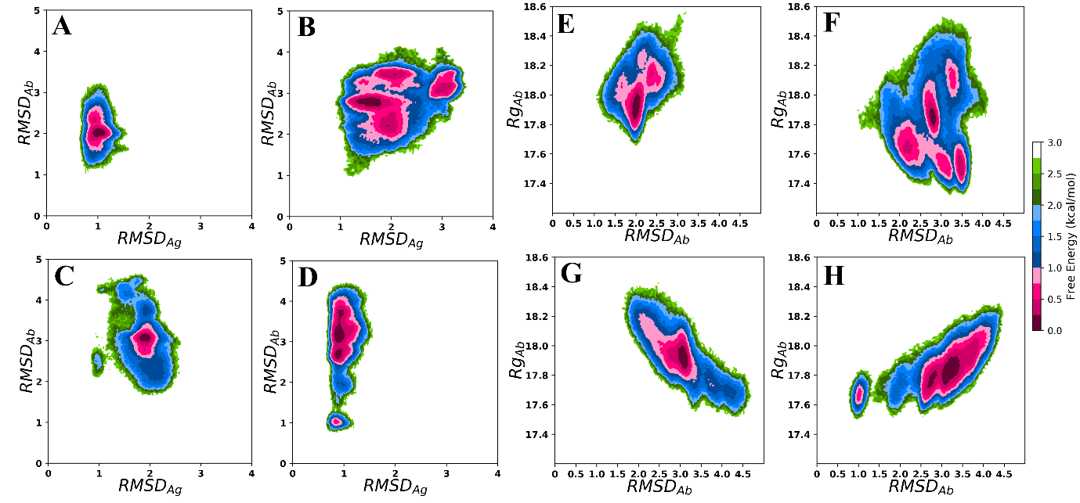
Fig. S3. The two-dimensional free energy landscape (FES) drawn with respect to RMSD of antigen vs RMSD of antibody for (A) DENV1, (B) DENV2, (C) DENV3, and (D) DENV4. FES drawn with respect to RMSD of antibody vs radius of gyration (RoG) of antibody for (E) DENV1, (F) DENV2, (G) DENV3, and (H) DENV4.

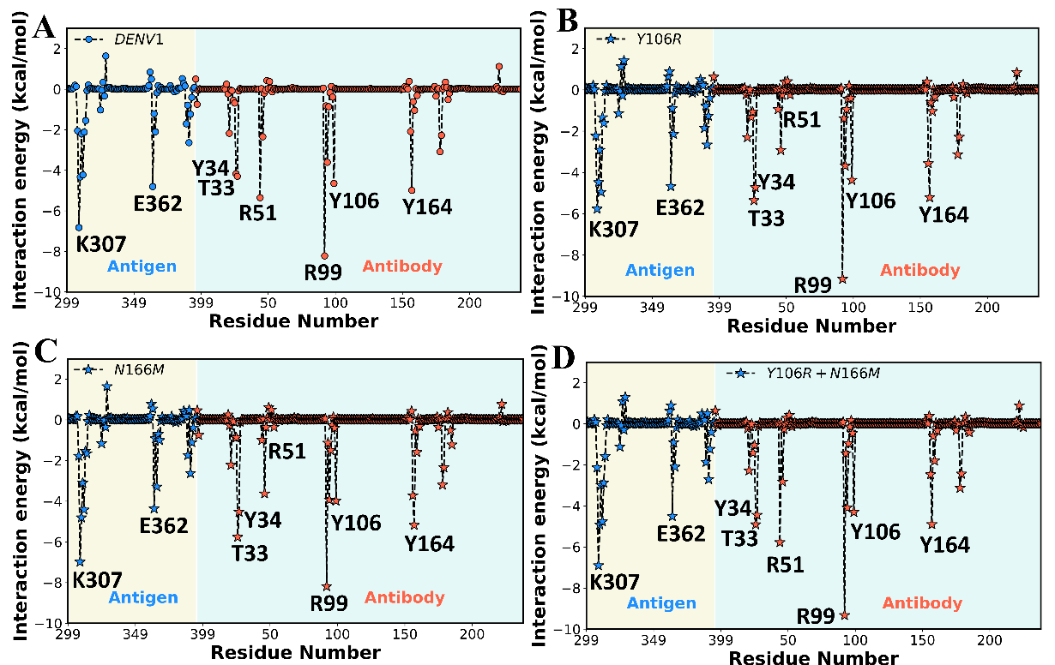
Fig. S4. The per-residual decomposition of binding free energy of DENV1 in wild-type and mutant varainats. (A) wild-type DENV1, (B) mutant, Y106R, (C) mutant, N166M, and (D) double mutants, Y106R+N166M.

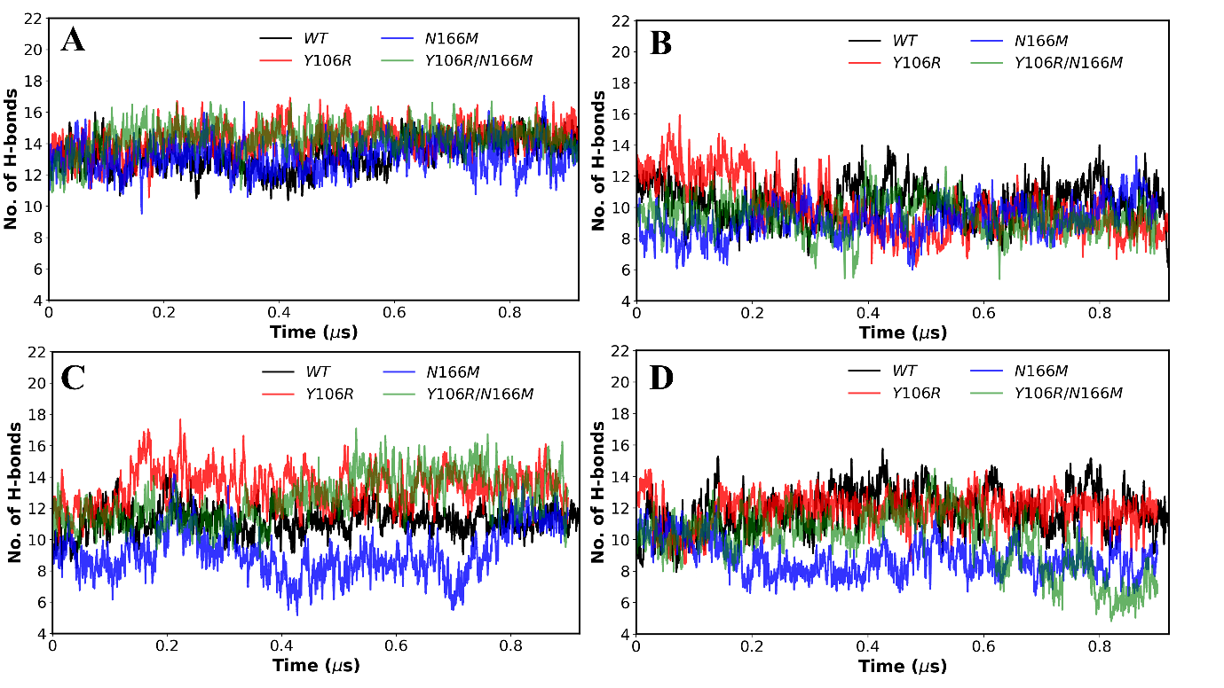
Fig. S5. The average hydrogen bond from MD simulation for each wild-type and mutant for (A) DENV1, (B) DENV2, (C) DENV3, and (D) DENV4, respectively.

