Supporting Online Material Lettow et al.

Table S1: Pathway-specific repressor proteins of S. cerevisiae investigated in this study.

Repressor | Function
Cti6 | Required for growth under conditions of iron-limitation (Puig et al. 2004) and for regulatory switch from repression to induction at the GAL1 promoter (Papamichos-Chronakis et al. 2002); contains a Cys/His PHD structural motif.
Opi1 | Contains a leucine zipper; counteracts transcription of phospholipid biosynthetic genes by activator Ino2 (White et al. 1991).
Ume6 | URS1-binding protein with a binuclear zinc-cluster motif; downregulates early meiotic genes and various metabolic genes (Strich et al. 1994).
Rox1 | HMG box-containing repressor of hypoxic genes in the presence of oxygen (Balasubramanian et al. 1993).
Yox1 | Homeobox-containing repressor which counteracts Mcm1 and inhibits early cell cycle boxes (ECBs) after M/G1 phase (Pramila et al. 2002).
Mot3 | Zinc finger repressor of hypoxic genes and genes of ergosterol biosynthesis (Hongay et al. 2002).
Dal80 | Zinc finger repressor (GATA-type) which down-regulates genes of nitrogen catabolite repression (NCR; Cunningham and Cooper 1991).
Yhp1 | Homeobox-containing repressor which counteracts Mcm1 and inhibits early cell cycle boxes (ECBs) after M/G1 phase (Pramila et al. 2002).
Whi5 | Represses cell cycle regulated transcription by SBF (Swi4/Swi6) during the early G1 phase (de Bruin et al. 2004).
Fkh1 | Contains forkhead and winged helix-turn-helix domains; positive and negative regulation of cell cycle-dependent transcription at the G2/M boundary (Zhu et al. 2000).
Rdr1 | Contains a binuclear zinc-cluster motif and represses genes mediating multidrug resistance (Hellauer et al. 2002).
Xbp1 | Contains a helix-turn-helix motif similar to that of activator Swi4 and represses cyclin genes of cell cycle progression and meiosis under stress conditions (Mai and Breeden 2000).
Gal80 | Represses UAS_{GAL}-dependent genes in the absence of galactose by inhibiting Gal4 activation domain (Ma and Ptashne 1987) and recruiting Cyc8/Tup1 (Lettow et al. 2022)
Ure2 | GST-related repressor of NCR-regulated genes in the presence of a favourable nitrogen source (Coffman et al. 1994)
Mig1 | General glucose repressor with a C2H2-zinc finger motif binding to upstream regions of glucose-regulated genes (Nehlin and Ronne 1990)
Nrg1 | Contains zinc finger motifs and represses glucose-regulated genes (Park et al. 1999)
Sko1 | Contains a basic leucine zipper motif and represses genes regulated by osmotic stress (Proft and Serrano 1999)
Mth1 | Negative regulation of hexose transporter genes (Lakshmanan et al. 2003)

Additional references to Table S1:

Balasubramanian B, Lowry CV, Zitomer RS (1993) The Rox1 repressor of the Saccharomyces cerevisiae hypoxic genes is a specific DNA-binding protein with a high-mobility-group motif. Mol Cell Biol 13:6071-6078.
Coffman JA, el Berry HM, Cooper TG (1994) The URE2 protein regulates nitrogen catabolic gene expression through the GATAA-containing UAS_{NTR} element in Saccharomyces cerevisiae. J Bacteriol 176:7476-7483.
Cunningham TS, Cooper TG (1991) Expression of the DAL80 gene, whose product is homologous to the GATA factors and is a negative regulator of multiple nitrogen catabolic genes in Saccharomyces cerevisiae, is sensitive to nitrogen catabolite repression. Mol Cell Biol 11:6205-6215.
de Bruin RA, McDonald WH, Kalashnikova TI, Yates J, Wittenberg C (2004) Cln3 activates G1-specific transcription via phosphorylation of the SBF bound repressor Whi5. Cell 117:887-898.
Lakshmanan J, Mosley AL, Özcan S (2003) Repression of transcription by Rgt1 in the absence of glucose requires Std1 and Mth1. Curr Genet 44:19-25.
Ma J, Ptashne M (1987) The carboxy-terminal 30 amino acids of GAL4 are recognized by GAL80. Cell 50:137-142.
Nehlin JO, Ronne H (1990) Yeast MIG1 repressor is related to the mammalian early growth response and Wilms' tumour finger proteins. EMBO J 9:2891-2898.
Park SH, Koh SS, Chun JH, Hwang HJ, Kang HS (1999) Nrg1 is a transcriptional repressor for glucose repression of STA1 gene expression in Saccharomyces cerevisiae. Mol Cell Biol 19:2044-2050.
Proft M, Serrano R (1999) Repressors and upstream repressing sequences of the stress-regulated ENA1 gene in Saccharomyces cerevisiae: bZIP protein Sko1p confers HOG-dependent osmotic regulation. Mol Cell Biol 19:537-546.
Puig S, Lau M, Thiele DJ (2004) Cti6 is an Rpd3-Sin3 histone deacetylase-associated protein required for growth under iron-limiting conditions in Saccharomyces cerevisiae. J Biol Chem 279:30298-30306.
Strich R, Surosky RT, Steber C, Dubois E, Messenguy F, Esposito RE (1994) UME6 is a key regulator of nitrogen repression and meiotic development. Genes Dev 8:796-810.
White MJ, Hirsch JP, Henry SA (1991) The OPI1 gene of Saccharomyces cerevisiae, a negative regulator of phospholipid biosynthesis, encodes a protein containing polyglutamine tracts and a leucine zipper. J Biol Chem 266:863-872.
Zhu G, Spellman PT, Volpe T, Brown PO, Botstein D, Davis TN, Futcher B (2000) Two yeast forkhead genes regulate the cell cycle and pseudohyphal growth. Nature 406:90-94.

Table S2: Plasmids constructed and used by Lettow et al.:

Plasmid | Genotype
M1102 | ARS CEN URA3 SIN3
M1185 | ARS CEN URA3 SIN3Δ1776-1947 (ΔPAH1)
M1186 | ARS CEN URA3 SIN3Δ4593-4673 (ΔPAH4)
M1253 | ARS CEN URA3 SIN3Δ1776-1947 Δ2332-2412 (ΔPAH1 ΔPAH2)
M1285 | ARS CEN URA3 SIN3Δ2332-2412 (ΔPAH2)
M1290 | ARS CEN URA3 SIN3Δ3073-3273 (ΔPAH3)
pCG1 | 2µm LEU2 MET25_{PR}-HA₃-lexA_{DBD}-NLS-XBP1 (full length)
pCG2 | 2µm LEU2 MET25_{PR}-HA₃-lexA_{DBD}-NLS-XBP1₅₇₄₋₆₄₇
pCG5 | 2µm LEU2 MET25_{PR}-HA₃-lexA_{DBD}-NLS-URE2 (full length)
pCG6 | 2µm LEU2 MET25_{PR}-HA₃-lexA_{DBD}-NLS-XBP1₁₋₄₃₀
pCG7 | 2µm LEU2 MET25_{PR}-HA₃-lexA_{DBD}-NLS-XBP1₄₃₀₋₆₄₇
pCG10 | tac_{Pr/Op}-GST-XBP1₁₋₄₃₀
pCH1 | tac_{Pr/Op}-GST-SKO1₁₋₂₀₀
pCH2 | tac_{Pr/Op}-GST-SKO1₂₀₁₋₄₂₇
pCH3 | tac_{Pr/Op}-GST-SKO1₄₇₉₋₆₄₇
pCH7 | tac_{Pr/Op}-GST-SKO1₂₇₀₋₄₂₇
pCH8 | 2µm LEU2 MET25_{PR}-HA₃-lexA_{DBD}-NLS-SKO1₁₋₂₀₀
pCH9 | 2µm LEU2 MET25_{PR}-HA₃-lexA_{DBD}-NLS-SKO1₂₀₁₋₄₂₇
pCH10 | 2µm LEU2 MET25_{PR}-HA₃-lexA_{DBD}-NLS-SKO1₄₇₉₋₆₄₇
pCW83 | 2μm URA3 MET25_{Pr}-HA₃-SIN3₁₋₃₀₀-CYC1_{Ter} (Grigat et al. 2012)
pCW117 | 2µm URA3 MET25_{Pr}-HA₃-SIN3₁₋₁₅₃₆-CYC1_{Ter} (Wagner et al. 2001)
pFK62 | tac_{Pr/Op}-GST-NRG1 (full length)
pFK63 | tac_{Pr/Op}-GST-ROX1 (full length)
pFK64 | tac_{Pr/Op}-GST-YOX1 (full length)
pFK64 | tac_{Pr/Op}-GST-YOX1₁₋₃₈₅
pFK66 | tac_{Pr/Op}-GST-SKO1 (full length)
pFK74 | 2µm LEU2 MET25_{PR}-HA₃-lexA_{DBD}-NLS-ROX1 (full length)
pFK75 | 2µm LEU2 MET25_{PR}-HA₃-lexA_{DBD}-NLS-NRG1 (full length)
pFK76 | tet_{Pr/Op}-HA₃-TUP1₁₋₇₁₃ (Lettow et al. 2022)
pFK77 | tet_{Pr/Op}-HA₃-CYC8₁₋₃₉₈ (Lettow et al. 2022)
pFK84 | 2µm LEU2 MET25_{PR}-HA₃-lexA_{DBD}-NLS-OPI1 (full length)
pFK86 | tac_{Pr/Op}-GST-ROX1₁₋₂₀₀
pFK87 | tac_{Pr/Op}-GST-ROX1₂₀₁₋₃₆₈
pFK88 | tac_{Pr/Op}-GST-YOX1₁₋₂₀₀
pFK89 | tac_{Pr/Op}-GST-YOX1₂₀₁₋₃₈₅
pFK91 | tac_{Pr/Op}-GST-DAL80 (full length)
pFK92 | tac_{Pr/Op}-GST-MOT3 (full length)
pFK93 | tac_{Pr/Op}-GST-YHP1 (full length)
pFK94 | tac_{Pr/Op}-GST-MTH1 (full length)
pFK95 | tac_{Pr/Op}-GST-ROX1₁₂₄₋₂₀₀
pFK96 | tac_{Pr/Op}-GST-YOX1₁₂₀₋₂₈₀
pFK100 | tac_{Pr/Op}-GST-DAL80₁₋₁₅₀
pFK101 | tac_{Pr/Op}-GST-DAL80₁₀₀₋₂₀₀
pFK102 | tac_{Pr/Op}-GST-DAL80₁₅₁₋₂₆₉
pFK103 | tac_{Pr/Op}-GST-MOT3₁₋₂₃₀
pFK104 | tac_{Pr/Op}-GST-MOT3₂₃₁₋₄₉₀
pFK109 | 2µm LEU2 MET25_{PR}-HA₃-lexA_{DBD}-NLS-UME6₅₀₈₋₅₉₄
pFS1 | tac_{Pr/Op}-GST-URE2₁₋₂₂₈
pFS2 | tac_{Pr/Op}-GST-URE2₂₀₁₋₃₅₄
pFS3 | tac_{Pr/Op}-GST-URE2₁₋₁₀₅
pFS4 | tac_{Pr/Op}-GST-URE2₁₀₆₋₂₂₈
pFS6 | 2µm LEU2 MET25_{PR}-HA₃-lexA_{DBD}-NLS-URE2₁₋₂₂₈
pFS7 | 2µm LEU2 MET25_{PR}-HA₃-lexA_{DBD}-NLS-URE2₂₀₁₋₃₅₄
pFS8 | 2µm LEU2 MET25_{PR}-HA₃-lexA_{DBD}-NLS-URE2₁₋₁₀₅
pFS9 | 2µm LEU2 MET25_{PR}-HA₃-lexA_{DBD}-NLS-URE2₁₀₆₋₂₂₈
pFT1 | tac_{Pr/Op}-GST-YOX1₂₃₅₋₂₈₀
pJL11 | 2µm LEU2 MET25_{PR}-HA₃-lexA_{DBD}-NLS-YOX1 (full length)
pJL11 | 2µm LEU2 MET25_{PR}-HA₃-lexA_{DBD}-NLS-YOX1₁₋₃₈₅
pJL12 | 2µm LEU2 MET25_{PR}-HA₃-lexA_{DBD}-NLS-YOX1₂₂₀₋₂₈₀
pJL16 | 2µm LEU2 MET25_{PR}-HA₃-lexA_{DBD}-NLS-YHP1 (full length)
pJL17 | 2µm LEU2 MET25_{PR}-HA₃-lexA_{DBD}-NLS-GAL80 (full length)
pJL18 | 2µm LEU2 MET25_{PR}-HA₃-lexA_{DBD}-NLS-MIG1 (full length)
pJL20 | 2µm LEU2 MET25_{PR}-HA₃-lexA_{DBD}-NLS-SKO1 (full length)
pJL33 | tac_{Pr/Op}-GST-UME6₅₀₈₋₅₉₄
pJL34 | tet_{Pr/Op}-HA₃-SIN3₁₋₄₈₀
pJL51 | 2µm LEU2 MET25_{PR}-HA₃-lexA_{DBD}-NLS-RDR1 (full length)
pJL67 | 2µm LEU2 MET25_{PR}-HA₃-lexA_{DBD}-NLS-YOX1₂₂₀₋₂₈₀ V248A
pJL68 | 2µm LEU2 MET25_{PR}-HA₃-lexA_{DBD}-NLS-YOX1₂₂₀₋₂₈₀ L255A
pJL69 | 2µm LEU2 MET25_{PR}-HA₃-lexA_{DBD}-NLS-YOX1₂₂₀₋₂₈₀ V257A
pJL70 | 2µm LEU2 MET25_{PR}-HA₃-lexA_{DBD}-NLS-YOX1₂₂₀₋₂₈₀ L262A
pJL72 | 2µm LEU2 MET25_{PR}-HA₃-lexA_{DBD}-NLS-YOX1₂₂₀₋₂₈₀ V266A
pJL74 | 2µm LEU2 MET25_{PR}-HA₃-lexA_{DBD}-NLS-YOX1₂₂₀₋₂₈₀ I270A L271A
pJL75 | 2µm LEU2 MET25_{PR}-HA₃-lexA_{DBD}-NLS-YOX1₂₂₀₋₂₈₀ R272A D273A
pJL82 | ARS CEN URA3 SIN3Δ4593-5820 (ΔPAH4 ΔHCR)
pJuW1 | 2µm LEU2 MET25_{PR}-HA₃-lexA_{DBD}-NLS-DAL80 (full length)
pJuW2 | 2µm LEU2 MET25_{PR}-HA₃-lexA_{DBD}-NLS-MOT3 (full length)
pJuW3 | tac_{Pr/Op}-GST-DAL80₁₅₁₋₂₀₀
pJuW4 | tac_{Pr/Op}-GST-MOT3₂₃₁₋₃₄₇
pJuW5 | tac_{Pr/Op}-GST-MOT3₃₉₅₋₄₉₀
pJuW6 | 2µm LEU2 MET25_{PR}-HA₃-lexA_{DBD}-NLS-DAL80₁₅₁₋₂₀₀
pJuW7 | 2µm LEU2 MET25_{PR}-HA₃-lexA_{DBD}-NLS-MOT3₂₃₁₋₃₄₇
pJuW8 | 2µm LEU2 MET25_{PR}-HA₃-lexA_{DBD}-NLS-MOT3₃₉₅₋₄₉₀
pMP20 | 2μm URA3 MET25_{Pr}-HA₃-SIN3₁₁₀₁₋₁₅₃₆-CYC1_{Ter} (Grigat et al. 2012)
pRAR1 | tac_{Pr/Op}-GST-WHI5 (full length)
pRAR100 | tac_{Pr/Op}-GST-RDR1₃₆₄₋₄₅₅
pRAR101 | tac_{Pr/Op}-GST-RDR1₄₅₅₋₅₄₆
pRAR102 | tac_{Pr/Op}-GST-XBP1₄₃₀₋₅₀₂
pRAR103 | tac_{Pr/Op}-GST-XBP1₅₀₂₋₅₇₄
pRAR104 | tac_{Pr/Op}-GST-XBP1₅₇₄₋₆₄₇
pRAR105 | tac_{Pr/Op}-GST-YOX1₂₂₀₋₂₈₀
pRAR2 | tac_{Pr/Op}-GST-FKH1 (full length) (Aref et al., 2021)
pRAR27 | 2µm LEU2 MET25_{PR}-HA₃-lexA_{DBD}-NLS-CTI6 (full length)
pRAR28 | 2µm LEU2 MET25_{PR}-HA₃-lexA_{DBD}-NLS-FKH1 (full length)
pRAR29 | 2µm LEU2 MET25_{PR}-HA₃-lexA_{DBD}-NLS-WHI5 (full length)
pRAR3 | tac_{Pr/Op}-GST-CTI6 (full length) (Aref and Schüller, 2020)
pRAR41 | tac_{Pr/Op}-GST-GAL80 (full length) (Lettow et al., 2022)
pRAR42 | tac_{Pr/Op}-GST-MIG1 (full length)
pRAR46 | tac_{Pr/Op}-GST-URE2 (full length)
pRAR71 | tac_{Pr/Op}-GST-RDR1 (full length)
pRAR72 | tac_{Pr/Op}-GST-XBP1 (full length)
pRAR93 | tac_{Pr/Op}-GST-RDR1₁₋₁₈₂
pRAR94 | tac_{Pr/Op}-GST-RDR1₁₈₂₋₃₆₄
pRAR95 | tac_{Pr/Op}-GST-RDR1₃₆₄₋₅₄₆
pRAR96 | tac_{Pr/Op}-GST-XBP1₁₋₂₁₅
pRAR97 | tac_{Pr/Op}-GST-XBP1₂₁₅₋₄₃₀
pRAR98 | tac_{Pr/Op}-GST-XBP1₄₃₀₋₆₄₇
pRT-lexA | 2µm LEU2 MET25_{PR}-HA₃-lexA_{DBD}-NLS
pSW11 | tet_{Pr/Op}-HA₃-SIN3₁₋₁₅₃₆ (Grigat et al. 2012)
pWTH150 | tac_{Pr/Op}-GST-OPI1 (full length)
pVS1 | tet_{Pr/Op}-HA₃-TUP1₁₋₃₃₉
pVS2 | tet_{Pr/Op}-HA₃-TUP1₃₄₀₋₇₁₃
pVS3 | tac_{Pr/Op}-GST-MATα2 (full length)
pVS5 | tet_{Pr/Op}-HA₃-TUP1₅₉₉₋₇₁₃
pYJ89 | 2μm URA3 MET25_{Pr}-HA₃-SIN3₈₀₁₋₁₁₀₀-CYC1_{Ter} (Grigat et al. 2012)
pYJ90 | 2μm URA3 MET25_{Pr}-HA₃-SIN3₆₀₁₋₉₅₀-CYC1_{Ter} (Grigat et al. 2012)
pYJ91 | 2μm URA3 MET25_{Pr}-HA₃-SIN3₃₀₁₋₆₀₀-CYC1_{Ter} (Grigat et al. 2012)

Pr, promoter; Op, operator.

Table S3: Oligonucleotides used by Lettow et al.

Name | Gene | Position | Sequence 5‘-3‘
F Alpha2 aa1 BamHI | MATα2 | +1/+20 | gatcggatccATGAATAAAATACCCATTAA
R Alpha2 aa613 HindIII | MATα2 | +633/+614 | gatcaagcttTCATTCTTTCTTCTTTGCCA
DAL80 START BamHI | DAL80 | +1/+20 | gatcggatccATGGTGCTTAGTGATTCGTT
DAL80 STOP HindIII | DAL80 | +810/+791 | gatcaagcttTTAATGTTGTGGGTGAGATT
DAL80 5F aa100 BamHI | DAL80 | +298/+317 | gatcggatccAATAAAATATTCAAGAGAAA
DAL80 5F aa151 BamHI | DAL80 | +451/+470 | gatcggatccGAGTGCTCCACGCAGCGGGG
DAL80 3R aa150 HindIII | DAL80 | +450/+431 | gatcaagcttTTACTTTGTGTTGGGAACGGTTT
DAL80 3R aa200 HindIII | DAL80 | +600/+581 | gatcaagcttTTATGAGGGTTCTAATAATGTTG
MIG1 5F 1aa BamHI | MIG1 | +1/+20 | gatcggatccATGCAAAGCCCATATCCAAT
MIG1 3R 505aa HindIII | MIG1 | +1515/+1496 | gatcaagtccTCAGTCCATGTGTGGGAAGG
MOT3 START BamHI | MOT3 | +1/+20 | gatcggatccATGAATGCGGACCATCACCT
MOT3 STOP HindIII | MOT3 | +1473/+1454 | gatcaagcttCTATTTGTTGTGACTAACAA
MOT3 3R aa230 HindIII | MOT3 | +690/+671 | gatcaagcttCTATGAGTGAGAAGAGTTGTTGC
MOT3 5F aa231 BamHI | MOT3 | +691/+710 | gatcggatccGCCCCAGCCCCGGCCCCCGG
MOT3 5F aa395 BamHI | MOT3 | +1183/+1202 | gatcggatccCTCAAGCATACAAATTATTTATT
MOT3 3R aa347 HindIII | MOT3 | +1041/+1022 | gatcaagcttTTATTGATGGATATATTTATGGTC
MTH1 START BamHI | MTH1 | +1/+20 | gatcggatccATGTTTGTTTCACCACCACC
MTH1 STOP HindIII | MTH1 | +1302/+1283 | gatcaagcttTCAGGATACTGAATCCGGCT
NRG1 START BamHI | NRG1 | +1/+20 | gatcggatccATGTTTTACCCATATAACTA
NRG1 STOP HindIII | NRG1 | +696/+677 | gatcaagcttTTATTGTCCCTTTTTCAAAT
RDR1 START XhoI | RDR1 | +1/+20 | gactctcgagATGGCATCCCCAGGATCGAC
RDR1 STOP HindIII | RDR1 | +1638/+1619 | gactaagcttTCATTACATAAAGTTTAACGTGT
RDR1 5F aa 182 Xhol | RDR1 | +546/+565 | gactctcgagCCAGAGCAACTGGCAAAGAA
RDR1 5F aa 364 BamHI | RDR1 | +1092/+1111 | gactggatccCCCCAAGACAGCGTGAACGC
RDR1 5F aa 364 Xhol | RDR1 | +1092/+1111 | gactctcgagCCCCAAGACAGCGTGAACGC
RDR1 5F aa 455 Xhol | RDR1 | +1365/+1384 | gactctcgagTGTGTCCTTCTTGCCATCGA
RDR1 3R aa 182 Hindlll | RDR1 | +546/+527 | gatcaagcttTCATGGATTAACAACATCAAATA
RDR1 3R aa 364 Hindlll | RDR1 | +1092/+1073 | gatcaagcttTCAGGGAATCAGGTGTGCTAACG
RDR1 3R aa 455 Hindlll | RDR1 | +1365/+1346 | gactaagcttTCAACAGACGTACTGGAATGAGG
ROX1 START BamHI | ROX1 | +1/+20 | gatcggatccATGAATCCTAAATCCTCTAC
ROX1 STOP HindIII | ROX1 | +1107/+1088 | gatcaagcttTCATTTCGGAGAAACTAGGC
ROX1 5F aa 201 BamHl | ROX1 | +601/+620 | gatcggatccATTCCATATTACTCAGCTCC
ROX1 5F aa124 BamHI | ROX1 | +370/+389 | gatcggatccCCCTTTAACAACAATATAGT
ROX1 3R aa 200 Hindlll | ROX1 | +300/+281 | gatcaagcttAGAATTTAGTTGAGATGACA
SKO1 Start BamHI | SKO1 | +1/+20 | gatcggatccATGTCAAGCGAGGAACGCTC
SKO1 Stop SalI | SKO1 | +1944/+1927 | gatcgtcgacTCATCAATTATTGTGAGGTAG
SKO1 5F aa201 BamHI | SKO1 | +601/+620 | gactggatccCAAATGCCTGGCTTTTTATT
SKO1 5F aa270 BamHI | SKO1 | +808/+828 | gactggatccAATATAATGCACCCAACTGTA
SKO1 5F aa479 BamHI | SKO1 | +1435/+1454 | gactggatccTGCGGCATAATACCCTCAAG
SKO1 3R aa200 XhoI | SKO1 | +600/+581 | gactctcgagTCATGAATCATTCGTGGGGAAGC
SKO1 3R aa200 XhoI | SKO1 | +600/+581 | gactctcgagTCATGAATCATTCGTGGGGAAGC
SKO1 3R aa427 XhoI | SKO1 | +1281/+1262 | gactctcgagTCACTCTTCATTCTCATCAAGTG
TUP1 PstI Start | TUP1 | +1/+24 | gactctgcagATGACTGCCAGCGTTTCGAATACG
TUP1 3R XhoI aa339 | TUP1 | +1017/+991 | gactctcgagTCATTTGTGTAACTCAACGTCAATTTCTCT
TUP1 5F PstI aa340 | TUP1 | +1018/+1038 | gactctgcagTCTTTGGATCATACTTCAGTT
TUP1 3R XhoI aa713 | TUP1 | +2142/+2119 | gactctcgagTTAATTTGGCGCTATTTTTTTATA
UME6 5F aa508 BamHI | UME6 | +1522/+1543 | gatcGGATCCTTAAGACGTAGAAGTAGATG
UME6 3R aa594 HindIII | UME6 | +1782/+1763 | gatcAAGCTTTTATGTAGAATTGTTGCTTTCGA
URE2 START BamHl | URE2 | +1/+20 | gatcggatccATGATGAATAACAACGGCAA
URE2 STOP Hindlll | URE2 | +1062/+1043 | gatcaagcttTCATTCACCACGCAATGCCT
URE2 5F aa106 BamHI | URE2 | +316/+336 | gactggatccTTTCAAGAACAACCACTGGAG
URE2 5F aa201 BamHI | URE2 | +601/+620 | gactggatccCTCTGGTCCGATGATTTAGC
URE2 3R aa105 XhoI | URE2 | +315/+292 | gactctcgagTCAAAATTTTGTAATTCTGGAATACTC
URE2 3R aa200 XhoI | URE2 | +600/+581 | gactctcgagTCATAATGGATTACCAGTCTCTT
WHI5 START BamHl | WHI5 | +1/+20 | gatcggatccATGAGTTTGAGAACGCCGAA
WHI5 STOP Xhol | WHI5 | +888/+869 | gactctcgagTTAAGACGTCTCCACTTCGG
XBP1 START BamHI | XBP1 | +1/+20 | gatcggatccATGAAATATCCCGCTTTTAG
XBP1 STOP HindIII | XBP1 | +1941/+1922 | gactaagcttTCATTATTGTTTTGAGTTTGTTT
XBP1 5F aa 215 BamHl | XBP1 | +645/+664 | gactggatccGTTATGAAGGGGCTTATAAA
XBP1 5F aa 430 BamHl | XBP1 | +1290/+1309 | gactggatccACTGCAGTGGCAAGACCTAG
XBP1 5F aa 502 BamHl | XBP1 | +1506/+1525 | gactggatccTCTCCAATAGGGCCAAGAGA
XBP1 5F aa 574 BamHl | XBP1 | +1722/+1741 | gactggatccAGACACTACAACGTCCCCTC
XBP1 3R aa 215 Hindlll | XBP1 | +645/+626 | gatcaagcttTCAAACATCCTGATACAGCCGCC
XBP1 3R aa 430 Hindlll | XBP1 | +1290/+1271 | gatcaagcttTCAAGTAGACGTAAAATTGGTAC
XBP1 3R aa 502 Hindlll | XBP1 | +1506/+1487 | gatcaagcttTCAAGAAGAAGTTTGAGAGGTGT
XBP1 3R aa 574 Hindlll | XBP1 | +1722/+1703 | gatcaagcttTCATCTTGGAGACTGGTACTGAG
YHP1 START BamHI | YHP1 | +1/+20 | gatcggatccATGGAAAGCAGAAATACCGT
YHP1 STOP HindIII | YHP1 | +1059/+1039 | gatcaagcttTCATTAGTTTTTGAAAGAATTGA
YOX1 START BamHI | YOX1 | +1/+20 | gatcggatccATGTCACAAGAAACAAAAAT
YOX1 STOP SalI | YOX1 | +1155/+1136 | gatcgtcgacTCAACCACGGAAAGCGTTCG
YOX1 5F aa 120 BamHl | YOX1 | +361/+380 | gatcggatccTATTCGGTTTCTTCAAAGAA
YOX1 5F aa 201 BamHl | YOX1 | +601/+620 | gatcggatccCCATCGAAGGAGAAACGAAT
YOX1 5F aa 220 BamHl | YOX1 | +660/+679 | gatcggatccGTTCAAATATGGTTCCAGAA
YOX1 5F aa235 BamHI | YOX1 | +703/+723 | gactggatccAGAATCGCCACTTCGAAGTCA
YOX1 3R aa200 SalI | YOX1 | +600/+580 | gactgtcgacTCAGCGCCTATTTAGGGAATGAT
YOX1 3R aa280 HindIII | YOX1 | +840/+821 | gatcaagcttTCAAGAACGAGAACATGAGCTTC
YOX1 3R aa385 HindIII | YOX1 | +1155/+1136 | gatcaagcttTCAACCACGGAAAGCGTTCG
YOX1 220-280 V248A fw | YOX1 | +724/+756 | ACTATAATACAAACGGCATCTCCACCATCTCCG
YOX1 220-280 V248A rev | YOX1 | +756/+724 | CGGAGATGGTGGAGATGCCGTTTGTATTATAGT
YOX1 220-280 L255A fw | YOX1 | +745/+777 | CCACCATCTCCGCCTGCGGACGTTCATGCTACG
YOX1 220-280 L255A rev | YOX1 | +777/+745 | CGTAGCATGAACGTCCGCAGGCGGAGATGGTGG
YOX1 220-280 V257A fw | YOX1 | +751/+783 | TCTCCGCCTCTGGACGCTCATGCTACGCCACTA
YOX1 220-280 V257A rev | YOX1 | +783/+751 | TAGTGGCGTAGCATGAGCGTCCAGAGGCGGAGA
YOX1 220-280 L262A fw |  | +766/+798 | GTTCATGCTACGCCAGCAGCATCCAGAGTCAAG
YOX1 220-280 L262A rev |  | +798/+766 | CTTGACTCTGGATGCTGCTGGCGTAGCATGAAC
YOX1 220-280 V266A fw |  | +778/+810 | CCACTAGCATCCAGAGCCAAGGCGGACATACTT
YOX1 220-280 V266A rev |  | +810/+778 | AAGTATGTCCGCCTTGGCTCTGGATGCTAGTGG
YOX1 220-280 I270A L271A fw |  | +790/+825 | AGAGTCAAGGCGGACGCAGCTCGTGATGGAAGCTCA
YOX1 220-280 I270A L271A rev |  | +825/+790 | TGAGCTTCCATCACGAGCTGCGTCCGCCTTGACTCT
YOX1 220-280 R272A D273A fw |  | +796/+831 | AAGGCGGACATACTTGCTGCTGGAAGCTCATGTTCT
YOX1 220-280 R272A D273A rev |  | +831/+796 | AGAACATGAGCTTCCAGCAGCAAGTATGTCCGCCTT

Artificially inserted cleavage sequences for restriction enzymes are shown in bold; capital letters represent genuine gene-specific sequences; capital letters underlined indicate sequences introducing site-specific mutations. Oligonucleotides used for functional analysis of CTI6, FKH1, GAL80 and OPI1 have been described by Aref and Schüller (2020), Aref et al. (2021), Lettow et al. (2022) and Wagner et al. (2001), respectively.

Supporting Online Figure 1:

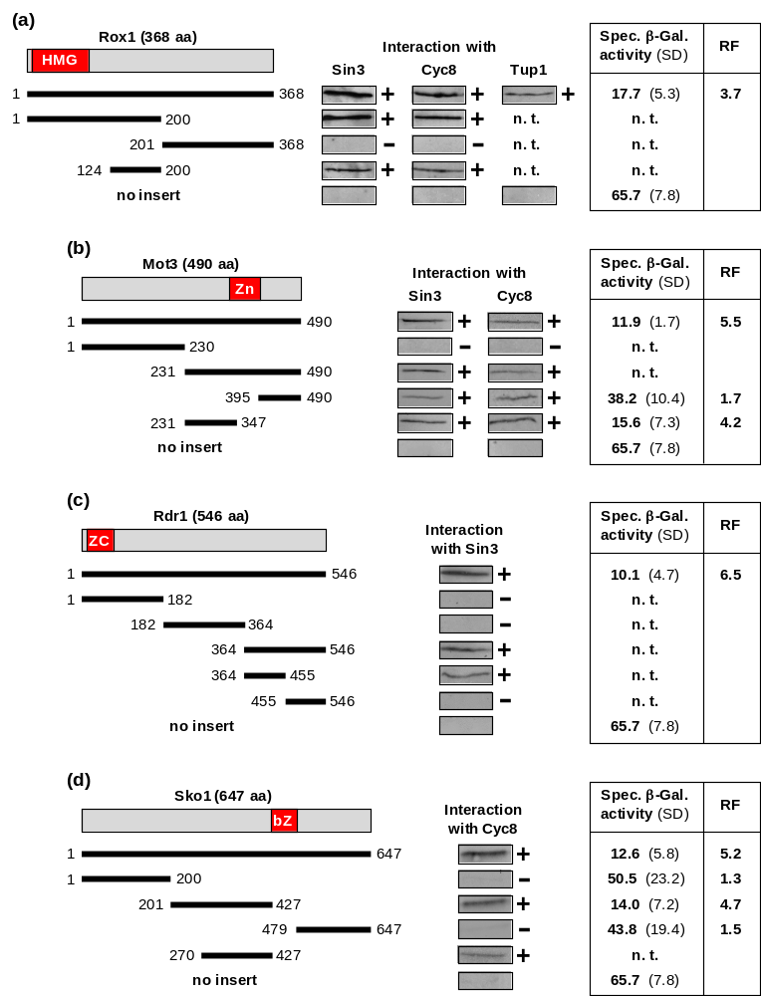

Supporting Online Fig. 1 Molecular analysis of corepressor interaction in vitro and gene repression in vivo by lexA fusions of repressors Rox1 (a), Mot3 (b), Rdr1 (c) and Sko1 (d). Length variants of repressor proteins were fused with GST, immobilized on GSH sepharose and incubated with bacterial protein extracts, containing HA-Sin3 (pJL34; aa 1-480, comprising PAH1 and PAH2), HA-Cyc8 (pFK77, aa 1-398, encoding TPR motifs) or HA-Tup1 (pFK76; full-length). GST expression plasmids and lexA fusion plasmids encoding length variants of Rox1, Mot3, Rdr1 and Sko1 are compiled in Supporting Online Material (Table S1). Gene repression in vivo was measured in transformants of strain RTS-lexA (reporter gene lexA_{Op}-CYC1-lacZ) which contain plasmids encoding lexA fusions. Empty vector pRT-lexA was used as a negative control for maximal reporter gene expression. Specific β-galactosidase activities are given in nmol oNPG hydrolyzed per min per mg of protein. bZ, basic leucine zipper; HMG, high mobility group motif; ZC, zinc cluster; Zn, zinc finger; n. t., not tested; RF, repression factor; SD, standard deviation; +, in vitro interaction; -, no interaction.

Supporting Online Figure 2:

Mapping of CID |  | Confidence of structural prediction
Cti6 | 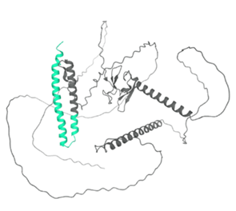 | 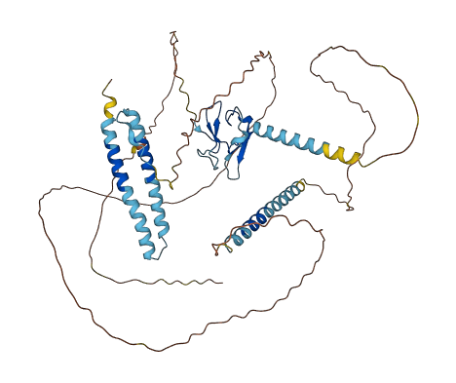
Dal80 | 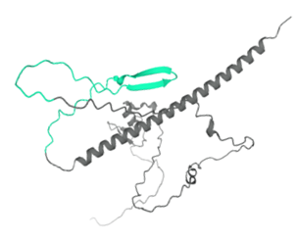 | 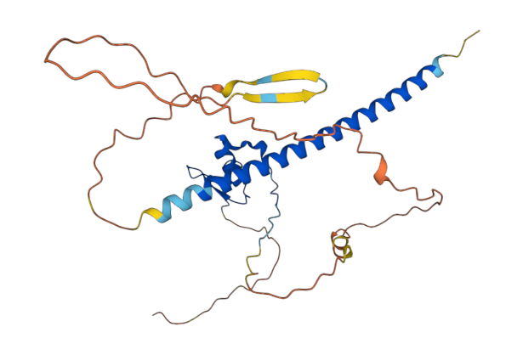
Fkh1 | 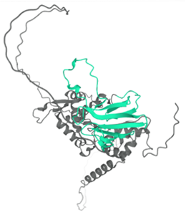 | 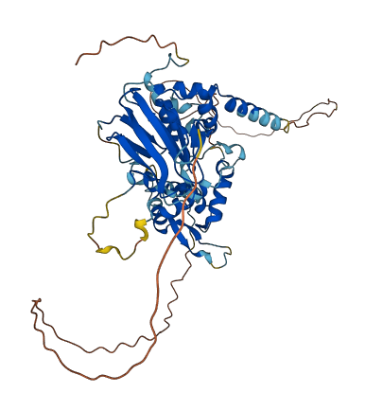
Gal80 | 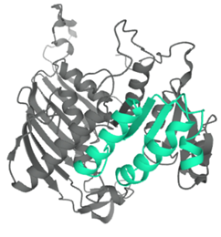 | 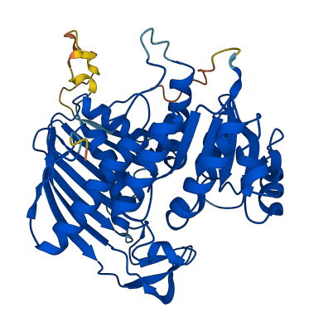
Mig1 | 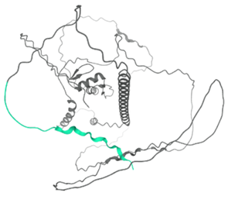 | 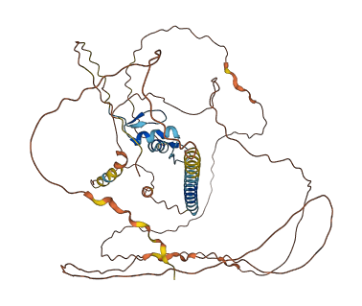
Mot3 | 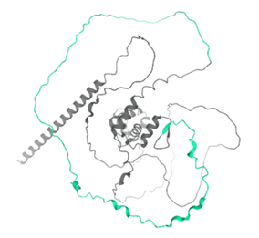 | 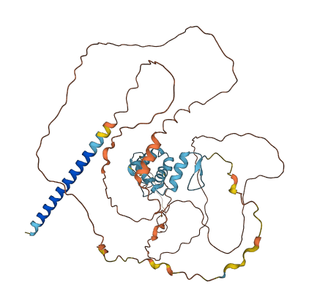
Opi1 | 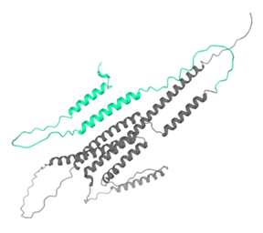 | 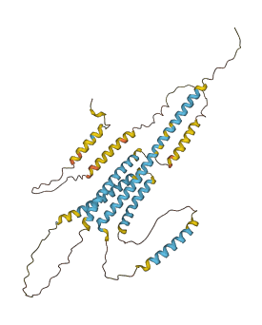
Rdr1 | 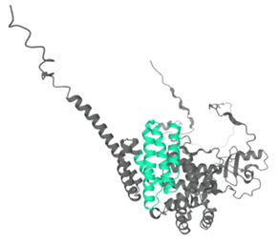 | 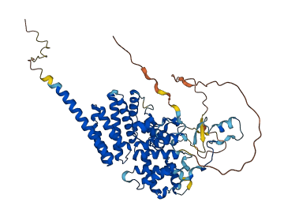
Rfx1 | 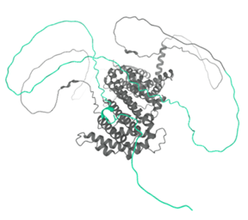 | 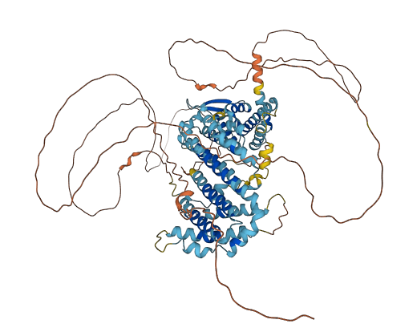
Rox1 | 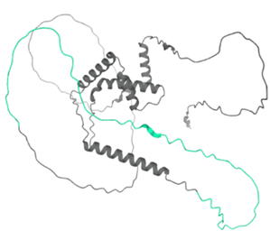 | 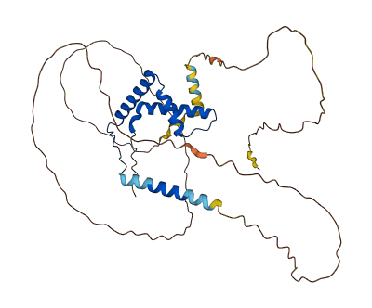
Sko1 | 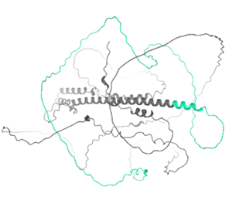 | 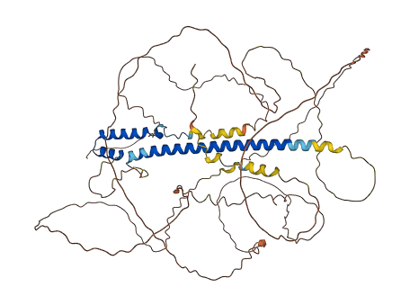
Ume6 | 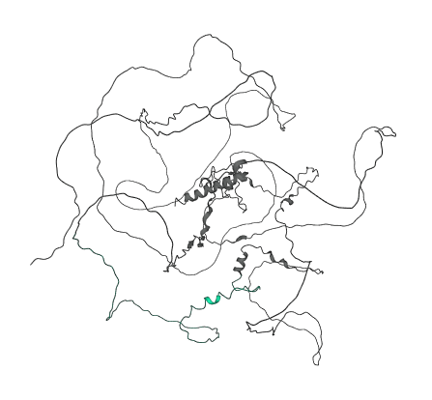 | 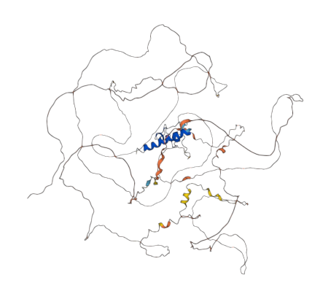
Ure2 | 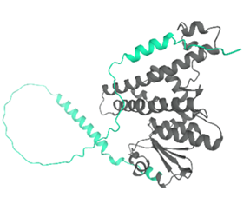 | 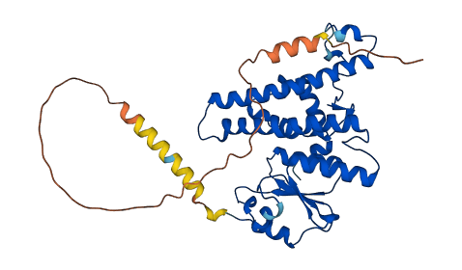
Xbp1 | 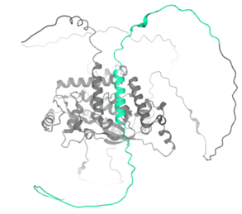 | 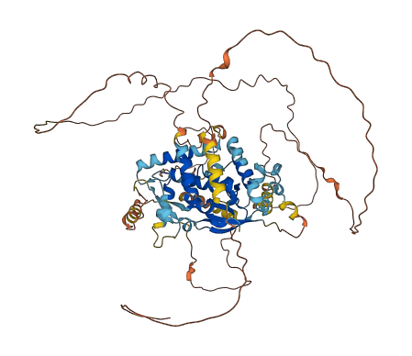
Yox1 | 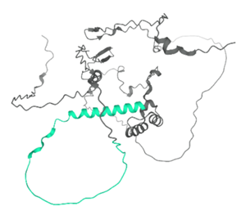  L262A  I270A  I271A | 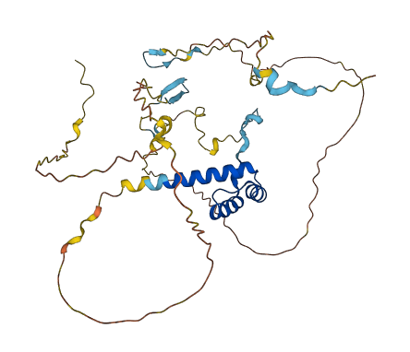  L262A  I270A  I271A

Supporting Online Fig. 2 Compilation of structure predictions of yeast repressor proteins by the bioinformatic tool Alphafold (https://alphafold.ebi.ac.uk). Corepressor interaction domains (CIDs; left columns) according to Table 2 are highlighted in turquoise. Positions of amino acids shown to be required for gene repression by Yox1 are encircled (red). Confidence of structural predictions are shown in right columns (colour code: dark blue, very high confidence; light blue, confident; yellow, low confidence; orange, very low confidence).

