Supplemental Methods
Patient characteristics and Samples
BM samples were obtained from newly diagnosed, untreated CMML patients and healthy BM donors. Written informed consent in accordance with the Declaration of Helsinki was obtained from all patients according to protocols approved by the ethics committee of the Guangdong Provincial People’s Hospital. Mononuclear cells (MNCs) were isolated from BM samples using Lymphocyte Separation Medium (Lonza) and stored in liquid nitrogen until use. The clinical and genetic characteristics of each enrolled CMML patient were listed in Supplemental File 1.

Cell culture
BM-MSCs were isolated and expanded according to an adapted protocol(1). MNCs were plated in the MesenCultTM Proliferation Kit medium containing 20% fetal bovine serum (STEMCELL Technologies) at 37°C and 5% CO₂. The medium was supplemented with GlutaMaxTM (Thermo Fisher Scientific), 100 IU/mL penicillin, 100 mg/mL streptomycin and 10 IU/mL heparin. Non-adherent cells were removed by medium change after 3d of culture. MSCs were expanded to confluency and passaged up to the fourth passage. Flow cytometry analyzed ex vivo expanded MSCs at 80% confluency to confirm adherence to the minimal criteria for defining multipotent MSCs(2). The absence of hematopoietic markers CD34, CD45 and CD44 and the high expression of CD73, CD90 and CD105 validated the cellular entities. Ex vivo expanded MSCs at 80% confluency were washed and used for subsequent experiments.

Genotyping and chromosomal evaluations on pairwise BM-MNC and BM-MSC samples
Genotyping and chromosomal evaluations were performed on BM-MSC and paired BM-MSC samples from the same individual. To avoid potential deleterious effects on the genomic stability MSCs(3), MSCs at P0 passage were used for detections. For genotyping, a targeted exon sequence (Exon-seq) method was used to detect exon loci covering the 130 most frequently mutated genes in myeloid malignancies (Supplemental Table 1). A VAF higher than 10% was considered evidence indicating credible mutations(3). For patients displaying mutations with a higher than 10% VAF in MSC samples, an additional Exon-seq using oral mucosal samples was performed to validate the possibility of germline mutations. Fluorescence in situ hybridization was performed using the CEP8 probes (Abbott VYSIS). After the steps of hypostasis, fixation, digestion, pretreatment, probe denaturation/hybridization, and post-hybridization washes, the hybridization signals were observed by Leica DM4000B fluorescence microscope(three-color filter). Each sample counted 200 cells per slide and recorded the corresponding hybridization signal. The positive cutoff is 5%.

AZA treatment on ex vivo expanded MSCs
At the standard treatment schedule of 75 mg/m² of AZA, the plasma concentration of AZA achieved in MDS patients ranges between 3 to 11 μM(4). AZA at 10 μM prominently produced the epigenetic modulations on MSCs without producing significant toxicities(5). Based on these results, AZA was stored as a lyophilized powder (MedChemoExpress) at -40°C, dissolved in DMSO, and then diluted into a working concentration of 10 μM in our present study. Ex vivo expanded MSCs at passages 2-3 were washed and treated with AZA (10 μM) or DMSO for 48h, followed by washing, and used for DNA methylating profiling, RNA-sequencing and other experiments.

DNA methylome profiling on AZA+/- MSC samples
Genome-wide DNA methylation of AZA+/- MSCs at passages 2-3 was assessed using the Illumina Infinium HumanMethylation850K BeadChip (Illumina Inc) according to the manufacturer’s instructions. In brief, the genomic DNA was transformed into sulfite, using NaOH to denature genomic DNA. The next step is DNA fragmentation, which digests the amplification products by the random endonuclease. Finally, the DNA fragment was hybridized with the chip, and the chip scanned and read the data through single base extension and staining. Raw data were transformed as array data (.IDAT files) and analyzed.

RNA-seq on AZA+/- MSC samples
Total RNA of AZA+/- MSCs at passages 2-3 was used as input material for the RNA sample preparations. Sequencing libraries were generated using NEB Next Ultra RNA Library Prep Kit for Illumina (NEB) following the manufacturer’s recommendations, and index codes were added to attribute sequences to each sample. The qualified libraries were pooled and sequenced on Illumina platforms with the PE150 strategy in Novogene Bioinformatics Technology Co., Ltd (Beijing, China). Base calling transforms the original fluorescence image files from the Illumina platform into short reads. These short reads are recorded in FASTQ format, containing sequence information and corresponding sequencing quality information.

Short-term and long-term co-culture of healthy HSPCs with AZA+/- MSCs
CMML-MSCs or HD-MSCs (AZA+/-) were plated at a near-confluent density of 2*10⁴/cm² in the H5100 medium (STEMCELL Technologies) with hydrocortisone (STEMCELL Technologies) as hematopoiesis-supportive feeder layers. 24h later, HD-derived CD34+ HSPCs were magnetically labeled and separated from MNCs according to the manufacturer’s instructions (Miltenyi Biotec). These magnetically separated HSPCs were immediately seeded in contact with the MSC feeder layer at a densities range from 1*10⁵/cm² to 5*10⁵/cm² in the H5100 medium and cultured for 7 days (short-term co-culture) or 14 days (long-term co-culture). On the last day, CD34⁺ were magnetically sorted and subjected to subsequent experiments.

Flow cytometry and DNA double-strand breaking detections
Cell viabilities of MSCs at passages 2-3 were determined by staining cells with Annexin V/PI (BD Biosciences). For the evaluation of cell surface markers, MSCs were suspended in PBS containing 5% bovine serum and stained with fluorescence-coupled antibodies as previously described(6): Human CD271-FITC (Biolegend), human CD146-PE (Bio Pharmingen), human CD31-APC (Biolegend), human CD235ab-PerCP/Cy5.5 (Biolegend), human CD45-PerCP/Cy5.5 (Biolegend), human Cadherin11-PE/Cy7 (BioLegend), human CD34-APC/Cy7 (Biolegend) and human CD34-PerCP/Cy5.5 (Biolegend). To detect total intracellular ROS in HSPSs, harvested HSPCs after short-term co-culture were stained using the Total ROS Assay Kit 520 nm (Invitrogen) and analyzed by flow cytometry following the manufacturer’s instructions. DNA double-strand breaking in HSPCs was detected using a Human Histone γH2AX Alex Fluor 488-conjugated antibody (R&D SYSTEMS) following the manufacturer’s instructions. To further validate the accumulation of γH2AX in the co-cultured HSPCs, immunofluorescence detections for γH2AX were performed using DNA Damage Assay Kit by γ-H2AX Immunofluorescence kit (Beyotime Biotechnology).

Clonogenic assays
After co-culturing with AZA+/- MSCs, CD34+ HSPCs were harvested and directly plated at densities ranging from 0.2*10³/cm² to 2*10³/cm² in growth factor-supplemented semi-solid methylcellulose medium (STEMCELL Technologies) in triplicate or duplicate. Colonies of CFU-E, BFU-E, CFU-GM and CFU-GEMM were scored with an inverted microscope after 14 days at 37°C, 5% CO₂ in a humidified atmosphere.

Senescence assay
Senescence was detected using the Senescence β-Galactosidase Staining Kit (Beyotime Biotechnology). Ex vivo expanded MSCs at passages 3-4 were cultured for one week without medium change, then subjected to β-galactosidase detections. The detection of intracellular β-galactosidase was performed following the manuscripture’s instructions.

RT-qPCR
The total RNA of MSCs at passages 2-3 was extracted from MSCs using the FastPure Cell/Tissue Total RNA Isolation Kit (Vazyme). Complementary DNA was synthesized using the HiScript II Q RT SuperMix for qPCR kit (Vazyme). The relative target quantity was determined using the comparative cycle threshold (ΔΔCT) method. Real-time polymerase chain reaction (RT-PCR) was performed using ChamQ Universal SYBR qPCR Master Mix (Vazyme) with target-specific primers (supplemental Table 2). Amplicons were normalized to endogenous GAPDH control.

Cytokine measurement
Ex vivo expanded MSCs at passages 2-3 were plated at the density of 2*10⁵/cm² in the MesenCultTM Proliferation Kit medium containing AZA (10 μM) or DMSO. After 48h of treatment, the supernatant was collected and subjected to ELISA assays for the detection of ANGPT1 (Elabscience), SCF1(Elabscience) and CXCL12 (Elabscience) following the manufacturer’s instructions.

Bioinformatics analysis
The array data (.IDAT files) was analyzed using the ChAMP package in R version 4.2.1 to derive the methylation level(7). The methylation status of all the probes was denoted as β value, which is the ratio of the methylated probe intensity to the overall probe intensity (sum of methylated and unmethylated probe intensities plus constant α, where α = 100). CpG probes showing |Δβ|≥0.10 (in test vs. control) and adjusted P value ≤0.05 was considered as differentially methylated probes (DMP) and were used for further analysis. DMRs were detected at a threshold of 7 sites per region using the “DMRcate” algorithm. Gene expression analysis and visualization were also done with R. Differential gene expression analysis was performed using DESeq2 R software(8). DESeq2 uses library-size-corrected read count data to find differentially expressed genes and is an error model based on the negative binomial distribution for the read counts. For gene expression analysis, the fits of the negative binomial with a generalized linear model were analyzed. Coefficients (interpreted as the log2-fold changes) were tested using the Wald test. According to Benjamini-Hochberg, the false discovery rate (FDR) was used for multiple testing corrections.

Statistics
Statistical analyses were performed by 2-sided paired or unpaired Student t-test or 1-way analysis of variance followed by Tukey multiple comparisons using GraphPad Prism (Graph Pad Inc). Results are shown as mean ± standard error of the mean (SEM). P values are presented where a statistically significant difference was found: *P>0.05; **P<0.01; ***P<0.001, ****P<0.0001.

Data Availability
The Gene Expression Omnibus (GEO) accession number for DNA methylation profiling data reported in this paper is GSE221269. All data generated in this study are available in the supplemental material files or available from the corresponding authors under reasonable request.

Supplemental Figures
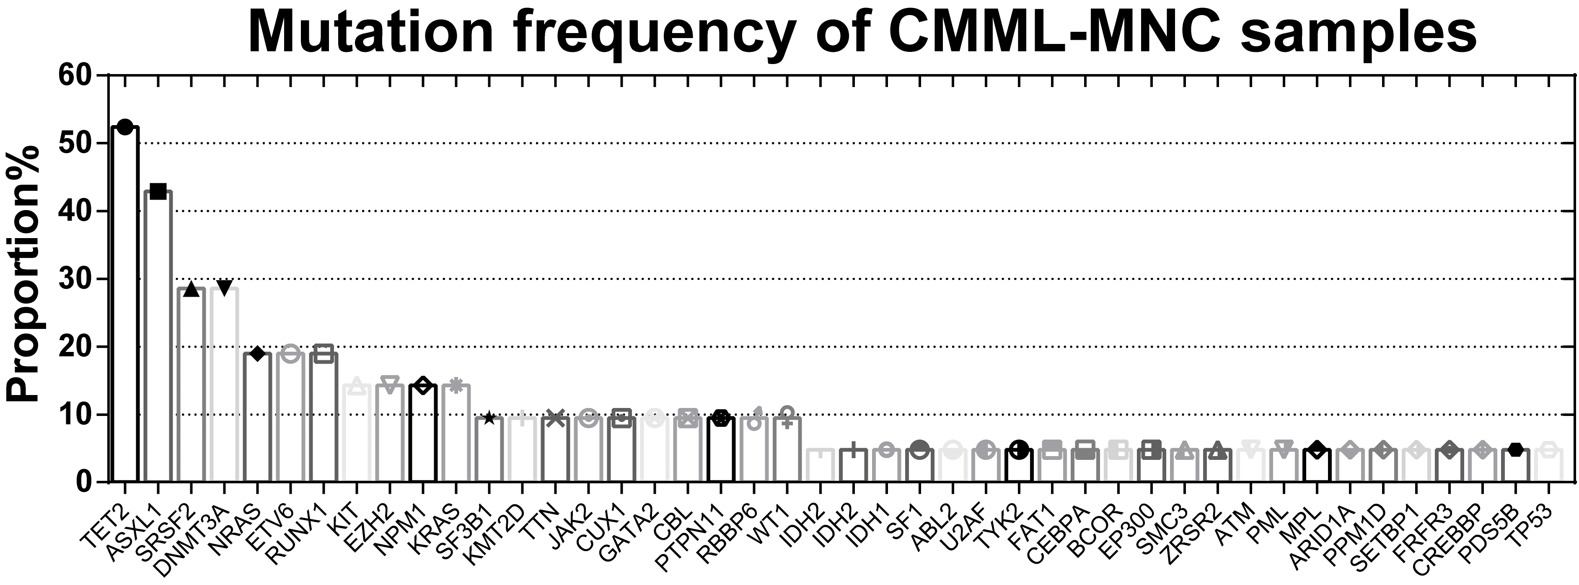
Supplemental Figure 1. Mutation frequency of CMML-MNC samples
Targeted Exon-seq to detect exon loci covering the 130 most frequently mutated genes was performed on CMML-MNCs samples (n=21). The mutation frequency of each mutated gene was displayed.

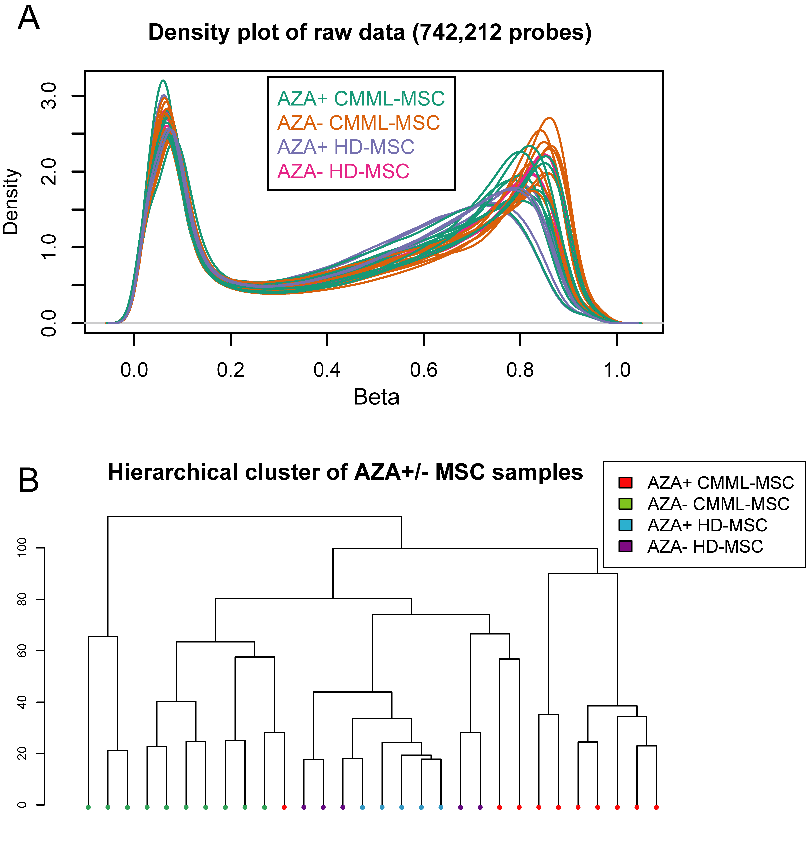
Supplemental Figure 2. Density curve and sample cluster plot based on methylation probes with normalized β values
(A) Density curves of the AZA+/- MSC samples based on the normalized β value of 742,212 methylation probes.
(B) Hierarchical cluster plot of the AZA+/- MSC samples based on the normalized β value of 742,212 methylation probes.

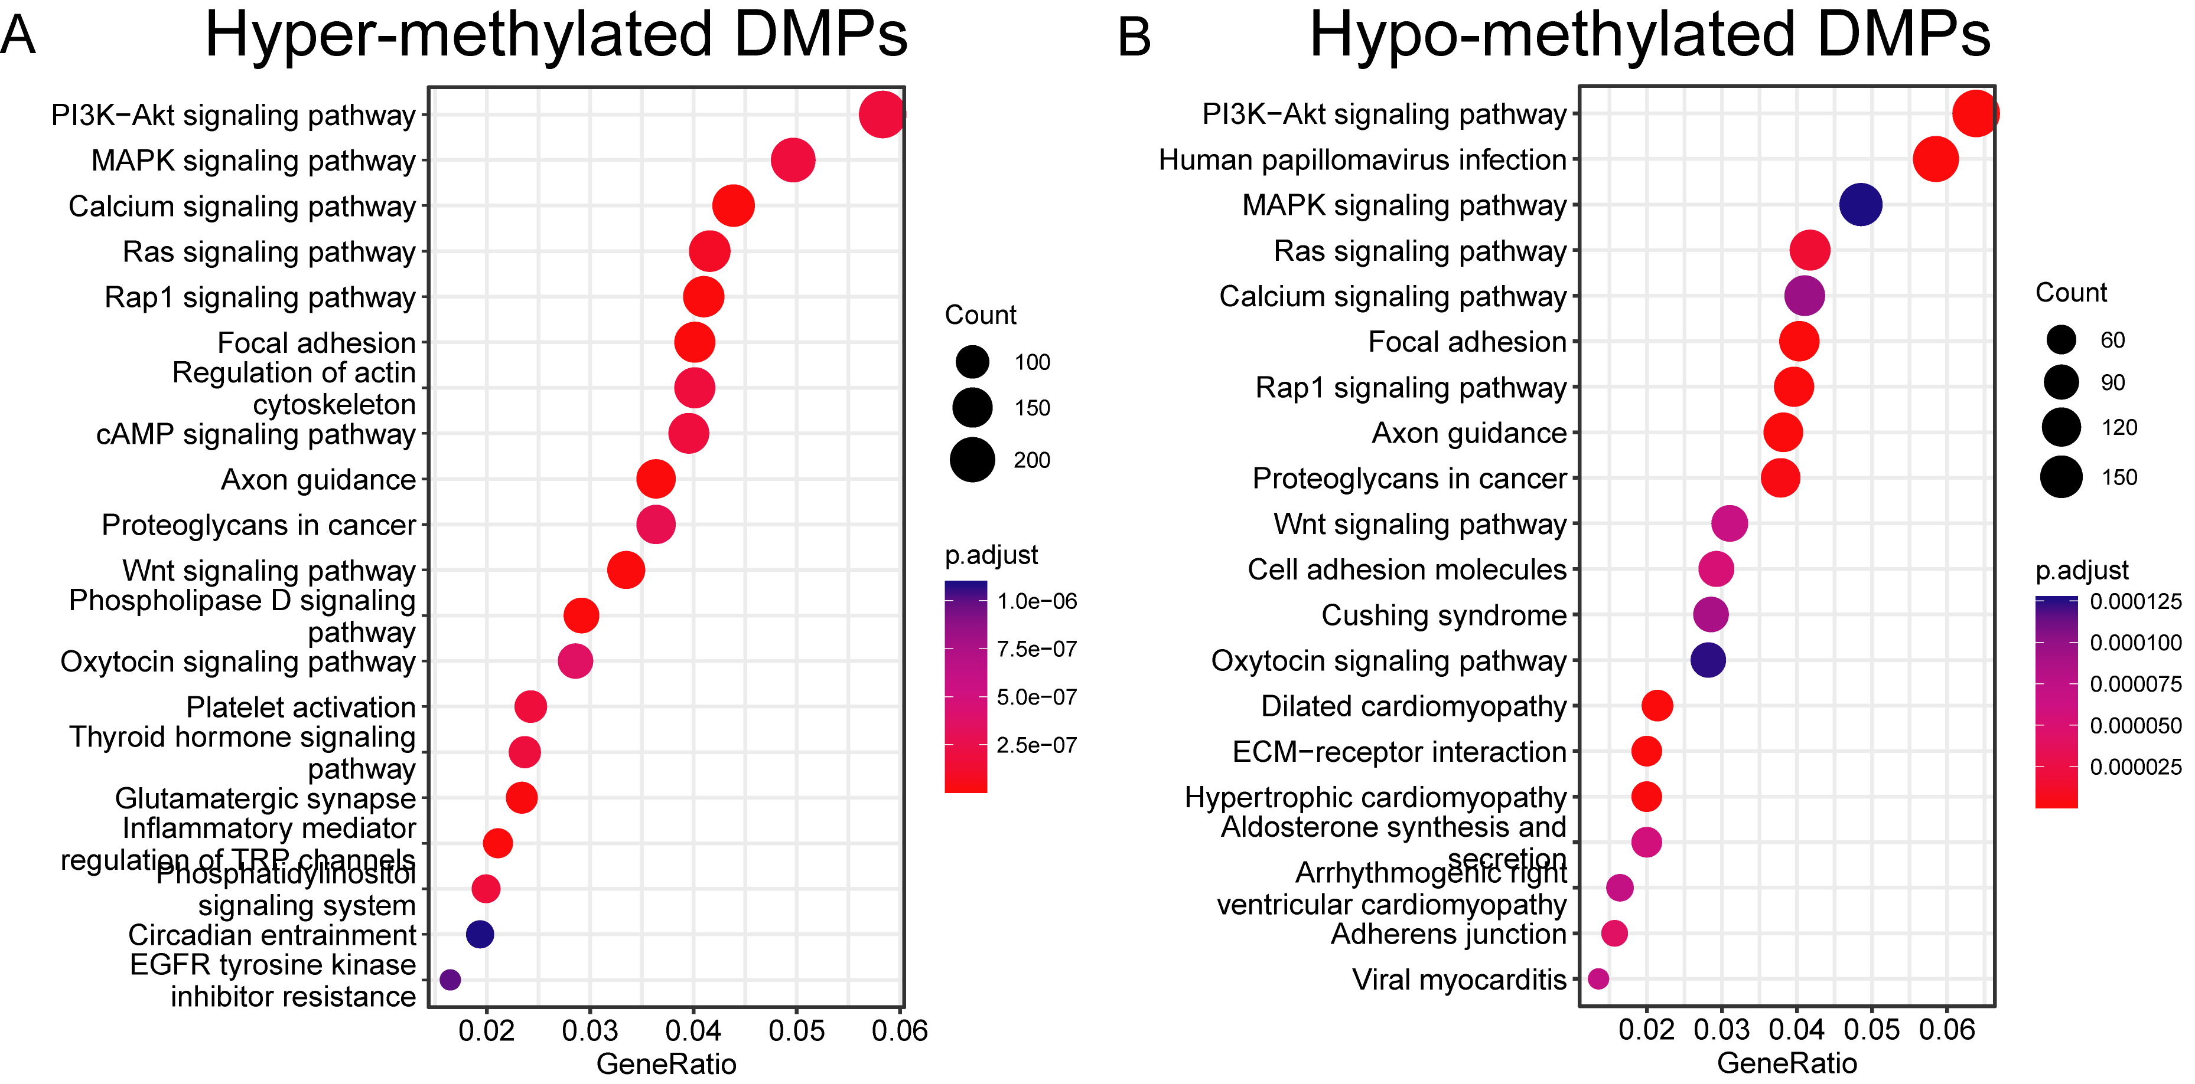
Supplemental Figure 3. Annotations of genes aligned by identified DMPs in CMML-MSCs
(A) KEGG analysis based on the identified gene list aligned by hyper-methylated DMPs in CMML-MSCs.
(B) KEGG analysis based on the identified gene list aligned by hypo-methylated DMPs in CMML-MSCs.

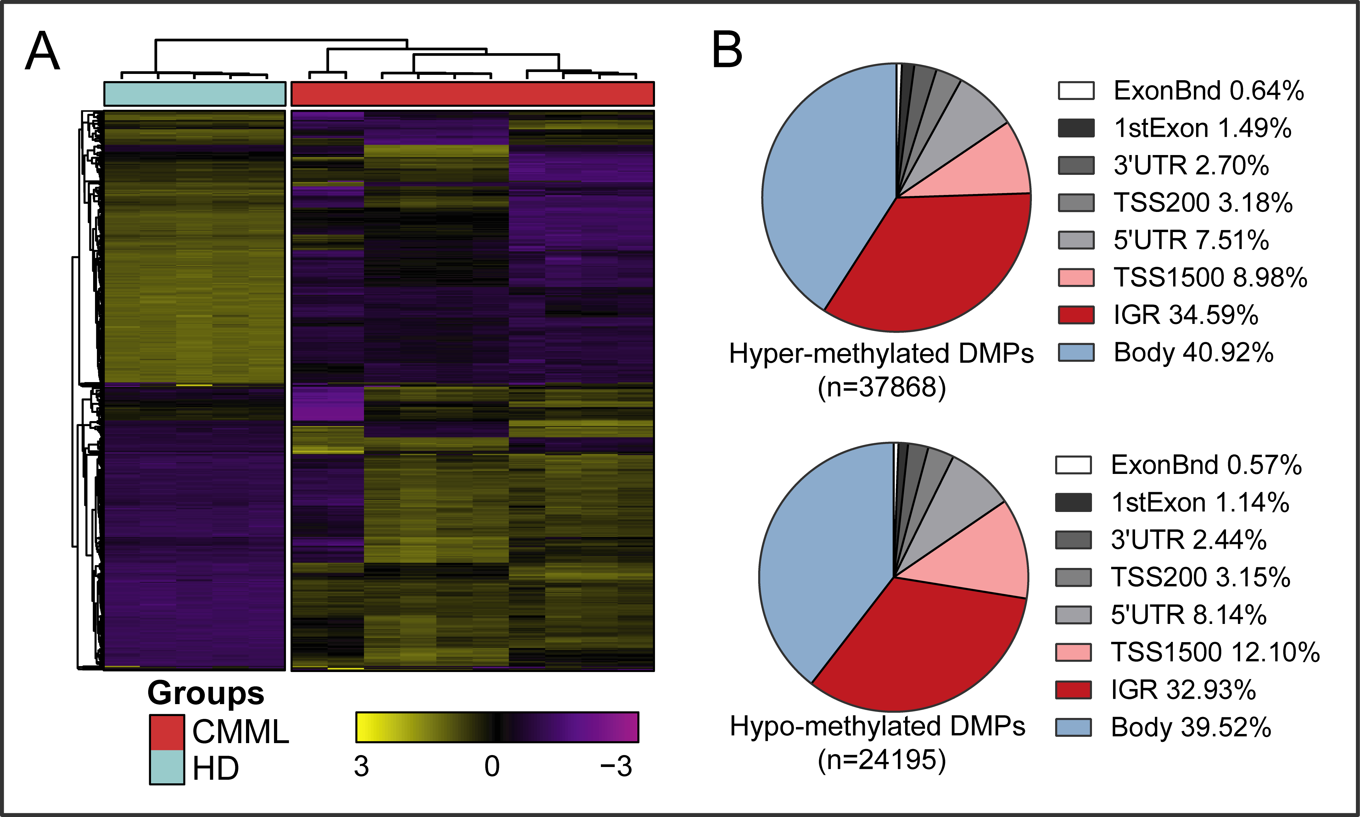
Supplemental Figure 4. DNA methylome-based hierarchical clustering and genomic distributions of DMPs
A. Hierarchical clustering heatmap based on the top 500 DMPs between the CMML-MSC and HD-MSC samples.
B. Pie charts indicate genome-based distributions of hyper-/hypo-methylated DMPs in CMML-MSC.

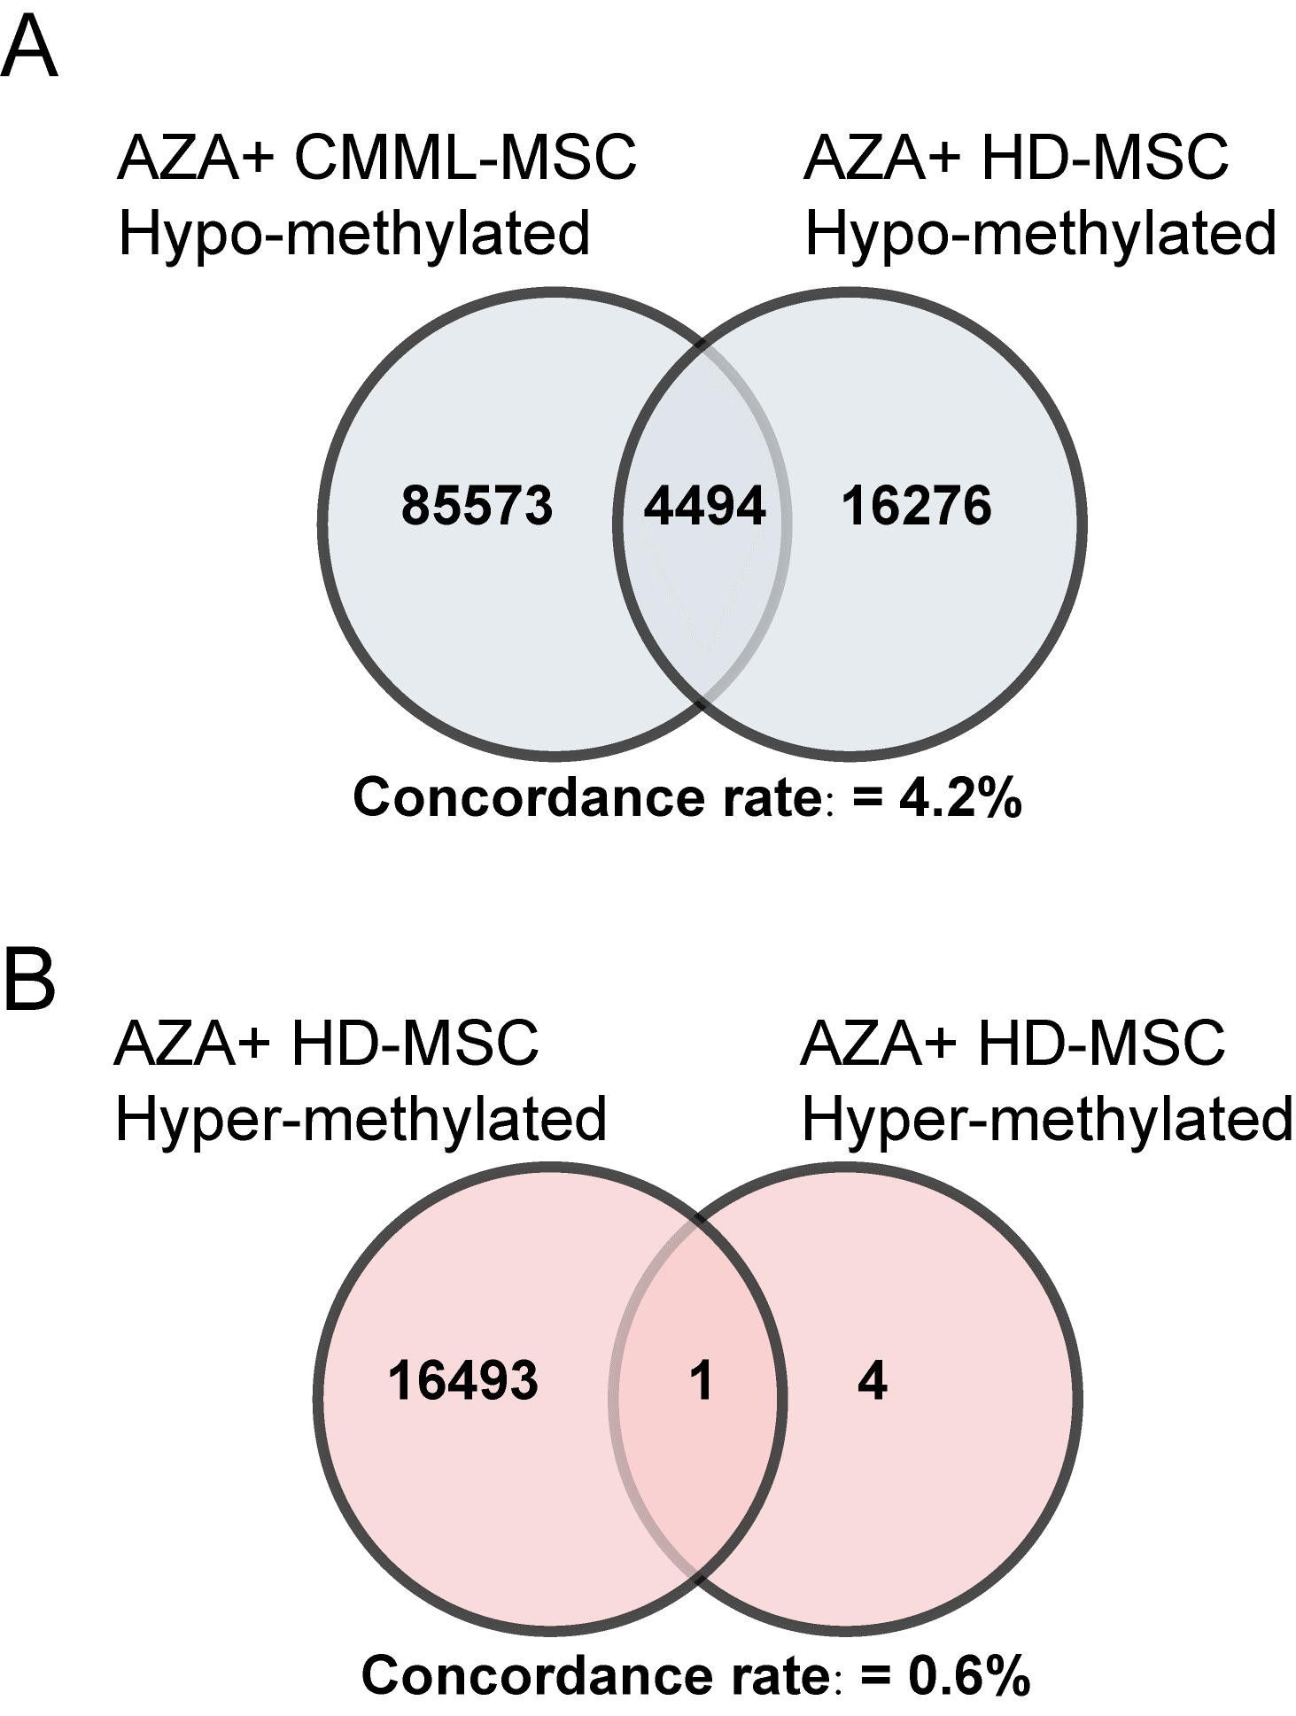
Supplemental Figure 5. The concordance rate of shared hyper-/hypo-methylated DMPs identified in the AZA+ CMML-MSC and AZA+ HD-MSC samples
(A) Venn diagrams showing the number and concordance rate of shared hypo-methylated DMPs.
(B) Venn diagrams showing the number and concordance rate of shared hyper-methylated DMPs.

Supplemental Tables
ABL | ANKRD26 | ARID1A | ARID1B | ASXL1 | ASXL2 | ATG2B | ATM | ATRX | BCOR
BCORL1 | BLM | BRAF | BRCA1 | BRCA2 | CALR | CBL | CCND1 | CCND2 | CDKN2A
CEBPA | CELA2A | COL12A1 | CREBBP | CRLF2 | CROCC | CSF3R | CSMD1 | CTCF | CUX1
DDX11 | DDX41 | DIS3 | DKC1 | DNMT3A | DOT1L | EP300 | EPPK1 | ETNK1 | ETV6
EZH2 | BRINP3 | FAT1 | FBXW7 | FLT3 | GATA1 | GATA2 | GFI1 | GNAS | GSKIP
HAX1 | HRAS | IDH1 | IDH2 | IKZF1 | IL7R | JAK1 | JAK2 | JAK3 | KDM5A
KDM6A | KIT | KMT2A | KMT2C | KMT2D | KMT6A | KRAS | MECOM | MPL | MUC16
MYC | MYD88 | NCOR1 | NCOR2 | NF1 | NFE2 | NOTCH1 | NOTCH2 | NPM1 | NRAS
NT5C2 | PAX5 | PBRM1 | PDGFRA | PHF6 | PIGA | PML | PPM1D | PRPF40B | PRPF8
PTEN | PTPN11 | PTPRT | RAD21 | RARA | RB1 | ROBO1 | ROBO2 | RUNX1 | SBDS
SETBP1 | SF1 | SF3A1 | SF3B1 | SH2B3 | SMARCA2 | SMC1A | SMC3 | SMN1 | SRP72
SRSF2 | STAG1 | STAG2 | STAT3 | SUZ12 | TERC | TERT | TET2 | TP53 | TTN
TYK2 | U2AF1 | U2AF2 | WAC | WT1 | ZAP70 | ZFP36L1 | ZMYM3 | ZNF608 | ZRSR2
Supplemental Table 1. The 130-gene panel of targeted Exon-seq

Supplemental Table 2. Primer sequences for RT-qPCR
Gene | Forward Primer (5’→3’) | Product length
TET1 (forward) | GACCCGGCCAGCGACCAAAAC | 112
TET1 (reverse) | AAGGGCGCAGGAAACAGAGTCAT | 112
SFRP1 (forward) | ACGTGGGCTACAAGAAGATGG | 184
SFRP1(reverse) | CAGCGACACGGGTAGATGC | 184
SFRP2 (forward) | GTTTCCCCCAGGACAACGA | 96
SFRP2 (reverse) | TGCAGGCTTCACATACCTTT | 96
ANGPT1 (forward) | CAAAGATTGACAAGGTTGTGG | 78
ANGPT1 (reverse) | AGCTACCACCAACAACAGTG | 78
CXCL14 (forward) | GCGCTTCATCAAGTGGTACA | 110
CXCL14 (reverse) | TTGCACAAGTCTCCCAACTG | 110
SCF (forward) | AATCCTCTCGTCAAAACTGAAGG | 163
SCF (reverse) | CCATCTCGCTTATCCAACAATGA | 163
CXCL12 (forward) | TTCCATTTGCAAGGGAAAAG | 236
CXCL12 (reverse) | ACACACAGCCAGTCAACGAG | 236

References
1. Schallmoser K, Rohde E, Reinisch A, Bartmann C, Thaler D, Drexler C, et al. Rapid large-scale expansion of functional mesenchymal stem cells from unmanipulated bone marrow without animal serum. Tissue engineering Part C, Methods. 2008;14(3):185-96.
2. Dominici M, Le Blanc K, Mueller I, Slaper-Cortenbach I, Marini F, Krause D, et al. Minimal criteria for defining multipotent mesenchymal stromal cells. The International Society for Cellular Therapy position statement. Cytotherapy. 2006;8(4):315-7.
3. Jann JC, Mossner M, Riabov V, Altrock E, Schmitt N, Flach J, et al. Bone marrow derived stromal cells from myelodysplastic syndromes are altered but not clonally mutated in vivo. Nature communications. 2021;12(1):6170.
4. Marcucci G, Silverman L, Eller M, Lintz L, Beach CL. Bioavailability of azacitidine subcutaneous versus intravenous in patients with the myelodysplastic syndromes. Journal of clinical pharmacology. 2005;45(5):597-602.
5. Wenk C, Garz AK, Grath S, Huberle C, Witham D, Weickert M, et al. Direct modulation of the bone marrow mesenchymal stromal cell compartment by azacitidine enhances healthy hematopoiesis. Blood advances. 2018;2(23):3447-61.
6. Xu R, Huang X, Li C, Deng C, Li M, Wu P, et al. Bone marrow mesenchymal stromal cells in chronic myelomonocytic leukaemia: overactivated WNT/β-catenin signalling by parallel RNA sequencing and dysfunctional phenotypes. British journal of haematology. 2021;193(5):928-40.
7. Tian Y, Morris TJ, Webster AP, Yang Z, Beck S, Feber A, et al. ChAMP: updated methylation analysis pipeline for Illumina BeadChips. Bioinformatics (Oxford, England). 2017;33(24):3982-4.
8. Love MI, Huber W, Anders S. Moderated estimation of fold change and dispersion for RNA-seq data with DESeq2. Genome biology. 2014;15(12):550.

