Supplementary Table S1 Summary of RNA sequencing, quality control and alignment results
Sample | Number of raw reads | Number of surviving reads | Surviving reads (%) | Number of mapped reads | Mapped reads (%) | Genes
1 | 213,401,856 | 213,255,838 | 99.93 | 184,777,470 | 86.65 | 11,187
2 | 194,164,712 | 193,983,724 | 99.91 | 168,511,777 | 86.87 | 11,243
3 | 205,093,538 | 204,895,900 | 99.90 | 177,443,813 | 86.60 | 10,960
4 | 198,327,514 | 198,158,896 | 99.92 | 173,438,061 | 87.52 | 11,188
5 | 216,353,356 | 216,161,442 | 99.91 | 191,537,838 | 88.61 | 11,157
6 | 195,625,952 | 195,477,176 | 99.92 | 167,666,370 | 85.77 | 11,151
7 | 178,343,004 | 178,239,598 | 99.94 | 154,740,375 | 86.82 | 11,375
8 | 204,412,592 | 204,316,902 | 99.95 | 177,594,272 | 86.92 | 11,188
9 | 181,709,148 | 181,538,710 | 99.91 | 154,872,490 | 85.31 | 10,943
10 | 218,761,844 | 218,622,872 | 99.94 | 191,540,034 | 87.61 | 11,305
11 | 237,510,502 | 237,343,172 | 99.93 | 215,292,991 | 90.71 | 11,746
12 | 175,574,102 | 175,463,934 | 99.94 | 155,722,734 | 88.75 | 11,536
13 | 185,868,090 | 185,724,908 | 99.92 | 164,628,708 | 88.64 | 11,307
14 | 173,424,146 | 173,324,374 | 99.94 | 158,098,991 | 91.22 | 11,746
15 | 220,764,806 | 220,628,522 | 99.94 | 191,482,255 | 86.79 | 11,219
16 | 174,177,176 | 174,080,220 | 99.94 | 153,658,876 | 88.27 | 11,303
17 | 213,875,066 | 213,675,818 | 99.91 | 182,897,846 | 85.60 | 11,231
18 | 191,855,660 | 191,738,392 | 99.94 | 165,977,330 | 86.56 | 11,129
19 | 205,782,596 | 205,656,296 | 99.94 | 178,054,232 | 86.58 | 11,456
20 | 235,088,342 | 234,909,086 | 99.92 | 202,033,036 | 86.00 | 11,433
21 | 198,469,448 | 198,327,096 | 99.93 | 173,854,847 | 87.66 | 11,463
22 | 189,305,288 | 189,184,896 | 99.94 | 164,478,279 | 86.94 | 11,423
23 | 193,761,902 | 193,628,786 | 99.93 | 167,514,977 | 86.51 | 11,303
24 | 161,705,438 | 161,609,070 | 99.94 | 140,385,186 | 86.87 | 11,439
25 | 188,780,844 | 188,649,956 | 99.93 | 169,516,537 | 89.86 | 11,650
26 | 218,848,164 | 218,717,794 | 99.94 | 194,601,491 | 88.97 | 11,649
27 | 215,266,218 | 215,137,846 | 99.94 | 193,424,579 | 89.91 | 11,650
28 | 246,025,724 | 245,898,274 | 99.95 | 224,652,618 | 91.36 | 11,766
29 | 178,457,600 | 178,322,804 | 99.92 | 158,799,601 | 89.05 | 11,535
30 | 175,353,224 | 175,222,624 | 99.93 | 156,403,655 | 89.26 | 11,490

Supplementary Table S2. List of upregulated (bold) and downregulated (regular) genes included in each significantly enriched Kyoto Encyclopedia of Genes and Genomes (KEGG) pathway, in spaghetti meat (SM) and woody breast (WB) compared to Normal.
KEGG pathway | DEGs in SM vs. Normal comparison | DEGs in WB vs. Normal comparison
Cytokine-cytokine receptor interaction | BMP2, CCL17, CCL19, CCL20, CCL4, CCL5, CCR2, CCR4, CCR5, CCR6, CCR7, CCR8, CD40, CD40LG, CLCF1, CSF1R, CSF2RA, CSF3R, CX3CR1, CXCL12, CXCL14, CXCR1, CXCR4, FAS, FLT3, GHR, HGF, IFNAR1, IL11, IL12RB2, IL11, IL12RB2, IL13RA1, LI17RA, IL18, IL18R1, IL18RAP, IL1B, IL1R1, IL1R2, IL1RAP, IL20RA, IL21R, IL22RA2, IL2RA, IL2RB, IL2RG, IL5RA, IL7R, INHBC, LIFR, PDGFRA, PDGFRB, RELT, TGFB1, TGFB3, TGFBR2, TNFRSF11A, TNFRSF13B, TNFRSF18, TNFRSF19, TNFRSF1A, TNFRSF1B, TNFSF8, XCL1, XCR1 | CCL17, CCL19, CCL4, CCL5, CCR4, CCR5, CCR6, CCR7, CCR8, CD40LG, CLCF1, CNTFR, FLT3, GHR, IL10RA, IL11, IL13RA1, IL17RA, IL18, IL18R1, IL1B, IL1R2, IL1RAP, IL20RA, IL21R, IL22RA2, IL2RA, IL2RB, IL2RG, IL5RA, IL7R, TGFB1, TGFBR2, TNFRSF18, TNFRSF19, TNFSF13B, TNFSF15, TNFSF8, XCL1, XCR1
Calcium signaling pathway |  | ADCY2, ADCY7, ATP2A2, CACNA1C, CACNA1E, F2R, HTR2A, HTR2B, ITPR2, MYLK, NOS1, P2RX1, P2RX2, P2RX3, P2RX4, P2RX7, PDE1B, PDGFRA, PHKA1, PHKA2, PHKB, PHKG1, PLCB1, PLCB2, PLCG2, PLN, PPP3CA, PPP3CC, PTAFR, PTGFR, SLC25A4, SLC8A1, SPHK1, TNNC1, TNNC2, VDAC1
Neuroactive ligand-receptor interaction | ADORA1, ADORA3, ADRA2A, ADRA2C, ADRB2, AGTR2, C3AR1, CHRM4, CHRNA1, CHRNA4, CHRNA5, CHRND, CHRNG, CNR1, EDNRA, F2R, F2RL1, FSHR, GABRA1, GABRA5, GHR, GPR156, GPR50, GZMA, HRH2, HTR2A, HTR2B, HTR6, HTR7, LHCGR, LPAR1, LPAR3, LPAR6, LTB4R, P2RX1, P2RX2, P2RX3, P2RX4, P2RX7, P2RY1, P2RY13, P2RY4, P2RY8, PTAFR, PTGDR, PTGER3, PTGER4, RXFP1, S1PR3, S1PR4, SSTR2, TSPO, VIPR1 | ADORA1, ADRB2, C3AR1, CHRM4, CHRNA1, CHRNA4, CHRNA5, CNR1, CRHR2, GABRA1, GABRA5, GHR, LTB4R, PTGDR, PTGER4, PTGFR, S1PR3, S1PR4

KEGG pathway | DEGs in SM vs. Normal comparison | DEGs in WB VS. Normal comparison
Phagosome |  | ANXA1, APPL2, ARHGAP25, BIN2, BTK, C3, CAMK1D, CNN2, COLEC12, CORO1C, CRP, DOCK2, F2RL1, FCER1G, GAS6, GSN, HAVCR1, HCK, IL1B, IL2RB, IL2RG, IRF8, ITGAV, ITGB2, ITGB3, LDLR, LIMK1, LPR1, LYAR, LYN, MARCO, MERTK, MYO1G, NCF2, NCF4, NCKAP1L, NR1H3, P2RX7, P2RY6, PLCG2, PLD4, PTPRC, PTPRJ, PTX3, RAB31, RAB39A, RAB7B, RAC2, ROHG, SIRPA, SOD1, SRC, SYK, SYT11, SYT7, THBS1, TIMD4, TLR4, TREM2, TUB, VAV2, VAV3
Oxidative phosphorylation | ATP5MC1, ATP5PB, ATP5PD, ATP5PF, ATP6V0A1, ATP6V0D2, COX10, COX5B, COX6C, COX7A2L, COX7C, COX10, LHPP, NDUFA1, NDUFA2, NDUFA4, NDUFA8, NDUFB4, NDUFB5, NDUFC2, NDUFS1, NDUFS3, NDUFS4, NDUFS6, NDUFS7, NDUFS8, SDHA, SDHB, SDHC, TCIRG1, UQCR11, UQCRB, UQCRC2, UQCRFS1, UQCRHL, UQCRQ
Cell adhesion molecules | CD28, CD40LG, CD80, CD86, CD8A, ITGB2, ITGB7 | CADM1, CADM3, CD4, CD40LG, CD80, CD86, CD8A, CTLA4, ITGB2, ITGB7, NRCAM, VCAN
Intestinal immune network for IgA production | CD28, CD40, CD40LG, CD80, CD86, CXCL12, CXCR4, ICOS, ICOSLG, ITGA4, TGFB1, TNFRSF13B, TNFSF13B

Supplementary Figure S1
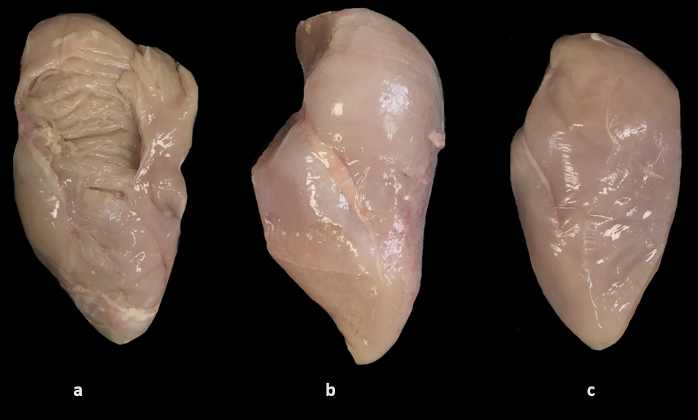
Classification of samples: (a) fillet with spaghetti meat; (b) fillet with woody breast; (c) normal fillet

