Supplementary Material
Untargeted metabolomic study of lung cancer patients after surgery with curative intent: possible metabolites of good prognosis, intervention failure and recurrence
S. Sanchez-Espirilla^{1,2,ƭ}, A. Pereira-Vega^{3ƭ} , B. Callejón-Leblic^{1*}, I. Díaz-Olivares, R. Santana-Martín⁴, C. Gotera Rivera⁴, J.L. Gómez-Ariza¹, J.L. López-Campos^{5,6}, A.I. Blanco-Orozo⁵, L. Seijo⁶, M. Rodríguez⁶, L. Padrón Fraysse³, A. Herrera-Chilla³, G. Peces-Barba⁴ and T. García Barrera^{1*}.
¹Department of Chemistry, Research Center for Natural Resources, Health and the Environment (RENSMA). Faculty of Experimental Sciences, University of Huelva, Campus El Carmen, Fuerzas Armadas Ave., 21007, Huelva, Spain. ²Department of Chemistry, Faculty of Sciences, National University of San Antonio Abad of Cusco, Av. de La Cultura, 773, Cusco, Peru. ³Pneumology Area of the Juan Ramón Jiménez Hospital in Huelva, Spain.⁴IIS Jiménez Díaz Foundation. ISCIII-CIBERES. Madrid, Spain. ⁵Medical-Surgical Unit of Respiratory Diseases. Institute of Biomedicine of Seville (IBiS). Virgen del Rocío University Hospital/University of Seville, Spain. ⁶ Center for Biomedical Research in Respiratory Diseases Network (CIBERES). Carlos III Health Institute, Madrid, Spain.⁷ University Clinic of Navarra. ISCIII-CIBERES, Madrid, Spain.
*Corresponding authors: belen.callejon@dqcm.uhu.es; tamara@dqcm.uhu.es

^{ƭ}These authors contributed equally and should be considered co-first authors.

Table S1. Clinical Characteristics of patients included in the study. PRE: samples from preoperative lung cancer patients; POSTA: samples from postoperative lung cancer patients collected at 1 month of surgery; POSTB: samples from postoperative lung cancer patients collected at 3-6 months of surgery; DM= Diabetes Mellitus; AH: Arterial Hypertension; DLP: Dyslipidemia; COPD: Chronic Obstructive Pulmonary Disease.

Clinical characteristics |  | CONTROL | PRE | POSTA | POSTB
Gender | Male | 21 | 29 | 7 | 8
Gender | Female | 14 | 19 | 6 | 4
Age (years ± SD) |  | 56.3 ± 13.1 | 65.7 ± 10.7 | 62.3 ± 9.1 | 67.33 ± 8.1
Smoking habits | Non-smoker | 16 | 11 | 0 | 0
Smoking habits | Smoker | 0 | 13 | 8 | 7
Smoking habits | Exsmoker | 19 | 24 | 5 | 5
NSCLC Type | Adenocarcinoma | - | 32 | 11 | 10
NSCLC Type | Adenocarcinoma lepídico | - | 1 | - | -
NSCLC Type | Adenoescamoso | - | 1 | - | -
NSCLC Type | Carcinoide | - | 2 | - | -
NSCLC Type | Carcinoma | - | 6 | - | -
NSCLC Type | Carcinoma escamoso | - | 1 | - | -
NSCLC Type | Epidermoide | - | 4 | - | -
NSCLC Type | Tumor Carcinoide Típico | - | 1 | - | -
Comorbidities | DM | 8 | 5 | 0 | 1
Comorbidities | AH | 0 | 20 | 5 | 8
Comorbidities | DLP | 0 | 17 | 2 | 4
Comorbidities | COPD | 0 | 15 | 8 | 5
Surgery | Lobectomy | - | 32 | 13 | 11
Surgery | Segmentectomy | - | 15 | 0 | 1
Surgery | Wedge resertion | - | 2 | 1 | 1

Table S2. Availability of preoperative and postoperative samples from the same patients. PRE: preoperative samples; POST: postoperative samples; A: available; NA: non-available.
Code | PRE | POST 1 month | POST 3 months | POST 6 months
P01-002 | NA | NA | A | A
P01-003 | NA | A | A | A
P01-004 | A | A | A | NA
P01-009 | A | A | A | A
P01-010 | A | A | NA | A
P01-011 | A | NA | NA | NA
P01-013 | A | A | A | A
P01-014 | A | A | A | NA
P01-015 | A | NA | NA | NA
P01-016 | A | A | A | NA
P01-017 | A | A | NA | NA
P01-018 | A | A | NA | NA
P01-019 | A | NA | NA | NA
P02-001 | A | A | NA | NA
P02-002 | A | A | NA | NA
P02-003 | A | A | NA | NA
P02-004 | A | NA | NA | NA
P02-005 | A | A | NA | NA
P03-002 | A | NA | NA | NA
P03-004 | A | NA | NA | NA
P03-006 | A | NA | A | NA
P03-007 | A | NA | NA | NA
P03-008 | A | NA | NA | NA
P03-009 | A | NA | NA | NA
P03-010 | A | NA | NA | NA
P04-001 | A | NA | A | A
P04-002 | A | NA | NA | NA
P04-003 | A | NA | NA | NA
P04-004 | NA | NA | A | NA
P04-007 | A | NA | NA | NA
P04-009 | A | NA | NA | A
P04-010 | A | NA | NA | NA
P04-011 | A | NA | NA | NA
P04-013 | A | NA | NA | NA
P04-014 | A | NA | NA | NA
P04-015 | A | NA | NA | NA
P04-016 | A | NA | NA | NA
P04-018 | A | NA | NA | NA
P04-019 | A | NA | NA | NA
P04-021 | A | NA | NA | NA
Continued Table S2.
Code | PRE | POST 1 month | POST 3 months | POST 6 months
P04-024 | A | NA | NA | NA
P04-026 | A | NA | NA | NA
P04-027 | A | NA | NA | NA
P04-028 | A | NA | NA | NA
P04-029 | A | NA | NA | NA
P04-030 | A | NA | NA | NA
P04-031 | A | NA | NA | NA
P04-032 | A | NA | NA | NA
P04-033 | A | NA | NA | NA
P04-035 | A | NA | NA | NA
P04-037 | A | NA | NA | NA

Table S3. Batch Recursive Feature Extraction parameters (UHPLC-QTOF-MS analysis)

Batch Recursive Feature Extraction
Extraction
Peak weight | > 600 counts
Ion species
Positive Mode | [M+H]⁺, [M+Na]⁺
Negative Mode | [M-H]⁻ , [M-Cl]⁻
Integration | Agile 2
Alignment Parameters
RT Tolerance | 0.00% ± 0.3 min
Mass Tolerance | 20 ppm ± 2.00 mDa
Molecular Feature Extraction Filters
Score (MFE) | > 97
Tolerance and EIC
Masses | ± 10.00 ppm
RT | ± 0.300 min
Possible m/z | Symmetric (ppm)
Peak Filter
Absolute area | > 20000 counts
Chromatogram Format | Centroid
Peak Spectrum
Average scans | 10 % of peak height
Find by ion filters
Score (Tgt) | > 97
Entities
IR-UHPLC-QTOF-MS
Number of entities found | Positive Mode: 333
Number of entities found | Negative Mode: 1218
Number of significant entities found | Positive Mode: 333
Number of significant entities found | Negative Mode: 155
HILIC-UHPLC-QTOF-MS
Number of entities found | Positive Mode: 683
Number of significant entities found | Positive Mode: 54

Table S4. Coefficient of variation (CV) of gut metabolites calculated in quality control (QC) samples. Lysophosphatidylcholine (LPC), lysophosphatidylethanolamine (LPE),Sphingomyeline (SM); dyacylglyceride (DG)

Compound | %CV in QC (n=8)
2-Ethoxynaphthalene | 3.07
4-(3-Pyridyl)-butanoic acid | 4.62
6-(2-Carboxyethyl)-7-hydroxy-2,2-dimethyl-4-chromanone glucoside | 0.64
6,10,14-Trimethyl-5,9,13-pentadecatrien-2-one | 4.54
Butyl ethyl malonate | 3.97
Cerulenin | 3.37
Choline | 3.94
DG(14:0/22:1) | 4.11
DG(16:0/24:1) | 3.34
Dihydro-5-(2-octenyl)-2(3H)-furanone | 3.13
E,e-Carotene-3,3'-dione | 6.19
Gabaculine | 6.36
Humulinic acid A | 4.14
Linalyl propionate | 5.38
LPC(17:0) | 0.62
LPE(20:1) | 2.20
Palmitic amide | 2.85
SM(d17:1/24:0) | 1.08
Stearamide | 1.15
Talaromycin A | 3.25
1-[(5-Amino-5-carboxypentyl)amino]-1-deoxyfructose | 2.85
1-Methylhistidine | 9.92
3-b-Galactopyranosyl glucose | 1.71
3-Galactosyllactose | 0.62
Cystine | 0.74
Gabapentin | 1.17
Glucosylgalactosyl hydroxylysine | 2.21
L-Carnitine | 3.21
N-(1-Deoxy-1-fructosyl)leucine | 1.25
Proline | 1.08
Tranexamic acid | 0.38

Table S5. PLS-DA Q² and R² values of pairwise comparison of CONTROL, PRE, POSTA and POSTB groups. A: Aqueous, O: Organic, P:Polar.

Parameters
Q²/R²Y
Analytical Methodology | Extract | PRE  vs CONTROL | POSTA  vs CONTROL | POSTB  vs CONTROL | PRE  vs POSTA | PRE  vs POSTB
ESI(+)-IP-UHPLC-QTOF-MS | A | 0.85/0.99 | 0.76/0.99 | 0.64/0.99 | 0.39/0.93 | 0.99/0.58
ESI(+)-IP-UHPLC-QTOF-MS | O | 0.73/0.92 | 0.77/0.99 | 0.78/0.99 | 0.20/0.82 | 0.65/0.98
ESI(-)-IP-UHPLC-QTOF-MS | A | 0.84/0.99 | 0.45/0.97 | 0.65/0.99 | 0.47/0.89 | 0.28/091
ESI(+)-HILIC-UHPLC-QTOF-MS | P | 0.83/0.93 | 0095/0.98 | 0.89/0.96 | 0.31/0.87 | 0.11/0.82

Table S6. Altered metabolites ordered by class. RT: retention time, FC: Fold change, N.S.: Not significant, lysophosphatidylcholine (LPC), lysophosphatidylethanolamine (LPE), Sphingomyeline (SM); dyacylglyceride (DG); Experimental Mass (EM); Theorethical Mass (TM); Methodology (MD); Ionization Mode (IM); p-value obtained from one way ANOVA followed by Tuckey Test and corrected by Benjamini-Hochberg multiple post-correction.

Metabolites | PRE vs  CONTROL |  |  | POSTA vs  CONTROL |  |  | POSTB vs  CONTROL |  |  | PRE vs  POSTA |  |  | PRE vs  POSTB |  |  | EM | TM | MD | IM | Class
Metabolites | FC | P | AUC | FC | P | AUC | FC | P | AUC | FC | P | AUC | FC | P | AUC
1-[(5-Amino-5-carboxypentyl)amino]-1-deoxyfructose | 1.05 | NS | - | 0.94 | NS | - | 0.98 | NS | - | 1.12 | 0.00 | 0.75 | 1.07 | NS | - | 308.1589 | 308.1584 | HILIC | ESI + | Organooxygen compounds
1-Methylhistidine | 0.88 | NS | - | 0.86 | 0.00 | 0.79 | 0.81 | 0.00 | 0.82 | 1.03 | NS | - | 1.08 | 0.02 | 0.70 | 169.0854 | 169.0851 | HILIC | ESI + | Carboxylic acids  and derivatives
Cysteine | 1.06 | NS | - | 1.21 | 0.00 | 1.00 | 1.29 | 0.00 | 0.94 | 0.96 | NS | - | 0.97 | NS | - | 240.024 | 240.0238 | HILIC | ESI + | Carboxylic acids  and derivatives
N-(1-Deoxy-1-fructosyl)leucine | 1.13 | NS | - | 0.91 | 0.01 | 0.75 | 1.10 | NS | - | 1.23 | 0.00 | 0.76 | 1.03 | NS | - | 293.1479 | 293.1475 | HILIC | ESI + | Carboxylic acids  and derivatives
Tranexamic acid | 0.94 | NS | - | 0.79 | NS | - | 1.26 | 0.00 | 0.81 | 1.18 | NS | - | 0.88 | 0.00 | 0.81 | 157.1106 | 157.1103 | HILIC | ESI + | Carboxylic acids  and derivatives
Butyl ethyl malonate | 1.35 | NS | - | 4.34 | 0.02 | 0.90 | 1.66 | 0.02 | 0.76 | 0.31 | 0.04 | 0.75 | 0.81 | 0.02 | 0.55 | 188.105 | 188.1049 | IP-UHPLC | ESI- | Carboxylic acids  and derivatives
Gabaculine | 1.90 | 0.00 | 0.66 | 0.68 | NS | - | 1.10 | NS | - | 2.82 | NS | - | 1.73 | NS | - | 139.0618 | 139.0633 | IP-UHPLC | ESI+ | Carboxylic acids  and derivatives
Argininic acid | 1.01 | NS | - | 1.15 | 0.01 | 0.77 | 1.14 | 0.03 | 0.69 | 0.96 | NS | - | 0.97 | NS | - | 175.0959 | 175.0957 | HILIC | ESI + | Carboxylic acids  and derivatives
Gabapentin | 1.71 | 0.00 | 0.74 | 1.57 | NS | - | 1.63 | 0.02 | 0.70 | 1.09 | NS | - | 1.05 | NS | - | 171.1266 | 171.1259 | HILIC | ESI + | Carboxylic acids  and derivatives
Proline | 0.63 | 0.00 | 0.70 | 0.63 | 0.02 | 0.72 | 0.80 | NS | - | 1.00 | NS | - | 0.79 | NS | - | 115.0639 | 115.0633 | HILIC | ESI + | Carboxylic acids  and derivatives
Stearamide | 0.38 | 0.02 | 0.81 | 0.72 | NS | - | 0.99 | NS | - | 1.01 | NS | - | 1.14 | NS | - | 283.2908 | 283.2875 | IP-UHPLC | ESI+ | Carboximidic acids  and derivatives
3-b-Galactopyranosyl glucose | 1.16 | 0.02 | 0.66 | 1.26 | NS | - | 1.22 | 0.00 | 0.89 | 0.85 | 0.00 | 0.80 | 0.87 | 0.01 | 0.72 | 342.1189 | 342.1162 | HILIC | ESI + | Epoxides
Cerulenin | 0.73 | 0.00 | 0.80 | 0.33 | 0.00 | 0.89 | 0.47 | 0.01 | 0.86 | 1.55 | NS | - | 2.19 | NS | - | 223.122 | 223.1208 | IP-UHPLC | ESI- | Epoxides
Glucosylgalactosyl hydroxylysine | 1.19 | 0.00 | 0.72 | 1.24 | 0.00 | 0.87 | 1.12 | NS | - | 0.95 | 0.04 | 0.69 | 1.07 | NS | - | 486.206 | 486.2061 | HILIC | ESI + | Fatty Acyls
Palmitic amide | 1.26 | NS | - | 1.26 | NS | - | 1.53 | NS | - | 1.04 | NS | - | 0.83 | 0.02 | 0.66 | 255.2579 | 255.2562 | IP-UHPLC | ESI+ | Fatty Acyls
DG(14:0/22:1) | 2.06 | 0.02 | 0.67 | 6.13 | 0.00 | 0.60 | 1.29 | 0.04 | 0.55 | 0.34 | 0.03 | 0.74 | 1.60 | NS | - | 622.5529 | 622.5536 | IP-UHPLC | ESI+ | Glycerolipids
DG(16:0/24:1) | 1.68 | 0.03 | 0.65 | 0.85 | NS | - | 0.43 | NS | - | 1.98 | NS | - | 3.91 | NS | - | 678.6113 | 678.6162 | IP-UHPLC | ESI+ | Glycerolipids
LysoPC(17:0) | 0.62 | NS | - | 0.90 | NS | - | 1.00 | NS | - | 0.69 | 0.01 | 0.56 | 0.62 | 0.04 | 0.5 | 509.35 | 509.3481 | IP-UHPLC | ESI+ | Glycerophospholipids
LysoPE(20:1) | 1.70 | NS | - | 1.50 | NS | - | 0.21 | NS | - | 1.13 | NS | - | 7.98 | 0.02 | 0.71 | 507.3325 | 507.3325 | IP-UHPLC | ESI+ | Glycerophospholipids
Dihydro-5-(2-octenyl)-2(3H)-furanone | 2.23 | 0.01 | 0.65 | 3.07 | NS | - | 3.70 | 0.00 | 0.61 | 0.73 | NS | - | 0.60 | NS | - | 196.1465 | 196.1463 | IP-UHPLC | ESI- | Lactones
2-Ethoxynaphthalene | 1.29 | NS | - | 10.62 | 0.00 | 0.80 | 5.28 | 0.01 | 0.69 | 0.12 | 0.00 | 0.67 | 0.24 | 0.03 | 0.6 | 172.09 | 172.0888 | IP-UHPLC | ESI+ | Naphthalenes
L-Carnitine | 1.16 | 0.00 | 0.70 | 1.18 | 0.00 | 0.79 | 1.02 | NS | - | 0.99 | NS | - | 1.04 | NS | - | 161.1056 | 161.1052 | HILIC | ESI + | Organonitrogen compounds
Continued Table S5.

Metabolites | PRE vs  CONTROL |  |  | POSTA vs  CONTROL |  |  | POSTB vs  CONTROL |  |  | PRE vs  POSTA |  |  | PRE vs  POSTB |  |  | EM | TM | MD | IM | Class
Metabolites | FC | P | AUC | FC | P | AUC | FC | P | AUC | FC | P | AUC | FC | P | AUC
Choline | 0.87 | NS | - | 1.15 | NS | - | 1.97 | 0.02 | 0.68 | 0.76 | NS | - | 0.44 | 0.01 | 0.61 | 103.1003 | 103.1 | IP-UHPLC | ESI+ | Organonitrogen compounds
3-Galactosyllactose | 1.45 | 0.00 | 0.89 | 1.59 | 0.00 | 0.99 | 1.48 | 0.00 | 0.93 | 0.91 | 0.00 | 0.83 | 0.98 | NS | - | 504.1683 | 504.1690 | HILIC | ESI + | Organooxygen compounds
Talaromycin A | 1.67 | NS | 0.56 | 3.62 | 0.03 | 0.73 | 3.60 | 0.00 | 0.81 | 0.46 | 0.00 | 0.77 | 0.46 | 0.02 | 0.68 | 230.1513 | 230.1518 | IP-UHPLC | ESI- | Organooxygen compounds
6-(2-Carboxyethyl)-7-hydroxy-2,2-dimethyl-4-chromanone glucoside | 1.06 | NS | - | 5.36 | 0.00 | 0.65 | 2.29 | 0.00 | 0.69 | 0.20 | 0.01 | 0.53 | 0.46 | 0.01 | 0.54 | 426.1522 | 426.1526 | IP-UHPLC | ESI- | Organooxygen compounds
6,10,14-Trimethyl-5,9,13-pentadecatrien-2-one | 0.63 | 0.00 | 0.55 | 0.12 | NS | - | 0.29 | NS | - | 1.03 | NS | - | 0.43 | NS | - | 262.2275 | 262.2297 | IP-UHPLC | ESI+ | Prenol lipids
E,e-Carotene-3,3'-dione | 1.79 | 0.03 | 0.62 | 0.45 | NS | - | 0.78 | NS | - | 3.97 | NS | - | 2.29 | NS | - | 564.398 | 564.3967 | IP-UHPLC | ESI+ | Prenol lipids
Linalyl propionate | 2.10 | NS | - | 1.03 | NS | - | 1.14 | 0.00 | 0.60 | 1.01 | NS | - | 1.11 | 0.05 | 0.54 | 210.1618 | 210.162 | IP-UHPLC | ESI- | Prenol lipids
4-(3-Pyridyl)-butanoic acid | 1.38 | NS | - | 1.35 | NS | - | 6.02 | 0.00 | 0.74 | 1.03 | NS | - | 0.23 | 0.00 | 0.61 | 165.0805 | 165.079 | IP-UHPLC | ESI+ | Pyridines and  derivatives
SM(d17:1/24:0) | 1.76 | NS | - | 1.14 | NS | - | 0.73 | 0.01 | 0.63 | 1.55 | NS | - | 2.41 | 0.00 | 0.62 | 800.6704 | 800.6771 | IP-UHPLC | ESI+ | Sphingolipids
Humulinic acid A | 2.05 | 0.01 | 0.69 | 3.93 | 0.04 | 0.62 | 6.07 | 0.00 | 0.52 | 0.52 | NS | - | 0.34 | NS | - | 266.1517 | 266.1518 | IP-UHPLC | ESI- | Vinylogous acids

Table S7. Venn diagram results. Common metabolites in the study groups.
Groups | Number of common metabolites | Metabolites
POSTA POSTB PRE | 4 | 3-Galactosyllactose  Humulinic acid A  Cerulenin DG(14:0/22:1)
POSTA PRE | 3 | Glucosylgalactosyl hydroxylysine  Proline  L-Carnitine
POSTB PRE | 3 | Dihydro-5-(2-octenyl)-2(3H)-furanone  3-b-Galactopyranosyl glucose  Gabapentin
POSTA POSTB | 8 | 1-Methylhistidine  Butyl ethyl malonate  Linalyl propionate  Talaromycin A  2-Ethoxynaphthalene  Cystine 6-(2-Carboxyethyl)-7-hydroxy-2,2-dimethyl-4-chromanone glucoside  Argininic acid

Table S8. Sensitivity and Specificity farthest to diagonal line ( Youden index) for ROC curves.
PRE/CONTROL
Compounds | Cutoff | Sensitivity | Specificity
3-Galactosyllactose | 17.5 | 0.792(0.667-0.886) | 0.903(0.774-0.968)
Steramide | 17.1 | 0.75(0.635-0.875) | 0.818(0.727-0.925)
Cerulenin | 17.2 | 0.792(0.667-0.886) | 0.758(0.62-0.895)
POST A/CONTROL
Compounds | Cutoff | Sensitivity | Specificity
Cystine | 23.3 | 0.923(0.769-1) | 1(1-1)
3-Galactosyllactose | 18.1 | 1(1-1) | 0.968(0.871-1)
3-b-Galactopyranosyl glucose | 21.8 | 0.923(0.769-1) | 0.903(0.79-1)
Glucosylgalactosyl hydroxylysine | 18.1 | 0.769(0.538-0.963) | 0.806(0.645-0.903)
L-Carnitine | 22.7 | 0.769(0.538-1) | 0.645(0.499-0.759)
1-Methylhistidine | 21.8 | 0.692(0.421-0.923) | 0.774(0.66-0.903)
Argininic acid | 22.9 | 0.846(0.692-1) | 0.806(0.66-0.903)
Butyl ethyl malonate | 19.4 | 0.75(0.54-0.96) | 0.848(0.727-0.97)
Cerulenin | 16.3 | 1(1-1) | 0.788(0.636-0.909)
2-Ethoxynaphthalene | 17.8 | 0.75(0.5-0.917) | 0.848(0.711-0.97)
POST B/CONTROL
Compounds | Cutoff | Sensitivity | Specificity
Cystine | 23 | 0.833(0.667-1) | 0.935(0.839-1)
3-Galactosyllactose | 17.8 | 0.889(0.749-1) | 0.935(0.854-1)
3-b-Galactopyranosyl glucose | 21.7 | 0.778(0.611-0.974) | 0.903(0.774-1)
1-Methylhistidine | 21.3 | 0.667(0.471-0.889) | 0.903(0.806-1)
Tranexamic acid | 21 | 0.722(0.556-0.889) | 0.806(0.677-0.968)
Cerulenin | 17 | 0.941(0.824-1) | 0.788(0.651-0.925)
Butyl ethyl malonate | 19.5 | 0.706(0.471-0.854) | 0.758(0.62-0.879)
PRE/POST A
Compounds | Cutoff | Sensitivity | Specificity
3-Galactosyllactose | 18.8 | 0.729(0.593-0.854) | 0.769(0.498-1)
3-b-Galactopyranosyl glucose | 22.2 | 0.688(0.583-0.792) | 0.846(0.692-1)
1-[(5-Amino-5-carboxypentyl)amino]-1-deoxyfructose | 21.5 | 0.625(0.51-0.75) | 0.923(0.769-1)
N-(1-Deoxy-1-fructosyl)leucine | 21.1 | 0.708(0.583-0.854) | 0.692(0.462-0.923)
Talaromycin A | 18.3 | 0.792(0.688-0.917) | 0.667(0.417-0.96)
E,e-Carotene-3,3'-dione | 16 | 0.688(0.572-0.823) | 0.833(0.583-1)
Butyl ethyl malonate | 19.2 | 0.792(0.646-0.886) | 0.583(0.333-0.833)
PRE/POST B
Compounds | Cutoff | Sensitivity | Specificity
Tranexamic acid | 21.1 | 0.812(0.697-0.886) | 0.722(0.556-0.918)

Figure S1. PCA plots showing the clustering of the QCs samples in a) aqueous extract determined by ESI(+)-IP-UHPLC-QTOF-MS; b) polar extract determined by ESI(-)-IP-UHPLC-QTOF-MS; c) organic extract determined by ESI(+)-IP-UHPLC-QTOF-MS; and d) polar extract determined by ESI(+)-HILIC-UHPLC-QTOF-MS. Black dots :CONTROL, green dots: PRE, blue dots: POSTA, red dots: POSTB, yellow dots: QC samples.
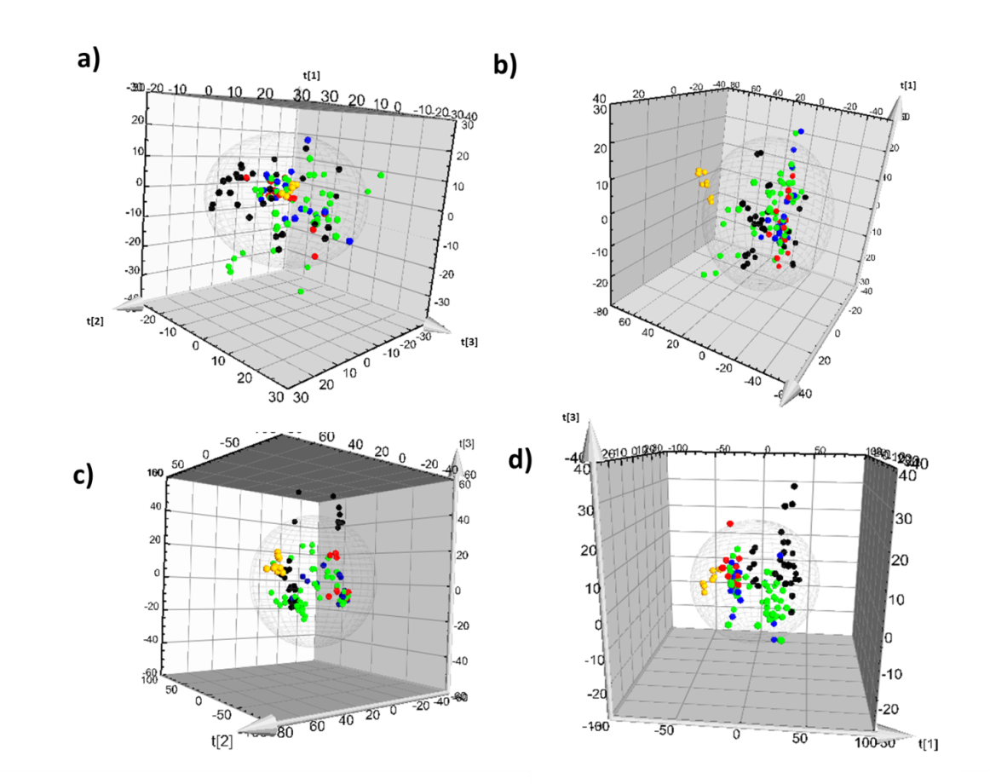

Figure S2. Metabolomic profiles of extract samples a) aqueous extract determined by ESI(+)-IP-UHPLC-QTOF-MS; b) polar extract determined by ESI(-)-IP-UHPLC-QTOF-MS; c) organic extract determined by ESI(+)-IP-UHPLC-QTOF-MS; and d) polar extract determined by ESI(+)-HILIC-UHPLC-QTOF-MS.

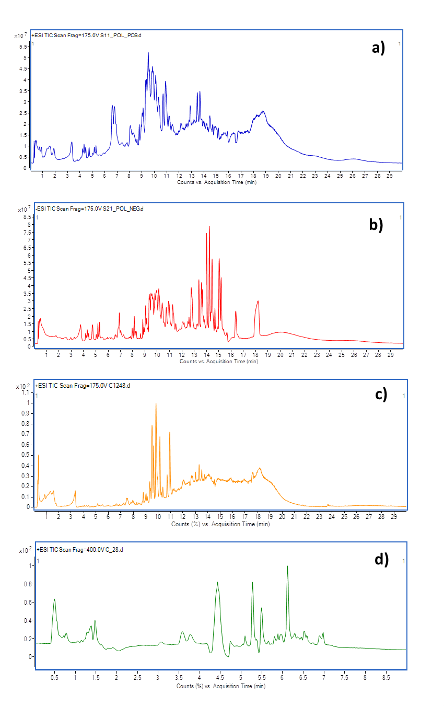

Figure S3. 2D-PLSDA plot pairwise PRE-CONTROL comparison of) aqueous extract determined by ESI(+)-IP-UHPLC-QTOF-MS; b) polar extract determined by ESI(-)-IP-UHPLC-QTOF-MS; c) organic extract determined by ESI(+)-IP-UHPLC-QTOF-MS; and d) polar extract determined by ESI(+)-HILIC-UHPLC-QTOF-MS. Black dots: CONTROL; green dots: PRE group.
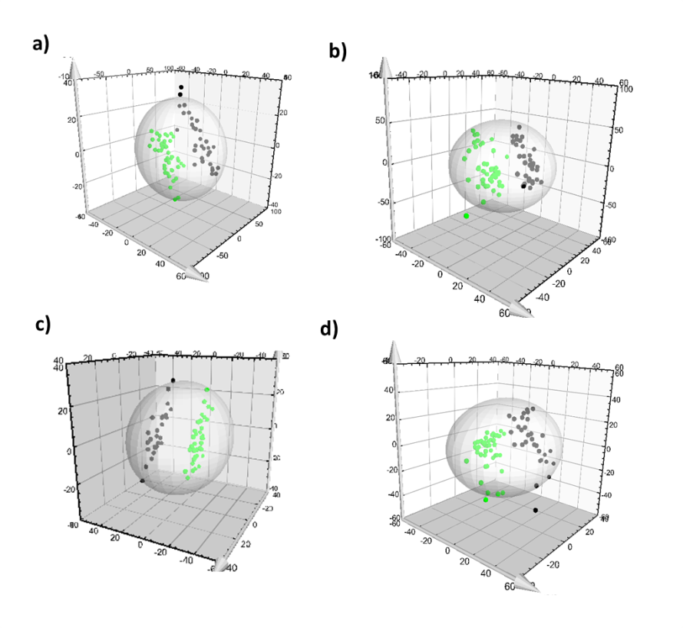
Figure S4. 2D-PLSDA plot pairwise POSTA-CONTROL comparison of) aqueous extract determined by ESI(+)-IP-UHPLC-QTOF-MS; b) polar extract determined by ESI(-)-IP-UHPLC-QTOF-MS; c) organic extract determined by ESI(+)-IP-UHPLC-QTOF-MS; and d) polar extract determined by ESI(+)-HILIC-UHPLC-QTOF-MS. Black dots: CONTROL; blue dots: POSTA group.

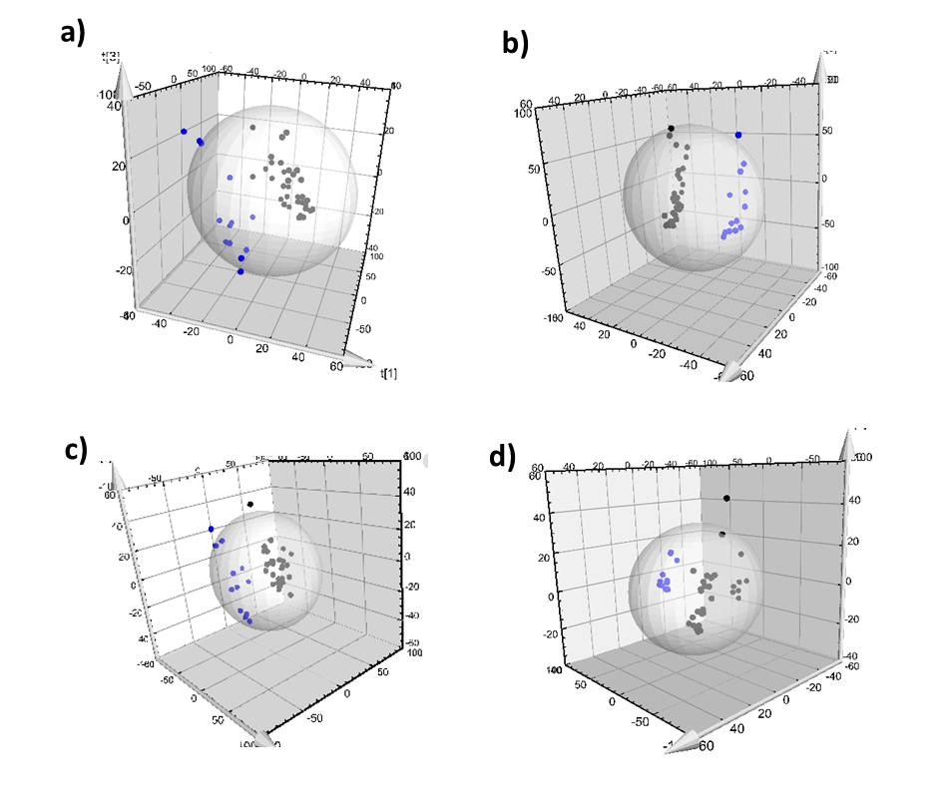

Figure S4. 2D-PLSDA plot pairwise POSTB-CONTROL comparison of) aqueous extract determined by ESI(+)-IP-UHPLC-QTOF-MS; b) polar extract determined by ESI(-)-IP-UHPLC-QTOF-MS; c) organic extract determined by ESI(+)-IP-UHPLC-QTOF-MS; and d) polar extract determined by ESI(+)-HILIC-UHPLC-QTOF-MS. Black dots: CONTROL; red dots: POSTB group.

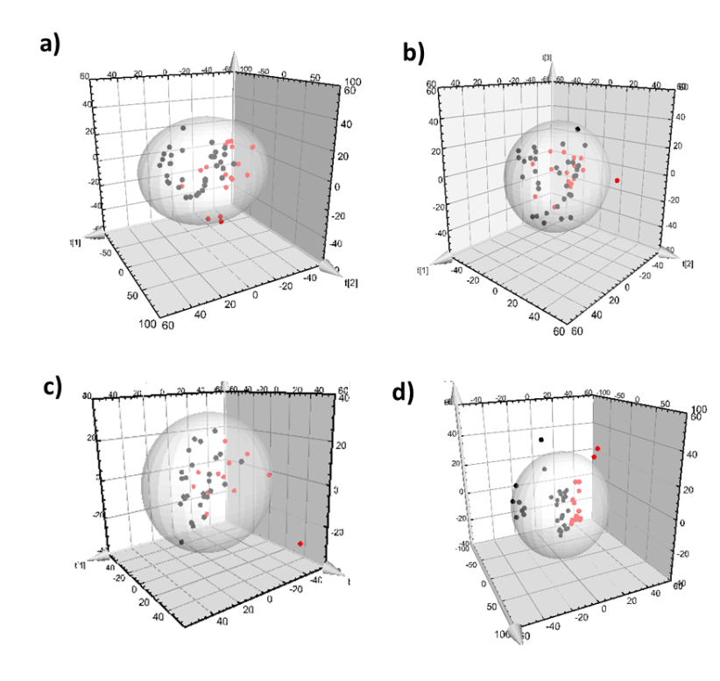
Figure S5. 2D-PLSDA plot pairwise PRE-POSTA comparison of) aqueous extract determined by ESI(+)-IP-UHPLC-QTOF-MS; b) polar extract determined by ESI(-)-IP-UHPLC-QTOF-MS; c) organic extract determined by ESI(+)-IP-UHPLC-QTOF-MS; and d) polar extract determined by ESI(+)-HILIC-UHPLC-QTOF-MS. Blue dots: POSTA group; green dots: PRE group.

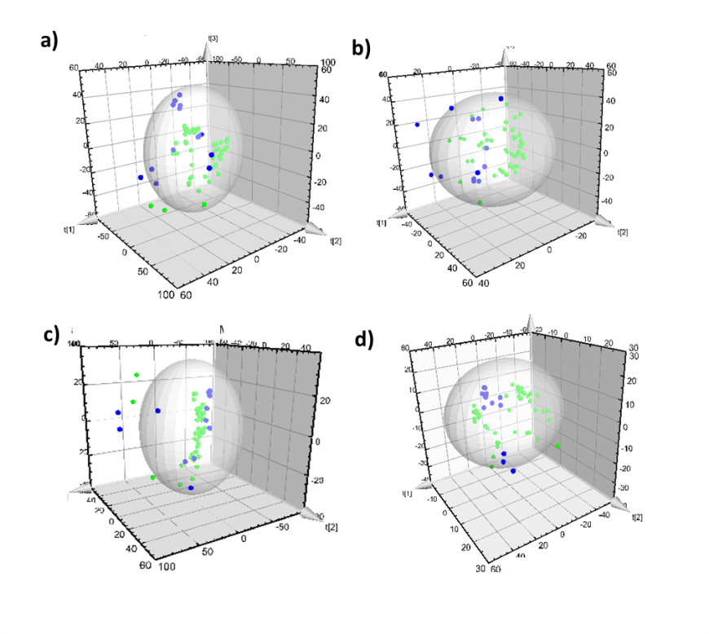

Figure S6. 2D-PLSDA plot pairwise PRE-POSTA comparison of) aqueous extract determined by ESI(+)-IP-UHPLC-QTOF-MS; b) polar extract determined by ESI(-)-IP-UHPLC-QTOF-MS; c) organic extract determined by ESI(+)-IP-UHPLC-QTOF-MS; and d) polar extract determined by ESI(+)-HILIC-UHPLC-QTOF-MS. Red dots: POSTB group; green dots: PRE group.

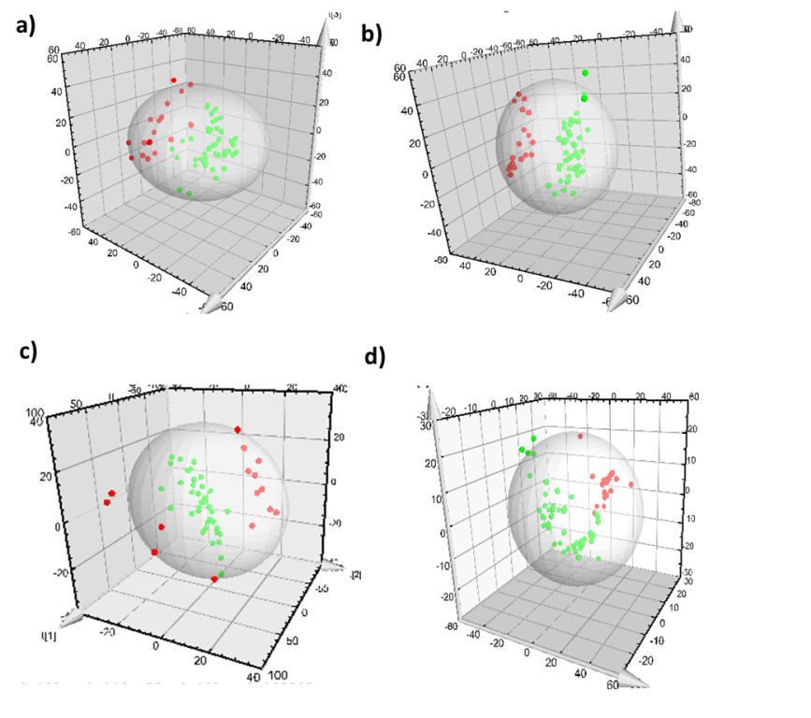

Figure S7. Main altered classes of metabolites in PRE, POSTA and POST B groups compared to CONTROL.
