Supplementary Material

Table S1 List of food groups, food items, and their respective weight to calculate the food consumption score
Food Group | Food Items | Weight
Main Staple | Traditional meals (e.g., dulemasi) | 2
Main Staple | Imported western meals (e.g., bread, pasta, rice, etc.) | 2
Pulses | Beans, peas, etc. | 3
Vegetables | Cabbage, onion, pepper, etc. | 1
Fruits | Banana, mango, etc. | 1
Meat and Fish | Traditional (e.g., lobster, bushmeat) | 4
Meat and Fish | Imported western (e.g., beef, pork, etc.) | 4
Milk | Milk, yogurt, etc. | 4
Sugar | Traditional drinks (e.g., cocoa, corn) | 0.5
Sugar | Imported western drinks (e.g., soft drinks, carbonated drinks, coffee, etc.) | 0.5
Oil | Oil, fat, and butter | 0.5

Table S2 List of expert interviews
Site | Role | Position
FAO | International Agency | Food Security Officer
Gardi Sugdub Community | Community Authority | Sagla
Gardi Sugdub Community | Community Leader | Local Marine Expert
Gardi Sugdub Community | Community Leader | Local Researcher
Gardi Sugdub Community | Community Leader | Local Tourism Expert
Gunayala Cultural Congress | Gunayala Authority | Secretary General
Gunayala Cultural Congress | Gunayala Authority | Subdirector of Patrimony
Indigenous Community Office - University of Panama (OPINUP) | Academic | Consultant
Inter-American Development Bank (IADB) | Development Agency | Consultant
Ministry Education | National Government | Coordinator Officer
Ministry of Environment | National Government | Protected Area Director
Ministry of Health | National Government | Gunayala Cultural Liaison
Ministry of Health | National Government | Nutrition Officer
Ministry of Health | National Government | Regional Head
Ministry of Health | National Government | Sanitation Officer
Ministry of Housing | National Government | Director of Development
Nargana Community | Community Authority | Saglas
Nargana Community | Community Leader | Catholic Church Priest
Nargana Community | Community Leader | Primary School Director
Panama National Coordinator Indigenous Women (CONAMUIP) | Civil Society/NGO | Gunayala Member
Panama National Coordinator Indigenous Women (CONAMUIP) | Civil Society/NGO | President
Panama Tourism Authority (ATP) | National Government | Communications Officer
Soledad Miria Community | Community Authority | Arga (Sagla's interpreter)
Soledad Miria Community | Community Authority | General Secretary
Soledad Miria Community | Community Leader | Head of Women Group
Spanish Agency for International Development Cooperation (AECID) | Development Agency | Indigenous Territory Director
Spanish Agency for International Development Cooperation (AECID) | Development Agency | Indigenous Territory Officer
Vice Ministry of Indigenous Affairs | National Government | National Coordinator
Vice Ministry of Indigenous Affairs | National Government | National Planning
Young Gunas Civil Society | Civil Society/NGO | Coordinator
Note All interviews conducted between February-March 2018

Table S3 Pairwise comparison between groups for each statistically significant variable
 | Young Men | Adult Men | Young Women
Age
Gardi Sugdub
Adult Men | 0.000***
Young Women | 0.939 | 0.000***
Adult Women | 0.000*** | 0.706 | 0.000***
Soledad Miria
Adult Men | 0.000***
Young Women | 0.696 | 0.000***
Adult Women | 0.000*** | 0.443 | 0.000***
Nargana
Adult Men | 0.000***
Young Women | 0.516 | 0.000***
Adult Women | 0.000*** | 1.000 | 0.000***
All Sites
Adult Men | 0.000***
Young Women | 0.967 | 0.000***
Adult Women | 0.000*** | 0.444 | 0.000***
Education (years)
Gardi Sugdub
Adult Men | 0.390
Young Women | 1.000 | 0.597
Adult Women | 0.084 | 1.000 | 0.149
Soledad Miria
Adult Men | 0.000***
Young Women | 1.000 | 0.006**
Adult Women | 0.000*** | 0.446 | 0.000***
All Sites
Adult Men | 0.001***
Young Women | 1.000 | 0.043*
Adult Women | 0.000*** | 1.000 | 0.001***
Income (USD/month)
Nargana
Adult Men | 0.720
Young Women | 0.355 | 0.060
Adult Women | 0.636 | 0.135 | 0.842
All
Adult Men | 0.550
Young Women | 0.148 | 0.018*
Adult Women | 0.807 | 0.163 | 0.455
Diet Change (years)
Gardi Sugdub
Adult Men | 1.000
Young Women | 0.007** | 0.094
Adult Women | 1.000 | 1.000 | 0.006**
Soledad Miria
Adult Men | 0.433
Young Women | 1.000 | 0.012*
Adult Women | 1.000 | 1.000 | 0.225
Nargana
Adult Men | 0.035*
Young Women | 1.000 | 0.144
Adult Women | 0.007** | 1.000 | 0.036*
All
Adult Men | 0.478
Young Women | 0.257 | 0.001***
Adult Women | 0.160 | 1.000 | 0.000***

Table S4 Western and traditional food group consumption before and after dietary transition within a 7 day period by sampling group and by study site
 | Gardi Sugdub |  |  |  |  | Soledad Miria |  |  |  |  | Nargana |  |  |  |  | All Sites
 | Past  FCS | Present  FCS | n | Sig. |  | Past  FCS | Present  FCS | n | Sig. |  | Past  FCS | Present  FCS | n | Sig. |  | Past  FCS | Present  FCS | n | Sig.
Traditional meals consumed within a week (days)
Young Men | 6.1 | 4.4 | 23 | .000*** |  | 5.2 | 3.3 | 24 | .002** |  | 3.4 | 2.7 | 20 | .228 |  | 5.0 | 3.5 | 67 | .000***
Adult Men | 6.6 | 5.0 | 23 | .007** |  | 6.0 | 4.0 | 26 | .000*** |  | 4.6 | 1.8 | 22 | .000*** |  | 5.7 | 3.6 | 71 | .000***
Young Women | 5.1 | 4.1 | 21 | .007** |  | 4.8 | 3.6 | 24 | .012* |  | 3.5 | 2.4 | 20 | .038* |  | 4.5 | 3.4 | 65 | .000***
Adult Women | 6.3 | 5.4 | 23 | .006** |  | 5.2 | 3.9 | 24 | .016* |  | 5.6 | 2.8 | 20 | .001*** |  | 5.7 | 4.1 | 67 | .000***
All Groups | 6.0 | 4.8 | 90 | .000*** |  | 5.3 | 3.7 | 98 | .000*** |  | 4.3 | 2.4 | 82 | .000*** |  | 5.2 | 3.7 | 270 | .000***
Western meals consumed within a week (days)
Young Men | 2.2 | 3.9 | 23 | .001** |  | 1.8 | 3.8 | 24 | .002** |  | 3.6 | 5.5 | 20 | .017* |  | 2.5 | 4.3 | 67 | .000***
Adult Men | 2.3 | 3.5 | 23 | .019* |  | 1.3 | 3.4 | 26 | .000*** |  | 2.6 | 5.1 | 22 | .004** |  | 2.0 | 4.0 | 71 | .000***
Young Women | 2.5 | 3.8 | 21 | .013* |  | 1.8 | 3.7 | 24 | .004** |  | 3.5 | 5.1 | 20 | .038* |  | 2.6 | 4.2 | 65 | .000***
Adult Women | 2.0 | 2.9 | 23 | .003** |  | 0.5 | 2.9 | 24 | .000*** |  | 1.7 | 4.7 | 20 | .001*** |  | 1.3 | 3.4 | 67 | .000***
All Groups | 2.3 | 3.5 | 90 | .000*** |  | 1.3 | 3.4 | 98 | .000*** |  | 2.8 | 5.1 | 82 | .000*** |  | 2.1 | 4.0 | 270 | .000***
Local bushmeat and fish consumed within a week (days)
Young Men | 5.5 | 4.4 | 23 | .005** |  | 4.8 | 3.1 | 24 | .002** |  | 3.4 | 2.6 | 20 | .081 |  | 4.6 | 3.4 | 67 | .000***
Adult Men | 5.9 | 4.8 | 23 | .014* |  | 5.5 | 3.7 | 26 | .000*** |  | 4.0 | 1.8 | 22 | .002** |  | 5.2 | 3.5 | 71 | .000***
Young Women | 4.3 | 3.4 | 21 | .019* |  | 4.7 | 3.3 | 24 | .009** |  | 2.5 | 1.4 | 20 | .006** |  | 3.9 | 2.7 | 65 | .000***
Adult Women | 5.6 | 4.5 | 23 | .001*** |  | 4.8 | 3.4 | 24 | .017* |  | 5.2 | 2.3 | 20 | .000*** |  | 5.2 | 3.4 | 67 | .000***
All Groups | 5.3 | 4.3 | 90 | .000*** |  | 5.0 | 3.4 | 98 | .000*** |  | 3.8 | 2.0 | 82 | .000*** |  | 4.7 | 3.3 | 270 | .000***
Imported meat and fish consumed within a week (days)
Young Men | 2.2 | 3.1 | 23 | .019* |  | 2.0 | 3.4 | 24 | .034* |  | 4.2 | 5.1 | 20 | .122 |  | 2.7 | 3.8 | 67 | .000***
Adult Men | 2.4 | 3.7 | 23 | .014* |  | 1.6 | 4.0 | 26 | .000*** |  | 2.5 | 4.4 | 22 | .007** |  | 2.2 | 4.0 | 71 | .000***
Young Women | 2.6 | 3.6 | 21 | .031* |  | 1.7 | 3.8 | 24 | .000*** |  | 2.6 | 3.9 | 20 | .037* |  | 2.2 | 3.8 | 65 | .000***
Adult Women | 2.2 | 2.7 | 23 | .065 |  | 1.7 | 3.8 | 24 | .001** |  | 2.2 | 5.4 | 20 | .000*** |  | 2.0 | 3.9 | 67 | .000***
All Groups | 2.3 | 3.3 | 90 | .000*** |  | 1.7 | 3.7 | 98 | .000*** |  | 2.9 | 4.7 | 82 | .000*** |  | 2.3 | 3.9 | 270 | .000***
Traditional drinks consumed within a week (days)
Young Men | 5.2 | 3.7 | 23 | .007** |  | 4.5 | 2.4 | 24 | .002** |  | 3.0 | 1.9 | 20 | .081 |  | 4.3 | 2.7 | 67 | .000***
Adult Men | 6.1 | 4.7 | 23 | .002** |  | 6.2 | 3.8 | 26 | .001** |  | 4.0 | 1.5 | 22 | .001*** |  | 5.5 | 3.4 | 71 | .000***
Young Women | 4.2 | 3.1 | 21 | .002** |  | 4.5 | 2.5 | 24 | .002** |  | 2.6 | 1.6 | 20 | .018* |  | 3.8 | 2.4 | 65 | .000***
Adult Women | 5.9 | 4.1 | 23 | .000*** |  | 4.8 | 3.5 | 24 | .052 |  | 5.5 | 1.5 | 20 | .000*** |  | 5.4 | 3.1 | 67 | .000***
All Groups | 5.4 | 3.9 | 90 | .000*** |  | 5.0 | 3.1 | 98 | .000*** |  | 3.8 | 1.6 | 82 | .000*** |  | 4.7 | 2.9 | 270 | .000***
Soft drinks and coffee consumed within a week (days)
Young Men | 2.6 | 3.6 | 23 | .029* |  | 2.3 | 4.3 | 24 | .007** |  | 4.4 | 5.6 | 20 | .009** |  | 3.0 | 4.4 | 67 | .000***
Adult Men | 2.3 | 3.8 | 23 | .008** |  | 1.5 | 3.9 | 26 | .001*** |  | 2.7 | 5.6 | 22 | .002** |  | 2.1 | 4.4 | 71 | .000***
Young Women | 2.7 | 3.8 | 21 | .017* |  | 1.6 | 4.5 | 24 | .000*** |  | 3.7 | 5.5 | 20 | .014* |  | 2.6 | 4.5 | 65 | .000***
Adult Women | 2.2 | 3.6 | 23 | .004** |  | 1.1 | 4.3 | 24 | .000*** |  | 2.5 | 6.1 | 20 | .001** |  | 1.9 | 4.6 | 67 | .000***
All Groups | 2.4 | 3.7 | 90 | .000*** |  | 1.6 | 4.2 | 98 | .000*** |  | 3.3 | 5.7 | 82 | .000*** |  | 2.4 | 4.5 | 270 | .000***

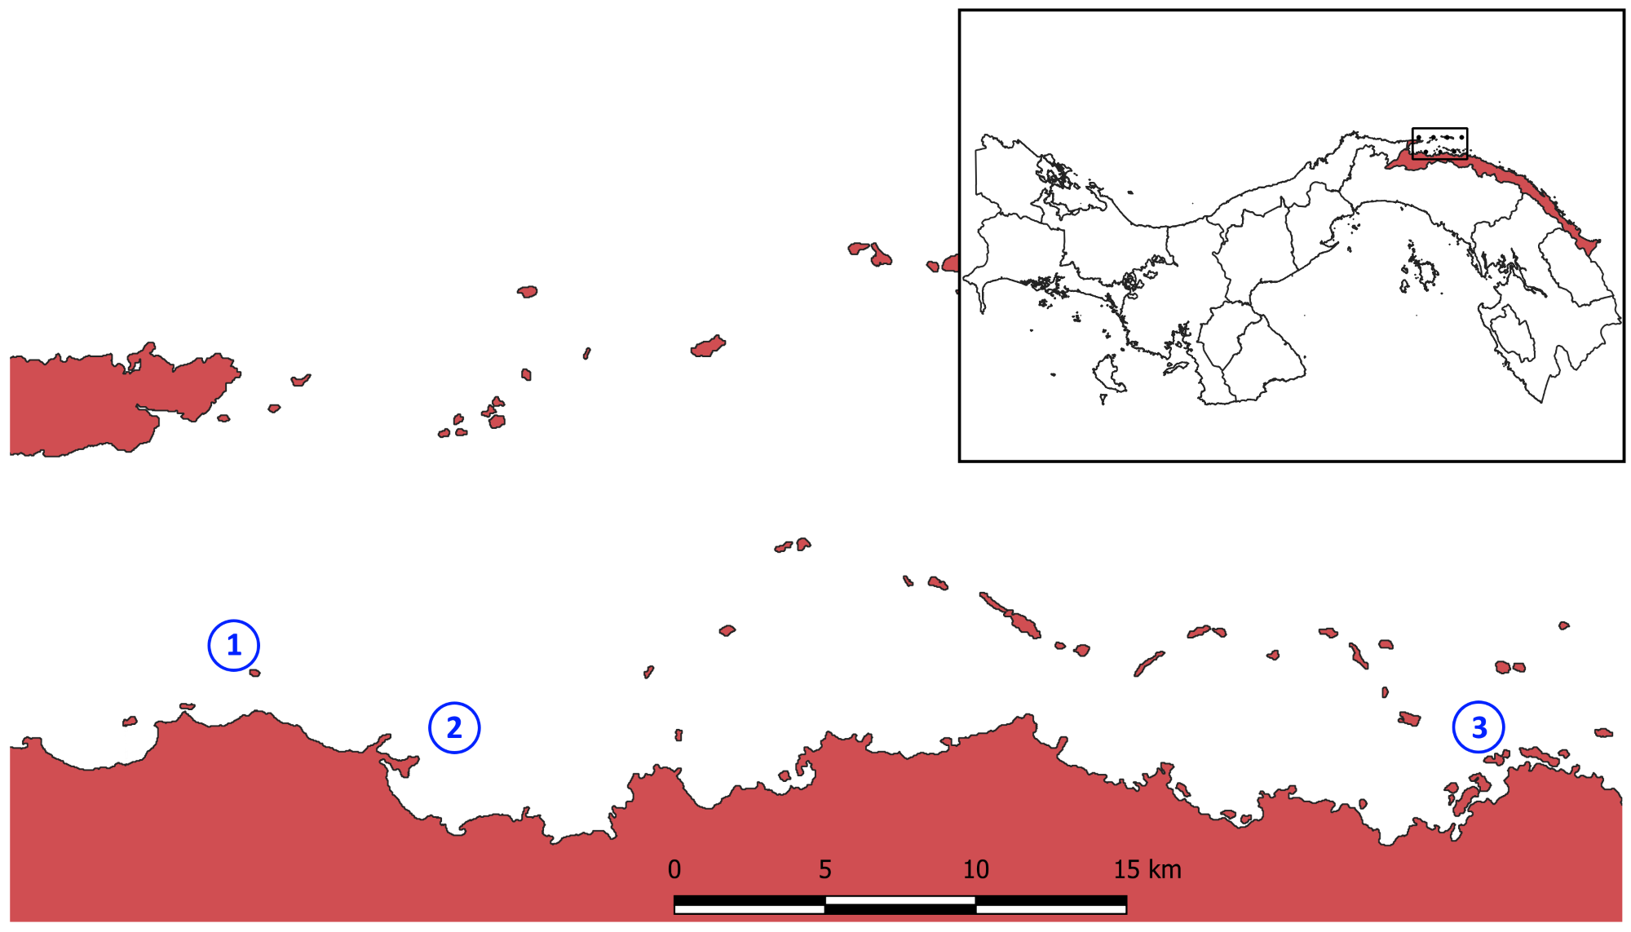
Figure S1 Study sites: 1) Gardi Sugdub, 2) Soledad Miria, 3) Nargana

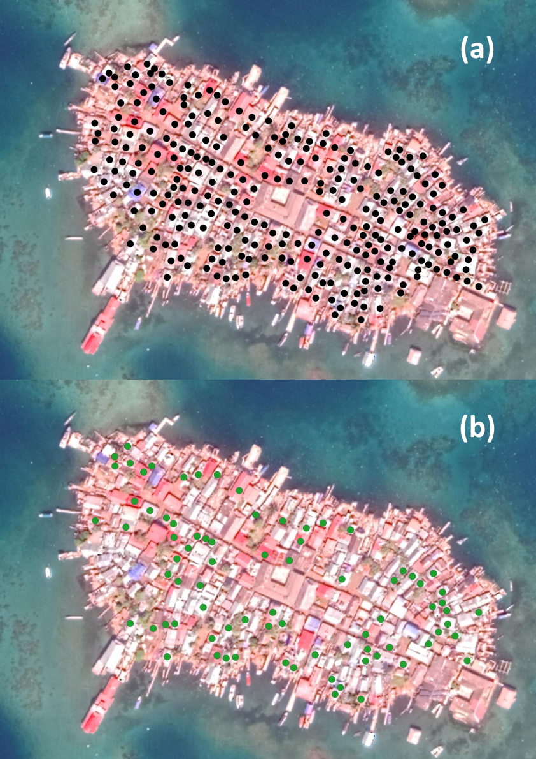
Figure S1 Household survey sampling selection method (Gardi Sugdub Gunayala, Google Maps, 2019).
Note: (a) Initial identification of each available structure using QGIS, (b) Final sampling using a random function in Excel.

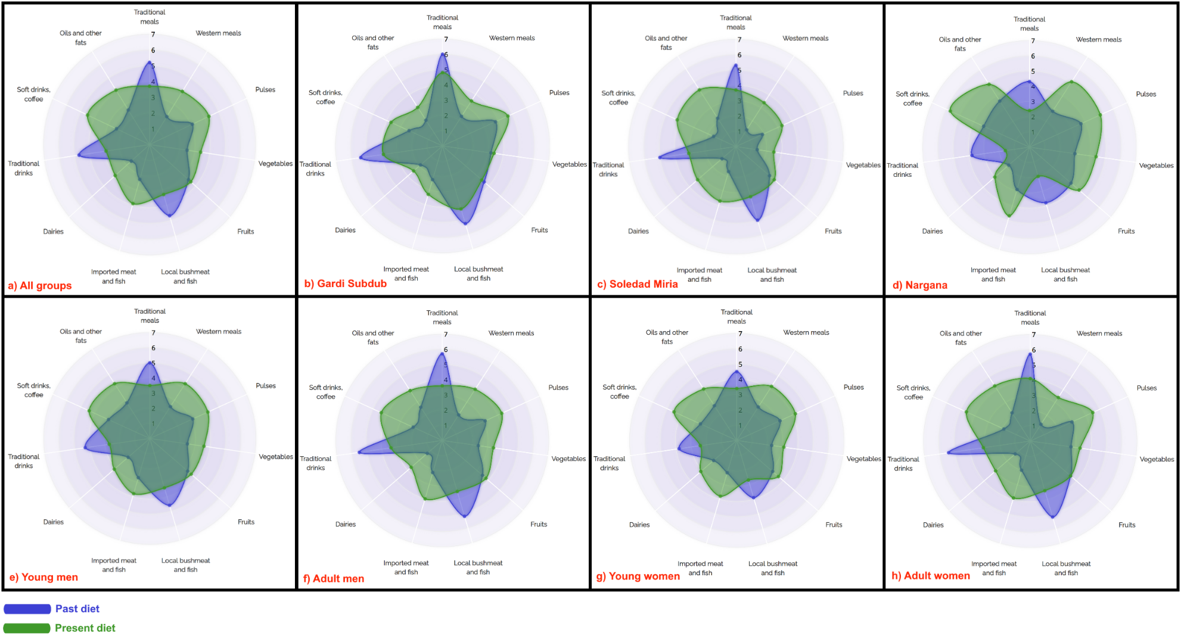
Figure S2 Changes in food group consumption within a week by study site and sampling group

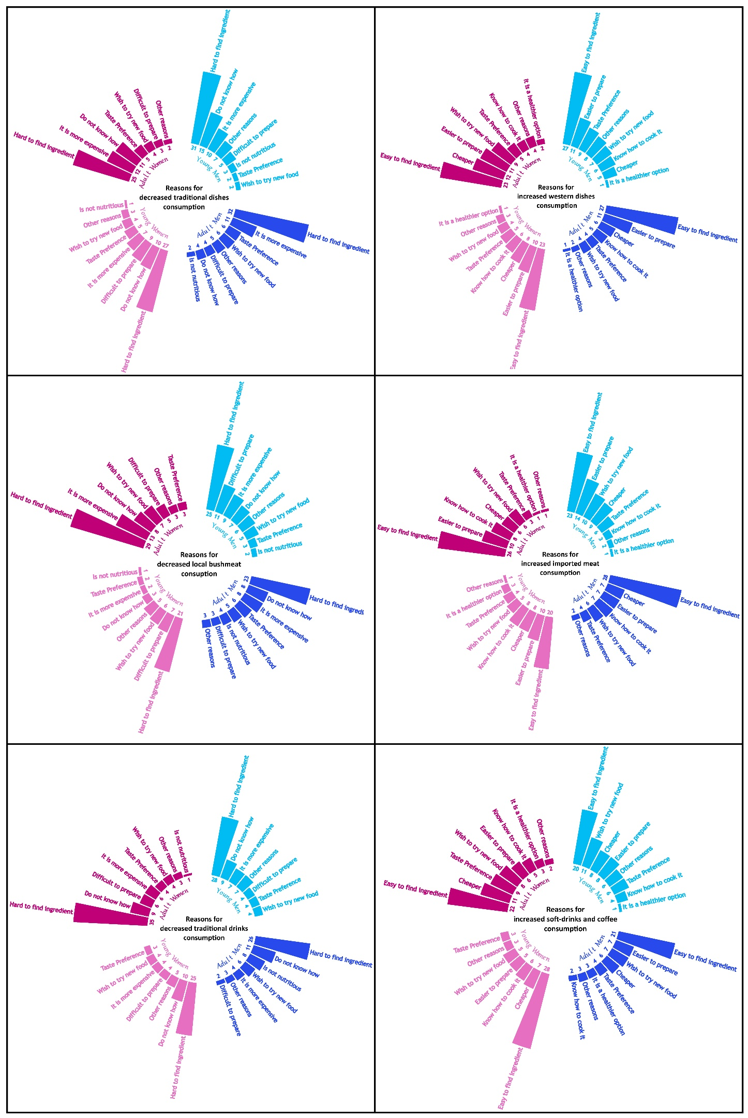
Figure S3 Reasons for dietary transition by sampling group
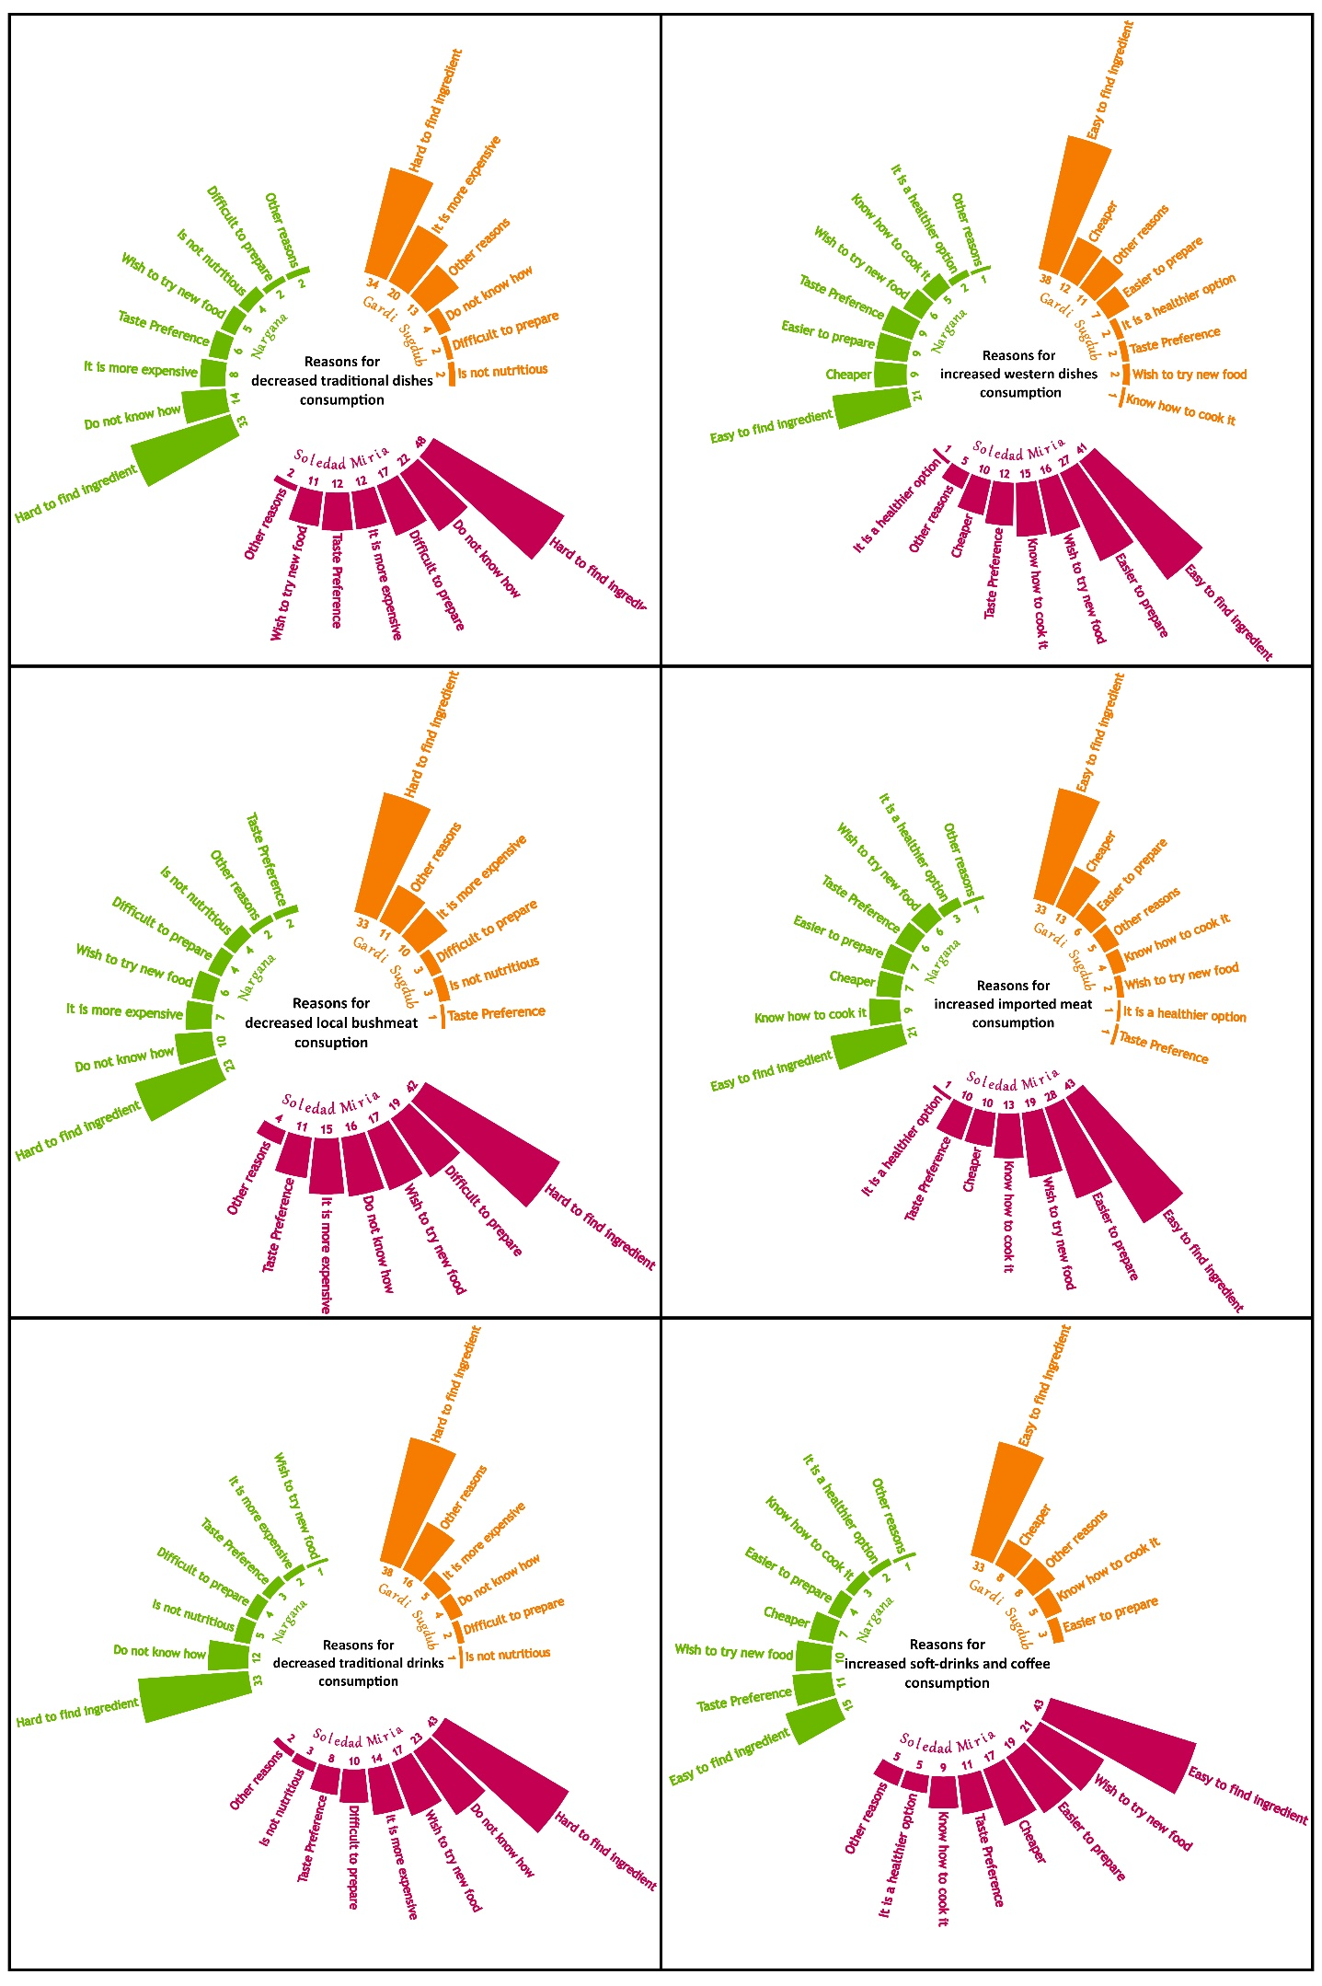
Figure S4 Reasons for dietary transition by study site

