Fig7
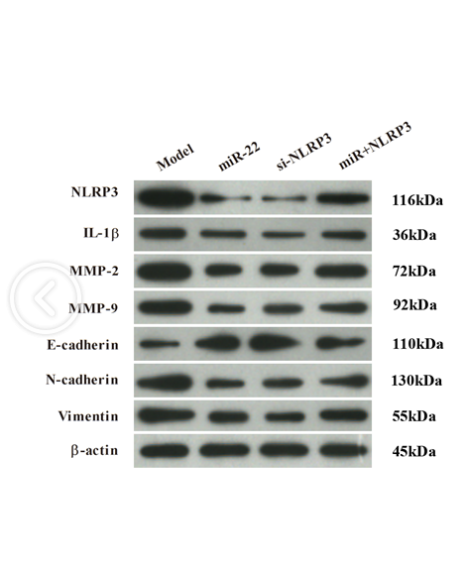

NLRP3
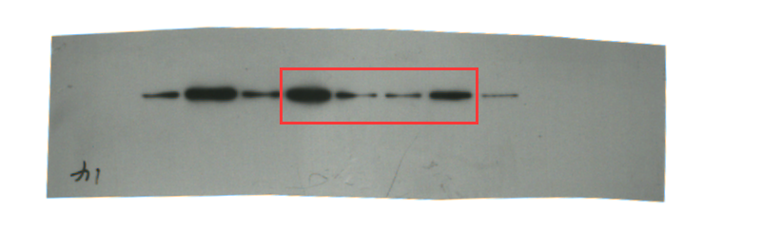
IL-1β .
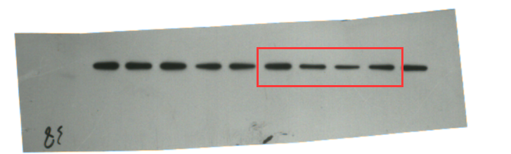
MMP-2
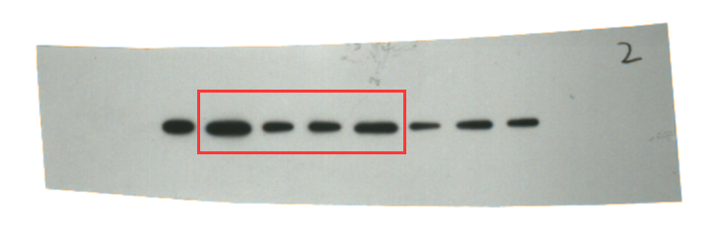
MMP-9
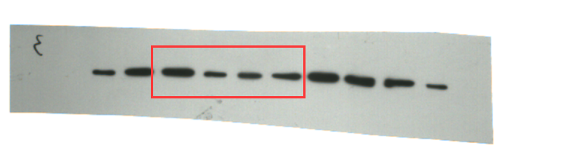
E-cadherin
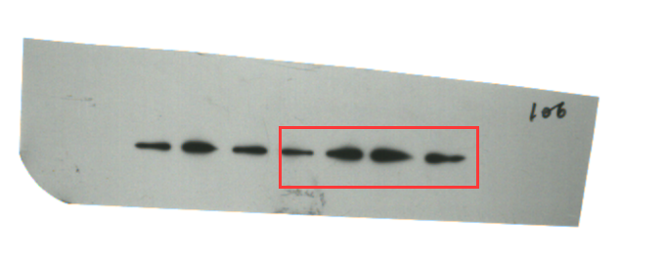
N-cadherin
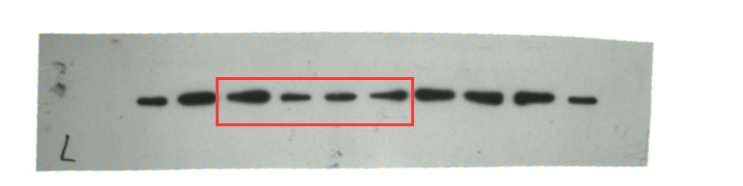
Vi mentin
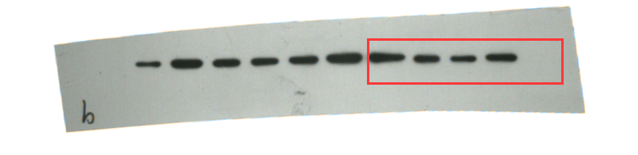
β-actin
