Table S1 AMF sequences numbers in each sample.
Samples | Sequence
Soil_CK1 | 94548
Soil_CK2 | 83579
Soil_CK3 | 88343
Soil_CK4 | 112745
Soil_W1 | 60104
Soil_W2 | 88874
Soil_W3 | 73152
Soil_W4 | 80893
Root_CK1 | 71940
Root_CK2 | 95710
Root_CK3 | 85331
Root_CK4 | 79942
Root_W1 | 79660
Root_W2 | 77956
Root_W3 | 96098
Root_W4 | 97350
Total | 1366225

Table S2 Dissimilarity analysis of AMF communities with permutational multivariate analysis of variance (PERMANOVA).
 | Df | SumsOfSqs | MeanSqs | F.Model | R² | Pr(>F)
Soil & Root | 3 | 3.0505 | 1.01682 | 4.8406 | 0.54754 | 0.001
Residuals | 12 | 2.5207 | 0.21006 |  | 0.45246
Total | 15 | 5.5712 |  |  | 1

Figure. S1 Annual mean temperature and precipitation of the study site from 1976 to 2021.
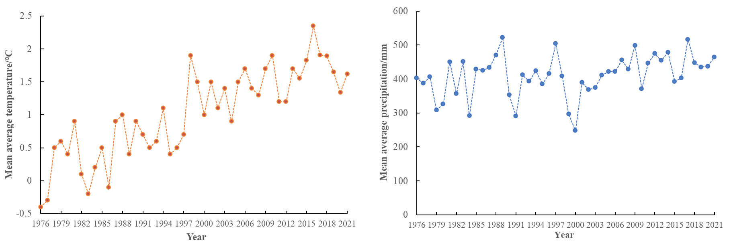

Figure S2 Taxonomic composition of soil and root AMF community at the genus level under different treatments.
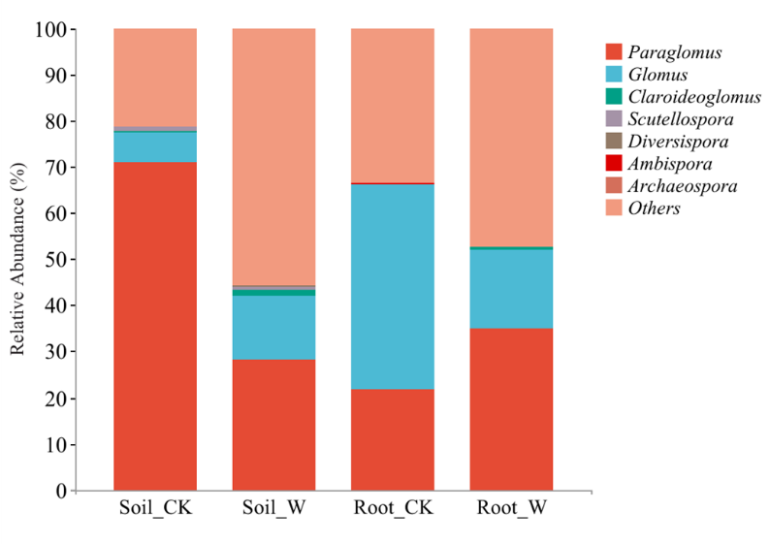

Figure. S3 Rarefaction curve of observed-species for AMF communities. Soil_CK, Soil_W, Root_CK and Root_W represent soil and root samples of Elymus nutans of control and warming, respectively.
