Table S1 Primer sequences used in this study
Primer | Forward Primer (5′-3′) | Reverse Primer (5′-3′)
ID02M05471 | ATATATTTGCTAGGCCCCTC | CGGAAATAAACAGTTGTGGT
STS 2-39.6 | TGCTGATGTTAATCTGTGGGTG | TGGCGGCTTGAGAGTGTTTGTAG
ID02M06080 | AGTTGGATTCCACTCCTTTC | TGTTGCTGGTAATTGACAAA
RM12895 | CGCTATGTGGCAGTTTAAGAGC | CTGTTGGAATCAAAGTGAGTGC
ID02M06317 | TGAGCATAAGAAGCTGAAAA | GAGAGAGAGAGAGGGGAGAG
RM12921 | TCGTATTTCCCGGTGTCTCAGG | ACTAGTACTCGGTGCAGGGAATCG
ID02M06497 | CCAATGGAAGGAATGAACTA | AACTCATTTTCGTTGTTGCT
RM12924 | CCCTATGAATTGTTTGGAGTGACC | CACTGGGTTCATGTCATAAGAAGG
RM12925 | CGAATGGAACGACAAGAGATGC | ATAGATCGACAACGTAGATCCACAGG
RM12938 | CCATCTGTCTCTCCTCCTTATCTCC | CTCCCACCAAATCTAGTGAATGG
RM12941 | TTATGCCATGTGGTCCAATCAGC | ATTTGAACCATTTGGGCCTTGG
RM12955 | CTCTCGTGCTCGTGAAACTACCTACC | CCGTTCTGTTACTGCACGATTCC
STS-2-55.4 | TGACTATGTAAGGTTGCTGCTG | ACAGCTCCACAGCAAAGAACC

Table S2 The number of SLAF markers on each chromosome
Chromosome | No. of SLAF markers
Chr1 | 1,218
Chr2 | 1,328
Chr3 | 1,275
Chr4 | 807
Chr5 | 788
Chr6 | 972
Chr7 | 740
Chr8 | 739
Chr9 | 518
Chr10 | 726
Chr11 | 696
Chr12 | 296
Total | 10,103

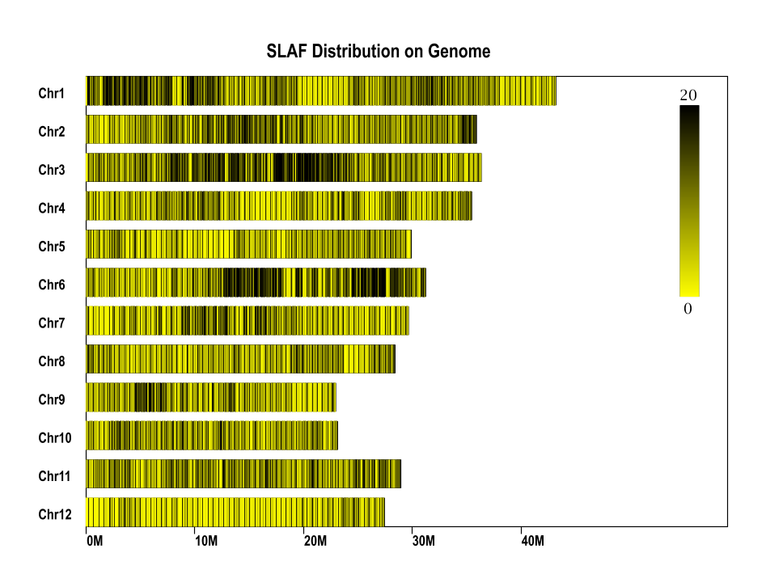
Fig. S1 Distribution of SLAF markers on the genome

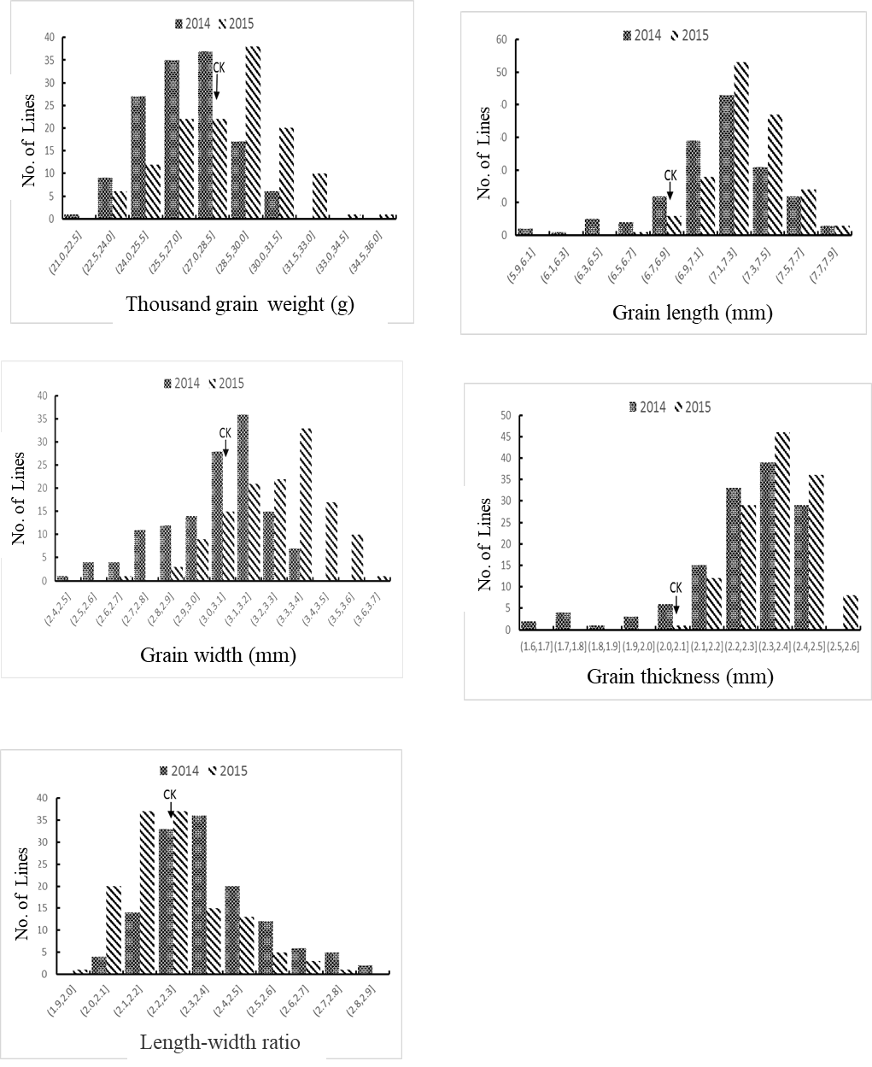
Fig. S2 Performance of grain size-related traits in ILs and Wuyujing3R (CK)
2014 and 2015 means materials planted in Yangzhou in 2014 and 2015, respectively.

